Dear Parents/Guardians,

Welcome to week 6 of the summer term!

It’s hard to believe that so long has passed since we were altogether in school. All the second class teachers in St. Philip the Apostle Junior National School are really missing the boys and girls.

Some of you might have your books back by now and if you do you can work on them with your family. Some of the second classes might be further ahead in some books than the others and some children might be further ahead or behind due to missing school. It’s for that reason we have kept the ‘weekly plan’ on the website a little different. We are also aware that not all children have their books.

Ms. O’Hare’s class have been using SeeSaw for a while but from Monday the 25th of May all classes in the school will have access to SeeSaw activities. SeeSaw will be used to compliment the other work being done at home. It is not compulsory for children to complete the activities on the app/site but there as an extra tool for parents and children to use if they wish to do so.

It is through a combination of photos and videos on the website, our weekly plan uploaded in the home learning tab, contact with teachers via the email address, workbooks and books at home and now with the addition of daily SeeSaw activities, we hope parents and children are receiving enough support and guidance at home.

If you do not have your child’s books and wish to collect them please email kids@stphilipsjns.ie to arrange a pick up date and time.
It is not compulsory for children to complete all activities and work on the weekly plan and on SeeSaw but it is recommended that they are engaging in some form of stimulation at home.

Mr. Conneely, Ms. O’Hora, Mrs. Maye, Ms. O’Hare, Mrs Watson.

Monday 25th May

Literacy:

As it’s the start of the week write ‘Our News’ – What did you get up to at the weekend? What day is it today? What’s the weather like? Remember to keep it interesting! You can draw a picture of your weekend and colour the picture too.

Word Family of the week: This week we are going to be learning about the sound ‘tion’ and ‘sion’. Both sounds very like ‘SH’ but we use them differently.

Today we’ll look at ‘tion’ words. Here are a few; action, fraction, fiction, question. Try saying them out loud! Can you think of anymore? Try thinking of words that have the “sh” sound in it! Many of them are spelled with ‘tion’.

Can you put the following words in the write sentences?

question | direction | fractions | fiction | Vacation
Station | celebration | actions | Optician | Pollution

- We learned __________ to go with the songs for Peace Proms.
- There are 2 quarters in 1 half. We learned this when we learned about ___________.
- My teacher read The Twits. When a story is made up we call it a work of _________.
- I asked my mam a ______________, can we go to the beach?
- When you throw litter in the park it is called ________________.
- Firemen and women work in a fire ____________.
- I think we’re lost. We went in the wrong ___________.
- Last Summer I went on ____________ to Spain.
- When my Aunty turned 40 we had a big party. It was a great _____________.
- When you need glasses you go to the _________________.
Can you make up clues for anymore ‘tion” words you listed above? Do 5 examples.

Check out this video for lots of examples of ‘tion’ words!
https://www.youtube.com/watch?v=las_fWNKEDw

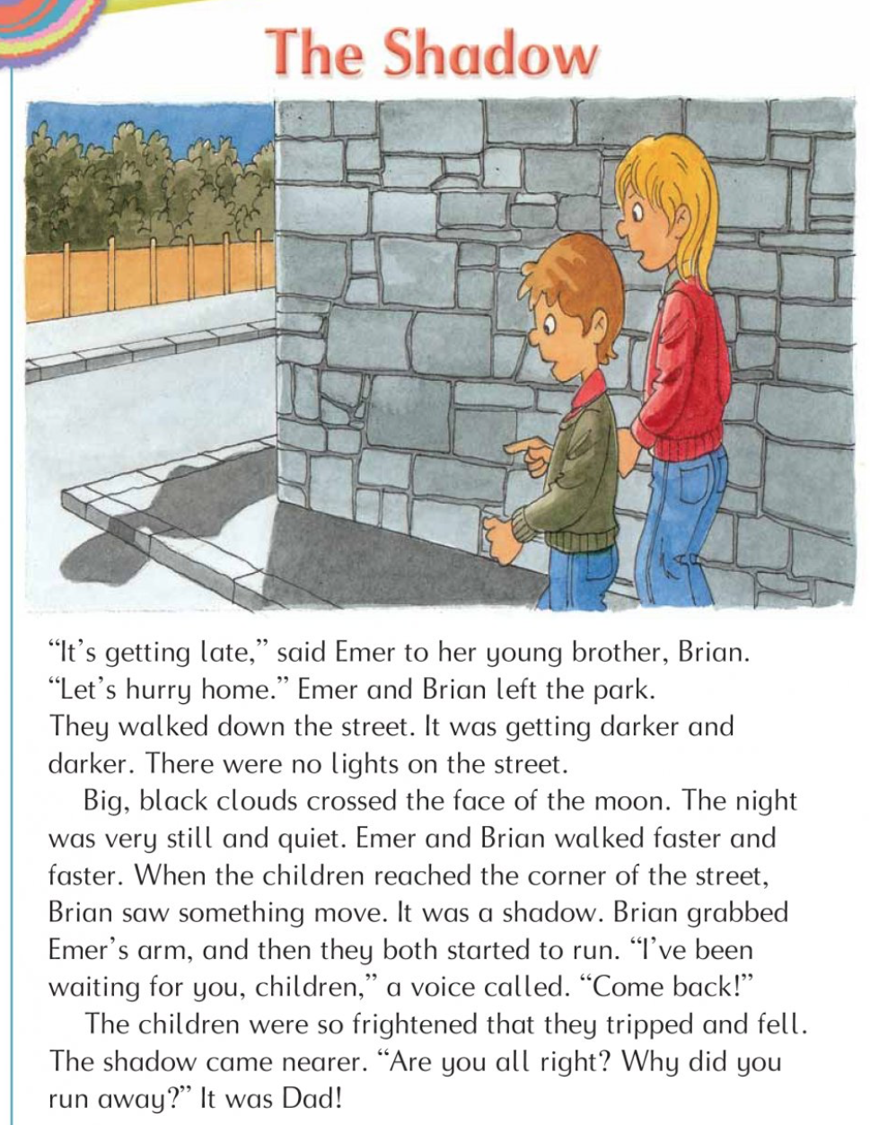
Reading- If you have your Green Genie workbook at home pick a reading comprehension to read a couple of times and complete the questions and activates that go with it. If you have it done and want to do another or you do not have your book here is one below.
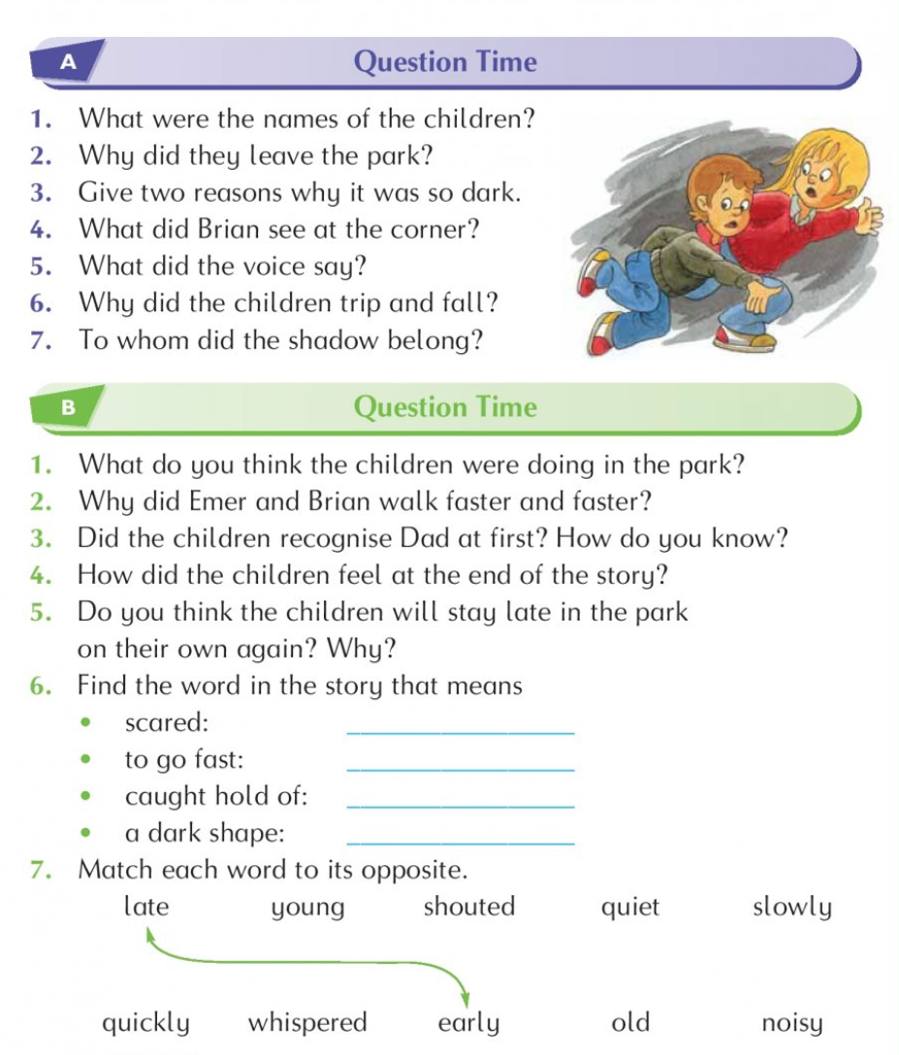

Send your answers to kids@stphilipsjns.ie !

Numeracy:

This week we are looking at the topic of capacity! Capacity is the word we use when we are talking about measuring a liquid.

Which can hold more water; a cup or a bucket? Easy! Now watch this video which helps explain it a little more. https://www.youtube.com/watch?v=zF3JSnEq7tU

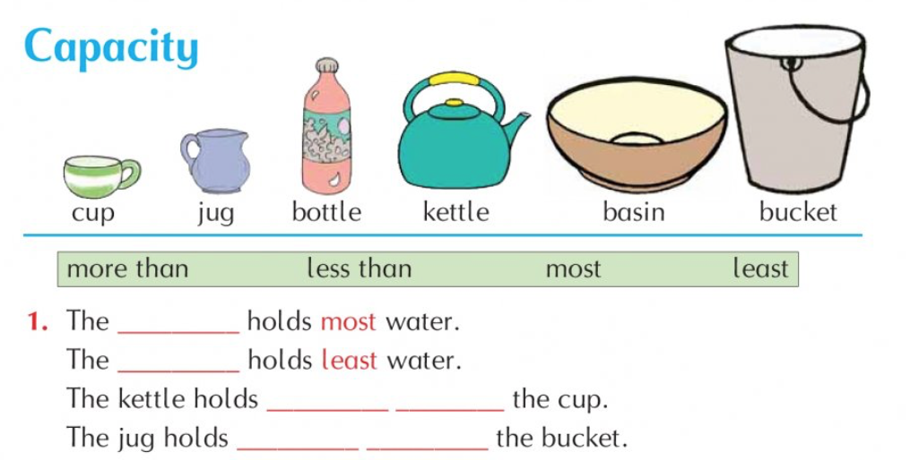

*If you have your Busy at Maths book at home try page 144.
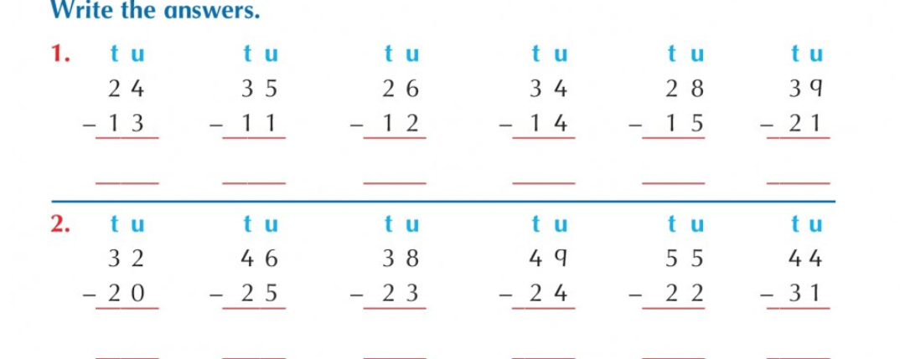
Gaeilge:
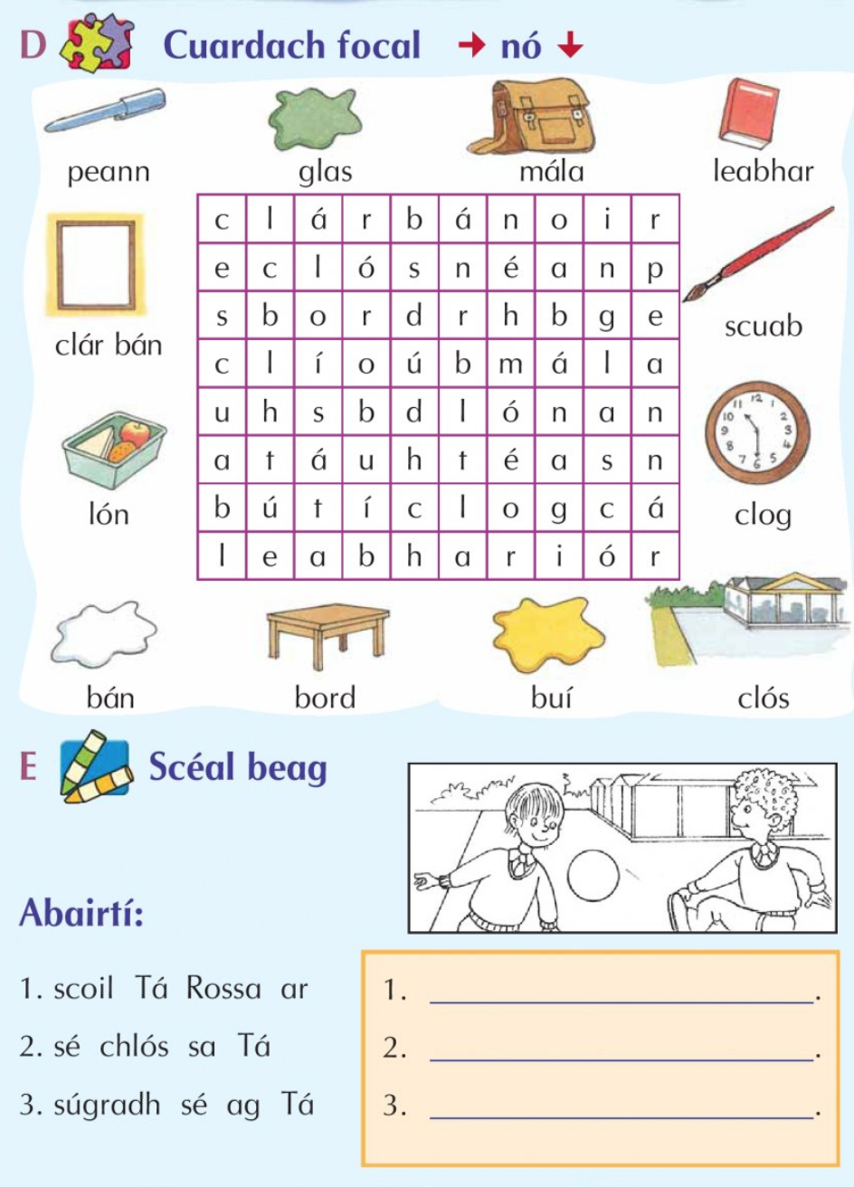
* If you have unfinished work in your Gaeilge workbook on the topic of Éadaí please have a go at doing a page or two.
SESE:
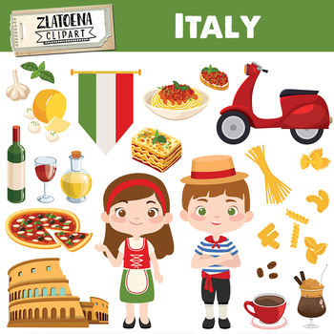
If we were in school at the minute we would be learning about….. Italy!

What do you know about Italy?

Where is it?

What do Italians eat?

Have you ever been there?

Have a chat about it with your family…

Please watch this really cool video about Italy and we’ll be learning about it all this week!
https://www.youtube.com/watch?v=g5mpdzUlFmw
Tuesday 26th May
Literacy
Lets watch that video with ‘tion’ words again!
https://www.youtube.com/watch?v=las_fWNKEDw

- Subtraction  - Addition  - Question  - Emotion  - Station | - Invitation  - Protection  - Attention  - Station  - Fraction
Can you put these ‘tion’ words into sentences? Remember finger spaces, full stops, capital letters, keep your writing on the line. You can do these sentences on a page or in your copy.

Send a picture of your sentences to kids@stphilipsjns.ie if you want your teacher to see!
If you have your books at home try reading an old comprehension we done in class. Maybe start at the beginning of your book!
Numeracy:

Yesterday we looked at how some different shaped objects hold more or less liquid than one another.

Estimating volume. The word estimating means you’re taking an educated guess.
Circle the object that you think holds more in these pictures.
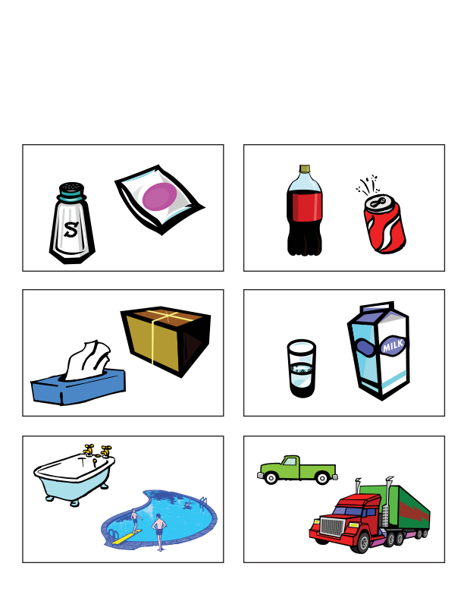
We cant measure water in a bottle with centimetres or kilometres, just like we can’t measure it in kilograms!
We measure liquid in millilitres and litres!
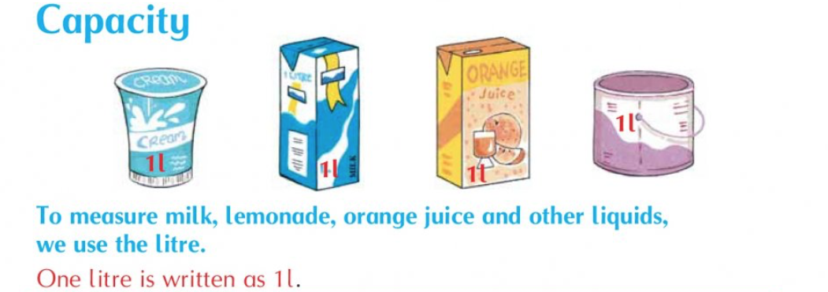
Maths:
Can you think of a few things that would be smaller than 1l? Maybe a spoonful of water, or a lid full of water.
Can you think of things that would be bigger than 1l? Maybe a truck full of water or a lake! Try drawing a picture and writing the word in the boxes below.

Things that are smaller than 1l | Things that are bigger than 1l

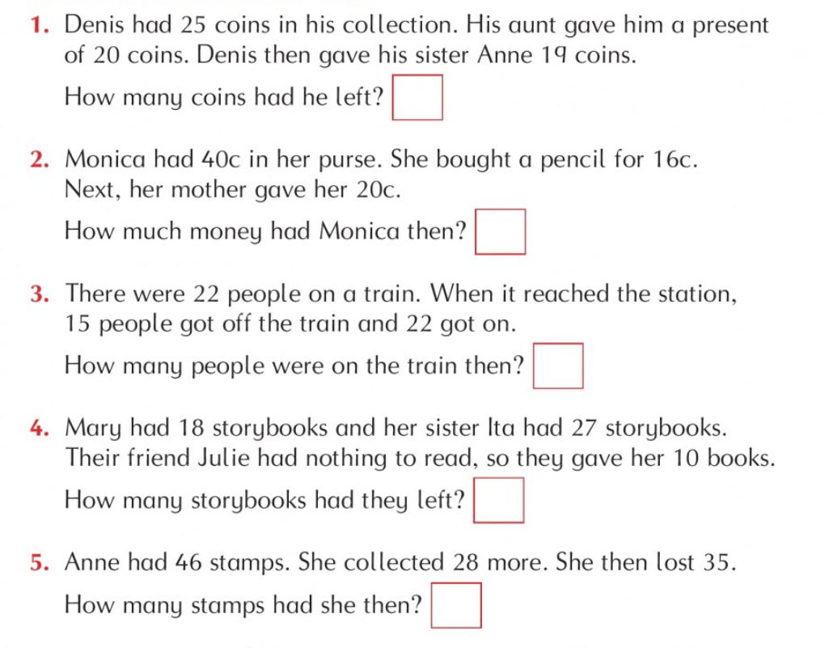
*If you have your Busy at Maths book at home try page 145.
Gaeilge:
*If you have your Gaeilge book at home complete a page or two of your choice.

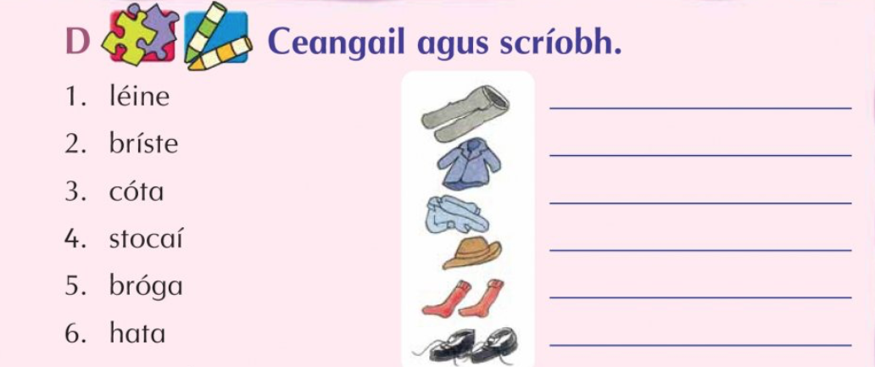

SESE:
Italy – From watching yesterdays video you should be able to remember loads about Italy. Have a look back at yesterdays video before reading this below.

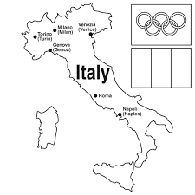
Italty is a country in Europe. Rome is the capital city of Italy. Over Over 61 million people live there. Italy has many volcanos and earthquakes. Italian is the official language of Italy. German and French is also spoken in Italy. Some major cities in Italy are Milan, Naples, Turin, and Palermo.

In your copy or on another page can you answer these questions.
Where is Italy located? What is the capital of Italy? What languages do they speak? What colour is the Italian flag? Can you colour the picture above.

Wednesday 27th May

The last two day we were learning about ‘tion’ words that have the ‘sh’ sound in them. Today we’re going to focus on ‘sion’ words that also have the ‘sh’ sound in them. Here are a few; decision, mansion, collision. Try saying them out loud! Can you think of anymore?

Can you fill the words into the right spaces?

collision | mission | session | decision | mansion

- What is your final ________________.
- I would love to live in a _______________.
- I saw a car _____________ collision on my way to school today.
- Lets have a music ______________!
- A spy works on a secret _______________.
Can you make up clues for anymore “sion” words you listed above?
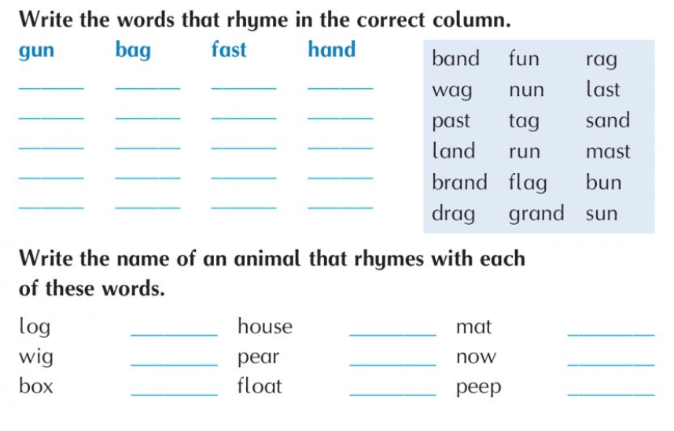
*If you have your Green Genie book have a go at a page in the book. Don’t forget to do some reading.

Numeracy:

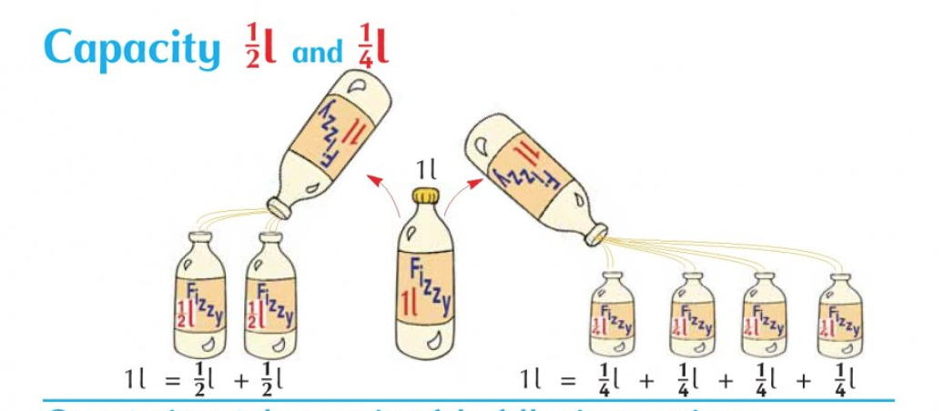

Just like when we were learning about fractions, there are four quarters in one whole. There are four quarter litres in one litre. Each quarter litre is 250ml.
*If you have your maths books do page 146.
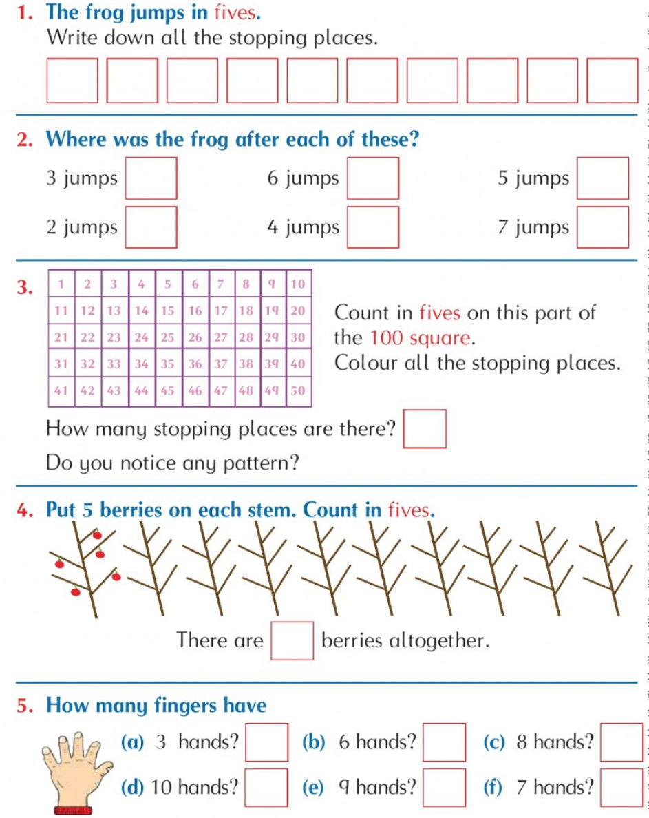

Gaeilge:
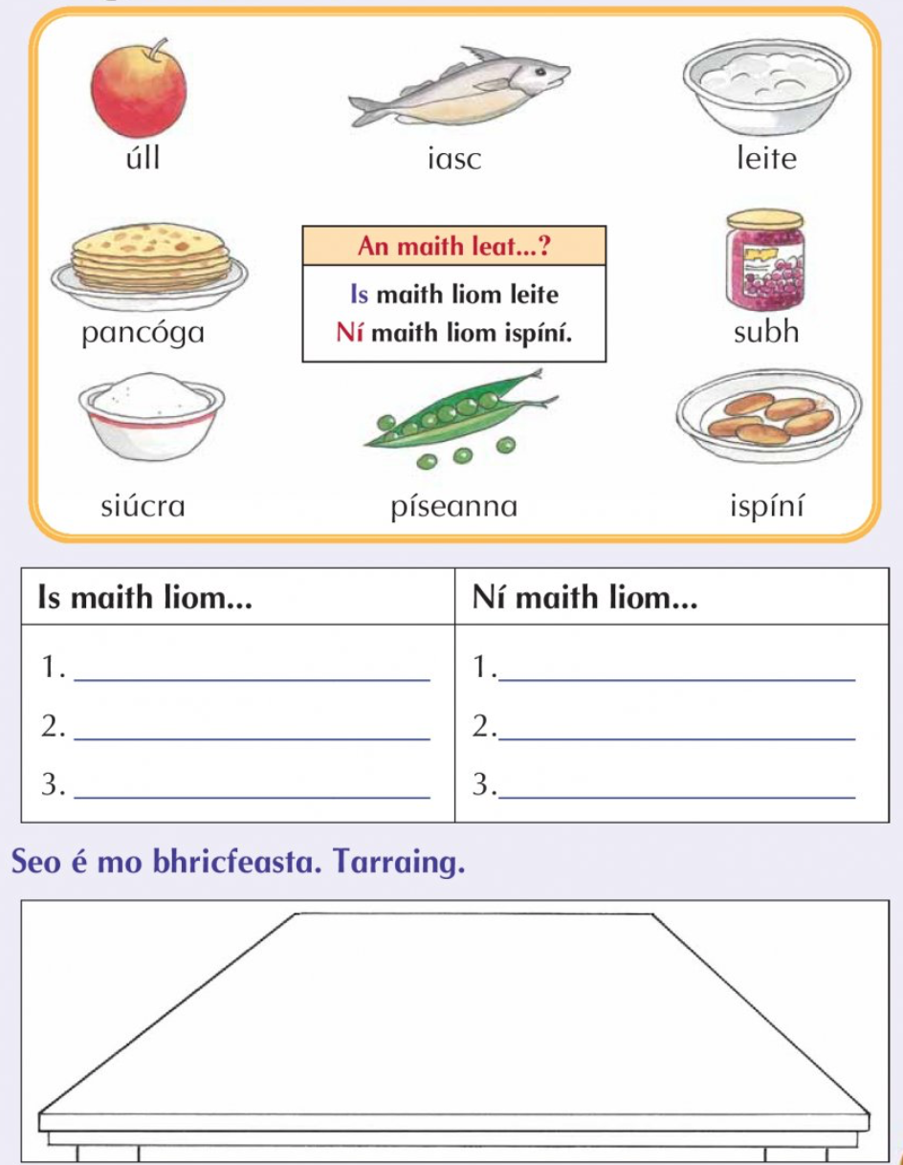

Italy art:
As we’ve been learning about Italy all this week how about we try make some art out of Italians favourite food – pasta! Here are some pictures you can try at home depending on what pasta you have!
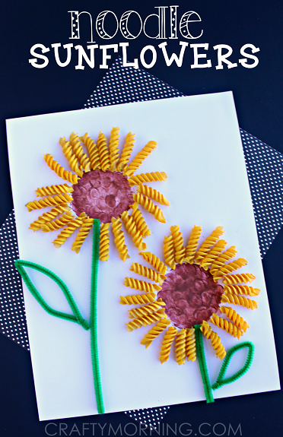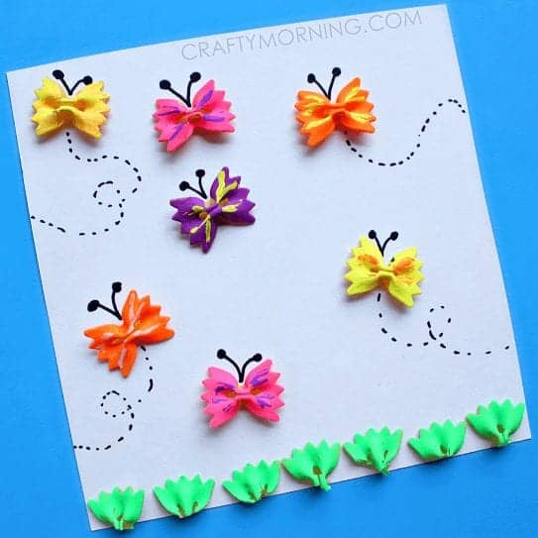

Send in photos of your clocks to kids@stphilipsjns.ie !

Active work
How many different animal ways can you travel?
Bear walk….. Slithering snake….. Bunny hops……

Thursday 28st May

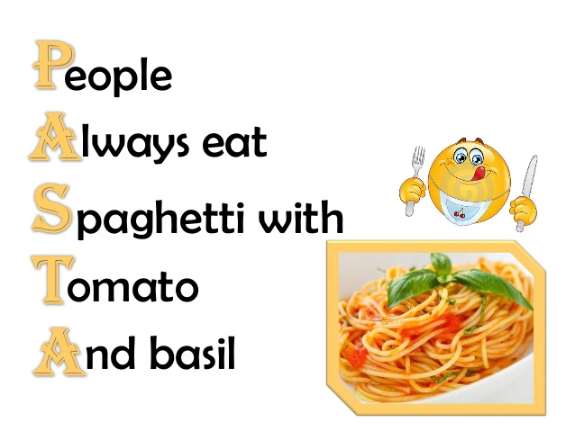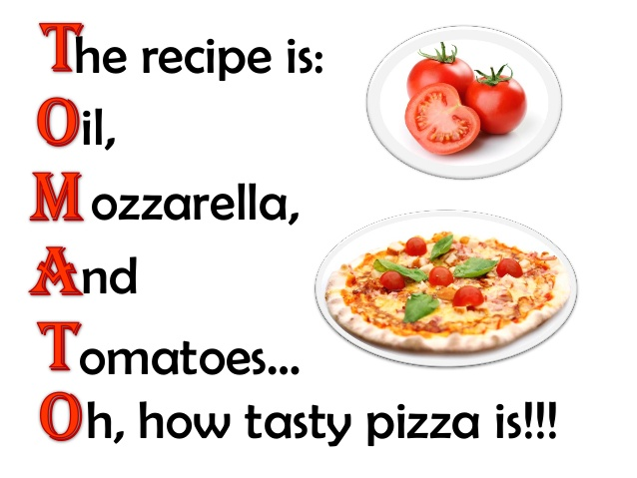
Here are two acrostic poems about Italian foods…. Pasta and tomato’s!
Can you write an acrostic poem with the word Italian?
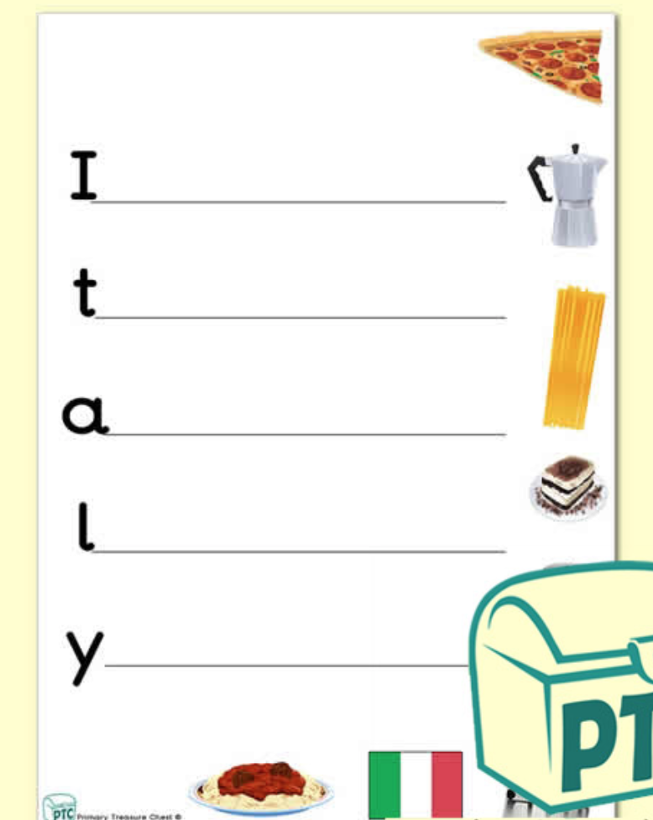

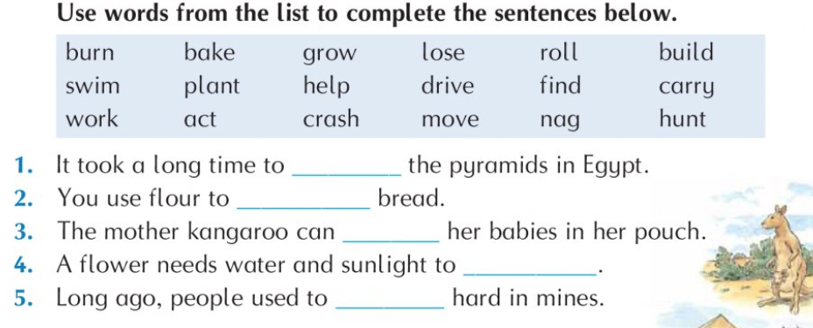

True or false:
- Italy is shaped like a hat_________________________
- Italians love to eat pasta ________________________
- The Italian flag is red, white and blue_______________
- There are no mountains in Italy____________________
- Ireland is next to Italy___________________________
- Italy has over 81 million people___________________
- The capital of Italy is Berlin______________________
- Italy has many volcanos__________________________
Gaeilge:
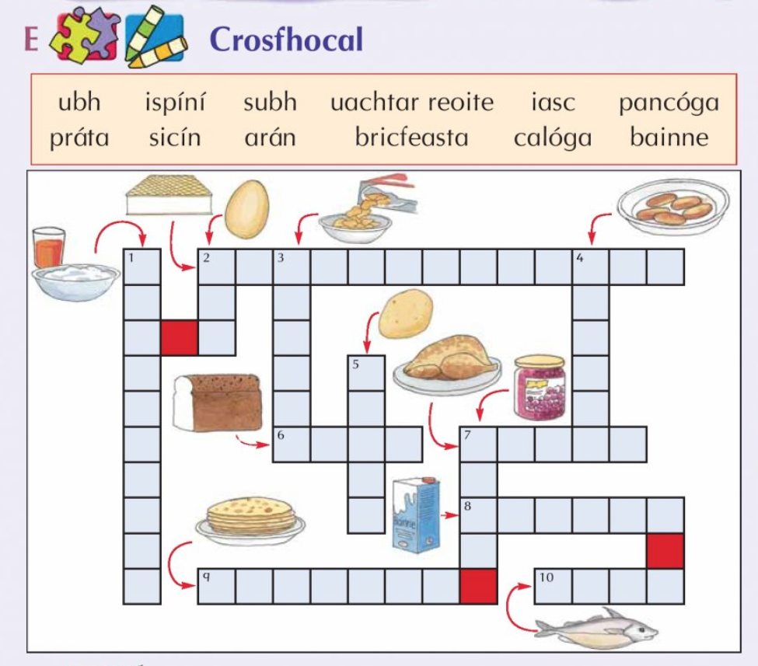
Maths:
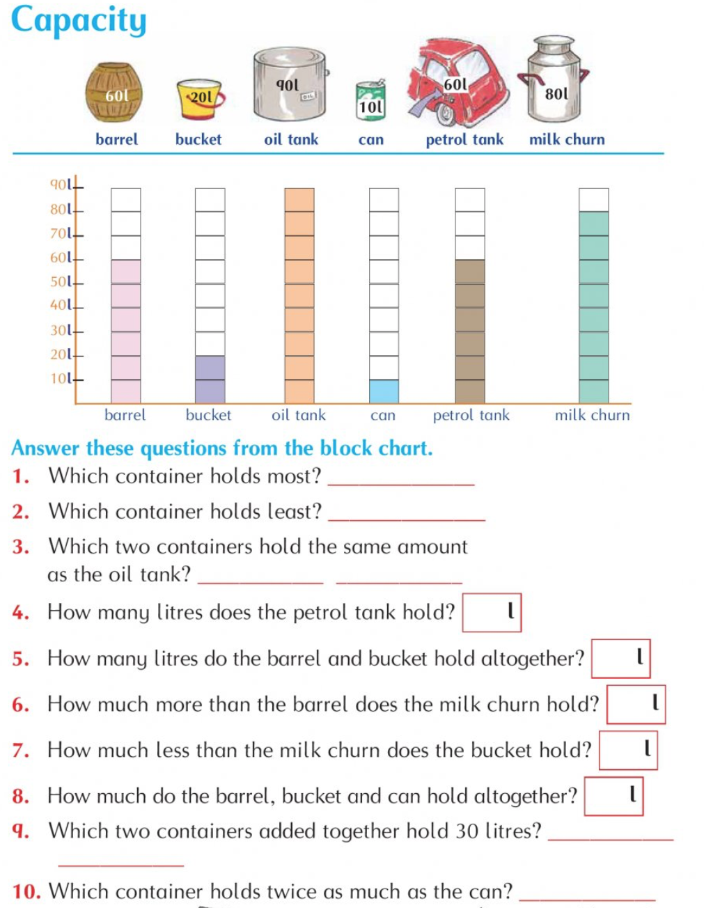

*If you have your maths book do page 147
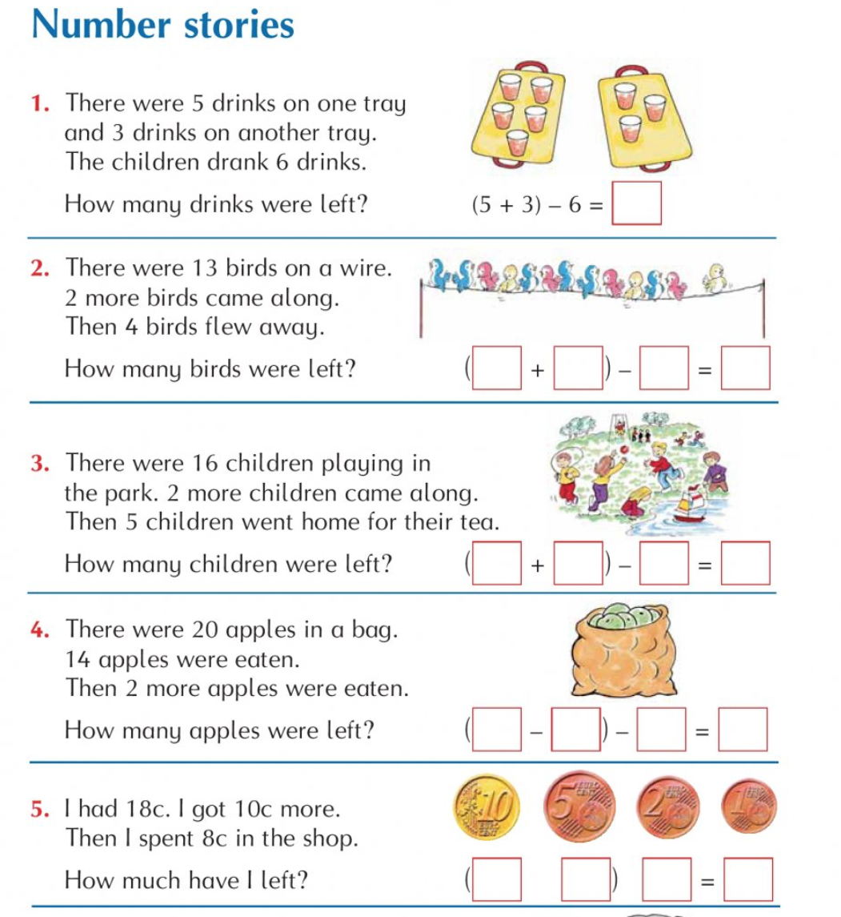

History:
Today we will be learning about how the city of Rome got its name. it’s the story of Romulus and Ramus.
Look at this short video to learn all about it:
https://www.youtube.com/watch?v=BfB97tLf7Ns
After watching the video answer the following questions:
- How did Romulus and Ramus know each other?
- Where were they from?
- What happened to Romulus and Ramus when they were only babies?
- What was the name of the river they were sent down?
- Who cared for the boys and looked after them?
- Who killed who?
- What did they name the city?
- Where is the city?
Send your pictures to kids@stphilipsjns.ie !

Draw a picture of the wolf taking care of the babies.

Friday 29th May

Well done boys and girls….. Its Friday! You made it!
Literacy:
Now that we know the difference between ‘sion’ and ‘tion’ words can you write as many as you can in the correct box.

-tion | -sion

Storytime…
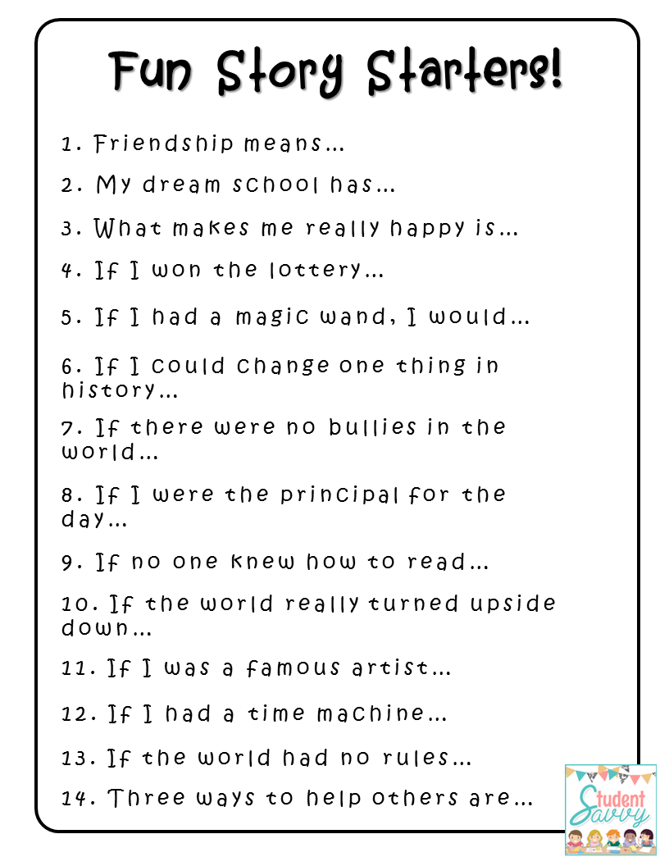
Here are some story starters for you to read. Read through them and pick one and write a story today.

REMEMBER:
- Full stops
- Capital letters
- Writing on the line
- Beginning
- Middle
- Ending
- Characters
- Setting
- Problem
- Resolution
- Read your story back to yourself and make sure it makes sense!
Numeracy:
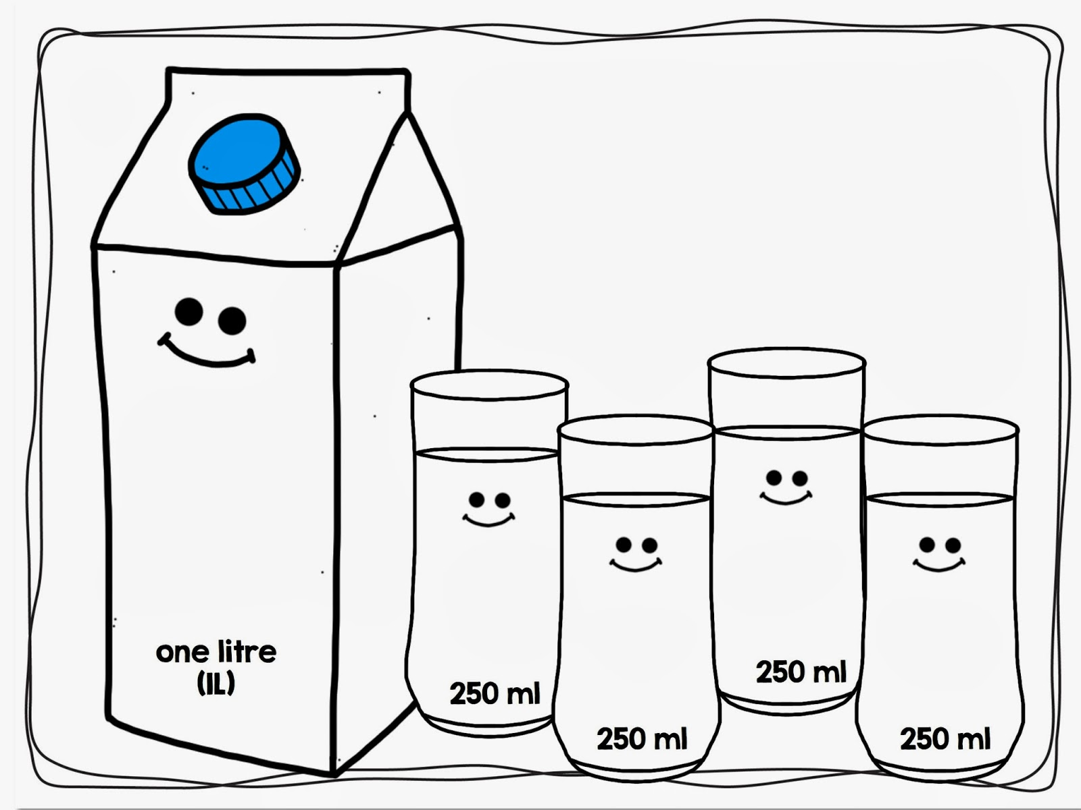

In this picture we can see one litre of milk. 1L of milk is the same as 1000 millilitres. You could get four even glasses of milk that are 250ml each in one litre carton of milk! If a carton is 1000 ml, and a glass is 250ml, how much do you think 1ml might be? Would you still be thirsty?
Why don’t you get some old buckets, cartons of milk and bottles and get measuring the bottles. Check on the lables of any drinks you have and see how many litres or millilitres they are! Some are 250ml… some are 750ml…. and some are 1l or 2l !
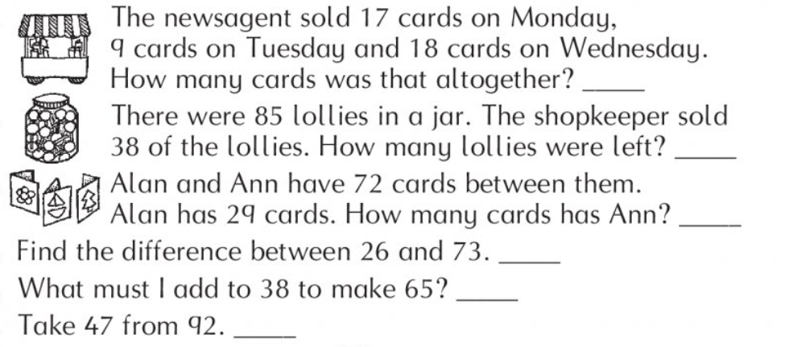
*Finish pages in maths book pg144 - 147
More 2 step problems!
1.

2.
3.
4.
5.
6.
Music
Because we were learning all about Italy give this song a listen and have a go at singing it!
https://www.youtube.com/watch?v=sj5GeJqt5-M

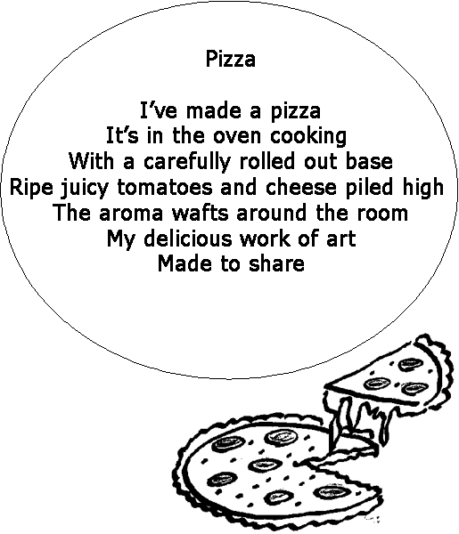

If you were to design your own PERFECT pizza what would be on it? Try writing out the ingredients you’d put on top! Would it be a Nutella and strawberries chocolate marshmallow pizza? Or maybe a spicy meaty cheesy hot pizza! Then design it and draw a picture!
Send pictures of your delicious pizzas to kids@stphilipsjns.ie
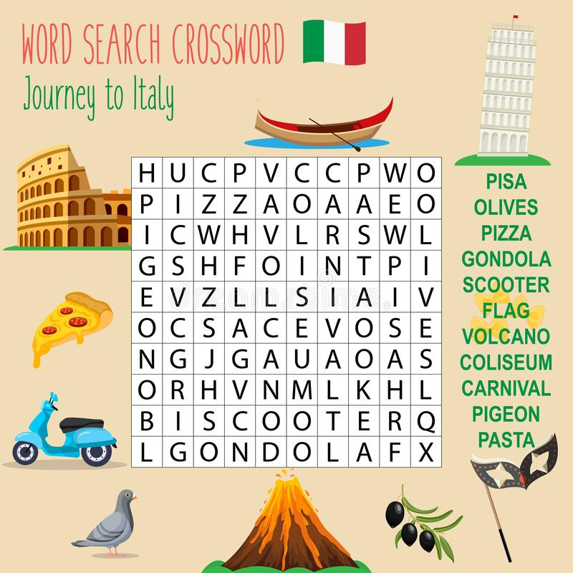

Active Work:
Now go outside and get active for 30 minutes!!!
