Dear Parents/Guardians,

Welcome to **week 7** of the summer term and the first week of June!

We hope you are all keeping well and enjoying the lovely sunny weather. All the second class teachers in St. Philips JNS are really missing the boys and girls.

Most children now have their workbooks at home. If you do not yet have your child’s books and wish to collect them please email [kids@stphilipsjns.ie](mailto:kids@stphilipsjns.ie) to arrange a pick up date and time. In parts of the weekly plan we have given suggested pages to do. Some classes might have different pages completed so you can choose a couple of pages from workbooks that you haven’t done yet. Please continue to send any pictures of work/ activities to [kids@stphilipsjns.ie](mailto:kids@stphilipsjns.ie)

We will be continuing to use Seesaw this week. **If anyone is having any difficulty logging into Seesaw or using the code, please send your teacher an email at** [**kids@stphilipsjns.ie**](mailto:kids@stphilipsjns.ie) . It is not compulsory for children to complete the activities on the app/site but it is there as an extra tool for parents and children to use if they wish to do so. It is great to see so many children engaging with the different platforms we are using, the weekly plan on the website, the Daily Challenges and Seesaw activities. Keep up the great work! ☺

**Note about next week**

Monday 8th of June is the beginning of Active Week! The teachers have lots of fun activities planned for the children. We will not be putting up a full weekly plan as the emphasis will be on active work for the week. Children are welcome to complete pages from their workbooks along with the active work if they would like to. Keep checking our school website [www.stphilipsjns.ie](http://www.stphilipsjns.ie) for more details!

Best wishes,

Mr. Conneely, Ms. O’Hora, Mrs. Maye, Ms. O’Hare, Mrs Watson.

**Monday 1st June**

**\*\*Today is a Bank Holiday which means that it is an extra-long weekend! However, if you would like to some activities today, here are some suggestions! ☺ \*\***

**Literacy**:

As it’s the start of the week write **‘Our News’** – What did you get up to at the weekend? What day is it today? What’s the weather like? Remember to keep it interesting! You can draw a picture of your weekend and colour the picture too.

Make sure to write about what month and season it is! ☺



Word Family of the week: This week we are going to be revising silent letters. Words with silent ‘k’ and silent ‘w’. Remember, when a letter is silent we don’t say that sound when we read the word.

**Silent ‘k’ words**. Here are a few; knit, knife, know, knot. Try saying them out loud! Can you think of anymore?

**Silent ‘w’ words.** Here are a few; wrist, wriggle, wrong, wrestle. Try saying them out loud! Can you think of anymore?

Can you put the following words in the right sentences?

|  |  |  |  |
| --- | --- | --- | --- |
| knit | kneel | knife | knock |
| sword | wren | wrong | wrist |

1. Did you hear someone _______ on the door?
2. The knight used a _______ when fighting against the enemy.
3. One of Ireland’s smallest birds is called a _______.
4. I will ______ down to reach the toy on the floor.
5. I would love to be able to ________ myself a new jumper.
6. I use a _______ and fork to eat my dinner.
7. Did you get the right or ______ answer?
8. I hurt my _________ when I fell off the slide.

Can you make up clues for anymore silent k or silent w words?

Send your answers to [kids@stphilipsjns.ie](mailto:kids@stphilipsjns.ie) ! ☺

**Here is a video all about silent letters:** <https://www.youtube.com/watch?v=ss9r236LRcw>

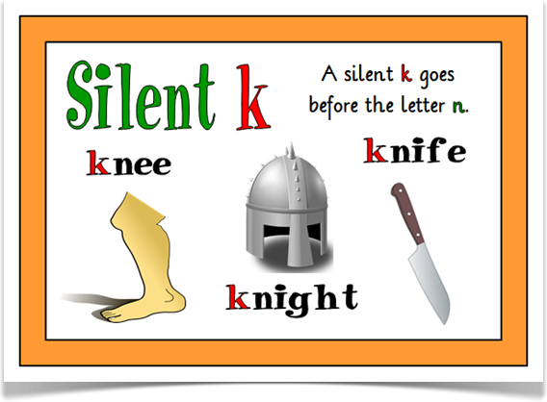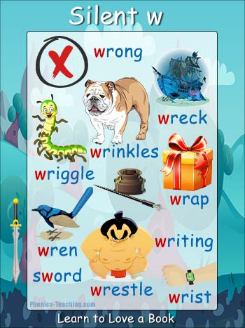

**Maths:**

|  |
| --- |
| **Maths Challenge Time!**   * Remember to read the words problem carefully. * Underline the important words and numbers that you need. * Think carefully – do I add or subtract? * Always start with the units when doing a tall sum! |
| Paul started watching a video on youtube at 12 o’clock (noon). He finished watching the video at half past 12. How long was the video? |
| Karen went to the shop with her sister. She carried home a bag of pasta weighing 1 kg. Her sister carried a bag of flour weighing twice that much. How much did the flour weigh? |
| Siobhan loved doing solos with her football. On Saturday she did 57 and on Sunday she did 45. How many solos was that altogether? |
| Mrs. Maye read 27 books during April. Ms. O’Hora read 35. How many more books did Ms. O’Hora read? |
| On a nature walk one day, Ms. Igoe counted 18 bumblebees, 25 ladybirds and 22 spiders.  How many creatures did she see altogether? |

Remember we have been practicing our counting? Try to count up in these numbers!

Count in 2s: 2, 4, 6, __, ___, ____, ____, ____.

Count in 3s: 3, 6, 9, ____, ____, ____, ____.

Count in 4s: 4, 8, ____, ____, ____, ____.

Count in 5s: 5, 10, ____, ____, ____, ____.

Count in 6s: 6, 12, _____, _____, _____, _____.

Count in 10s: 10, 20, _____, _____, ______, ______.

All that great counting will help you with your maths page!

**\*If you have your Busy at Maths book at home try page 140. If you already have that page done, pick another from the Pattern section\*\***

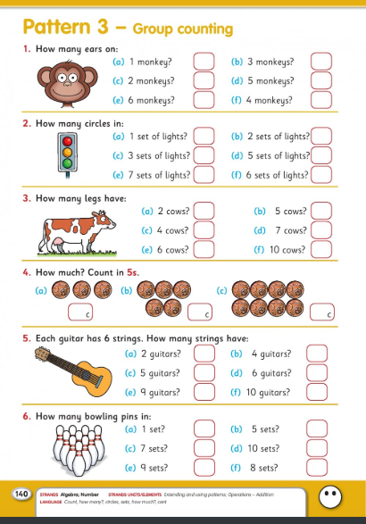

**Gaeilge:**

We use the Bua na Cainte book in school and now parents can set up an account online. This means that children can access the lessons online and listen to the stories and new vocabulary. Details for setting up a Bua na Cainte account can be found here <https://www.stphilipsjns.ie/news/great-news--bua-na-cainte-is-now-available/?p=5&>

If you can log into Bua na Cainte, click into Siopadóireacht (Shopping) Ceacht 1 + Ceacht 2.

Try doing page 93 (if you did not complete it already!) and page 94 in your Bua na Cainte workbook in the section called ‘Siopadóireact’.

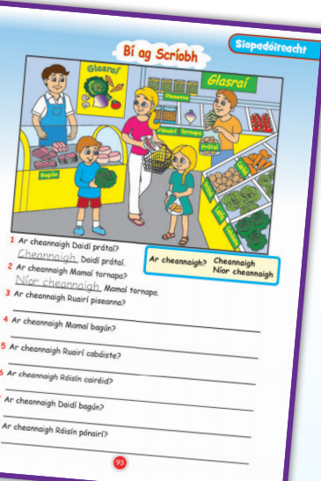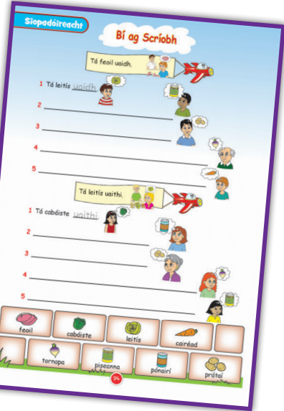

Cad a cheannaigh tú sa siopa? (What did you buy in the shop?)

Cheannaigh mé ______ (I bought___)

Try writing out this question and write in your own answers! Use these words to help you:

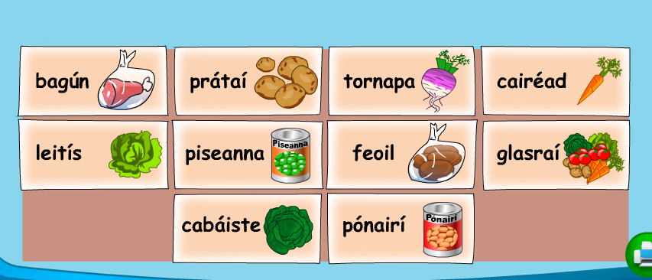

**SESE:**

Our SESE topic this week is zoo animals!

* What is a zoo?
* Have you ever been to the zoo?
* Can you make a list of any animals you might see at the zoo?

Dublin zoo have a great website with lots of information about the different animals.

Here is a video about a variety of zoo animals <https://www.youtube.com/watch?v=fzBctvF0qvI>

Today we are going to focus on the elephant! What information do you already know about elephants?

There is some super information on the Dublin Zoo website all about elephants. There is a video on the website showing the elephants taking a bath!

Take a look here <https://www.dublinzoo.ie/animal/elephant/>

Have a look at the Dublin Zoo elephant webcam <https://www.dublinzoo.ie/animals/animal-webcams/elephants/>

Read this information about elephants and answer the questions below.

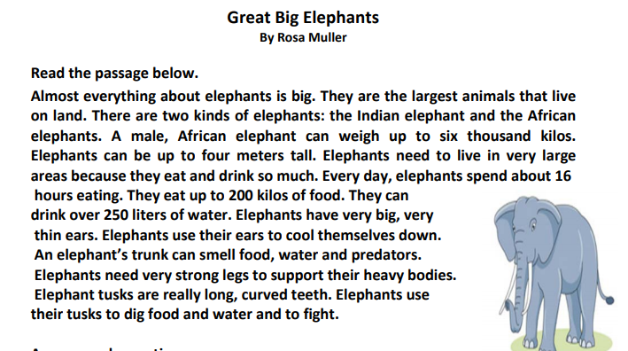

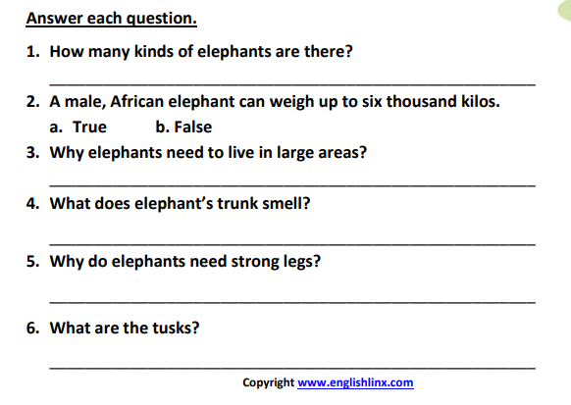

**Check the daily challenge on the school website!**

**Tuesday 2nd June**

**\*\*Check Seesaw to see if there are some new activities for you to do today!\*\***

**Literacy**

Have a look at our silent letters from Monday’s activity! Can you put these silent k and silent w words into sentences? Remember finger spaces, full stops, capital letters, keep your writing on the line. You can do these sentences on a page or in your copy.

1. knot 2. knitting 3. knife 4. knee 5. writing 6. wrap 7. wrong 8. sword

Send a picture of your sentences to [kids@stphilipsjns.ie](mailto:kids@stphilipsjns.ie) if you want your teacher to see! ☺

***Reading***- If you have your **Green Genie workbook** at home complete this reading comprehension on **page 92 and 93** in your book and English copy. Make sure to read it a couple of times and complete the questions and activities that go with it.

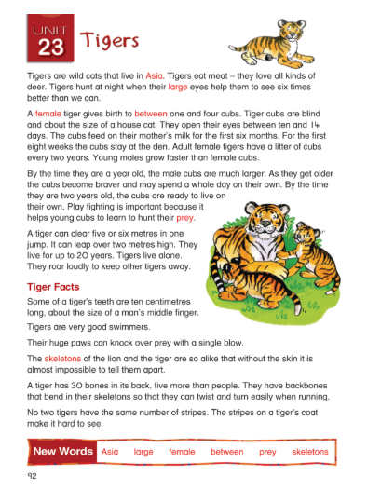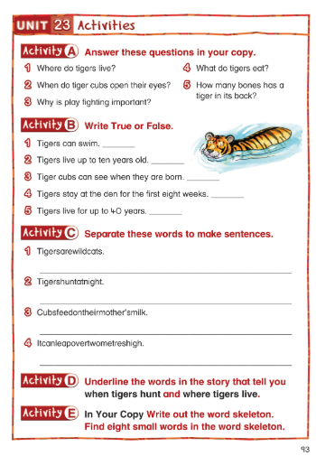

Here is another reading comprehension if you would like to try it!

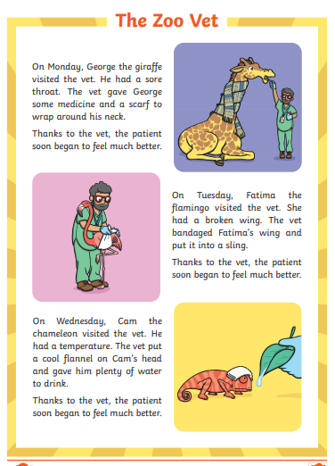

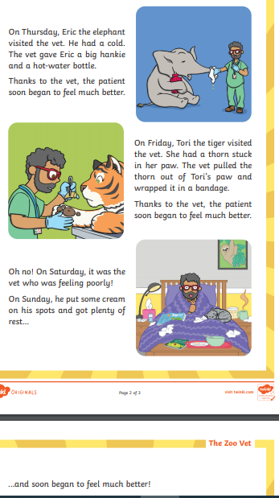

Questions about ‘The Zoo Vet’

1. Who visits the vet on Monday?
2. Why does Cam the chameleon visit the vet?
3. Name three treatments the vet gives to the animals?
4. On what day does Tori the tiger visit the vet?
5. Would you like to be a vet? Why / why not?

Send your answers to [kids@stphilipsjns.ie](mailto:kids@stphilipsjns.ie) or take a picture and upload it to your Seesaw account! ☺

**Maths:**

|  |
| --- |
| **Maths Challenge Time!**   * Remember to read the words problem carefully. * Underline the important words and numbers that you need. * Think carefully – do I add or subtract? * Always start with the units when doing a tall sum! |
| Sara and her mam went for a walk one afternoon. They left home at 4 o’clock and got back at quarter to 5. How long were they walking for? |
| In a survey on hot lunches, 2nd class were asked to pick their favourite one. Here are the results:  24 children picked bolognaise  26 children picked chicken dippers  7 children picked korma  13 children picked lasagna  Q. What lunch was the most popular?  Q. What lunch was the least popular? Q. How many children took part in the survey? |
| Following a fitness video, Mr. Conneely did 25 push ups, 30 jumping jacks and 60 skips using his skipping rope. For how many exercises did his feet leave the floor? |
| Chris loved doing art and he did three new pieces of art each week.  How many pieces of art did Chris have after five weeks? |
| Ms. Watson baked 63 cookies last week. Ms. O’Hare baked 46 cookies last week. How many more did Ms. O’Hare bake? |

Pick a page to do in your maths book!

**Gaeilge:**

Let’s revise the new vocabulary we read yesterday all about Siopadóireacht (Shopping)

Cad a cheannaigh tú sa siopa? (What did you buy in the shop?)

Cheannaigh mé ______ (I bought___)



If you have logged into the Bua na Cainte app, look at Ceacht 3 Siopadóireacht.

Some new sentences for today:

1. Cé mhéad atá ar an gcabáiste? (How much does the cabbage cost?)
2. Cé mhéad atá ar an leitís? (How much does the lettuce cost?)
3. Cé mhéad atá ar na piseanna? (How much do the peas cost?)

Try writing those 3 sentences and drawing a picture to match!

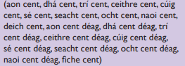

Can you count all the coins using the words above? Aon cent (1 cent), dhá cent (2 cent)

**If you have your Irish book at home, complete page 95**

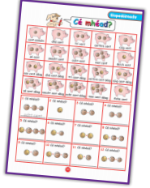

**Music:**

Take a listen to the song ‘Roar’. Can you copy the dance moves? What animals are mentioned in the lyrics?

<https://www.youtube.com/watch?v=Jr8l8PWqZis>

**Wednesday 3rd June**

**\*\*Check Seesaw to see if there are some new activities for you to do today!\*\***

**English:**

Today we are going to look back over plural words. A plural means more than one. Different types of words have different plural rules!

1. These words can be made into a plural just by adding ‘s’. Can you finish the last boxes?

|  |  |
| --- | --- |
| 1 car | 2 cars |
| 1 ball | 2 balls |
| 1 cat | 2 ______ |
| 1 dog | 2 _______ |

1. If a word ends in –s, -x, -ch, -sh, we usually add ‘es’. Can you finish the last boxes?

|  |  |
| --- | --- |
| 1 witch | 2 witches |
| 1 brush | 2 brushes |
| 1 fox | 2 ______ |
| 1 glass | 2 _______ |

Check your Green Genie book and if you have not done it already, do page 83 about plurals!

Here is another activity about plurals:

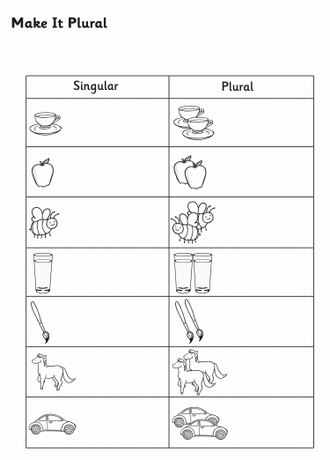

**Maths:**

|  |
| --- |
| **Maths Challenge Time!**   * Remember to read the words problem carefully. * Underline the important words and numbers that you need. * Think carefully – do I add or subtract? * Always start with the units when doing a tall sum! |
| For his birthday, Brian asked for money, as he was saving up for a new bike. His mam gave him 20 euro and his nanny gave him 15 euro. Then he bought his little brother a treat for 4 euro.  How much money did Brian have saved towards his bike? |
| Put these bottles of water in order of weight, starting with the heaviest:  330ml, 100ml, 750ml, 1 litre |
| A train left Dublin at 2 o’clock and stopped in Kilkenny and Waterford. If it got to Waterford 2 hours later, what time did the train arrive in Waterford? |
| On a hundred square, what is the number…   * Above 65? * Below 33? * To the left of 77? * To the right of 54? |
| This month, the 21st of May is on a Thursday. What **day** will be on the following dates?   * 23rd * 19th * 28th |

Pick a page to do in your maths book!

**Gaeilge:**

Have a look at the video all about Siopadóireacht

<https://www.youtube.com/watch?v=yjH_S8zEFS0>

* Cén lá é inniu?
* Cén lá a bhí sé inné?
* Conas atá an aimsir inniu?

**Zoo animal art:**

Since we have been learning all about zoo animals this week, here is a super activity on how to draw a giraffe! Give it a try if you can and send in a photo of your artwork to [kids@stphilipsjns.ie](mailto:kids@stphilipsjns.ie) ! ☺

Art for kids hub: <https://www.youtube.com/watch?v=2nr587hSR7o>

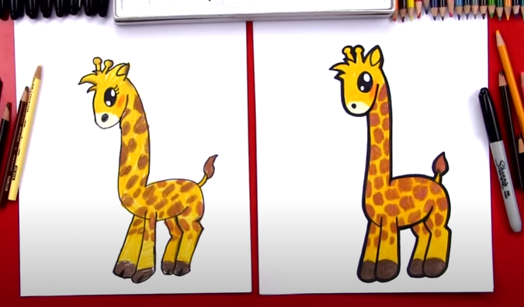

**Thursday 4th June**

**\*\*Check Seesaw to see if there are some new activities for you to do today!\*\***

Today we are going to continue to look back over plural words. A plural means more than one. Different types of words have different plural rules!

1. When a word ends in ‘f’, we change it to v and add ‘es’. When a word ends in ‘fe’ we change it to ‘ves’. Can you finish the last boxes?

|  |  |
| --- | --- |
| 1 leaf | 2 leaves |
| 1 wife | 2 wives |
| 1 loaf | 2 ______ |
| 1 thief | 2 _______ |

1. If a word ends in y we usually change it to ‘i’ and add ‘es’. Can you finish the last boxes?

|  |  |
| --- | --- |
| 1 baby | 2 babies |
| 1 pony | 2 ponies |
| 1 story | 2 ______ |
| 1 lady | 2 _______ |

Check your Green Genie book and if you have not done it already, do page 83 about plurals!

Here is another activity about plurals:

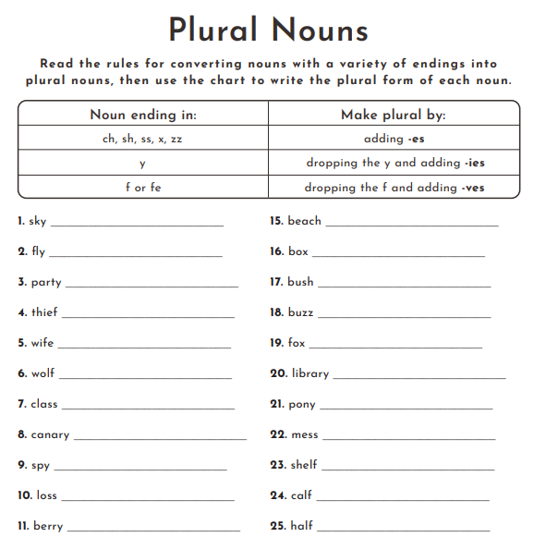

**Literacy:**

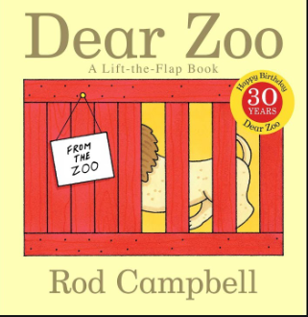

Listen to and read the story ‘Dear Zoo’. A video of it can be found here <https://www.youtube.com/watch?v=rudDGRQ9QGA>

*Answer these questions*

1. Did you like the story?
2. What was your favourite part of the story?
3. What animals were in the story?
4. What adjectives were used to describe the animals in the story? Remember an adjective is a describing word, example, big / small.
5. Draw a picture of your favourite part of the story.

Send in your answers to [kids@stphilipsjns.ie](mailto:kids@stphilipsjns.ie) or upload your answers to your Seesaw account ☺

**Gaeilge:**

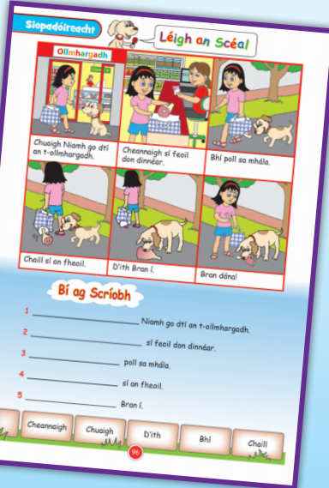

Bua na Cainte Ceacht 4 Siopadóireacht

Try page 96 in your Bua na Cainte book.

**Maths:**

2 Step Number problems

***Take a look at Ms O’Halloran’s video on the website all about two step problems!*** <https://www.stphilipsjns.ie/news/maths-two--step-problems/>

Let’s try one together!

Mary had 16 sweets and Laura had 20 sweets. They ate 25 sweets together. How many were left?

Step 1: 16 + 20 = 36 We are working out how many they had altogether. This is a plus sum.

Step 2: 36 – 25 = 11 We worked out how many were left. This is a takeaway sum.

Make sure to write out each step!

**Now try some in your maths book page 158 and page 159**

**Art:**

Create your own zoo! Draw a map of your zoo. Make sure to include some drawings of where the different animals will be. You could include where the entrance and exit will be, where the shop will be, where the car park is etc. Here are some pictures to give you an idea!

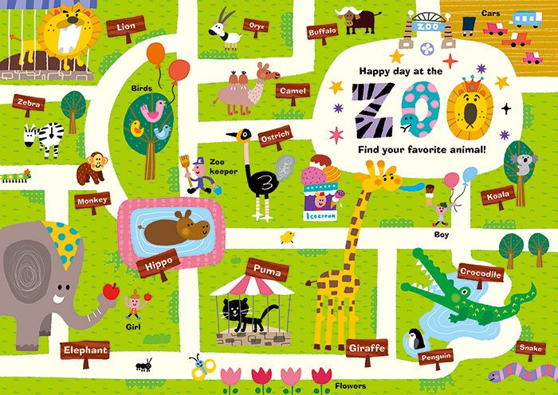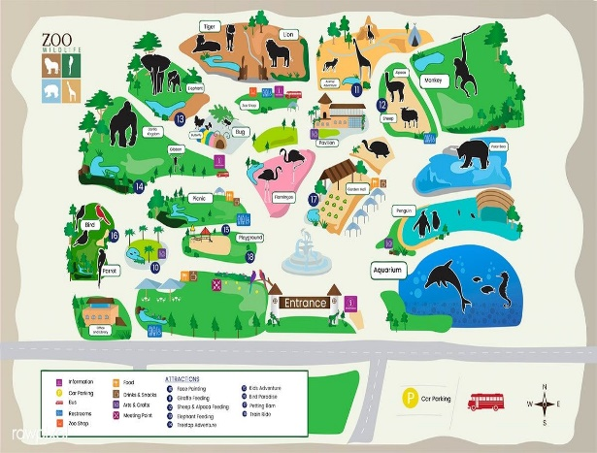

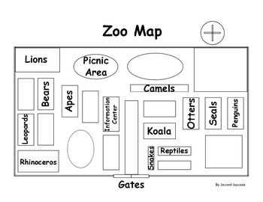 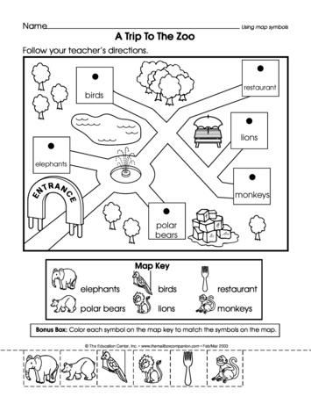

**Send a picture of your zoo map to** [**kids@stphilips.ie**](mailto:kids@stphilips.ie) **☺**

**Friday 5th June**

**Well done boys and girls….. Its Friday! You made it! ☺**

**\*\*Check Seesaw to see if there are some new activities for you to do today!\*\***

**Poetry:**

A Shark is a Pet by Kenn Nesbitt

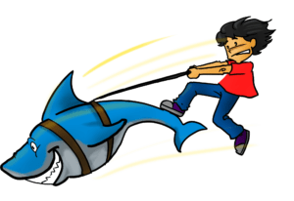

A shark is a pet  
that you don’t want to get.  
There is nothing less fun than a shark.  
He doesn’t have fur.  
He won’t cuddle or purr,  
and he never takes walks in the park.

Instead he just stares  
and intensely prepares,  
as he circles and waits in the dark,  
to nibble your nose  
and your fingers and toes,  
for his bite is much worse than his bark.

*Read the poem and answer these questions:*

1. Make a list of rhyming words in the poem. For example, dark/ bark
2. What 2d shape is mentioned in the poem?
3. What word in the poem means the same as looking at someone without blinking?
4. Would you like to have a shark as a pet? Why / why not?
5. Draw a picture of the poem.

*Send in your answers to* [*kids@stphilipskids.ie*](mailto:kids@stphilipskids.ie) *or take a picture and post it on your Seesaw account to show your teacher!*

**SESE:**

Have a think about all the zoo animals we learned about this week.

We would like you to write a fact file about your favourite zoo animal! You can do extra research about your favourite animal using the national kids geographic website.

Make sure to write about:

1. What do they look like?
2. Where do they live?
3. What do they eat?
4. Any other interesting facts you have learned?

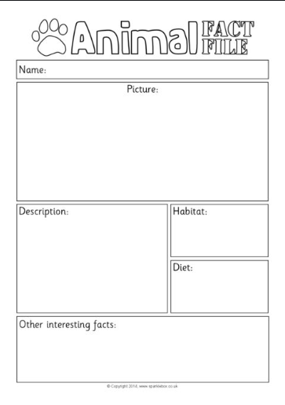

Send your facts to [kids@stphilipsjns.ie](mailto:kids@stphilipsjns.ie) ! ☺

**Maths**

Let’s look back over the topic of data! Write the answers to the questions below and send them into your teacher.

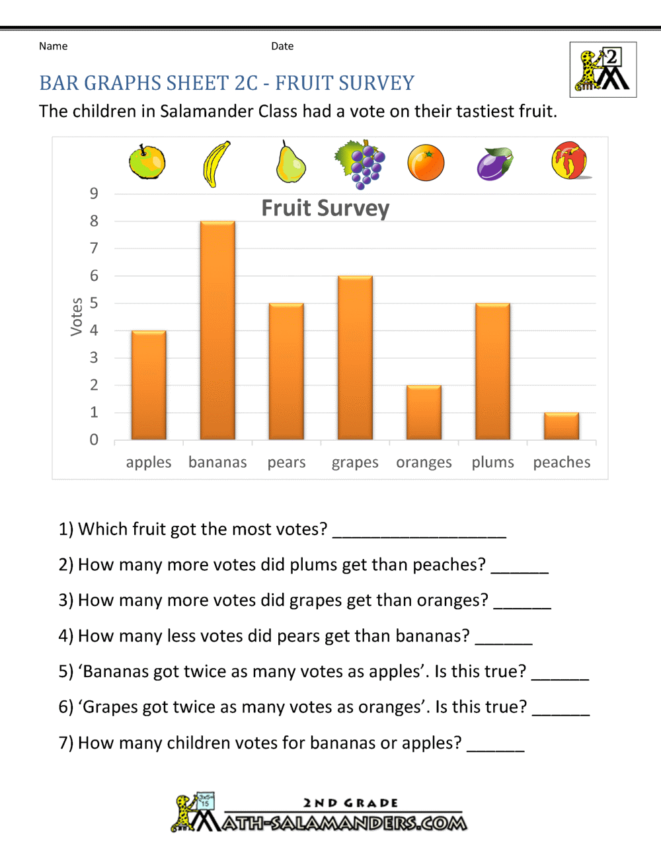  
  
Maths book: Choose one of the maths challenge pages (page 156 and page 164)

**Active Work:**

Try this kids workout on youtube <https://www.youtube.com/watch?v=mhHY8mOQ5eo>

If it is a sunny day, try to go outside for a run around and some fresh air!