Monday 1st June 2020

Hello boys and girls.

Welcome to the month of June. We hope you are all keeping safe and well. We are so proud of you all. We know June is a month for nice things in school so we will aim to plan some nice things for you to do
Here is a list of suggested activities for you to try over the next week. Try as much or as little as you can and don’t forget to logon to Seesaw for extra activities assigned by your teacher.

If you do try out any of the activities we would love you to show us your work.
Send a photo/video with teachers name in the subject box to kids@stphilipsjns.ie or upload a photo of your work to seesaw app. We can't wait to see what you have been up to!

Virtual Tour

This week we will be exploring sea creatures and learning some facts about them.
As we cannot go to an aquarium we are going to bring the aquarium to you.
Why not click on this link to an aquarium in America and follow the guide around.
See how many different sea creatures you can see.
Enjoy the music and the sights, it’s great fun!
https://www.youtube.com/watch?v=4ioux65pohQ

English:

Reading:
It is so important to keep up a little bit of reading each day.
Read with your parent, an older brother/sister or on your own.
Remember:
- Reading a book that your child finds easy is good for building up their fluency.
- Reading a book with some difficult words is good for problem solving.
- Reading a book that is too difficult is not beneficial.

- Reader: Read a few pages of your reader/any other book each day.
Chat to your Mam/Dad about the story. Mam & Dad can ask you questions, or you can try asking Mam & Dad questions about the story too! Why not record yourself doing some reading and send to your teacher by email/seesaw!

- Online reading: If you are finished your assigned reader for home, go to https://home.oxfordowl.co.uk/. Parents can set up an account and then you can browse ebooks for your age and complete activities.
As we are learning about sea creatures this week, read this story about Starry Eyed Stan
https://www.twinkl.ie/resource/t-l-54210-starry-eyed-stan-ebook-english
Complete a story map based on the story-what happens first, next....
https://www.twinkl.ie/resource/t-l-54561-starry-eyed-stan-story-map-english

- Two little frogs Workbook: Continue with the next unit from your book this week.

- Sounds Scavenger hunt:
Find something in your house that
- begins with ‘h’
- begins with ‘pl’
- ends with ‘g’
- ends with ‘s’

- Tricky words
These are the words that we have covered so far this year.
The  to  and  he  a | I  you  it  of  in | was  said  his  that  she | for  on  they  but  had
at  him  with  up  all | look  is  her  there  some | out  as  be  have  go | we  am  then  little  down
do  can  could  when  did | what  so  see  not  were | get  them  like  one  this | my  would  me  will  yes
big  went  are  come  if | now  long  no  came  ask | very  an  over  your  its | ride  into  just  blue  red
from  good  any  about  around | want  don't  how  know  right | put  too  got  take  where | every  pretty  jump  green  four

Games to help practice tricky words:

- Tricky Word Bingo: Draw out a 3x3 grid and pick out 9 words to write in the spaces.
Call out a selection of words from the box and the child crosses out the word once they hear their word called.

- Tricky Word Hunt: pick a tricky word and see where you can find it e.g. in books, newspapers, etc.

- Practice Spelling the words, using the following method:
Look-Say-Cover-Write-Check
Pick a tricky word
Look at and say the word
Cover the tricky word and have a go writing it again
Check to see if it’s right or wrong.

Writing:
- My News: Write a recount of something interesting that happened over the last few days. Use these questions to guide the child. What day is it today? What is the weather like? What did you get up to at the weekend? Afterwards, you can draw a nice picture and colour it in.
- Diary: Continue to write a Diary of what you are doing during these weeks. Just write a few sentences about what you are doing each day. It will be very interesting to read it someday!
- Write about the character of Stan from the ebook: What was the character like in the beginning of the story and how did he change?
https://www.twinkl.ie/resource/t-l-54556-starry-eyed-stan-character-description-activity-sheets-english

- Write a postcard: Write a postcard from Jay in the story about his adventures with Stan
https://www.twinkl.ie/resource/t-l-54706-starry-eyed-stan-postcard-from-jay-differentiated-activity-sheets

- Free writing: Write about something you want to write about.
Give the child complete control over what they would like to write about. During this activity, there is no need to focus on the children’s spellings. The important thing is that they write freely about something they are interested in. At the end, get the child to read what they have written back to you.
Some things your child may be interested in writing about:
- a story about summer
- a note/message for Mam/Dad
- words from your favourite story/song
- a poem
- make a shopping list
- label a picture

Maths:

**Check out the new videos on the school website, uploaded by Ms. Williams for 1st Class maths ideas and activities**
We have selected some pages from your maths book to complete so don’t forget to check them out

Counting:
- Counting forwards in 1’s up to 100.
- Consider starting at different numbers.
- Start at 33 and count forward to 52.
- Start at 15 and count to 46.
- Counting backwards in 1’s from 100.
- Again start at different numbers,
- Start at 27 and count backwards to 1.
- Start at 77 and count backwards to 50.
- Counting in 10’s up to 100 (maths book p.127)
- Start with different numbers.
- Start at 6, ….. 6, 16, 26, 36
- Start at 22,……… 22, 32, 42, 52, 62
- Count in 2’s (maths book p.125)
- Count in 5’s (maths book p.126)

Counting Games:
- Buzz off, Sit down!
Your child might have played this in school with their class and could play it with an adult or an older sibling or even in a group.
Pick a target number to count to.
Now pick another number to start counting from and take turns counting until you reach the chosen number. When you reach the target number, the person who has said that number, gets to turn to the next person and say “Buzz off sit down!” and they’re out of the game.
Eg. The target number is 43. Everyone in the game/circle takes a turn saying a number until you get to 43.

- Bingo: Split the page into nine boxes. Put a number in each one. Bingo master can call out numbers until one player has got all the numbers and says: Bingo!
- Snap: Good for number recognition and quick thinking.
- Snakes and ladders: Very good for counting and fun for all the family!
Tens and Units:
- How many tens in 60? Answer = 6
- How many tens in 80?
- How many tens and units in 65? Answer = 6 tens and 5 units
- How many tens and units in 84?
- How many tens and units in 77?

Maths book: try pages on tens and units eg p.89,90,91,92,93

Addition:
- Continue to practice your doubles up to 20 eg. 6 + 6 = 12, 8 + 8 = 16.

- Practice your Numbers in Love (numbers facts that make 10)
3 + 7 = 10. 9 + 1 = 10.
- Addition with 10
Try adding 10 to different numbers eg. 10 more than 40?
Here are some to try
60+10=
70+10=
Now try with any number
55+10=
82+10=

Subtraction:
- Practice subtraction sums within 20.
Remember - Keep the big number in your head, count backwards and use your fingers to help keep track of the number you are taking away.
15 – 5 =
13 – 7 =
20 – 4 =

Adding Tens and Units
Do you remember how you used a numberline or the criss cross method to add tens and units?
  - Draw a numberline, write the number to start with and draw bigjumps for tens and small jumps for units
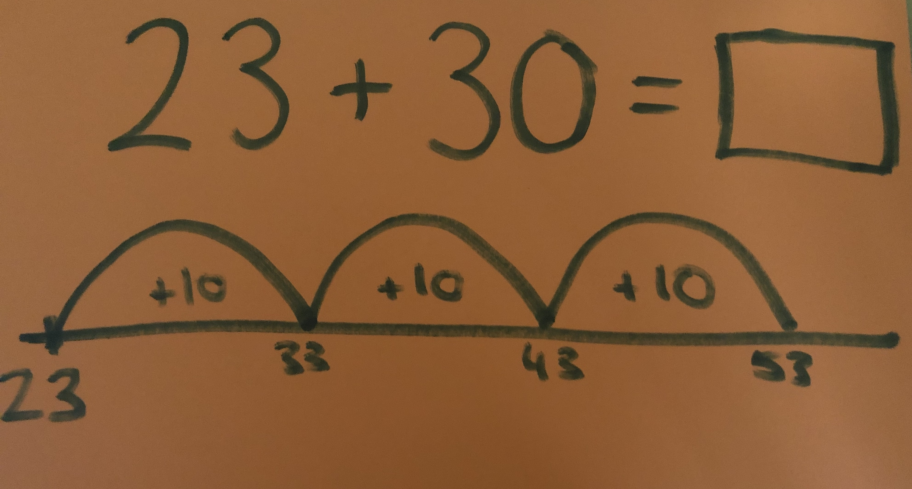

  - Criss Cross method- draw a V to join the tens and join the units. Add the tens and add the units. Then work out the answer
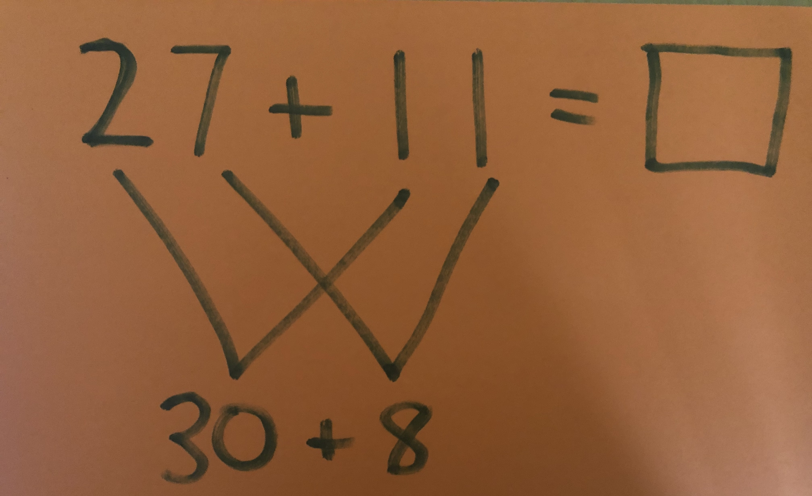

Choose a method and try these sums on a page, take a photo and send to email/seesaw
44+20=
32+41=
25+13=
51+36=
62+25=

Other Maths Activities:
Weight
Talk about things that are heavy and light, make a list of heavy and light objects
Practice using a balance http://www.crickweb.co.uk/ks2numeracy-shape-and-weight.html
https://www.twinkl.ie/resource/au-n-565-lighter-or-heavier-powerpoint
Heavier or Lighter - Maths book p.121

Hundred Square
Look at p.128 in maths book and fill in the hundred square counting up to 100.
Notice how all the columns going down end in 1,2,3,4,5,6,7,8,9,0 and go up by 10.
Can you fill in the numbers beside, above and below the numbers in the middle box?
Take a photo of the page and send to your teacher.

ICT games Website:
- Ten more https://www.ictgames.com/mobilePage/hundredHunt/
- Funky Mummy https://www.ictgames.com/mobilePage/funkyMummy/index.html
- Helicopter Rescue https://www.topmarks.co.uk/learning-to-count/helicopter-rescue

Twinkl Website Worksheet suggestions:
https://www.twinkl.ie/resource/au-n-567-lightest-to-heaviest-activity-sheet
https://www.twinkl.ie/resource/tp-n-81-heavy-or-light-activity-sheet
https://www.twinkl.ie/resource/t-t-21543-heavy-and-light-cut-and-paste-sorting-activity
https://www.twinkl.ie/resource/t-he-073-10-more-10-less-worksheet
https://www.twinkl.ie/resource/summer-themed-addition-and-subtraction-within-20-summer-mosaic-worksheet-t-n-2546940

Irish:
***See News page for an Irish conversation video with Ms. Watson and Mr. Conneely***
- Continue to practice songs/poems learnt in school. Eg. “Ceann Gualainn Glúin is Cos” “Cad atá uait don bricfeasta?” “Suas leis na lámha” “An Luan, An Mháirt”
- Comhrá: ‘Cad is ainm duit?’ _______ is ainm dom
- ‘Cén aois thú?’ Tá mé 6/7/8 bliana d’aois
- ‘Conas atá tú?’ Tá/Níl mé go maith
- ‘An maith leat úll?’ Is maith liom/ Ní maith liom
- ‘Cén rang ina bhfuil tú?’ ‘Tá mé i rang a hAon’
- ‘Cén lá atá inniu ann?’ ‘Inniu an Luan.’
- ‘Cén sort lá atá ann?’ ‘Tá an lá grianmhar’
- Comhair as Gaeilge..a haon, a dó, a trí, a ceathair, a cúig, a sé, a seacht, a hocht, a naoi, a deich srl.
- Look at programmes on TG4 and in particular, Cúla 4 online
- Stories on Seidean Si https://www.seideansi.ie/
- Bua na Cainte (see instructions to download on News page)
Siopadóireacht
Ceacht 1-7 & complete pages in book

SESE:
Sea Creatures:
Read about sea creatures
https://www.twinkl.ie/resource/t-tp-856-sea-creature-fact-powerpoint
Choose a sea creature and complete a factfile about it
https://www.twinkl.ie/resource/t-t-10132-sea-creatures-factfile-worksheets

Sharks:
This week we will be learning about one sea creature, the shark.
Here are some facts about the Great White Shark
- 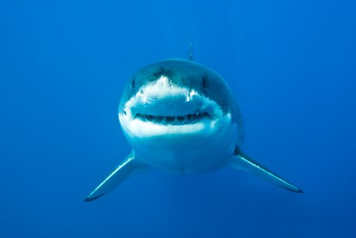
1) Great white sharks can be found throughout the world’s oceans, mostly in cool waters close to the coast.
2) These super swimmers are the largest predatory fish (fish that eat other fish or animals) on our planet. On average, they grow to around 4.6m long, but some great whites have been measured at 6m – that’s half the length of a bus!
3) Great white sharks are grey with a white underbelly, from where they get their name. They have a streamlined shape and powerful tails that propel them through the water at over 60km per hour!
4) Any creature unlucky enough to find itself in the gob of a great white is in for a nasty shock! This is because this marine beast’s mouth is equipped with a set of 300 sharp, triangular teeth arranged in up to seven rows.
5) Whilst many think of these beasts as fearsome man-eaters, humans aren’t, in fact, on the great white’s menu. Phew! There are around 5-10 attacks a year, but researchers believe that, rather than preying on humans to eat them, the sharks are instead taking a “sample bite” out of curiosity, before swimming off.
6) So what do they eat? Well, when they’re young, they feed on small prey, such as fish and rays. But when they’re older and bigger, they generally feast on sea mammals such as sea lions, seals and small whales.
7) Great white sharks have such a strong sense of smell that they can detect a colony of seals two miles away. And check this out – if there was only one drop of blood in 100 litres of water, a great white would smell it!
8) These cunning creatures like to take their prey by surprise. They usually position themselves underneath their unsuspecting victims before swimming up and…chomp! They often burst out of the water in a leap (called a breach) before falling back in with their meal in their mouths.
9) When a great white gives birth, she usually has two to ten youngsters, called “pups“.
10) Great white sharks are at the top of the food chain and aren’t likely to be killed by other sea creatures. Sadly, however, they are under serious threat by human activity. Illegal hunting of these beautiful beasts, and overfishing, have meant that today great white sharks are a vulnerable species on the IUCN Red List.

Look at this video all about sharks
https://www.youtube.com/watch?v=ZFk0xhqT5fQ

Complete this activity
https://www.twinkl.ie/resource/t-l-51771-sharks-differentiated-reading-comprehension-activity

Write down 5 facts about sharks that you learned in your copy and draw a picture of a shark.

Music:
Song Singing
As our topic for the week is The Sea sing along with the Little Mermaid song ‘Under the Sea’
https://www.youtube.com/watch?v=nQV7DKBqGdk

Also why not try singing along to a song called Wonderful Life from the film Smallfoot
https://www.youtube.com/watch?v=ow9_519_xVQ

Musical Instruments
Try and make a musical instrument at home

Homemade Harmonica
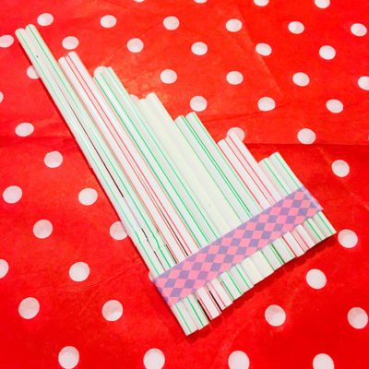
Harmonicas are fascinating, with their petite size and distinct sound, but how do they work? If you take a look at the inside of a harmonica, you will see that thin strips of brass—all different lengths—vibrate when you breathe into the harp. You can mimic this setup by taping different sized straws together and blowing into the airways. Or, filling glasses with different amounts of water and lightly dinging the rim of the glass with a spoon.

Can Drums
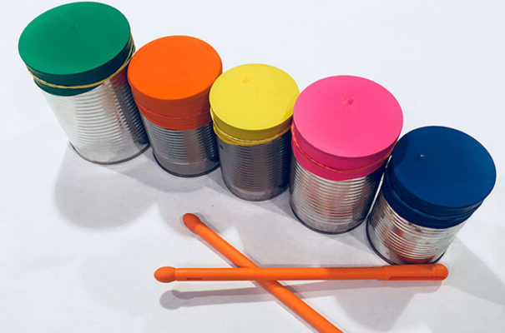
Drums create the rhythm to a tune, making this instrument a key element in a tempo lesson. Whether you dance to the beat or sing along with the percussion, drums are a great guide. You can create drums at home by using everyday items like soup cans, Pringles containers, or even a tabletop! All you need is some kind of a drum stick to tap along with.

PE:
- ‘PE with Joe’ streamed live each morning at 9am on ‘The Body Coach TV’ Youtube channel.
And every Friday is ‘Fancy Dress Friday’ so you can dress up in your costume while exercising!
- ‘Go Noodle’ online channel for guided dancing
- ‘Cosmic Kids Yoga’ online channel
- Can you remember any pilates moves Selma thought you?
Cat stretch (stretch back up to ceiling)
Superman (raise right arm and left leg, switch)
Shoulder Bridge (lie on floor with feet on ground and push feet into ground to lift back)
Roll like a ball (lie down, hug knees into chest & roll back and forward)
- 10@10 on Rte player, 10 minutes of guided exercise
- Walk, jog, run, cycle around your local area.
- Practice your football/basketball skills in your garden.
- Playground games your child may know: The Bean Game, Sea-Ship-Shore, Sprouts, Flush the Toilet
- Obstacle course: Get the children to set up an obstacle course for themselves to play in
- Challenge: Balance on one foot for 10 seconds and change to other leg

Art:
Newspaper Shark art

What’s needed:
– light blue, dark blue, black and white cardstock paper
– newspaper
– googly eyes
– scissors
– glue
Directions
1. Start by cutting out your shark face shape from your newspaper. The fun part about this craft is how everyone creates a personalised shark by how they cut out their face. You can make it skinny or wide, short or tall, however you choose. Glue your shark face onto your light blue cardstock paper.
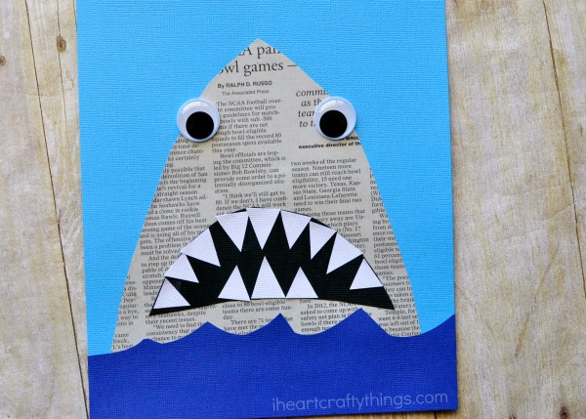
2. Cut out ocean waves from your dark blue cardstock paper (or construction paper) and glue them at the bottom of your light blue paper, underneath your shark face.
3. Cut out a shark mouth and teeth from your black and white cardstock paper. Glue them onto your shark face, together with your googly eyes
Tide Pool Project
What’s needed:
2 paper plates
Clear plastic wrap (cling film)
Water colours (markers or paint)
Drawings or clip art of tide pool creatures
Glue and stapler
​Directions:
- Paint/colour the inside of one paper plate blue.
- Cut the centre from the other paper plate and paint/colou the left over rim to look like rocks.
- Glue clear plastic wrap behind the rocks.
- Glue drawings or clip art of tide pool creatures on the blue plate.
- Staple/Glue the two plates together around the outside edges.

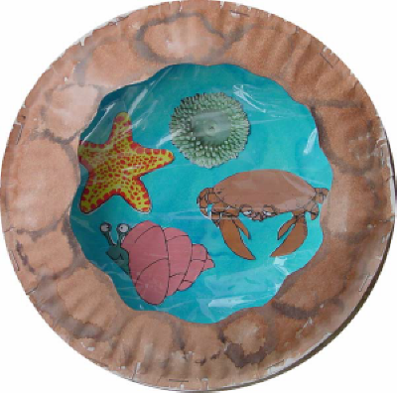

Don’t Forget to share your creations with us on kids@stphilipsjns.ie

