**Senior Infants work 14th June 2020**

Hello boys and girls! I hope you are all well and staying safe. This week’s home school learning theme is minibeasts! Try and do an activity for a few minutes every day. Send messages, work or photos to your teacher if you like by email to [kids@stphilipsjns.ie](mailto:kids@stphilipsjns.ie).

Take care,

Ms. Crimin, Ms. Scully and Ms. Carroll

**English**

* Read books and share stories as much as possible.
* For free Jolly Phonics readers search for ‘Sara Wernham’ on the Apple Books App. 
* Listen to a story about a mini beasts called ‘Mad About Minibeasts’ by Giles Andreae <https://www.youtube.com/watch?v=SW-7MgHEZOE>

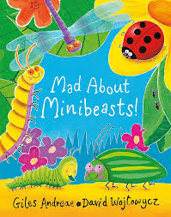

* **Poem** – Learn the poems ‘Wiggly Woo’ and ‘Caterpillar Crawling’. Can you find the rhyming words in the poems? Make some actions to accompany the poems! What’s your favourite part of the poem? Draw a picture from the poem!

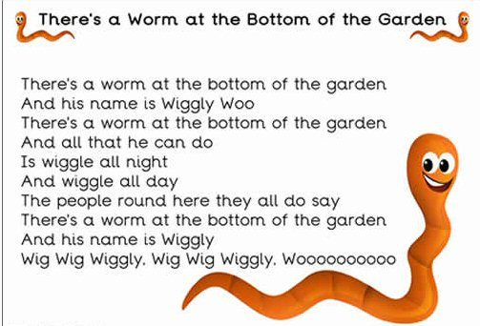

**Caterpillar Crawling**

One little caterpillar crawled on my shoes,

Another came along and then there were two,

Two little caterpillars crawled on my knee,

Another came along and then there were three!

Three little caterpillars crawled on the floor,

Another came along and then there were four!

Four little caterpillars watch them crawl away,

They’ll all turn into butterflies one fine day!

* Go on a minibeasts hunt in your garden/ park and then make a list of all the minibeasts you found.

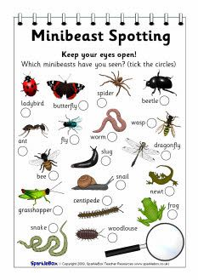

* Draw a map of your garden/ local park and draw the route you took on your mini beast adventure. Can you label the different parts of your garden/ park too?
* Write a short note to your friend and tell them about your minibeasts adventure.
* Keep a diary – draw pictures and write a sentence about what you did or your favourite part of that day/week.
* Play a game of ‘I Spy’ in the garden. I spy with my little eye something beginning with L. That’s right, it’s a ladybird!
* Geraldine the Giraffe: Watch Geraldine the Giraffe learns **ue** and **ou** on youtube. Go for a sound hunt and see can you find any things in your house that have the sounds ue and ou in it e.g. barbecue, blue, glue, house, pound. Make a list of all the things you found.

<https://www.youtube.com/watch?v=BCeE3B_tAq8>

<https://www.youtube.com/watch?v=-qtCB7CYH3I>

* Learn the Tricky Words song (focus on the words me, be, you, are, was, all, they, my)

<https://www.youtube.com/watch?v=R087lYrRpgY>

* Tricky words word hunt: Write some tricky words on pieces of card and hide the around the house. Children have to collect and read the words. Can you put these tricky words into sentences?
* Tricky words slap: Write some tricky words on pieces of paper and lay them out on the table. Each player has a wooden spoon. Adult calls out the word and players have to slap the word as fast as they can. Fastest player keeps the card. Child with the most cards at the end of the game wins.
* **Snap**: Divide the words equally between you and your parent/brother/sister/teddy. Turn over one each on top of each other. Say snap and hit the deck if there are two in a row the same.
* **Spelling: Look-Say-Cover-Write-Check Challenge**: Pick a tricky word, Look at and say the word, Cover the tricky word and have a go writing it again, Check to see if it’s right or wrong.

**Phonic Spelling Challenges**

Choose the ones your child can do. If your child can’t do it, you write it and let them copy. Do it every day that you have time.

* Parent calls out single letters and child writes it down.
* Parent calls out words (sun, mud, up, mat, jam, cat, dog, gar den) and child writes it down.
* Parent calls out sentence (I sat in the sun) and child writes it down.
* Say the sound ue/ ou. Draw some pictures with the ue and ou sounds e.g. house, mouse, blue, glue.

**Maths**

* **Ladybird Counting Game** <https://www.topmarks.co.uk/learning-to-count/ladybird-spots>
* **Video about Capacity** <https://www.youtube.com/watch?v=zF3JSnEq7tU>
* **Capacity:** Can you fill some containers to make them full/ nearly full/ empty/ nearly empty?

Guess how many cups of water it would take to fill a saucepan.

Look for some containers around your house e.g. saucepan, bucket, cup, egg cup. Can you order them starting with the container that would hold the least amount? Which container would hold the most?

* **Numeral formation:** Practise writing numerals using the correct formation.
* **Making number lines:** Make your own number line 1-20. Decorate it as you wish. Use it to help you count and check which number come before or after.

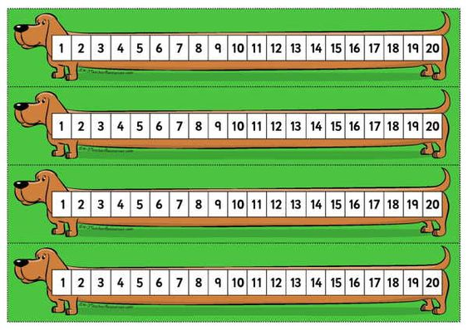

* **Active Counting:** Children can take a trip to the number gym.

Pick a starting number and finishing number (either counting backwards or forwards)

Pick an activity e.g. jogging on the spot, star jumps, “weight-lifting”, squats etc. Children count while engaging in the physical activity.

**Music:**

* Learn the song ‘If I Were a Mini Beast’ from Out of the Ark Music at Home. See can you make up any actions to go with the song!

<https://www.youtube.com/watch?v=-eajwaH0_2c>

**SESE:**

* Here are some useful videos to watch about mini beasts. Which minibeast is your favourite? Can you find it in your garden/ park? What do you know about this minibeast? Can you draw a picture of your favourite minibeast and write a short fact about it?

<https://www.youtube.com/watch?v=JuHg5oWF_mo>

<https://www.youtube.com/watch?v=9RtW9zG0854>

<https://www.youtube.com/watch?v=jaIBGJjr4-4>

**Art & Crafts:**

* Build a Bug: Using different coloured paper cut into 2D shapes invent your own minibeast!

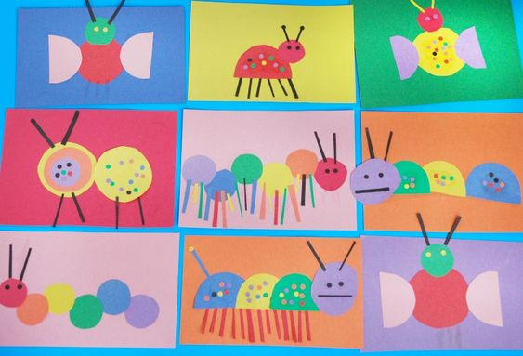

* Construct a bug using playdough, googly eyes and pipe cleaners.

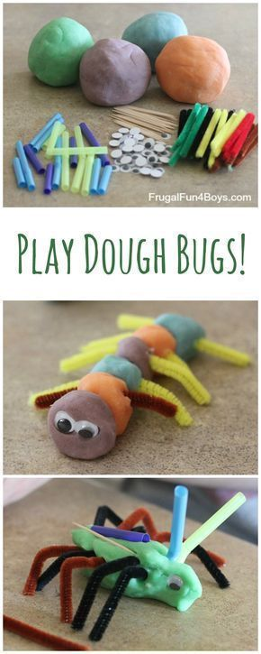

**Physical Activity**

* PE with Joe Wicks- Watch live every day at 9am (lots of saved videos available too!)

<https://www.youtube.com/watch?v=QvWzWqLk8iQ>

* 10@10 - daily 10minute exercise videos. (<https://rtejr.rte.ie/10at10/>)
* Make up your own bug action cards and take it in turns to guess which minibeast you are!

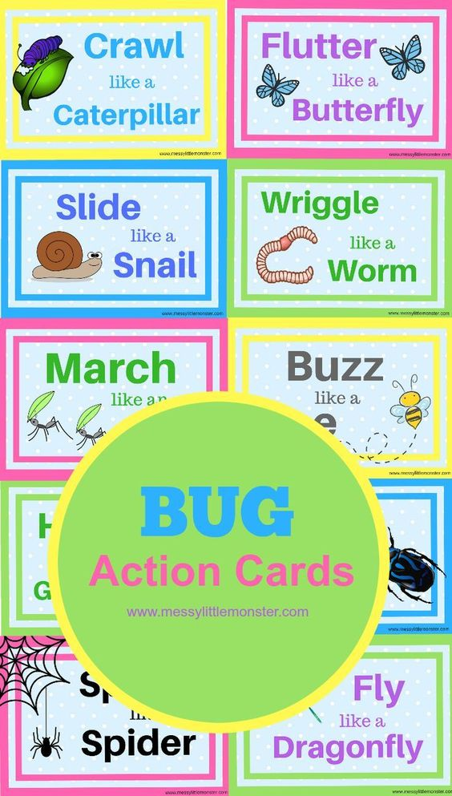

* Cosmic Kids Yoga Bugs Version <https://www.youtube.com/watch?v=qIT-9Nnlvn0>

**Other Activities: The following are activities that are excellent for developing the children’s logic skills, creativity as well as aiding with academic development.**

* Jigsaws
* Water and Sand-play
* Building with Lego and blocks
* Learn to tie your laces
* Nature walk/Scavenger walk
* Make a list of things to look out for on a walk. (Children could help to write the list)
* Take a photo of what you find or draw pictures when you come home.