**Senior Infants work 22nd of June 2020**

Hello boys and girls!

Can you believe that we are in the final week of Senior Infants? Well done on all your hard work so far.

This week’s home school learning theme is summer holidays and the beach! Try and do an activity for a few minutes every day. You can send messages, work or photos to your teacher by email to [kids@stphilipsjns.ie](mailto:kids@stphilipsjns.ie) or using the SeeSaw app.

Take care,

Ms. Crimin, Ms. Scully and Ms. Carroll

**English**

* Read books and share stories as much as possible.
* Listen to a story about a mini beasts called ‘What the Ladybird heard at the Seaside’ by Julia Donaldson <https://www.youtube.com/watch?v=PvguZ1YvKLw>

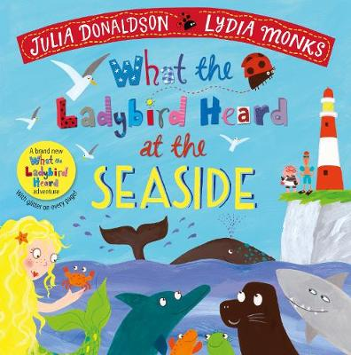

* **Poem** – Learn the poem: ‘In Summer’ by Liana Mahoney

**In Summer**

Pour on the lotion, rub it in.

Perfect for my summer skin.

On my bike or in the pool,

A sip of water keeps me cool.

Shades are on, flip-flops too.

In summer, there’s so much to do!

* Try out this new version of ‘Old McDonald’, maybe you could come up with some new actions or sounds for other ocean creatures.

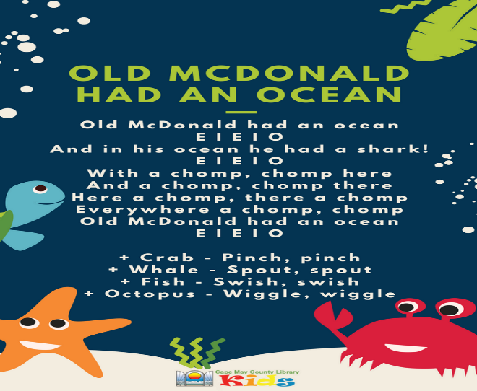

* Make a list of things you would like to do during the summer holidays, maybe it’s a trip to the beach, learn how to rollerblade, visit Dublin Zoo or do a hundred bounces on a trampoline!
* Watch Ms. O’Sullivan’s rockpool adventure video on the school website <https://www.stphilipsjns.ie/news/a-rock-pool-adventure/>
* Draw a picture of the beach and rockpool, include labels of the different sea creatures that she found in the rockpool and things that you find at the beach.
* Pick a sea creature and write down some facts that you know about that sea creature. For example: An octopus has eight legs. A jellyfish can sting you. Etc.
* Take an imaginary summer holiday and write a postcard to your teacher telling them all about your trip. Remember that you can go anywhere in your imagination so maybe you’ll send me a postcard from the beach, Disneyland, the jungle or even outer space!
* Keep a diary – draw pictures and write a sentence about what you did or your favourite part of that day/week.
* Play a game of ‘I Spy’ things at the sea. I spy with my little eye something beginning with B. That’s right, it’s a boat!
* Geraldine the Giraffe: Watch Geraldine the Giraffe learns **ar** on YouTube. Go for a sound hunt and see can you find any things in your house that have the sounds ar in it e.g. car, star, carpet, bar, art, markers. Make a list of all the things you found.

<https://www.youtube.com/watch?v=QXBQDsgRuMo>

* Revise the Tricky Words that we have learnt this year using some of the following activities:
* **Wet Tricky Words!** – Use a paint brush and water to write your tricky words on the path
* **Tricky words word hunt:** Write some tricky words on pieces of card and hide the around the house. Children have to collect and read the words. Can you put these tricky words into sentences?
* **Tricky words slap:** Write some tricky words on pieces of paper and lay them out on the table. Each player has a wooden spoon. Adult calls out the word and players have to slap the word as fast as they can. Fastest player keeps the card. Child with the most cards at the end of the game wins.
* **Snap**: Divide the words equally between you and your parent/brother/sister/teddy. Turn over one each on top of each other. Say snap and hit the deck if there are two in a row the same.
* **Spelling: Look-Say-Cover-Write-Check Challenge**: Pick a tricky word, Look at and say the word, Cover the tricky word and have a go writing it again, Check to see if it’s right or wrong.
* **Phonic Spelling Challenges**
* Choose the ones your child can do. If your child can’t do it, you write it and let them copy. Do it every day that you have time.
* Parent calls out single letters and child writes it down.
* Parent calls out words from the ‘un family’ e.g. bun, gun, run, hun and child writes it down.
* Parent calls out sentence (I sat in the sun) and child writes it down.
* Say the sound **ar**. Draw some pictures with the ue and ou sounds e.g. hard, star, far etc.

**Maths**

* Try these maths games:

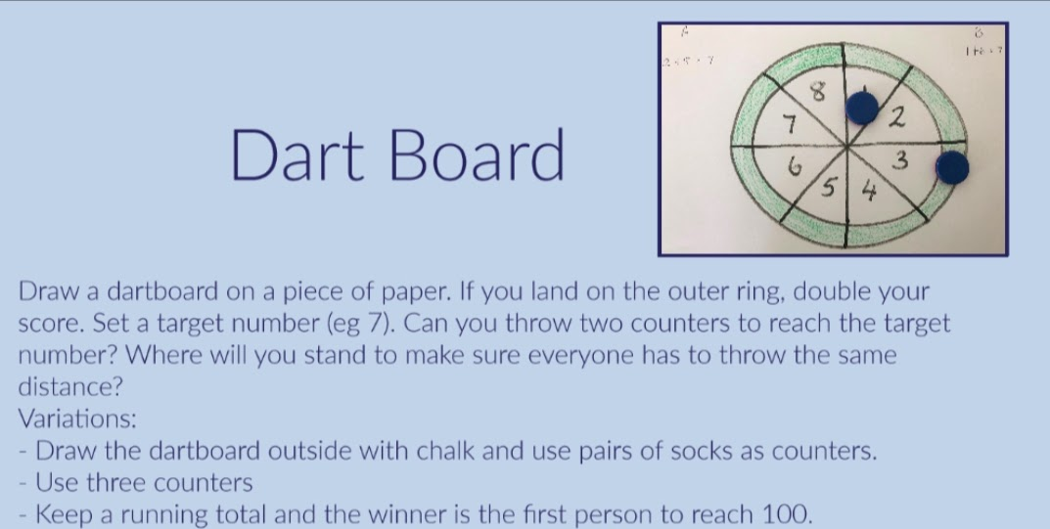

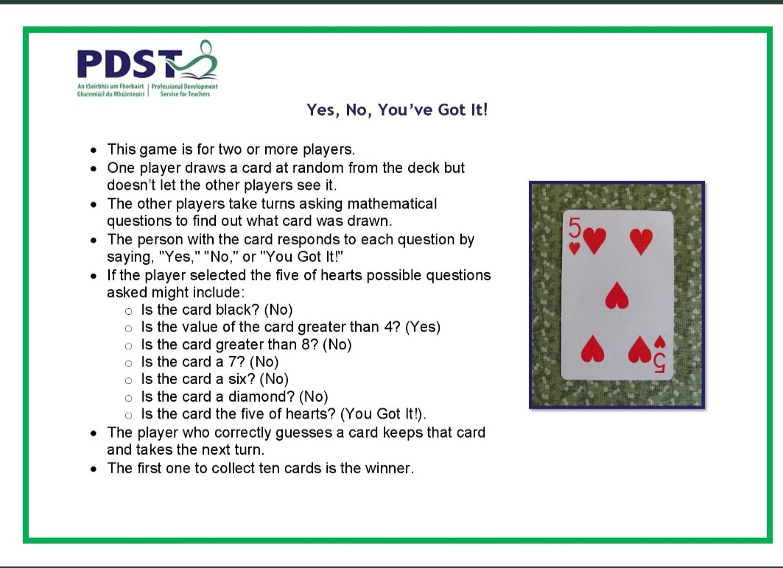

* **Numeral formation:** Practise writing numerals using the correct formation.
* **Active Counting:** Children can take a trip to the number gym. Pick a starting number and finishing number (either counting backwards or forwards). Pick an activity e.g. jogging on the spot, star jumps, “weight-lifting”, squats etc. Children count while engaging in the physical activity.

**Music:**

* Learn the song ‘’I love Summertime’ Can you make up a verse about where you love to visit in the summertime. <https://www.youtube.com/watch?v=Xg5i9rxxuJM>

**SESE:**

* Listen and read along with the story ‘Night Monkey and Day Monkey’ by Julia Donaldson.

<https://www.youtube.com/watch?v=ICxLOO9pua0>

* Sunglasses challenge: Can you design and make a pair of sunglasses for Night Monkey, so the sun won’t hurt his eyes.
* You can use one of your teddies as a model for the sunglasses, but they have to be able to wear them without falling off.
* You have to use recyclable materials in your glasses.
* The glasses should have transparent (see-through) lenses so that Night-Monkey can still see where he’s going and climb trees.

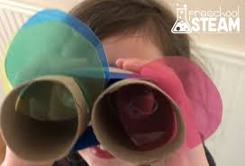

**Physical Activity**

* PE with Joe Wicks- Watch live every day at 9am (lots of saved videos available too!)

<https://www.youtube.com/watch?v=QvWzWqLk8iQ>

* 10@10 - daily 10minute exercise videos. (<https://rtejr.rte.ie/10at10/>)
* Make up your own sea creature cards and take it in turns to guess which sea creature you are!

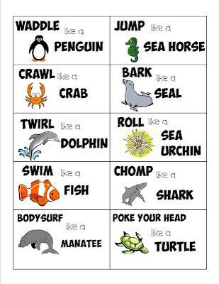

* Cosmic Kids Yoga ‘Nibs the octopus’

<https://www.youtube.com/watch?v=hUBRoLRioiY>