Dear Parents/Guardians,

Welcome to week 10, the last week of the summer term!

Thank you for all the lovely messages and pictures we have received at [kids@stphilipsjns.ie](mailto:kids@stphilipsjns.ie) . It has been wonderful to hear from the children and see all the great work they have been doing at home.

This will be the last weekly plan before the summer holidays. We would again like to really emphasise that you are welcome to see this suggested weekly outline of activities as a menu - you can explore as many or as little of the tasks as you can, depending on your own family routine. There may be days where you explore a small number of suggested school tasks with your child and other days where you may have more time for school-based activities and explore a little more.

There is no pressure on any family to complete all of the weekly suggested tasks. You are welcome to prioritise the activities that you feel will benefit your child most and enrich their daily routine.

This week will also be the last week of Seesaw activities before the summer holidays. On Friday, your child’s teacher will put up a special message for their class. It will appear both on Seesaw and the school website.

Thank you for your continued support through these unprecedented times. We wish you and your families a lovely summer break. We are disappointed that we couldn’t have a graduation ceremony with the children but we will organise a get together with them when we are back in school.

Best wishes,

*Mr. Conneely, Ms. O’Hora, Mrs. Maye, Ms. O’Hare, Mrs Watson.*

**Monday 22nd June**

**Literacy**

As it’s the start of the week write **‘Our News’** – What did you get up to at the weekend? What day is it today? What’s the weather like? Remember to keep it interesting! You can draw a picture of your weekend and colour the picture too.

***Reading***- Read the page below and answer the following questions

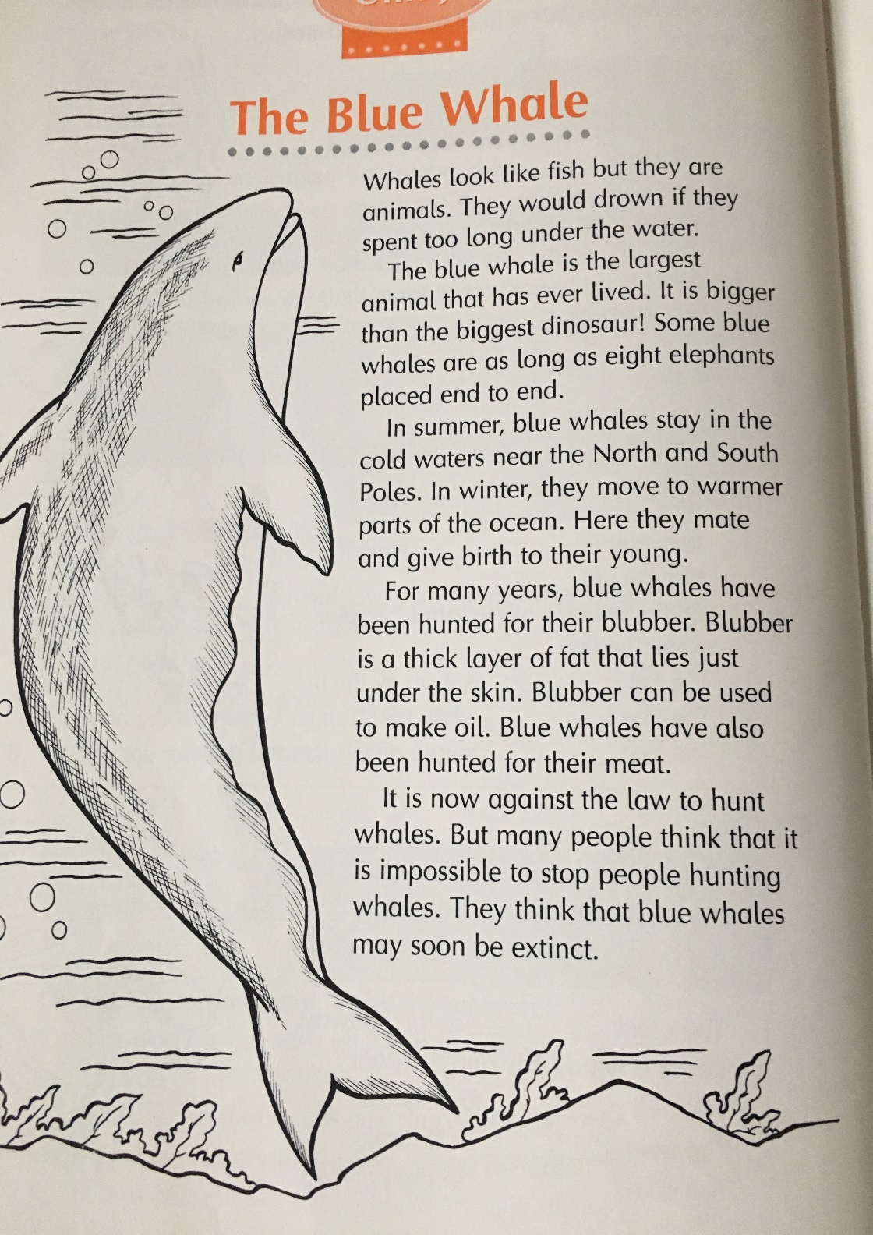

1. In what way are whales different from fish?
2. Name the largest animal that has ever lived.
3. Where do blue whales stay in summer?
4. Where do they move to in winter? Why?
5. Give two reasons why blue whales have been hunted.
6. What is blubber?
7. What use can be made of blubber?
8. Why do some people think that blue whales may soon become extinct

**Do you remember when we use capital letters?**

* Beginning of a sentence
* Names of people
* Names of places
* Days of the week and months
* Special days

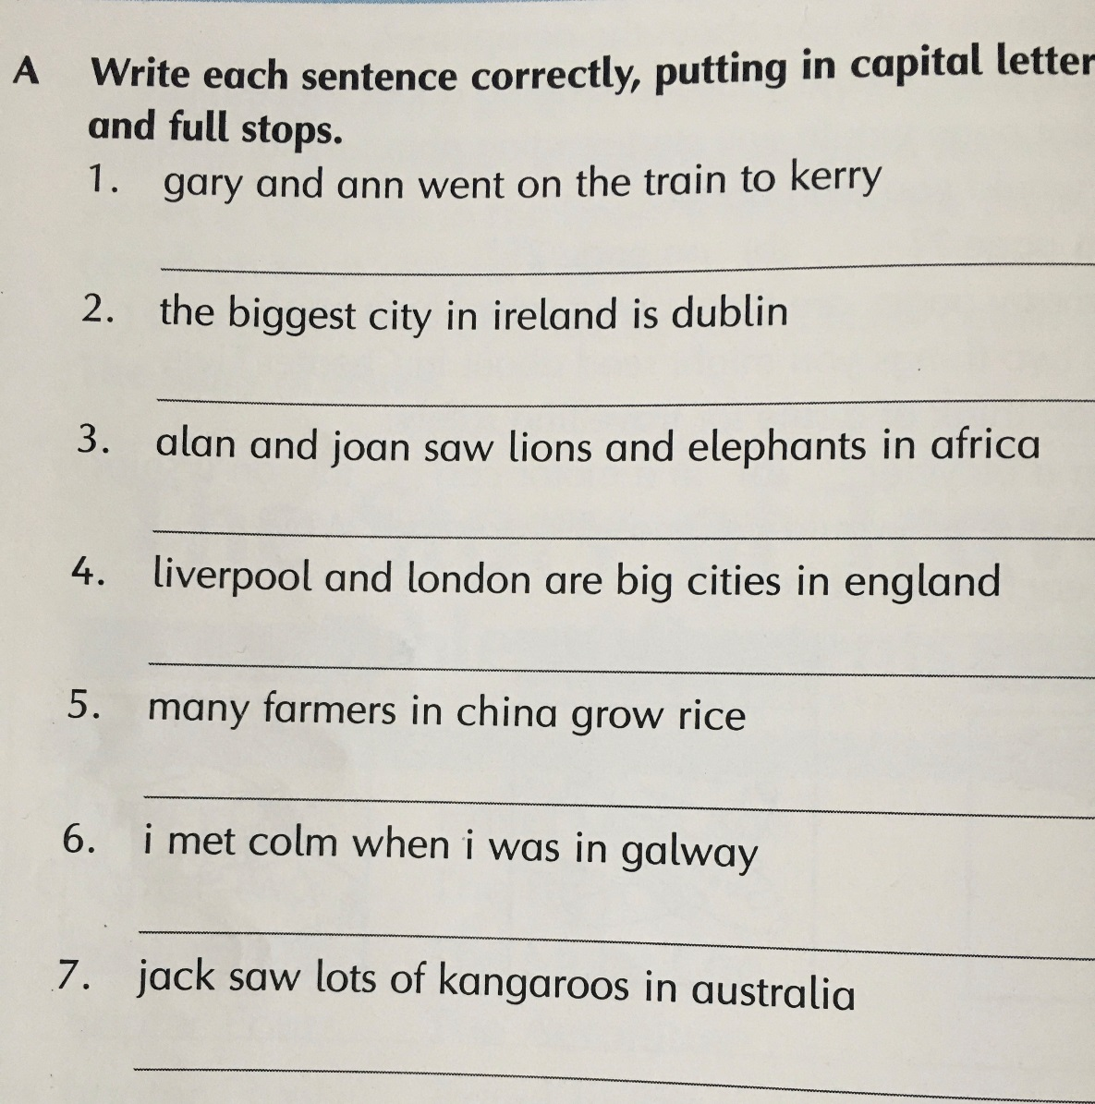

**Numeracy**

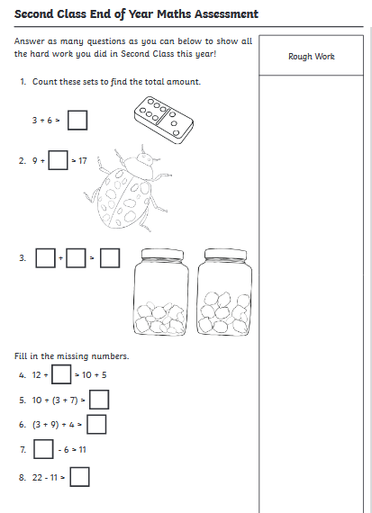

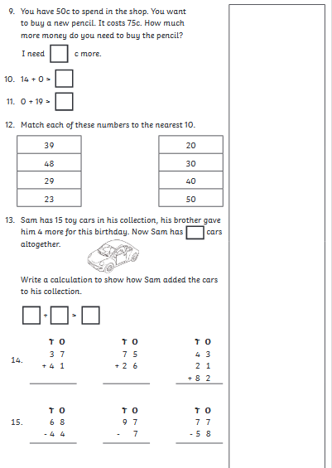

**Gaeilge** – An Samhradh (Summer)

Draw the following pictures and write the words.

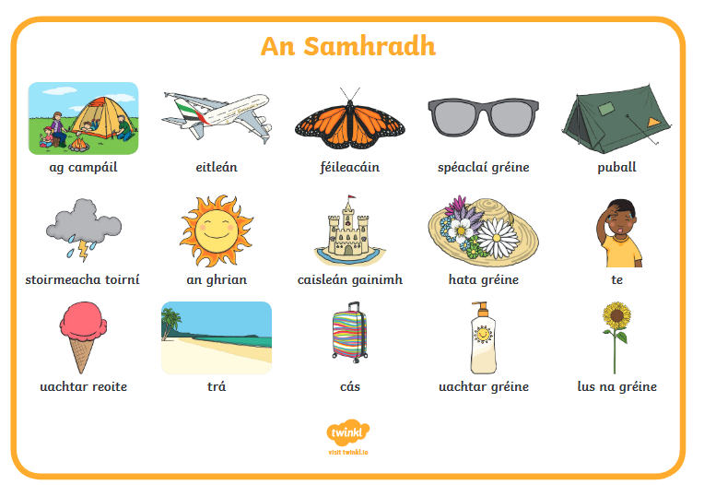

An maith leat uachtar reoite?

An maith leat bheith ag campáil?

An bhfuil hata gréine agat?

Anbhfuil spéaclaí gréine agat?

An bhfuil cás agat?

**S.E.S.E – 5 Senses**

Can you name the 5 senses?

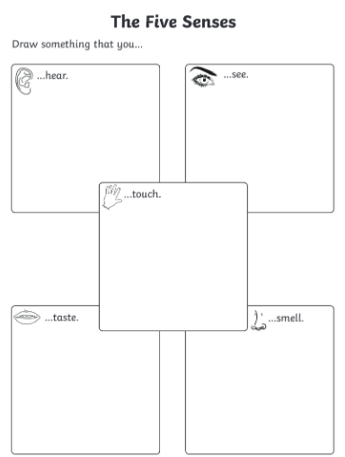

**Daily Challenge:**

Check out today’s daily challenge on the school website and try to complete it.

**Tuesday 23rd June**

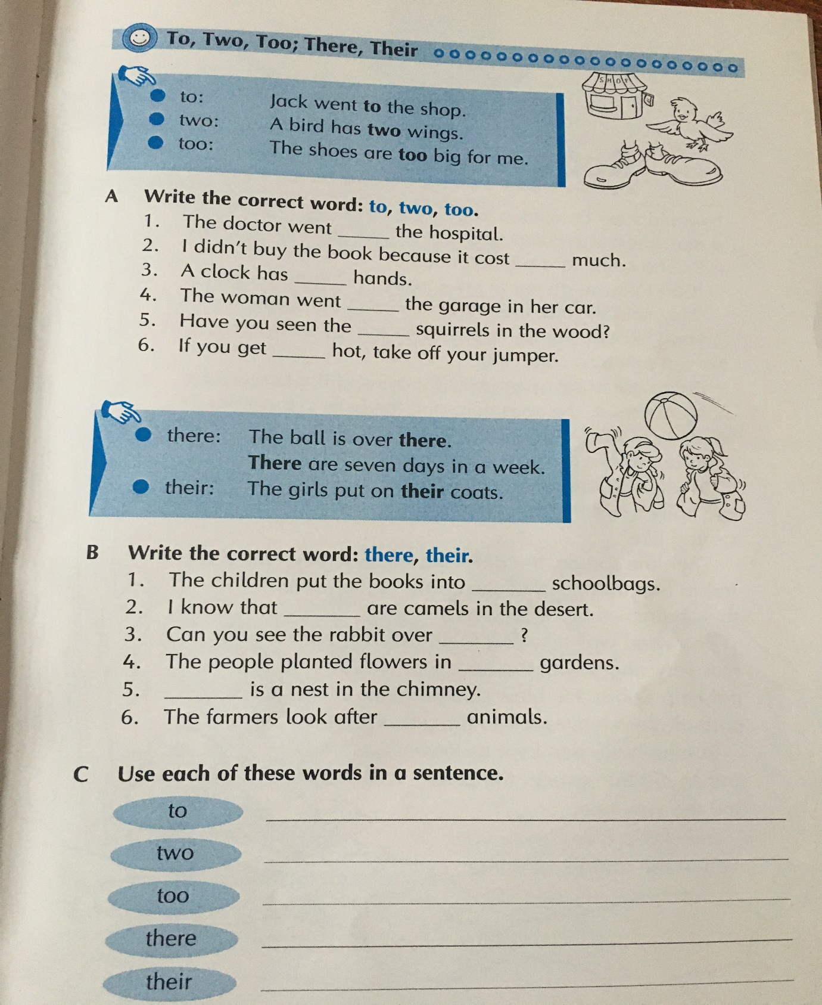

**Numeracy**

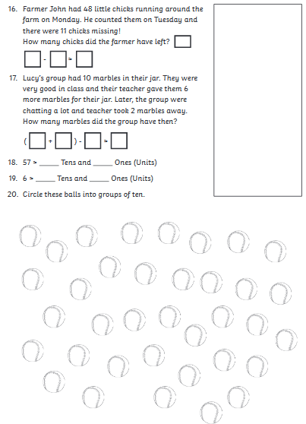

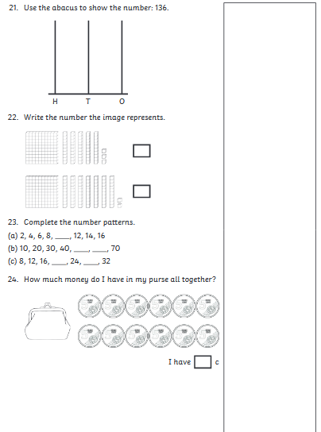

**S.E.S.E. – 5 Senses**

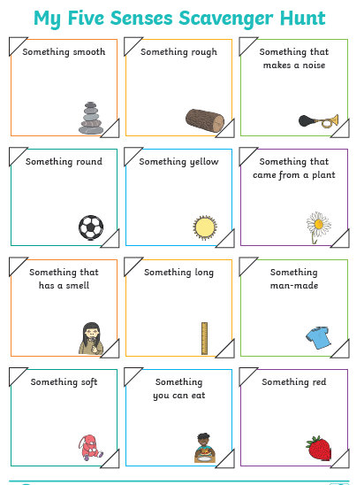

**Art**

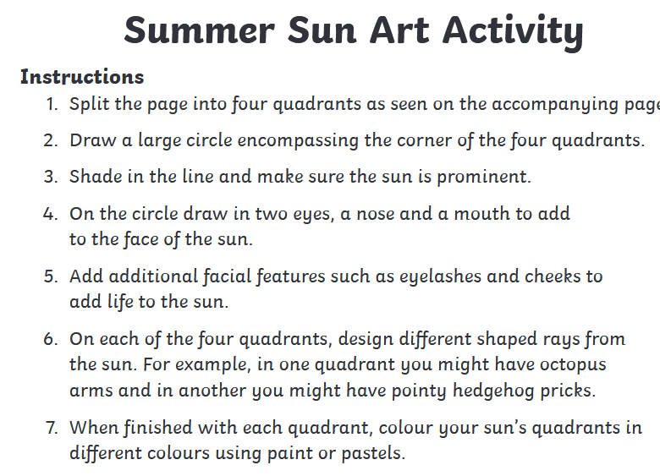

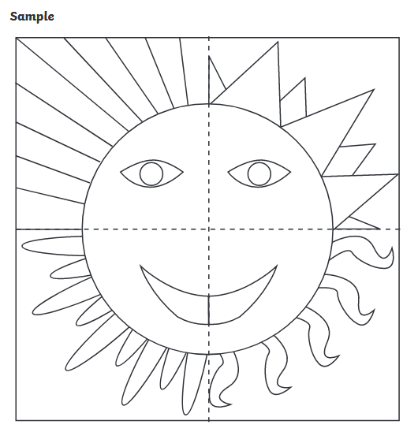

**Active Work:**

Look up the website from Active Week and do some of the activities that you enjoyed. There are lots to choose from! Have fun!

**Daily Challenge-**

Check out today’s daily challenge on the school website and try to complete it.

**Wednesday 24th June**

**Literacy**

Can you remember what words we use to ask questions?

**Who? Why? What? When? Where? How?**

Try these:

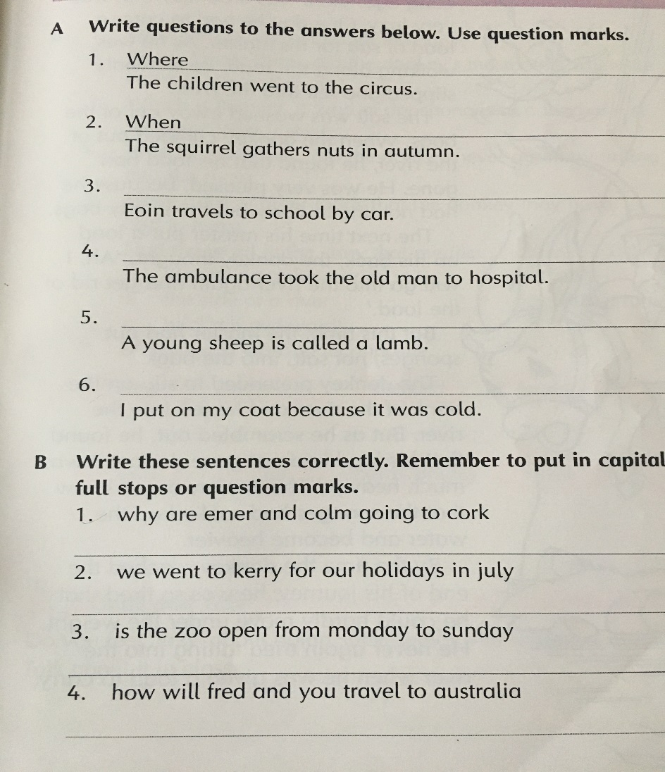

Summer Sensory Poem

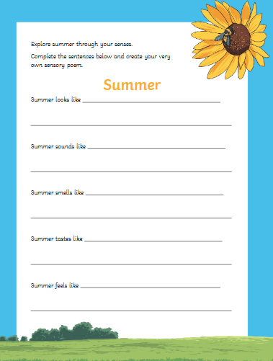

**Numeracy**

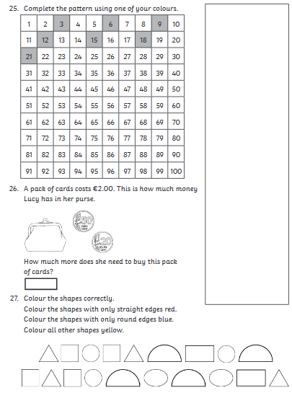

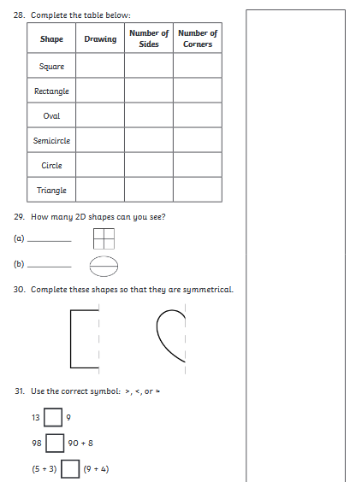

**Gaeilge- Éadaí Samhraidh**

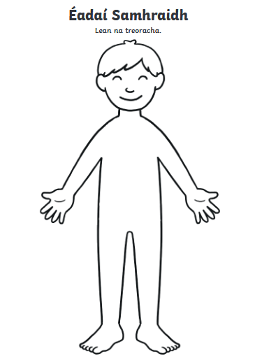

1. Cuir léine air.
2. Cuir briste gairid air. (shorts)
3. Cuir caipín air.
4. Cuir spéaclaí gréine air.

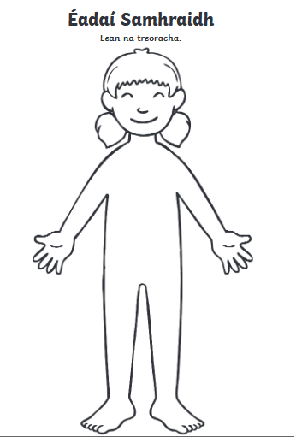

1. Cuir culaithe snámha uirthi.
2. Cuir hata gréine uirthi.
3. Cuir spéaclaí gréine uirthi.
4. Cuir bróga samhraidh uirthi.

**Active Work:**

Look up the website from Active Week and do some of the activities that you enjoyed. There are lots to choose from! Have fun!

**Daily Challenge-**

Check out today’s daily challenge on the school website and try to complete it.

**Thursday 25th June**

**Literacy**

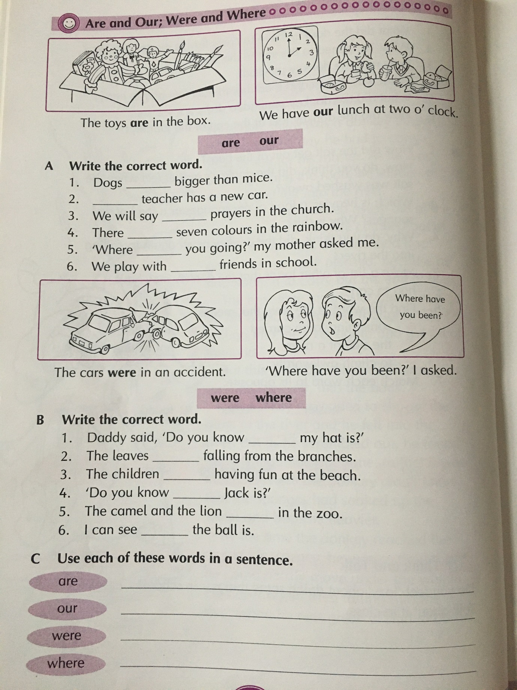

Think back on your year in second class and fill in the boxes below.

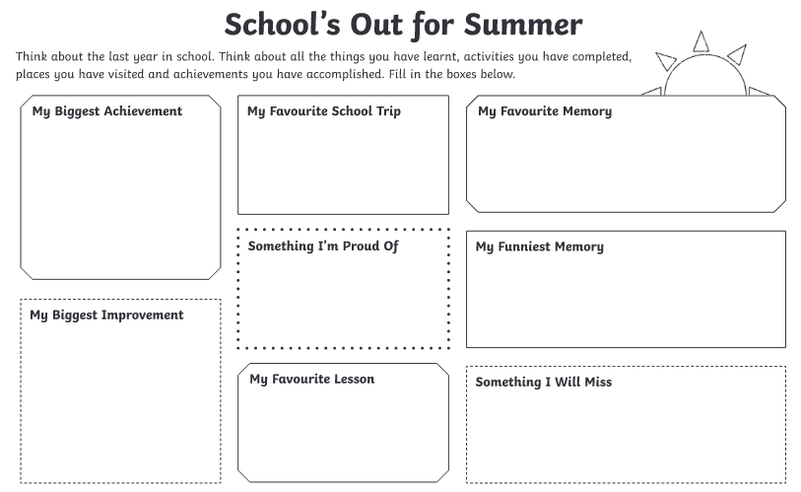

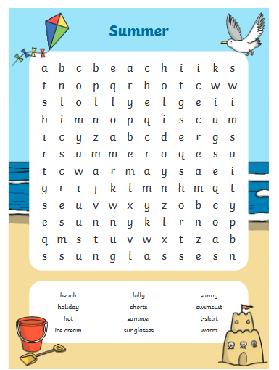

**Numeracy**

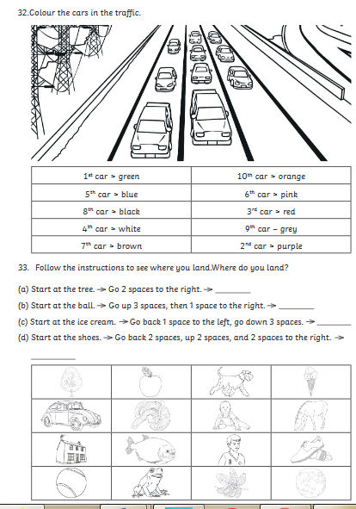

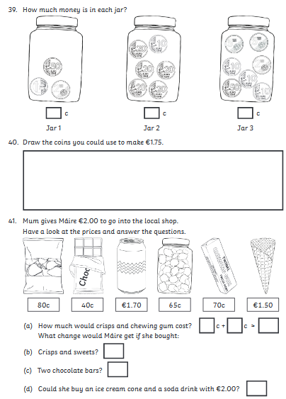

**S.E.S.E – Summer**

Read the following passage and answer the questions.

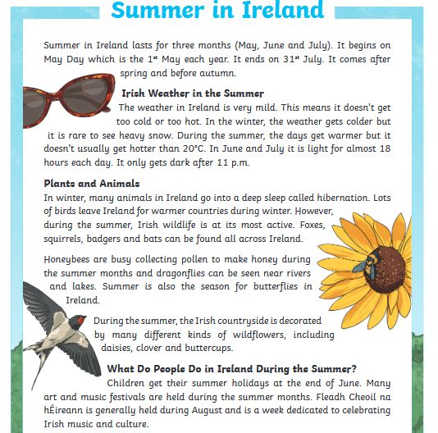

1. When does the Irish summer begin and end?
2. What season comes before summer? What season comes after summer?
3. Describe the weather in Ireland during the summer.
4. What time does it get dark during the summer?
5. What kind of animals can be found during the summer?
6. What do honeybees do during the summer?
7. What kind of wildflowers are found during the summer?
8. What is the celebration held in August, dedicated to Irish music and culture called?

**Art**

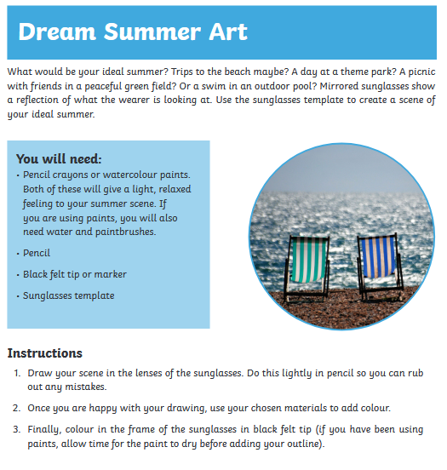

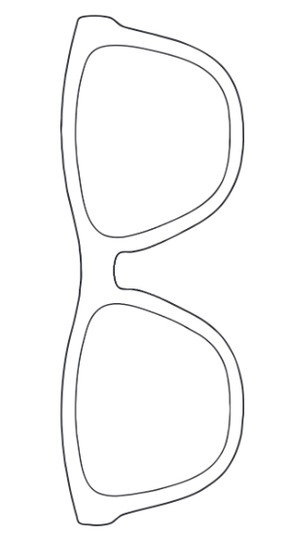

**Active Work:**

Look up the website from Active Week and do some of the activities that you enjoyed. There are lots to choose from! Have fun!

**Daily Challenge-**

Check out today’s daily challenge on the school website and try to complete it.

**Friday 26th June**

**Literacy**

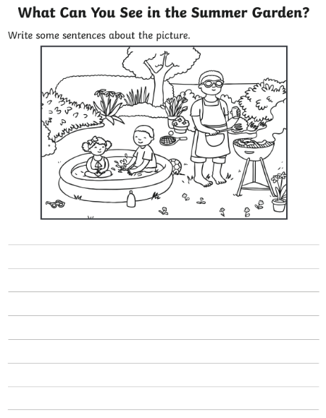

Think about your summer holidays and all the lovely things you would like to do.

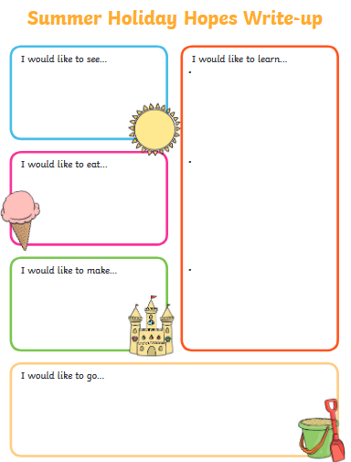

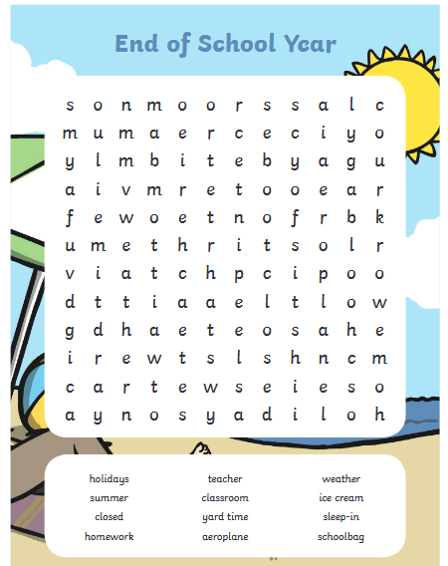

**Numeracy**

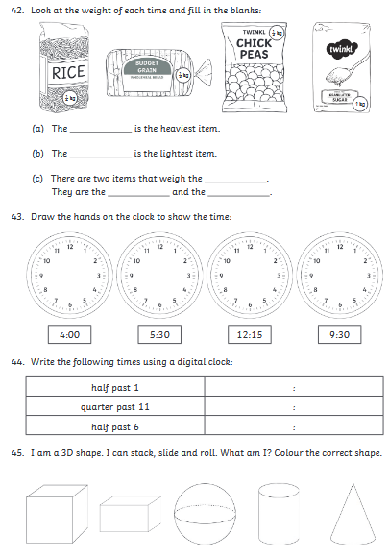

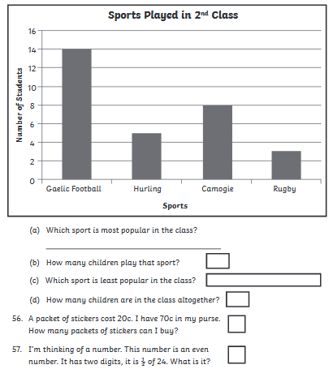

**S.E.S.E.**

Go on a nature walk. How many of these things can you find?

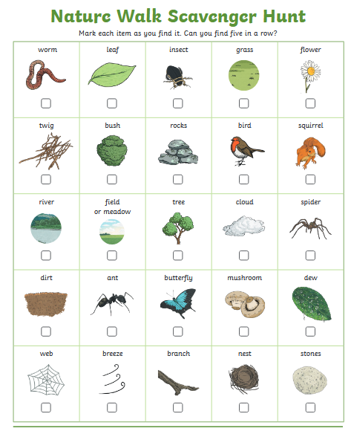

**Active Work:**

Look up the website from Active Week and do some of the activities that you enjoyed. There are lots to choose from! Have fun!

**Daily Challenge-**

Check out today’s daily challenge on the school website and try to complete it.

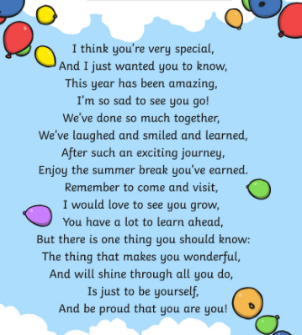

**Well done on all your hard work boys and girls!**

**We hope you all have a wonderful summer ☺**

**Ms. O’Hora, Mrs. Maye, Mr. Conneely, Ms. O’Hare, Mrs. Watson**

