

A Happy New Year to everyone. We hope you all had a great Christmas break and that Santa Claus was good to you all. As we have to revert back to distance learning we hope that the work to follow will help. We will be continuing to use Seesaw also. **If anyone is having any difficulty logging into Seesaw or using the code, please send your teacher an email at** [**kids@stphilipsjns.ie**](mailto:kids@stphilipsjns.ie) .Put teachers name in the reference box for easy access. All the children have been using SeeSaw in school and know how to use the functions to record, save and post work. You can also use SeeSaw to send messages directly to you teacher. Keep up the great work! ☺

|  |
| --- |
| **January 11th – 15th**  **Theme – Winter**  winter clipart - Clip Art Library |

**English**

Let’s have a look at some winter poetry. Brrr it’s cold out there!

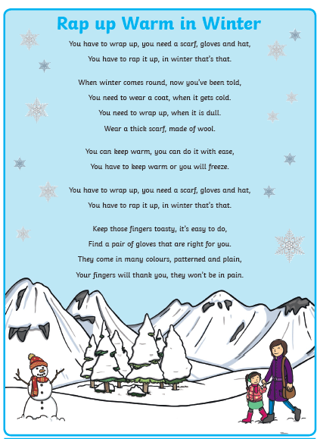

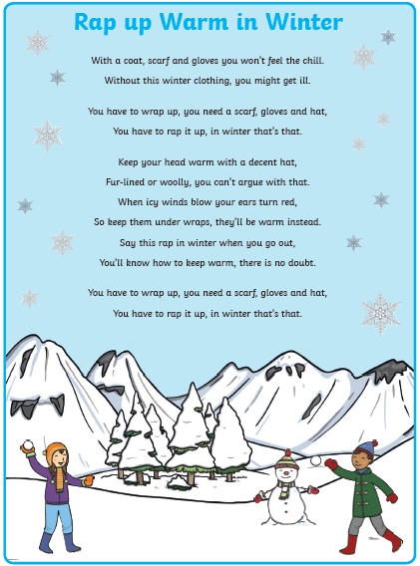

Now that you have read the Winter Rap let’s answer some questions ! You can use any copy to write your answers. Remember to give your work a title and number your answers !

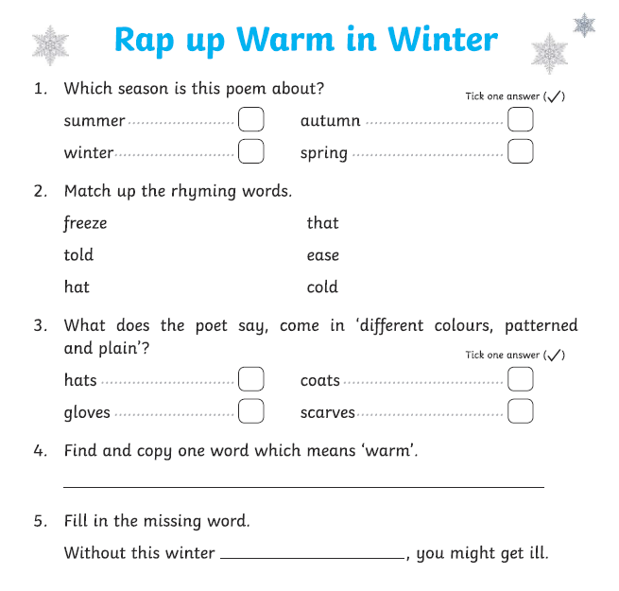

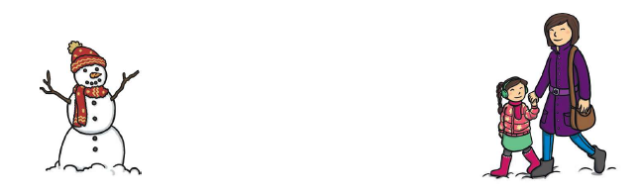

WINTER TIME COMPREHENSION

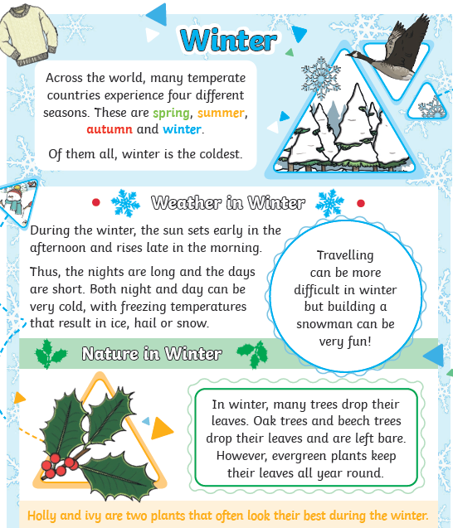

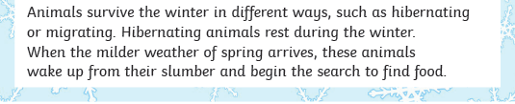

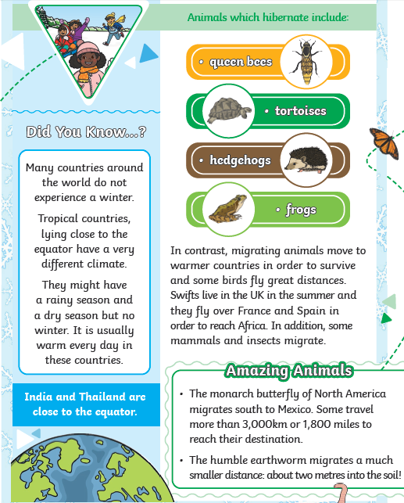

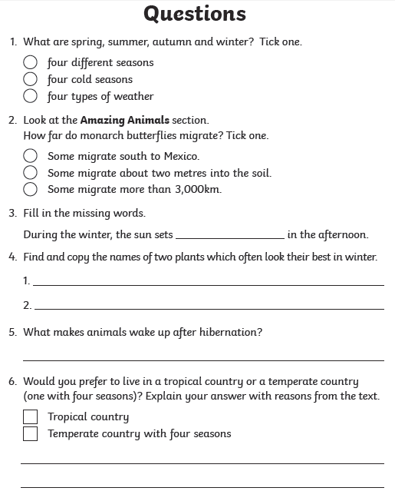

Ireland is a temperate country because we have four distinct seasons, Spring, Summer, Autumn and Winter. Examples of tropical countries are Australia and Brazil.

Let’s have a little look at opposites !! 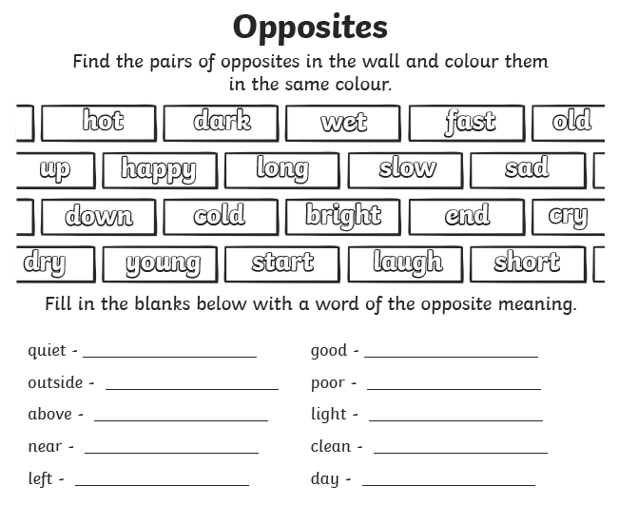

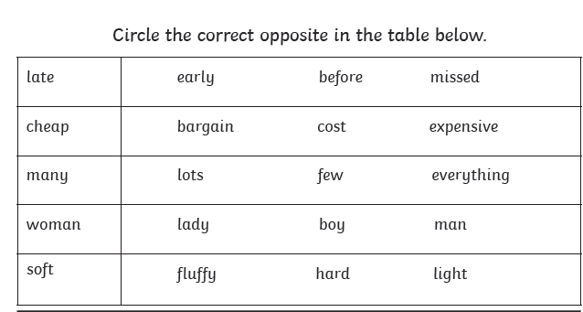

**Maths**

There are lots of fun maths games and activities you can play at home with whoever is there with you so have a think about all the maths games you play with your teacher and with Ms. O’Halloran at maths time!

*Games to play with your family:*

* **Buzz off sit down.** In this game you pick a number and everyone takes turns saying numbers till you hit the chosen number. When you reach the number you get to turn to the person next to you and say “Buzz off sit down!” and they’re out of the game. E.g. The chosen number is 29. Everyone goes around the circle saying a number till you get to 29 and then someone has to sit down.
* **Grandma’s in the kitchen**. This game can be played with 2 or more people. Don’t forget to say the rhyme that goes with it! Pick a number and take turns counting up to that number till you hit it. Whoever does is the winner. This game is great because you can practice counting in 2’s, 3’s, 5’s, 10’s or even in 10’s off the decade. E.g. The chosen number is 180. Player 1 says 10, player 2 days 20, player 1 says 30 and you keep going till player 1 or 2 says 180.
* **Beat the teacher (or beat mammy, daddy, nana, grandad your brother or sister!)** Take turns counting to a number.
* **Card games.** All you need is a deck of cards and you can play loads of games with your family. House is a nice easy game to start with.
* **Uno.** This is another great card game that is maths related. You’re using your maths brains to keep an eye on the number cards.

*Online games*

* There are lots of great websites you can use to practice your counting, addition and subtraction. You can play these games on someone’s smartphone, a tablet/i-pad or a computer. Here are just a few.
* [***https://www.topmarks.co.uk/maths-games/5-7-years/counting***](https://www.topmarks.co.uk/maths-games/5-7-years/counting)
* [***https://www.mathplayground.com/math-games.html***](https://www.mathplayground.com/math-games.html)
* [***https://home.oxfordowl.co.uk/kids-activities/fun-maths-games-and-activities/***](https://home.oxfordowl.co.uk/kids-activities/fun-maths-games-and-activities/)
* [***https://ie.ixl.com/math/class-2***](https://ie.ixl.com/math/class-2)

***Practice your addition and subtraction***

* By now in second class we have covered lots of different ways to do your addition and subtraction sums. Have a go at practicing some of these.

**Addition**

*  We can do it a tall sum way. Remember if the units go over 9 you will have to carry a ten over to the other side.
* 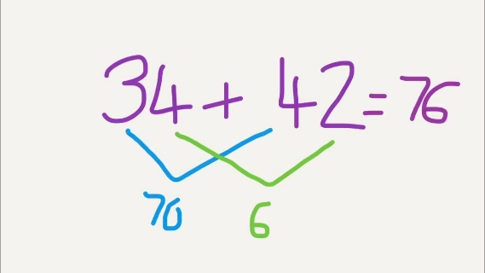We can add two numbers using criss cross. Don’t forget to add the tens and then add the units
* We can do it on a number line. Add the smaller number to the bigger number and add the hundred, tens and then the units.

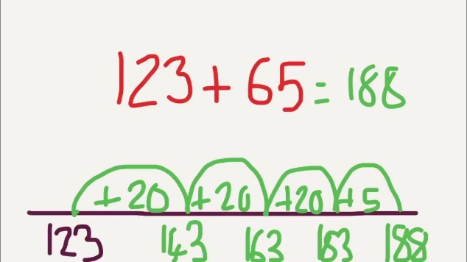

|  |
| --- |
| Using any of the methods try these sums:   * 23 + 63 = * 48 + 67 = * 162 + 564 = * 123 + 42 = * 88 + 27 = * 127 + 67= * 424 + 73 = |

**Subtraction**- Careful with your take away sums. We can only do our take away/ subtraction sums two ways! A tall sum or a number line.

**-**If the number on top is bigger than the number on the bottom we can do it the tall sum way but if not we are going to have to do it a number line way. Remember we draw the line, put the bigger number (we are taking from) to the right of the line and then take away the tens first and then the units.

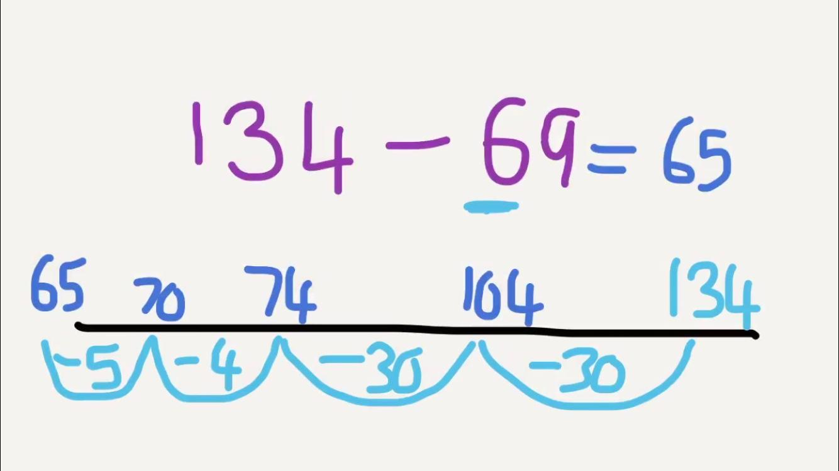

|  |
| --- |
| Choose a method and try these:   * 284 – 122 = * 645 – 123 = * 59 – 22 = * 123 – 56 = * 88 – 19 = * 138 - 26 = |

**Word problems**

* You can write your own word problems and do the sums later. Or how about you write some for your brother or sister and they can write some for you? Here are some examples that might help.
* *Mrs. Molloy had 220 pairs of runners. Ms. Slattery has 133 pairs. How many do they have altogether?*
* *Mrs. Hynes has 78 colouring pencils and when Mr. McGinty used them she lost 23 of them. How many does Mrs. May have now?*
* *Ms. O’Halloran has 54 books read since Januray. Mr. Conneely has twice that much read. How many did Mr. Conneely read? How many did they both read?*

Remember when you are writing these sums and doing them to see if the number is getting bigger or smaller. Here are some maths words you can use in your word problems.

|  |  |
| --- | --- |
| **Addition words** | **Subtraction words** |
| Altogether  More  Also  Together  Plus  Total  Increase | Less  What is the difference  Fewer  Take away  Lost  Deduct  Decrease |

*Other maths activities you can do:*

* You can practice your skip counting in 2’s, 3’s, 5’s, 10’s and 10’s off the decade. E.g. 3, 13, 23, 33,etc. It’s easy to count up but I wonder can you skip count backwards? From 100 or even 200!
* Practice telling the time. We all know the o’clock pretty well in second class but can you remember how to tell if its quarter to and quarter past a time?

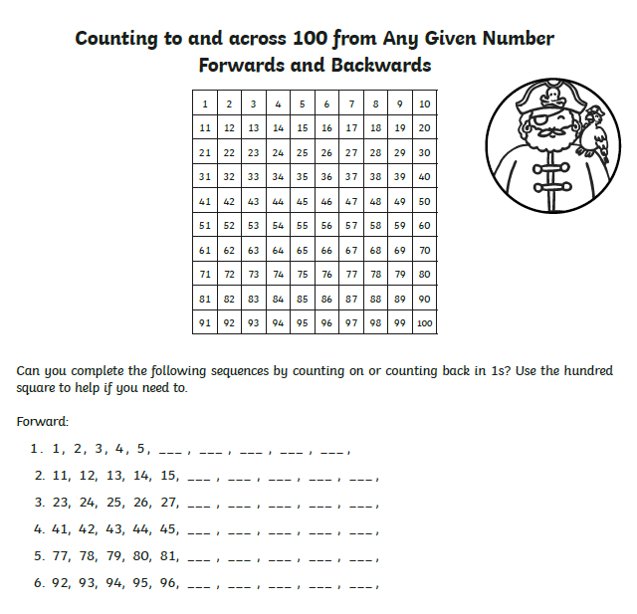

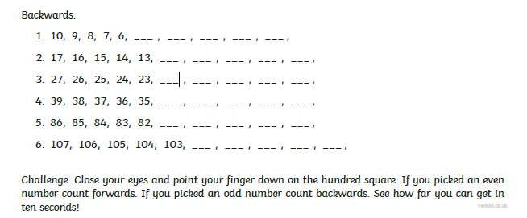

<https://www.topmarks.co.uk/place-value/place-value-charts>

<https://www.topmarks.co.uk/learning-to-count/place-value-basketball>

**GEOGRAPHY & SCIENCE**

Take a look at the Winter Time power-point. If you cannot open it here it is also on the school website under

* Classes
* Home Learning
* Second Class
* January 2021

Get help reading the presentation. Some words might be tricky !!



In your copy or on one of the pages below write seven things all about winter that you remember from the presentation. Keep your writing neat and remember to write your letters correctly. Take your time ! There are two different pages to choose from. These are also on the website.

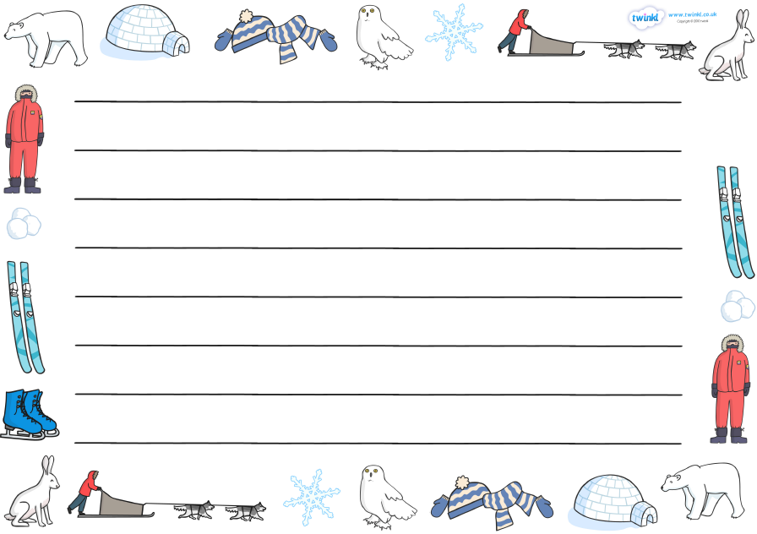

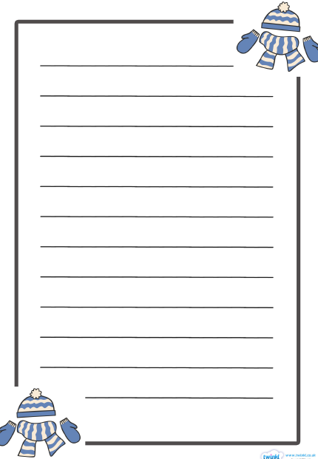

Gaeilge

An Aimsir (an i’m-shir)

The Weather

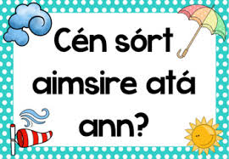

* Cén sort aimsire atá ann ? (Cane sort i‘m-shir-a a-taw ow-in)

What is the weather like ?



(power-point is also on the website)

|  |  |
| --- | --- |
| Grianmhar – (green-fur) /Sunny | Gaofar – (gwe-fur) / Windy |
| Scamallach – (skaam-a-lock) / Cloudy | Cur báistí – (cur bah-sh-tee) /  raining |
| Cur sneachta – (cur sh-nacht-a) / snowing |  |

Tarraing an Aimsir / Draw the weather

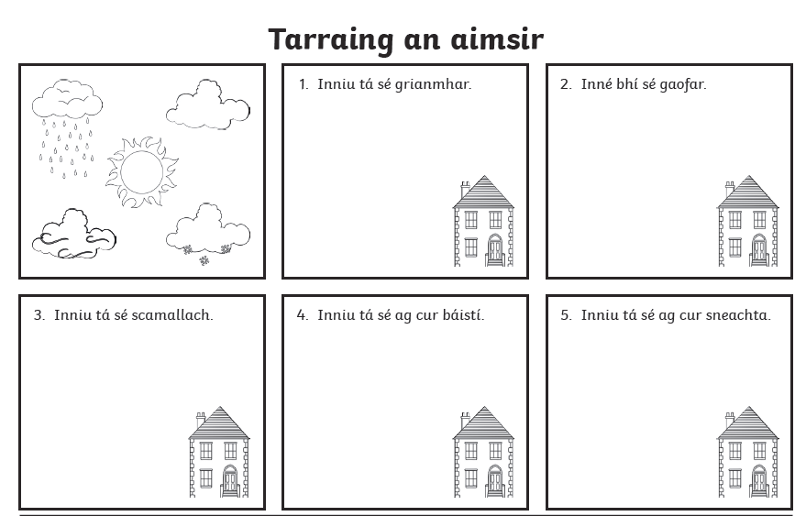

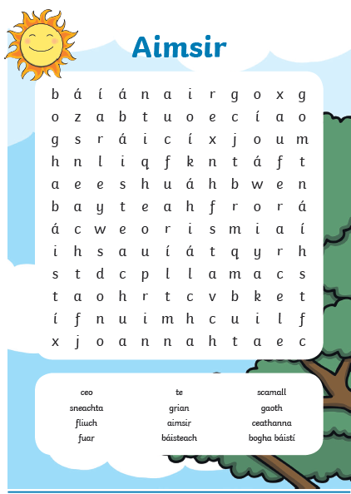

|  |
| --- |
| C:\Users\teacher3\AppData\Local\Microsoft\Windows\INetCache\Content.MSO\8AFC1D3A.tmp  Please remember to exercise. We love the following website in class.  <https://rtejr.rte.ie/10at10/>  There are loads of different episodes to choose from and all are only 10 minutes long. Keep exercising!! |
| C:\Users\teacher3\AppData\Local\Microsoft\Windows\INetCache\Content.MSO\F5B98958.tmp  If you have a plastic bottle with a lid, clean it out and fill it with rice or pasta or water and listen to the different sounds you can make. Send your teacher a recording of your music making on seesaw.  Enjoy !!!  Try to make an instrument with any of the objects below. Remember if you are using a scissor or tape to get help from an adult.  Help clipart, Help Transparent FREE for download on WebStockReview 2021    Free Winter Theme Cliparts, Download Free Clip Art, Free Clip Art on Clipart  Library  It’s winter time let’s draw a snowman. On a page start at picture number 1 and then keep going until picture number 6. Now you know how to draw a snowman. Send your teacher a picture when you have it completed. |
|  |
|  |