Home Learning January 11th – 15th 2021

**Hello Children and Parents,**

**We hope you are all keeping well and that you enjoyed your Christmas holidays! Unfortunately we cannot go back to school just yet but we have listed below some fun games and activities for you to do at home. We will also be posting some activities on SeeSaw. Please do not feel under pressure to complete every activity. We would love to see pictures/ videos of your work- please post them to the SeeSaw app if you would like to share them with us. If anybody has not joined SeeSaw or has lost their login code, please email us at** [kid@stphilipsjns.ie](mailto:kid@stphilipsjns.ie) **and we will get back to you as soon as possible!**

**Take care and stay safe,**

**Ms. Crimin, Mr. Conneely and Ms. O’Halloran**

**Phonics:**

* **Revision of sounds learned already: s, a, t, i, p, n, c, k, e, h, r, m and d.**

**Practise doing the actions for each sound and practise singing the songs.**

<https://www.youtube.com/watch?v=_s-1sxzjPX8>

**Go for a sound hunt around your house and see if you can find these letters (on books/ cereal boxes/ labels).**

* **Our new sound this week is the sound ‘g’ (sounds like ‘g’ as in ‘girl’). Can you think of some words that start with the sound ‘g’? e.g. girl, garden, goat, gloves.**

**Practise singing the Jolly Phonics song and learn the action.** <https://www.youtube.com/watch?v=wiI16fMPr1Q>

**Have a look around your house and see if you can find some things that start with the sound ‘g’.**

**Magic bag: Put a collection of items into a bag and sort them into two groups (things that start with ‘g’ and things that do not start with ‘g’)**

**Watch Geraldine the Giraffe ‘g’ and see what ‘g’ things she finds in her house!** <https://www.youtube.com/watch?v=P2DdC5Q6D64>

**Poetry:**

**This week we are learning the poem ‘Chubby Little Snowman’. Can you think of some actions to go with the poem? Draw a picture of a snowman- don’t forget to give your snowman a hat, scarf and gloves! Maybe you could use some cotton wool to make his body and head.**

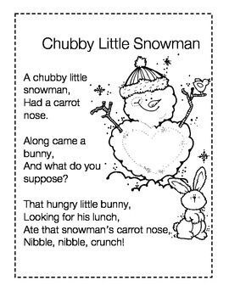

**Story:**

* **Listen to the stories ‘Mog the Forgetful Cat’ and ‘Mog on Fox Night’ by Judith Kerr.**

[**https://www.youtube.com/watch?v=Tr1ovFTpN7I**](https://www.youtube.com/watch?v=Tr1ovFTpN7I) **(Mog the Forgetful Cat)**

[**https://www.youtube.com/watch?v=ssC0VsEsles**](https://www.youtube.com/watch?v=ssC0VsEsles) **(Mog on Fox Night)**

* **Have a chat about the stories: Who was in the story? What do you think will happen next? What was your favourite part of the story? Which story did you like best? Who was your favourite character in the story?**
* **Draw a picture of your favourite part of the story.**
* **Make a reading den in your house- use chairs, sheets, blankets and cushions to create a cosy den for reading your favourite books! Ask a grown up or an older brother or sister to help you. Here are some ideas:**

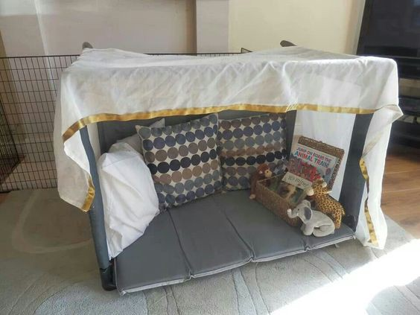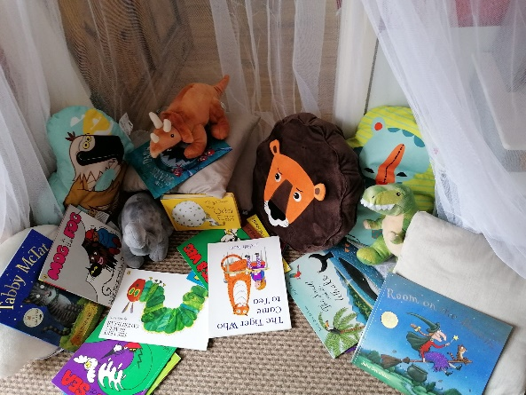

**Fine Motor Activities:**

* **Develop fine motor skills at home by playing with playdough/putty, popping bubble wrap and cutting using scissors. Boys and girls could even help out around the house and hang up socks with pegs (strengthens fingers)!**
* **Practise your cutting skills and make some cool hair for your character as in the picture below:**

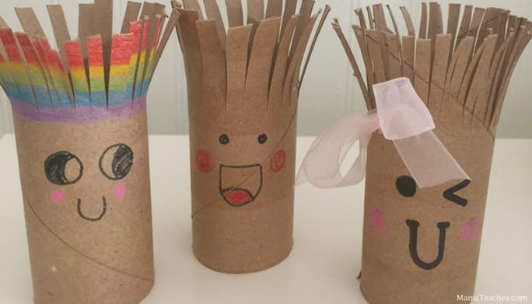

* **Develop fine motor skills by peeling and putting stickers onto paper like below:**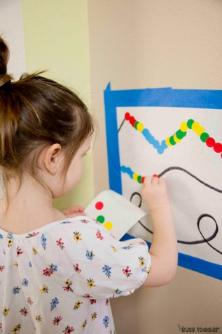

**Handwriting:**

* **This week we are practising using the tripod grip when we are writing.**

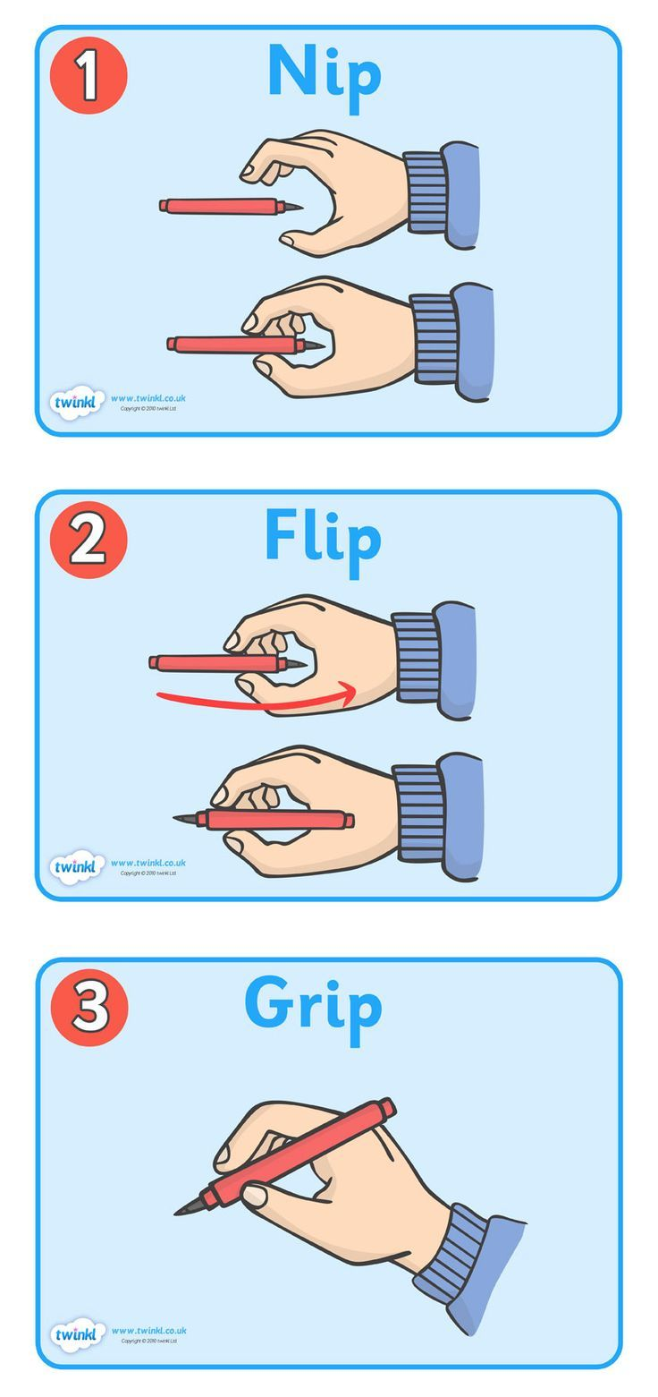

* **Here is a little warm up dance for your fingers before you start writing:** <https://www.youtube.com/watch?v=N6kPcQSSsEY>
* **Practise forming the letters ‘c’ and ‘o’. Remember to have your seat tucked in all the way and take your time!**

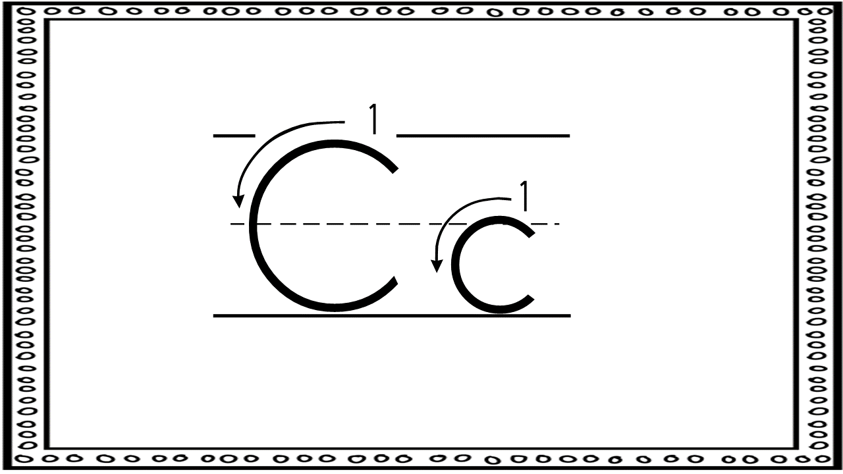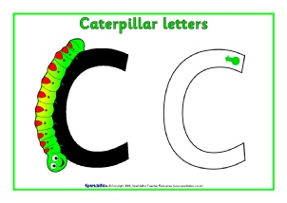

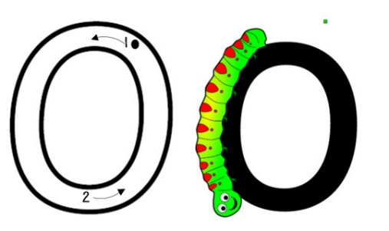

**Maths:**

* **Days of the Week:** Practise saying the days of the week at home and sing the song at home. What day is it today? What day will it be tomorrow? What day was it yesterday? <https://www.youtube.com/watch?v=mXMofxtDPUQ>
* **Months of the Year:** Learn the months of the year at home. What year is your birthday in? What month is it now? <https://www.youtube.com/watch?v=Fe9bnYRzFvk>
* **Counting:** Practise counting forwards 1- 20 at home and backwards from 10.
* **Magic counting bucket:** Get your child to close their eyes and drop some marbles (up to 5) slowly into a pot (counting bucket). Ask your child to tell you how many marbles you put in and allow them to check.
* **Online games:**

Here are a selection of some counting games to play at home.

<https://www.topmarks.co.uk/learning-to-count/teddy-numbers>

<https://www.topmarks.co.uk/learning-to-count/gingerbread-man-game>

<https://www.topmarks.co.uk/learning-to-count/underwater-counting>

* **Number of the week:**

This week we are learning all about the number three. Can you go for a number hunt around your house and find the number 3?

Here are some videos to help with the learning of number 3:

<https://www.youtube.com/watch?v=KkUWDvRS9gM> (Number of the Week 3)

<https://www.youtube.com/watch?v=GWVC3Nu3atw> (Charlie and the Number 3)

Draw a picture of sets of three e.g. draw three flowers/ cars/ hearts.

Make sets of 3 e.g. three forks, three teddies.

Numeral formation: Practise forming the numeral 3 using a pencil.

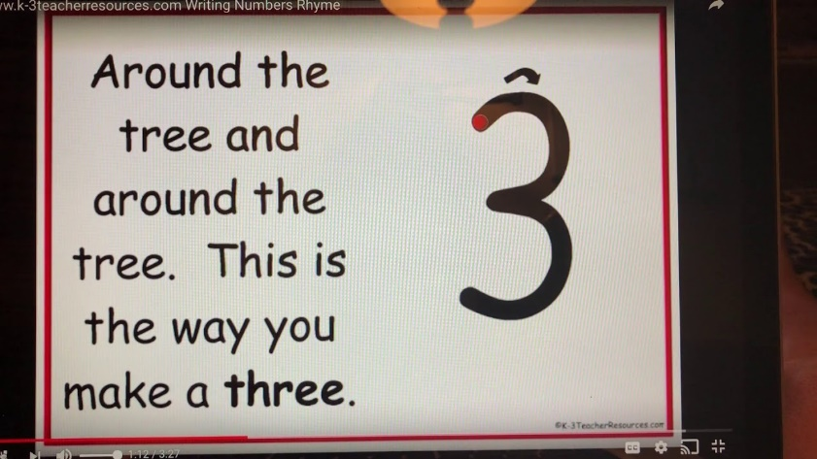

**Gaeilge**

* Look at programmes on TG4 and in particular, Cúla 4 online
* **BUA NA CAINTE**
* The Irish programme we use in school has become available online for home use.
* Go to [www.edco.ie/bua](http://www.edco.ie/bua)
* Select the PC folder for use on a laptop
* Choose Junior Infants and continue to Direct Download
* It may take a while to download and install
* Focus on An Aimsir (Ceacht 1- 4)

**P.E.:**

* PE with Joe Wicks- Watch live every day at 9am (lots of saved videos available too!) <https://www.youtube.com/watch?v=QvWzWqLk8iQ>
* 10@10 - daily 10minute exercise videos. <https://rtejr.rte.ie/10at10/>
* Cosmic yoga: Practise stretching and mindfulness using Cosmic Yoga.

<https://www.youtube.com/watch?v=K7FUbTac_ds&list=PL8snGkhBF7nhTxJt1M7d6A7mmD3kK6wE1>

**Art:**

* **Make some puffy paint:**

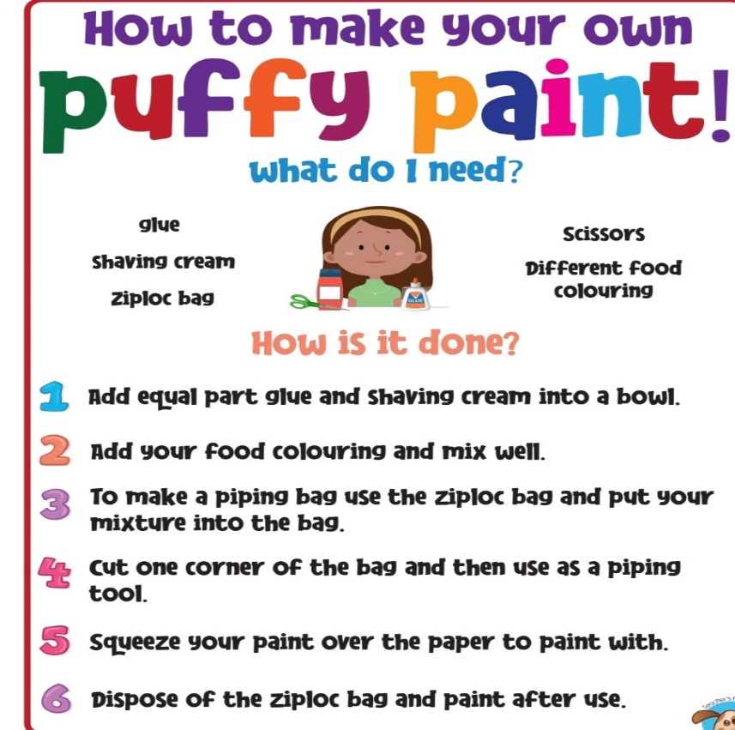

* Build a snowman using playdough or clay:

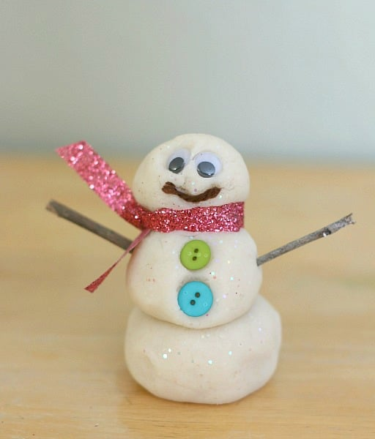 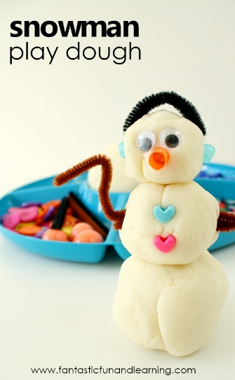

* Create a penguin using paint and a toilet roll tube:

