

|  |
| --- |
| Hi Everybody. This is our work for week 2.  JANURARY 18TH – 22ND  THEME: POLAR LANDS  C:\Users\teacher3\AppData\Local\Microsoft\Windows\INetCache\Content.MSO\5A37D1F2.tmp |

Remember to keep checking in on SeeSaw too. There is plenty of work to keep everybody busy and learning. If you have any questions, please send them to your teacher on SeeSaw. You can send a video or a note. You can also send an email to [kids@stphilipsjns.ie](mailto:kids@stphilipsjns.ie)

Pop your teachers name on the subject bar and we will get your message. Hope you enjoy reading and learning about the Polar regions.

**English**

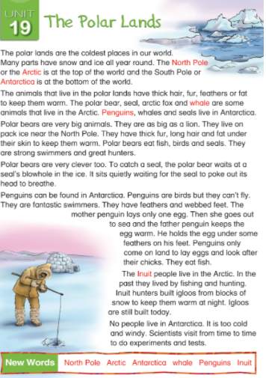

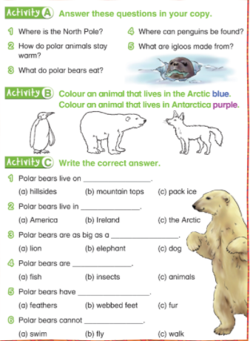

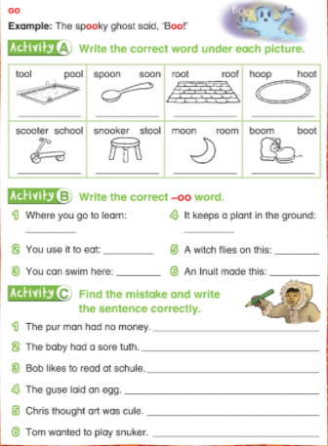

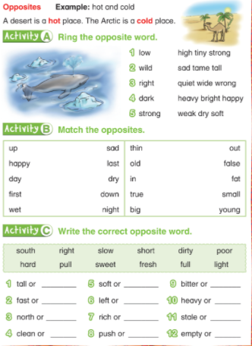

MATHS

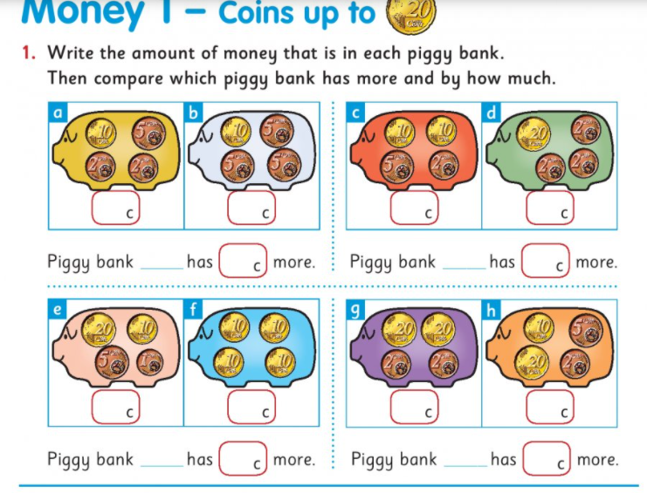

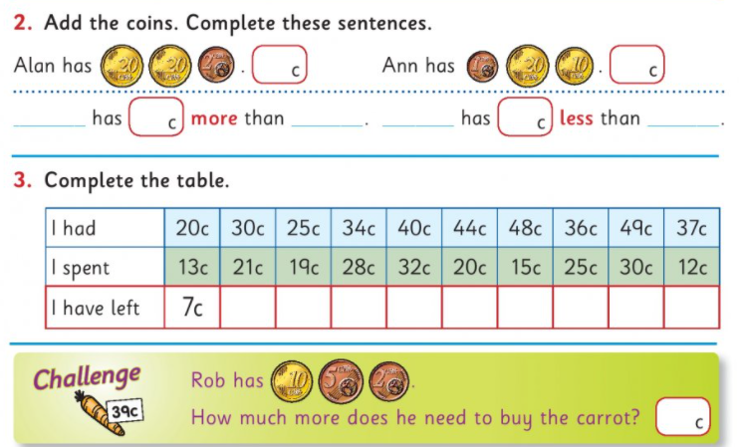

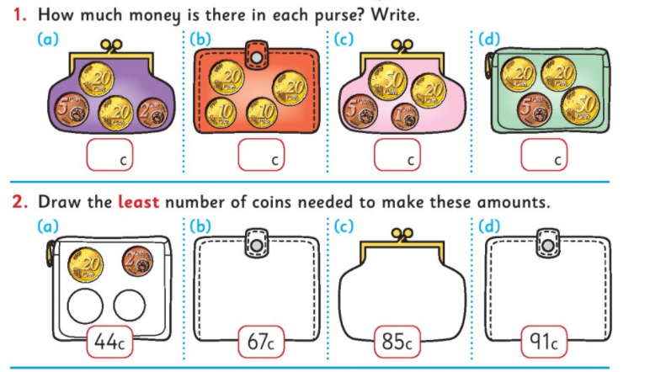

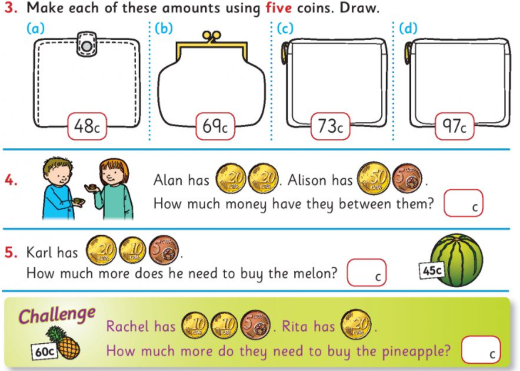

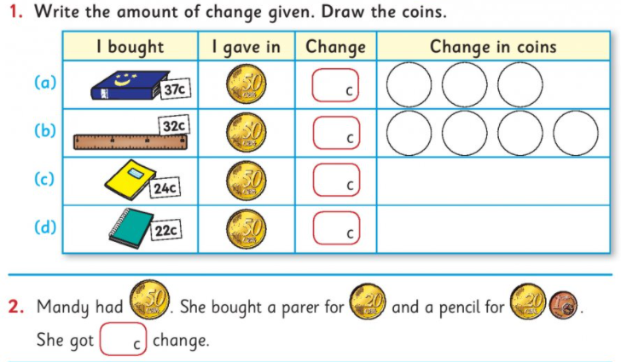

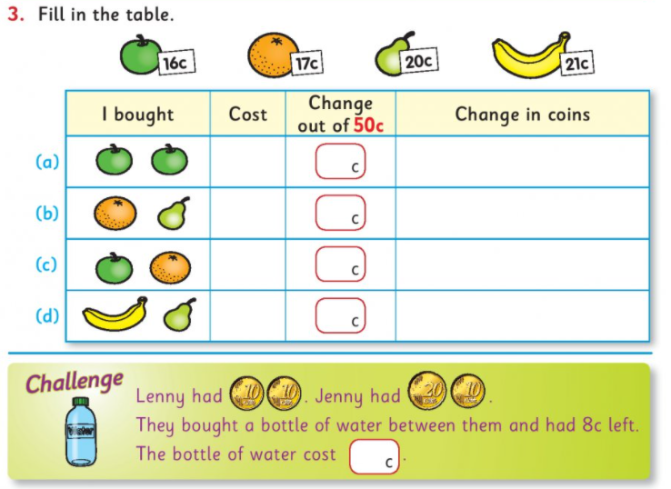

|  |
| --- |
| Money Actvities  <https://www.topmarks.co.uk/money/coins-game>  <https://www.topmarks.co.uk/money/toy-shop-money/eur>  Enjoy these games all about money! |

Continue with some addition and subtraction

Choose a method – number line or criss-cross

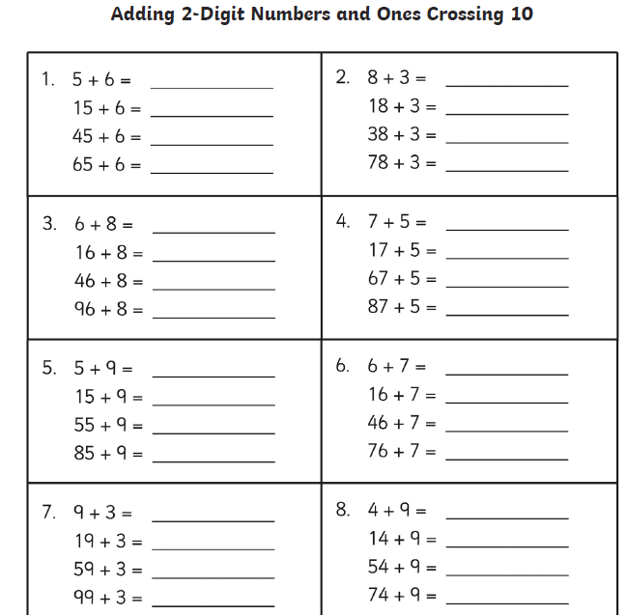

Gaeilge

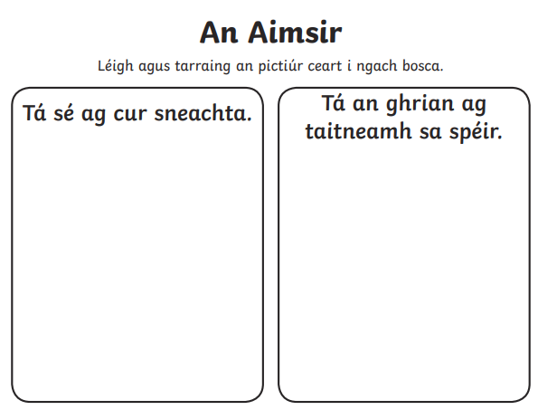

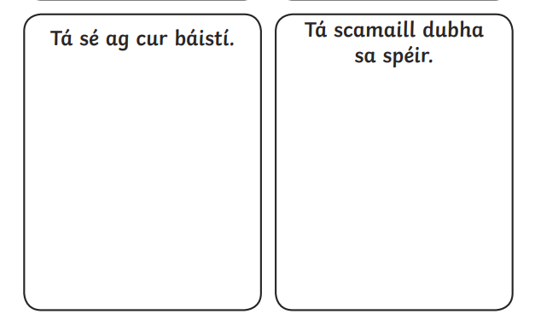

GEOGRAPHY & SCIENCE

Let’s read about some Polar animals

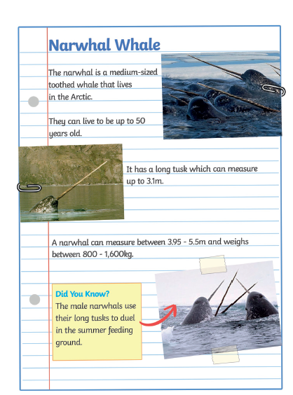

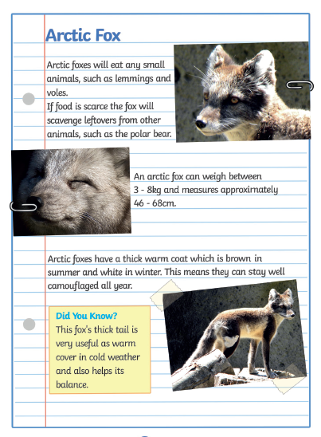

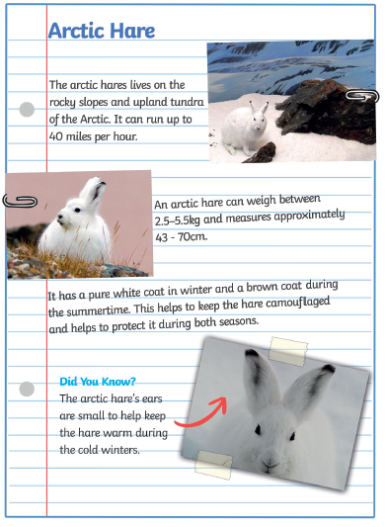

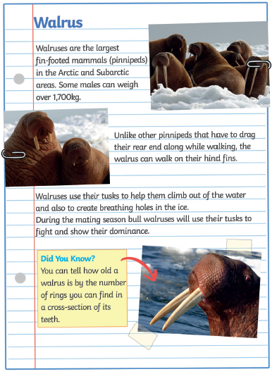

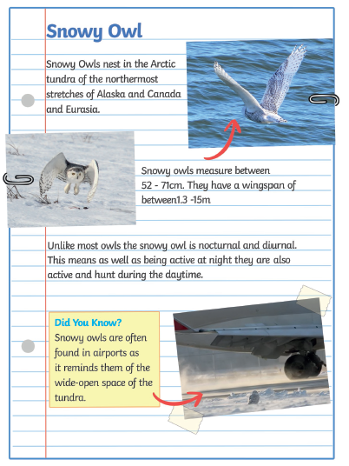

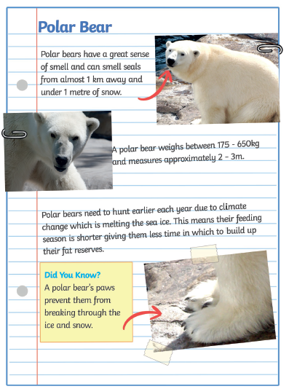

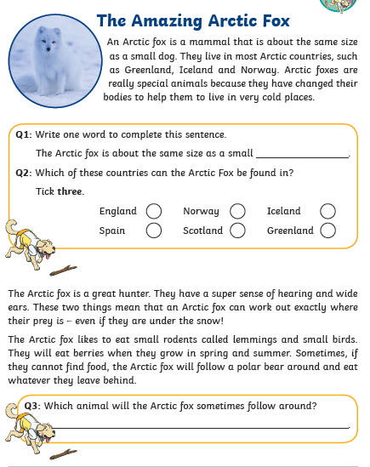

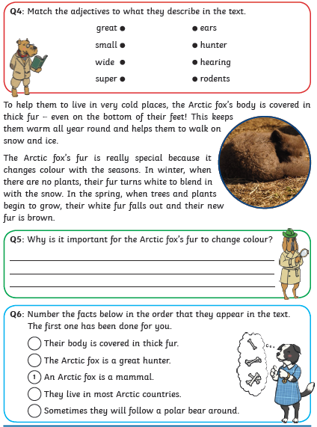

Now it’s your turn.

|  |
| --- |
| Write a few lines about your favourite polar animal |
| Draw a picture of your favourite polar animal |

|  |
| --- |
|  |
| C:\Users\teacher3\AppData\Local\Microsoft\Windows\INetCache\Content.MSO\2D1B3CA7.tmp  Polar Animal Art.  Step by step  Give it a go |
| C:\Users\teacher3\AppData\Local\Microsoft\Windows\INetCache\Content.MSO\8AFC1D3A.tmp  Please remember to exercise. We love the following website in class.  <https://rtejr.rte.ie/10at10/>  There are loads of different episodes to choose from and all are only 10 minutes long. Keep exercising!! |
| Have a look at some Polar Animals  <https://www.youtube.com/watch/DXxzjmCFwTI>  Next week we will be looking at Tom Crean – an explorer of the polar regions. |