|  |
| --- |
| Hi Everybody. This is our work for week 3.  JANURARY 25TH – 29th  THEME: POLAR LAND EXPLORER – TOM CREAN  C:\Users\teacher3\AppData\Local\Microsoft\Windows\INetCache\Content.MSO\2FEA252.tmp |



Remember to keep checking in on SeeSaw too. There is plenty of work to keep everybody busy and learning. If you have any questions, please send them to your teacher on SeeSaw. You can send a video or a note. You can also send an email to [kids@stphlipsjns.ie](mailto:kids@stphlipsjns.ie)

Pop your teachers name on the subject bar and we will get your message.

Hope you enjoyed reading and learning about the Polar regions and the different type of animals that live there. This week we will look at an explorer called Tom Crean who went on adventures to the Polar region.

ENGLISH

Here’s a story about a penguin. Do you remember we read about the polar animals last week.

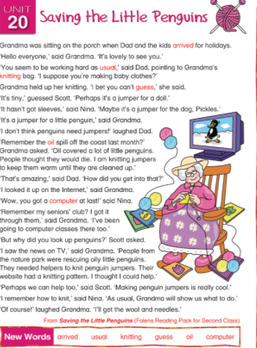

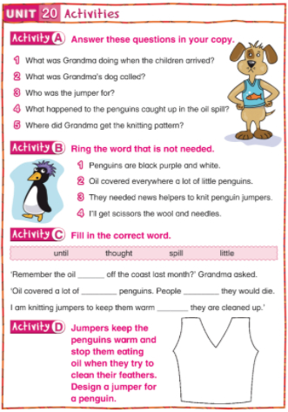

Remember to write you answers to Activity A . Write full sentences and remember to use capital letters and full stops.

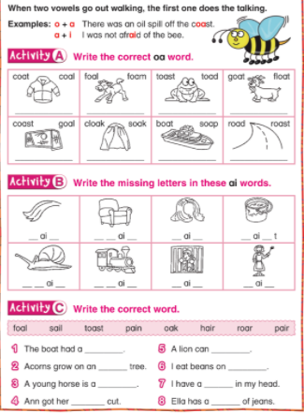

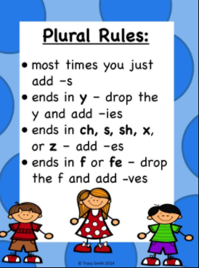

NOW IT’S YOUR TURN

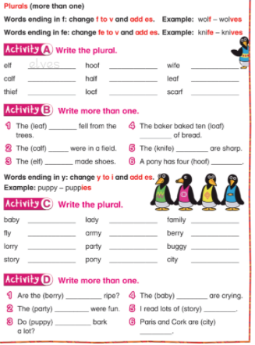

MATHS

LET’S PRACTICE SOME ADDITION

USE A STRATEGY THAT YOU KNOW

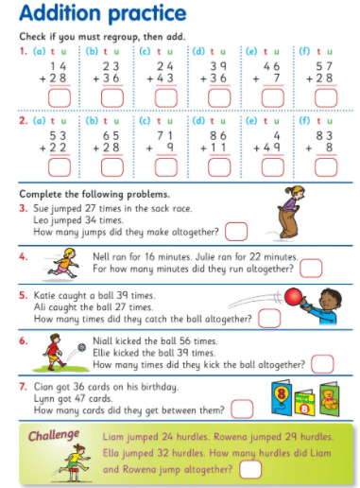

MONEY, MONEY, MONEY

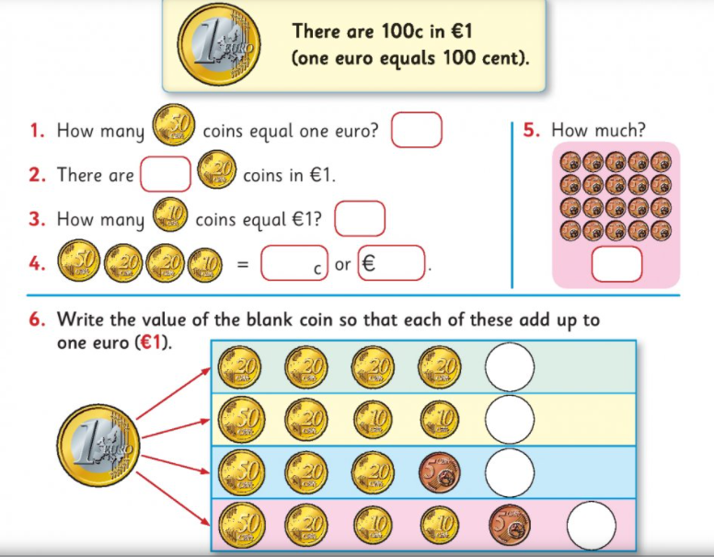  
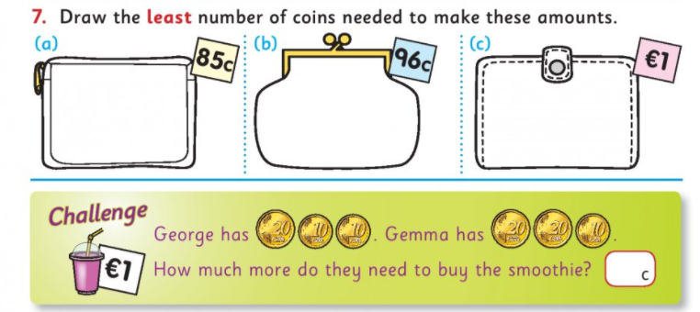

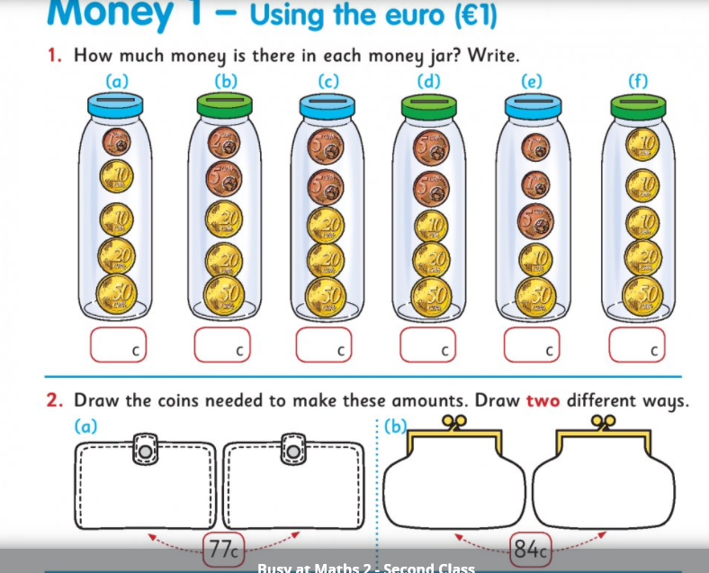

What coins can you use to make the following amounts ?

43c

28c

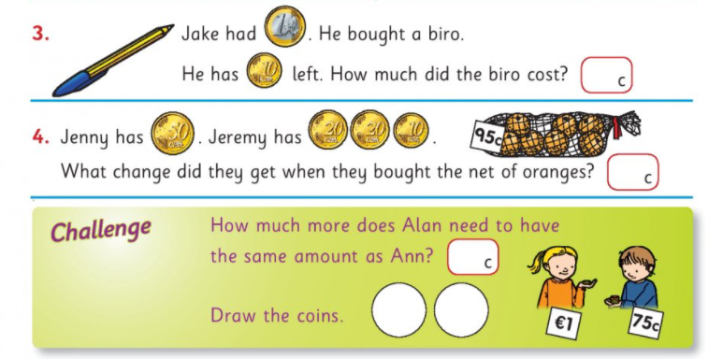

KEEP PRACTISING ADDING UP COINS.

REMEMBER TO LOOK AT

THE VALUE (NUMBER) ON THE COIN !

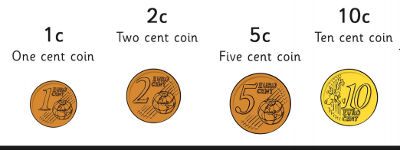

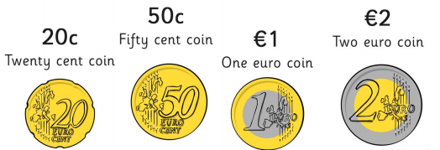

SOME MUSICAL ACTIVITIES

USE YOUR BODY TO MAKE AN ORCHESTRA

GET YOUR FAMILY TO HELP OUT.

You are going to use different parts of your body to make music and pretend to be an orchestra.

Start with the head - bounce hand up and down and say "BOING, BOING"

Then add one sound each time, keeping the same order beginning again each time from the start.

Push finger onto nose and say "Honk, Honk"

Pull one ear lobe then the other and say "Ding, Dong"

Clap hands and say "Clap, Clap"

Tap knees and say "Tap, Tap"

Stamp feet and say "Stamp, Stamp"

If you are standing up - you can wiggle your bottom and say "wiggle, wiggle"

Put them all together and you have your own orchestra!

For a bit of extra fun, do it backwards, starting with the bottom/feet - it's quite tricky!



**HISTORY, GEOGRAPHY & SCIENCE**



**Have you ever imagined what it would be like to go exploring somewhere you have never been before? What would you bring with you? How would you stay warm? What new things would you see?**

**Let’s read about such an explorer called TOM CREAN.**

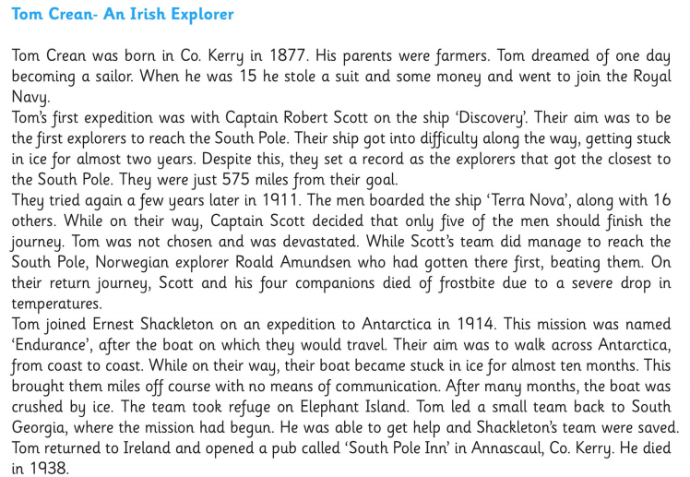

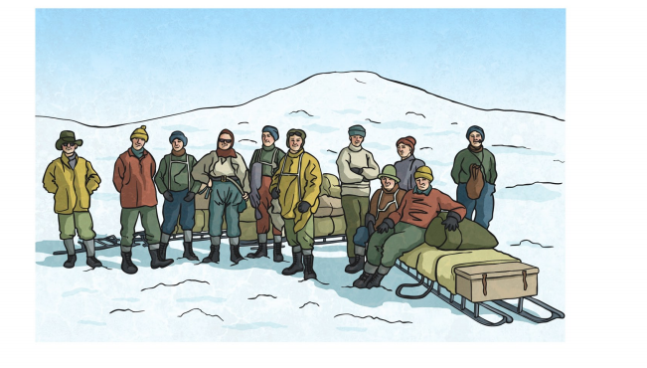

LET’S ANSWER SOME QUESTIONS

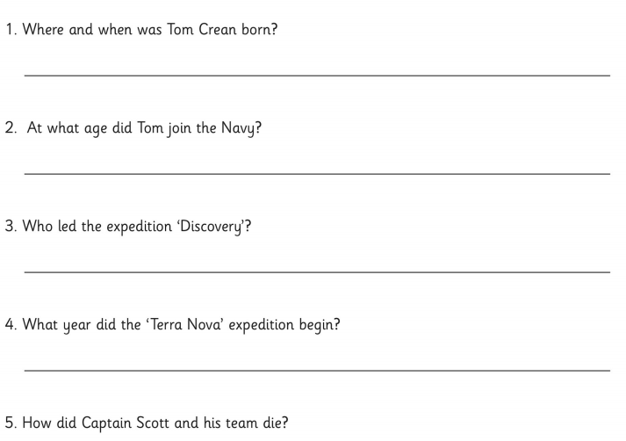

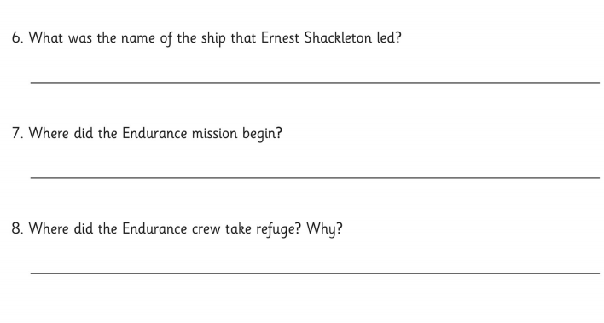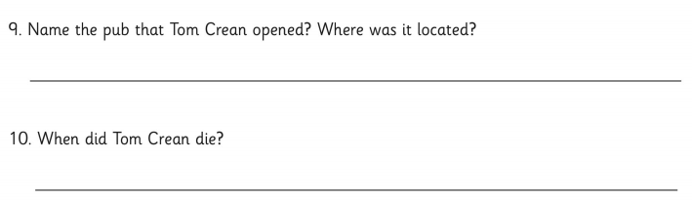

|  |
| --- |
| WORD BANK  EXPEDITION: A journey taken for a reason or purpose  BOARDED: To get on a boat, ship or plane  DEVESTATED: Very upset  COMPANIONS: Friends, people who go places with you  FROSTBITE: Injury to the body caused by extreme cold  MISSION: An important job or assignment given to a person or a group of people, usually involving travelling abroad. |

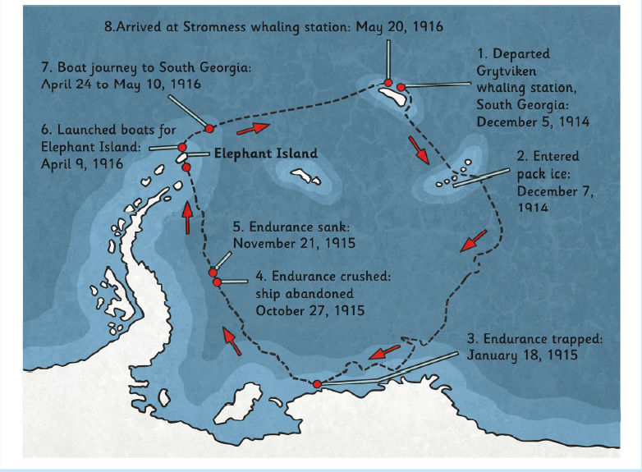

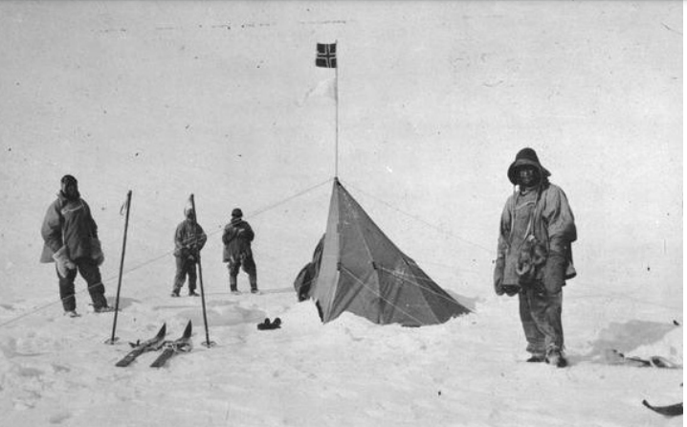

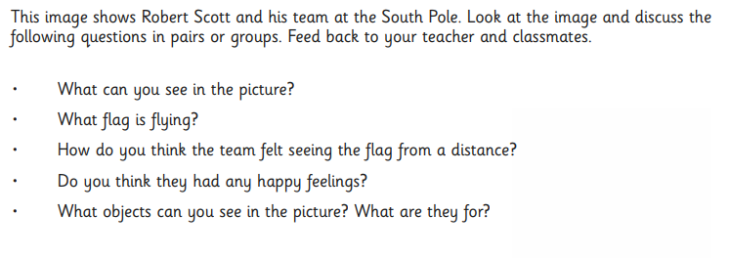

IF YOU LIKE YOU CAN USE THE RECORD TOOL ON SEESAW TO LET ME KNOW HOW YOU WOULD FEEL IF YOU WERE IN SUCH COLD WEATHER IN THE SOUTH POLE !! BRRRR!!

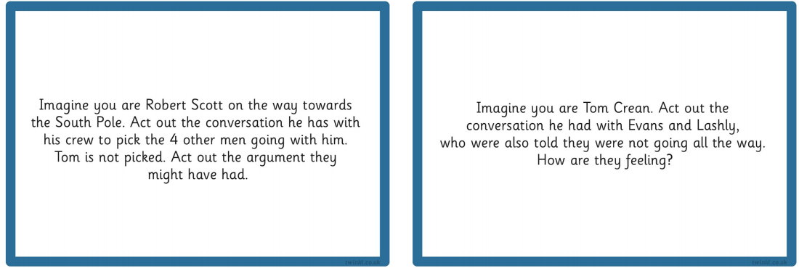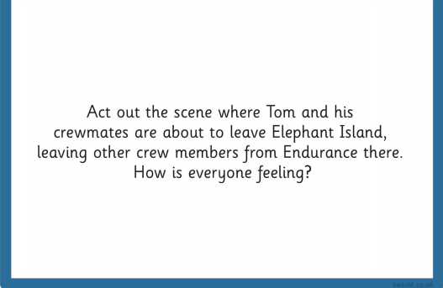

Get your family to act out a scene from the story and try to guess the scene !

Don’t forget about the weather

Ná déan dearmad faoin aimsir

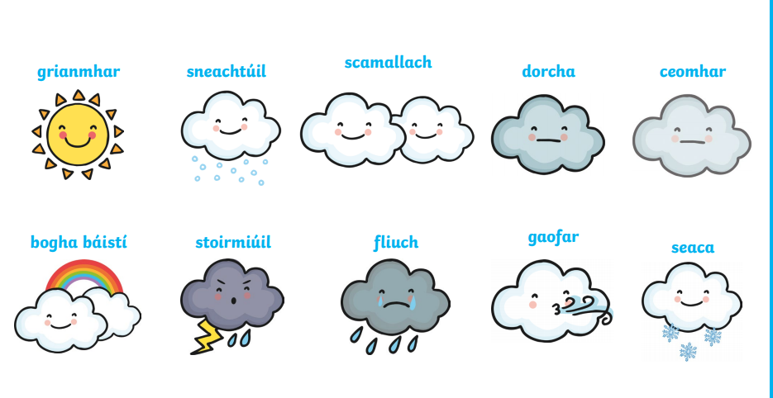

Tá sé grianmhar.

Tá sé ag sneachtúil.

Tá sé scamallach.

Tá sé dorcha.

|  |
| --- |
| C:\Users\teacher3\AppData\Local\Microsoft\Windows\INetCache\Content.MSO\8AFC1D3A.tmp  Please remember to exercise. We love the following website in class.  <https://rtejr.rte.ie/10at10/>  There are loads of different episodes to choose from and all are only 10 minutes long. Keep exercising!! |