Hello everybody and welcome to week 2 of Home Learning.

Thank you for all your responses last week, the children have been doing great work at home.

As we said, **please do not feel under pressure to complete every activity.**

**We love to see pictures/ videos of your children’s work- please post them to the SeeSaw app if you would like to share them with us. If anybody has not joined SeeSaw or has lost their login code, please email us at** [kid@stphilipsjns.ie](mailto:kid@stphilipsjns.ie) **and we will get back to you as soon as possible!**

**Take care and stay safe,**

**Ms. Crimin, Mr. Conneely and Ms. O’Halloran**

**Phonics:**

* **Revision of sounds learned already: s, a, t, i, p, n, c, k, e, h, r, m, d and g.**

**Practise doing the actions for each sound and practise singing the songs.**

<https://www.youtube.com/watch?v=_s-1sxzjPX8>

* **Our new sound this week is ‘o’.**

**Say the sound ‘o’.** **Listen to the song from Jolly Phonics** <https://youtu.be/wyzVsq9pgHs>

Look for some objects in your house that have the ‘o’ sound or think of someone you know that might have the ‘o’ sound in their name.

Go on a letter hunt and see if you can find the letter ‘o’ in your books or on a label.

Find all the light switches in your house and say ‘o’ when you turn them on or off.

Watch this video of Geraldine Giraffe learning the ‘o’ sound <https://youtu.be/YIQQo9eYVqk>

Complete the online activities for ‘o’ on <https://slp.cjfallon.ie/>. We use the Sounds like Phonics programme in school, so maybe you would like to revise the activities for the sounds you have learned already! Click on **Book A** to find the letters.

**Poetry:**

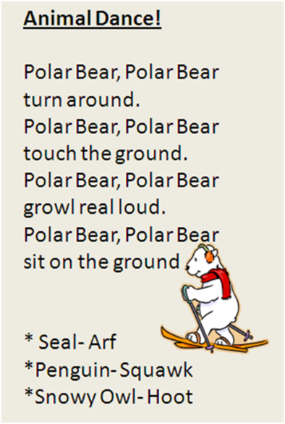**This week we are learning a rhyme about animals that live in snowy places! Can you say the rhyme and do the actions? Which animal is your favourite, the polar bear, seal, penguin, or snow owl? Which words rhyme or sound the same?**

**Story:**

* **Listen to the story Polar Bear Polar Bear What Do You Hear?** <https://www.youtube.com/watch?v=ehoGdGokXfc>**. Can you say the sounds that all the animals made? What is your favourite animal in the story? Listen to the story again and then see how many animals you can remember without looking at the pictures!**
* **Which animal started with a ‘h’?**

**Which animal started with a ‘p’?**

* **Where does a polar bear live? Where does a zebra live?**
* **This story has a boa constrictor in it… can you remember the song we learned about a boa constrictor?**
* **Listen to the story Harry the Dirty Dog** <https://www.storylineonline.net/books/harry-the-dirty-dog/>
* **If you have a dog, does he ever act like Harry? Does your dog like baths? What else does your dog like?**
* **Talk about the story… Why did Harry run away from home? How did he turn from a white dog into a black dog? What made Harry run back to his house? Why did his family not recognise him when they came back? What would you have done if Harry was your dog?**
* **Did you like the story? Why?**
* **There are lots of other fantastic stories to listen to on** Storylineonline.com

**Handwriting:**

* **This week we are practising using the tripod grip when we are writing.**

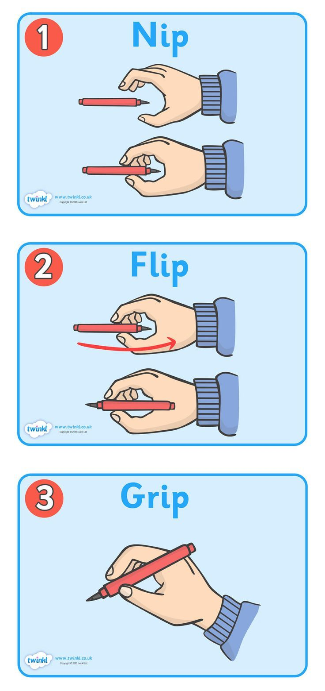

* **Here is a little warm up dance for your fingers before you start writing:** <https://www.youtube.com/watch?v=N6kPcQSSsEY>
* **Practise forming the letters ‘a’. It starts off like c, but keep your pencil on the page to go straight up, and straight back down.**

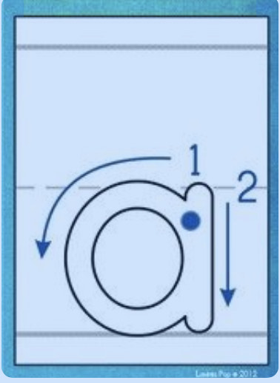

**Keep practicing writing ‘c’ and ‘o’ aswell. Practice makes perfect 😊**

* **Remember to have your seat tucked in all the way and take your time!**

**Maths:**

* **Days of the Week:** Practise saying the days of the week and sing the song at home. What day is it today? What day will it be tomorrow? What day was it yesterday? <https://www.youtube.com/watch?v=mXMofxtDPUQ>
* **Counting:** Keep practising counting 1-10 and 1-20.
* Can you start on number 2 and stop at 8?
* Can you start on 3 and stop at 11?
* Can you count from 1-10 in a whisper/roar/just miming?
* Can you count backwards from 5 down to 1, or 10 down to 1?
* Can you clap your hands/tap your head/stamp your foot as you say each number?
* Play **Beat the Teacher (**Mum, Dad, Granny or your big sister or brother could be new teacher). Pick a target number e.g. 9. Starting on one, take turns saying a number each until you reach no.9. The person who says 9 is the winner!
* Fingers: Can you show the numbers 1-10 using your fingers? I-5 is easy, 6-10 can be a bit tricky but keep practising!
* Listen to this song by the Singing Walrus <https://www.youtube.com/watch?v=DR-cfDsHCGA>
* **Numerals:** If you have some cardboard, make the numerals 1-5, or 1-10.

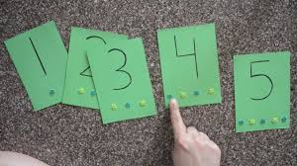

* Can you put them into the correct order?
* Can you draw the correct number dots/hearts/rainbows for each card?
* **Missing Number** Put your cards in the correct order, close your eye and ask Mum or Dad to take away one number. Open your eyes and tell them which number is missing! If you want to make it harder, play **Close the Gap:** After removing one number, push the others together to “Close the gap” so that it’s not obvious which one is missing!

Can you make a set to match each number? You can use anything you can find in your house e.g 1 apple, 2 dolls, 3 pieces of lego, 4 blocks, 5 crayons etc.

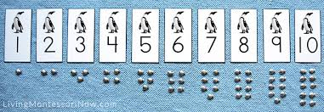

* **2D Shape:**
* Go on a shape hunt in your house and try to find a square, circle, triangle and rectangle.
* Can you say the names of those shapes?
* What shape is a cereal box? Your bed? A doughnut?
* How many sides does each shape have?
* What shape has 3 sides? Can you practise writing number 3 as you did last week?

Here is another favourite from the Singing Walrus, sing along 😊 <https://www.youtube.com/watch?v=OEbRDtCAFdU>

**Fine motor skills:** If you can find some 2D shapes in your house, put them on paper and trace around them to draw their shapes, then cut them out.

**Gaeilge**

* Look at programmes on TG4 and in particular, Cúla 4 online
* **BUA NA CAINTE**
* The Irish programme we use in school has become available online for home use.
* Go to [www.edco.ie/bua](http://www.edco.ie/bua)
* Select the PC folder for use on a laptop
* Choose Junior Infants and continue to Direct Download
* It may take a while to download and install
* Focus on An Aimsir (Ceacht 5-8)

**P.E:**

<https://learning.fingal.ie/course/view.php?id=137>

On this website, you will find lots of activities and videos to get moving and practice some sports skills, suitable for all ages.

Follow Buddy the dog and keep active with him while listening to a story here: <http://www.claresports.ie/get-active/get-active-primary-schools/>

Keep up your ballet skills here:

<https://www.youtube.com/watch?v=6ZYpu4pHEkY>

**Art:**

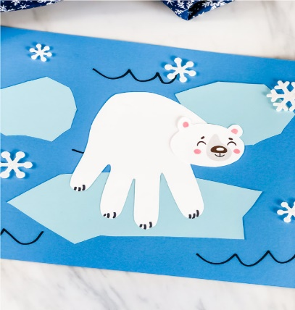

* **T**ry this polar bear art using your handprint. Cut out some icebergs and snowflakes to decorate your page.
* Rockets: Design your own rocket using a toilet roll and some colours and card. For the top of your rocket, cut out a circle and then curl it into a cone shape. You will need glue to stick it on.

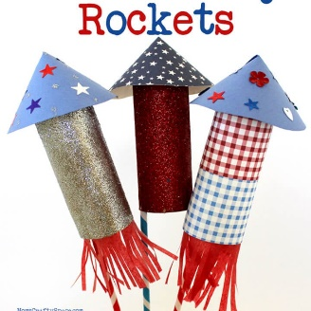

* Eye mask: If you are doing some meditation or taking time to relax during the day, you can make a simple eye mask to help you keep your eyes closed!

All you need is:

* a sock
* rice
* lavander or any smell you like. (optional)

Just fill the sock ¾ full with the rice. Add a couple of drops of lavender oil.

Then tie the open end in a knot or with an elastic band, and pop it over your eyes as you like back and take some nice deep breaths 😊