Welcome everyone to week 3 of our home learning!

25th – 29th of January 2021

We would just like to say a big thank you and well done to all the parents and children who have been working hard at home and engaging with activities provided. We’ve loved seeing videos, pictures, photos, voice notes from the children and we hope you are all doing well at this difficult time.

As we said, please **do not feel under pressure** to complete every activity.

As mentioned, we love to see pictures/ videos of your children’s work- please post them to the SeeSaw app if you would like to share them with us. If you have any questions regarding SeeSaw or difficulty logging in please do not hesitate to email [kid@stphilipsjns.ie](mailto:kid@stphilipsjns.ie) and we will get back to you as soon as possible!

Take care and stay safe,

*Ms. Crimin, Mr. Conneely and Ms. O’Halloran*

**Phonics:**

* Revision of sounds learned already: s, a, t, i, p, n, c, k, e, h, r, m, d, g and o. Daily practice of these letters is really important as the children are missing out on the morning letter checks they would usually have with their teacher. Unfortunately, if the sounds aren’t practiced everyday your child will lose them.

Practise doing the actions for each sound and practise singing the songs.

<https://www.youtube.com/watch?v=_s-1sxzjPX8>

* Our new sound this week is **‘u’.**

Say the ‘u’ sound, listen to the story and find the ‘u’ sound in the story/picture. <https://www.youtube.com/watch?v=BRyhBeUdeZU>

Say the sound ‘u’. Listen to the song from Jolly Phonics <https://www.youtube.com/watch?v=cUbrQ_Kfux8>

* Can you think of any words that start with ‘u’? Can you think of anything you could draw starting with ‘u’? Try list out as many words starting with ‘u’ as you can!
* Go on a letter hunt and see if you can find the letter ‘u’ in your books or on a label.
* Can you make some words with ‘u’ in them? Using the sounds you’ve learned try making some words with ‘u’ in it. E.g. cup, nut, pup, etc.
* Watch this video of Geraldine Giraffe learning the ‘u’ sound <https://www.youtube.com/watch?v=kmmewEew6lM>
* Complete the online activities for ‘u’ on <https://slp.cjfallon.ie/>. We use the Sounds like Phonics programme in school, so maybe you would like to revise the activities for the sounds you have learned already! Click on **Book A** to find the letters.

**Poetry:**

Because it’s still Winter, grey and gloomy we are going to learn a poem/rhyme about the rain.

"I put on my coat  
And boots on the feet.  
I put on my hat  
And stroll down the street.  
  
The rain falls down  
From the clouds above  
Splashing in puddles.  
Is what I love! "

Can you draw a picture of you in your coat and wellies/boots splish splashing about in the rain and puddles. Make sure to send your picture to your teacher on SeeSaw or by email, [kids@stphilipsjns.ie](mailto:kids@stphilipsjns.ie)

**Story:**

* Listen to the story **The Rainy Day** <https://www.youtube.com/watch?v=av2FP2n2qrg>   
  Can you remember what clouds are made of? What do the animals do when it starts to rain? What colourful thing sometimes comes out when it rains? Can you name the colours in the rainbow?
* We are learning about the ‘u’ sound this week, what could we use to protect us from the rain starting with ‘u’?
* Do you like to jump in puddles?
* What animals like when it rains in the story? Can you think of anymore animals that might like the rain?
* What happens to the ground when it rains a lot?
* Listen to the story **No More Noisy Nights** <https://www.storylineonline.net/books/no-more-noisy-nights/>
* Talk about the story… Why could Jackson not sleep? The first night Jackson was so tied when he got up what did he put on his cereal and toast? Who kept Jackson awake the second night? What activities did Jackson give all the people who kept him awake?
* Did you like the story? Why?
* There are lots of other fantastic stories to listen to on Storylineonline.com

**Handwriting:**

* This week we are practising using the tripod grip when we are writing.
* Watch this video and practice picking up your pencil and writing. <https://www.youtube.com/watch?v=RclxBdiuvOM>   
    
  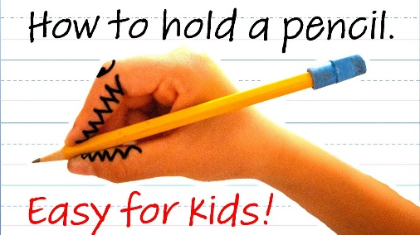
* Revise practicing the letters c, o and a. If you have practiced these loads and you’re really good you can move on to practicing writing the letter d. It starts like a “c, o and a” but you go the whole way up to the top and back down to make a “d”.

* Remember to sit up properly, have your other hand on the table and hold your pencil properly.

**Maths:**

* **Days of the week:** It’s very important to check in with children every day and ask them what day of the week it is. Your child might know the days of the week but can they sequence them properly?
* **Counting:** Keep practising counting 1-10 and 1-20.
* Practice counting from a random number onwards, maybe start on the number 6, or 11.
* Can you say the number that comes next? This is a two-person game. One person says a number between 1-20 and the other person has to say what number comes next! E.g. what comes after 3? 5? 14? 17? Etc.
* Why don’t you dance while you count! Watch this video, count along with it and dance too! <https://www.youtube.com/watch?v=_MVzXKfr6e8>
* Play **Beat the Teacher (**Mum, Dad, Granny or your big sister or brother could be new teacher). Pick a target number e.g. 9. Starting on one, take turns saying a number each until you reach no.9. The person who says 9 is the winner!
* Fingers: Can you show the numbers 1-10 using your fingers? I-5 is easy, 6-10 can be a bit tricky but keep practising!
* Listen to this counting song;   
  [**https://www.youtube.com/watch?v=D0Ajq682yrA**](https://www.youtube.com/watch?v=D0Ajq682yrA)
* **Numerals:** This week we are going to learn all about the number 4

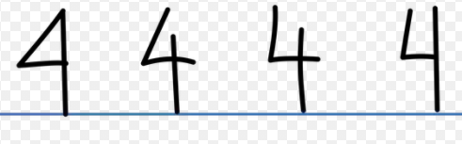

* The number four is written in many ways but the way that is circled is the way we learn in school and is the easiest way for children to write it. Children can be shown that it comes in different ways but when we are writing it that this is how we write it.
* Listen to the song and count along! <https://www.youtube.com/watch?v=-4djlIJR8R4>
* Can you go on a number hunt looking for the number 4? Where can you see the number 4 in your home or garden?
* Make a set of items in the numebr 4. A set of four cherries, a set of four shoes, a set of four candles, etc.
* How many different ways can you show the number four on your hands?
* Can you draw a set of four items? Draw four umbrellas, four giraffes, four hearts.
* Here are two more great videos on the number 4:

<https://www.youtube.com/watch?v=UfCj_dvNuPI>   
<https://www.youtube.com/watch?v=HzlfPXwy1YY>

* **Patterns**
* We were learning all about patterns in school, sometimes it’s a pattern by colour, but sometimes it’s by shape or size.
* Can you spot any patterns at home? Maybe in the tiles in the kitchen or bathroom.
* Can you make a pattern with things at home? Maybe fork, spoon, fork, spoon, fork, spoon.
* Or maybe you could make a pattern with only spoons based on size. E.g. Big spoon, Big spoon, small spoon, big spoon, big spoon, small spoon.

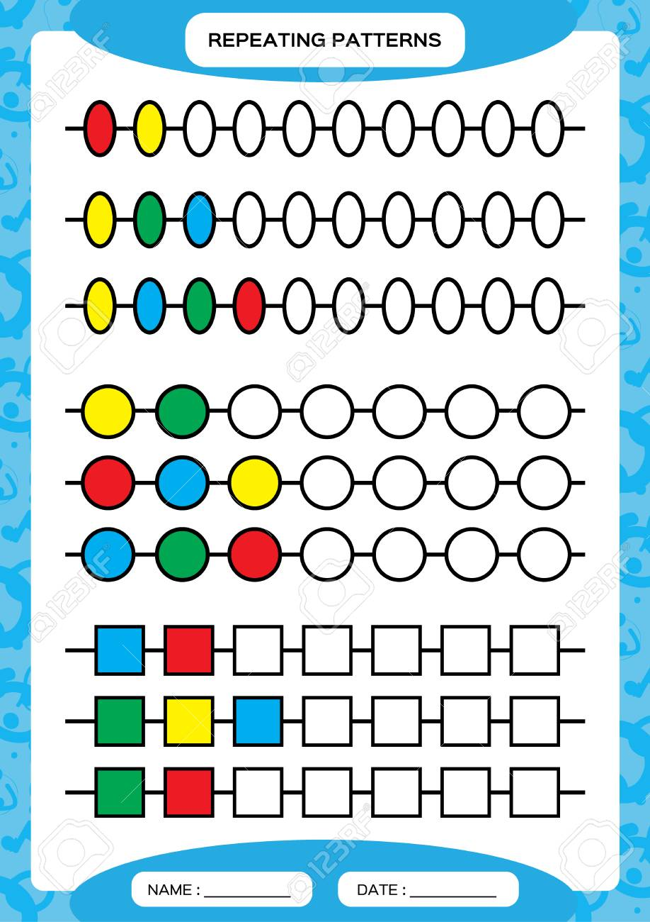

**Gaeilge**

* Look at programmes on TG4 and in particular, Cúla 4 online
* **BUA NA CAINTE**
* The Irish programme we use in school has become available online for home use.
* Go to [www.edco.ie/bua](http://www.edco.ie/bua)
* Select the PC folder for use on a laptop
* Choose Junior Infants and continue to Direct Download
* It may take a while to download and install
* Revise on Caitheamh Aimsire

**P.E:**

Why not practice yoga – the boys and girls in junior infants love this! All you need is some space to lie down on the ground and maybe a nice rug.   
<https://www.youtube.com/user/CosmicKidsYoga>   
Pick a yoga lesson your child would like to complete. Some are as short as five minutes and some are longer.

Here is a kids friendly Zumba dance!

https://www.youtube.com/watch?v=ymigWt5TOV8

**Art:**

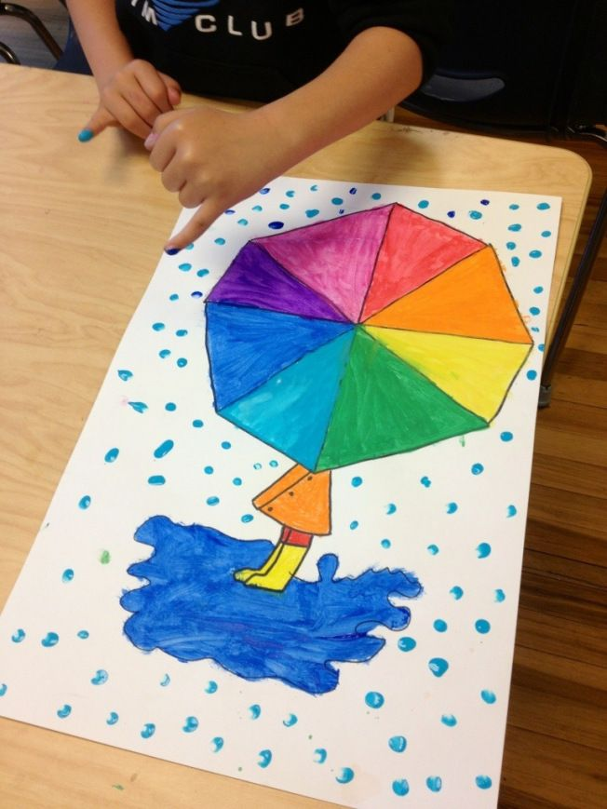

* **Rain art:** We have been learning the ‘u’ sound for umbrella and we have been learning a rain poem too! So why not draw and colour an umbrella picture.
* Colour or paint the umbrella the colours of the rainbow and then use your fingers to make the raindrop and puddles on the ground.
* Umbrellas: Use bun cases and pipe cleaners to make your own u… u…. umbrellas! If you don’t have pipe cleaners, you could use lollipop sticks or even match sticks.

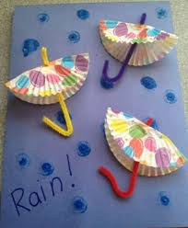

**Pattern:**If you want to make your own patterns but don’t have cubes or counters at home why don’t you make your own. All you need is pasta, paint and some sandwich bags.

* Fill a small sandwich bag with a handful of Pasta and a squeeze of any paint colour you want. Then open bag, or pour out on newspaper to dry.
* Repeat step one but with different paint colour.
* Depending on how many paint colours you use when your pasta is dry you can practice creating patterns, breaking patterns, or making a pattern and closing your eyes and someone changes it and you have to spot what! It’s lots of fun and a great maths skill for your child to practice.

