**Prayer for Forgiveness**

O my God, help me to remember the times when I didn't live as Jesus asked me to.

Help me to be sorry and to try again.

Amen.

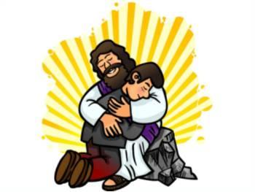

**Prayer after Forgiveness**

O my God, thank you for forgiving me.

Help me to love others.

Help to live as Jesus asked me to.

Amen

**The Confiteor**



I confess to almighty God. And to you, my brothers and sisters,  
That I have sinned through my own fault,  
In my thoughts and in my words,  
In what I have done  
And in what I have failed to do;  
And I ask blessed Mary, ever virgin,  
All the angels and saints,  
And you my brothers and sisters  
To pray for me to the Lord our God.  
Amen