Welcome everyone to week 4 of our home learning!

1st Feb – 5th Feb 2021

Dear parents and children,

We hope you and your families are keeping well in these difficult times. Well done on all of your efforts the past few weeks. We have really loved seeing all of the work that you’ve done at home. Keep up the good work! Our theme this week for home learning is food/ the restaurant. As we have mentioned before, please **do not feel under pressure** to complete every activity. The wellbeing of your child is more important now than ever before. Feel free to share any of your children’s work on the Seesaw app- we love to see what you’ve been learning about at home! If you have any questions regarding SeeSaw or difficulty logging in please do not hesitate to email [kid@stphilipsjns.ie](mailto:kid@stphilipsjns.ie) and we will get back to you as soon as possible!

Take care and stay safe,

*Ms. Crimin, Mr. Conneely and Ms. O’Halloran*

**Phonics:**

* Revision of sounds learned already: s, a, t, i, p, n, c, k, e, h, r, m, d, g, o and u. Daily practice of these letters is really important as the children are missing out on the morning letter checks they would usually have with their teacher.
* Sound hunt: Write each sound on a piece of card and hide around your house. Child searches for sound cards and says each sound as he/ she collects them.
* Practise doing the actions for each sound and practise singing the songs.

<https://www.youtube.com/watch?v=_s-1sxzjPX8>

* Game: What sound is it Mr. Wolf?

Adult pretends to be Mr. Wolf and stands at a distance from the child. Child says ‘What sound is it Mr. Wolf?’ Mr. Wolf shows the child a sound e.g. a. The child thinks of as many words starting with that letter/ sound as they can e.g. apple, ambulance, ant. Child may hop forward for each word that they think of. Repeat then using another letter/ sound. When child reaches Mr. Wolf they win!

* Our new sound this week is **‘l’.**

Say the sound ‘l’. Listen to the song from Jolly Phonics.

<https://www.youtube.com/watch?v=O4-Rt2sqyrU>

* Can you think of any words that start with ‘l’? Can you think of anything you could draw starting with ‘l’? Try list out as many words starting with ‘l’ as you can!
* Go on a letter hunt and see if you can find the letter ‘l’ in your books or on a label.
* Watch this video of Geraldine Giraffe learning the ‘l’ sound
* Complete the online activities for ‘l’ on <https://slp.cjfallon.ie/>. We use the Sounds like Phonics programme in school, so maybe you would like to revise the activities for the sounds you have learned already! Click on **Book A** to find the letters.

**Poetry:**

Pizza on the table,

Pizza on the chair,

Pizza on the ceiling,

Pizza in my hair.

Pizza on my fingers,

Pizza on my toes,

Pizza on my chinny chin,

Pizza on my nose.

Pizza on the table,

Pizza on the chair,

Pizza on the ceiling,

Pizza everywhere!

Can you think of some actions to do with this poem? We’d love to hear you saying the poem on Seesaw! Draw a picture to go with the poem. What is your favourite part of the poem?

**Story:**

* Listen to the story **Handa’s Surprise** <https://www.youtube.com/watch?v=ocnRQi89nK8>
* What do you think will happen in this story? What do you think the surprise will be? What animals did you see in the story? What fruit did Handa collect? Did you like this story? What was your favourite part of the story?
* Draw a picture of your favourite part of the story.
* Listen to the story **Oliver’s Vegetables** [**https://www.youtube.com/watch?v=I94vTFr4LQs**](https://www.youtube.com/watch?v=I94vTFr4LQs)
* Chat about the story… What was your favourite part of the story? What did Oliver only like to eat at the start? What are chips made from? Why were the potatoes hiding? Do you like vegetables? Which vegetable is your favourite? Why is it important to eat vegetables?
* Draw a picture of your favourite part of the story. Send your picture to your teacher on Seesaw or [kids@stphilipsjns.ie](mailto:kids@stphilipsjns.ie)

**Handwriting:**

* This week we are practising using the tripod grip when we are writing.
* Watch this video and practice picking up your pencil and writing. <https://www.youtube.com/watch?v=RclxBdiuvOM>   
    
  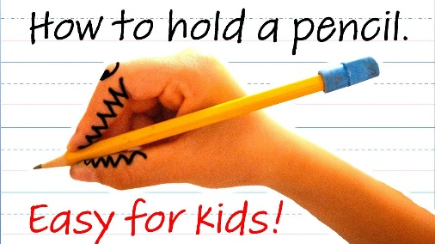
* Revise practicing the letters c, o, a and d (lower case). This should be practised for a few minutes every day to develop child’s handwriting and pencil grip. Please encourage correct formation of letters.

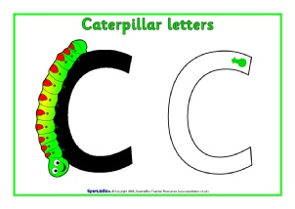 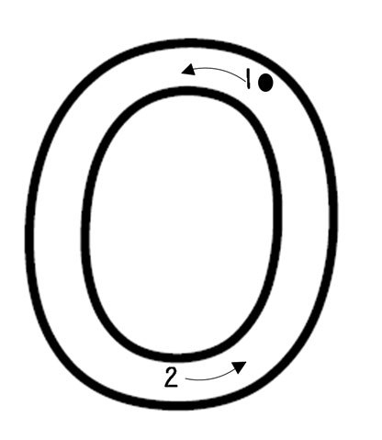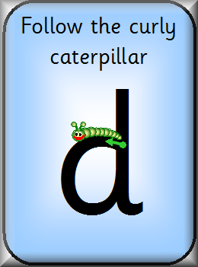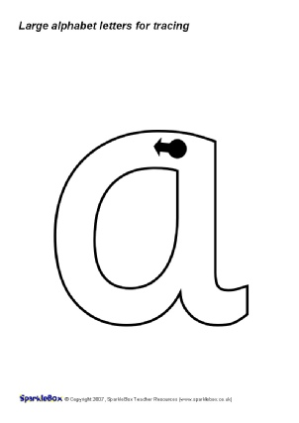

* This week we are learning how to write the letter ‘g’.

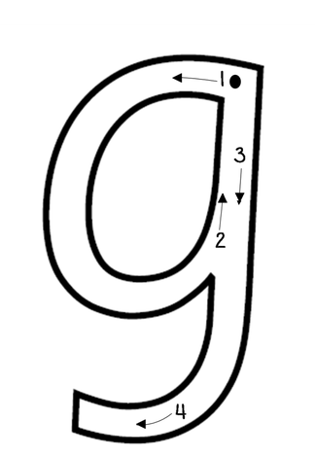

* Remember to sit up properly, have your other hand on the book/ paper and hold your pencil properly.

**Maths:**

* **Days of the week:** It’s very important to check in with children every day and ask them what day of the week it is. What day is it today? What day was it yesterday? What day will it be tomorrow? What days are at the weekend?
* **Months of the year:** Here is a video to help with learning of the months of the year. <https://www.youtube.com/watch?v=Fe9bnYRzFvk> Sing along with the video and have a chat about the months. What month is your birthday in? What month is it now? What month will it be next?
* **Counting:** Keep practising counting 1- 20 and backwards from 15- 0.
* Practice counting from a random number onwards, maybe start on the number 6, or 11.
* Can you say the number that comes next? This is a two-person game. One person says a number between 1-20 and the other person has to say what number comes next! E.g. what comes after 3? 5? 14? 17? Etc.
* **Grandma’s in the Kitchen:** Pick a number between 1 and 20 as your magic number and write it on a piece of paper. Child and adult then say the rhyme: *Grandma’s in the kitchen, doing a bit of knitting, how many stitches does she make?* Then child and adult count to and fro until they get to the magic number. E.g. child says 1, adult says 2, child says 3 etc. Person who says the magic number is the winner!
* **Teddy Bear Hide and Seek:** For this game you need a bowl/ box and up to 4 small toys/ teddies. Lay all 4 toys on the table. Child closes eyes and adult hides some of the toys under the box/ bowl. Child must guess how many toys are hiding. Take turns hiding the toys.
* Fingers: Can you show the numbers 1-10 using your fingers? I-5 is easy, 6-10 can be a bit tricky but keep practising!
* Listen to these counting songs:  
  <https://www.youtube.com/watch?v=Aq4UAss33qA>

[**https://www.youtube.com/watch?v=EbgwPx6mYu4**](https://www.youtube.com/watch?v=EbgwPx6mYu4)

* **Numeral formation:** Continuous revision of numeral formation is important. Please practise writing the numerals 1- 3 at home.

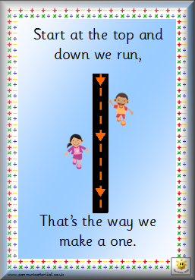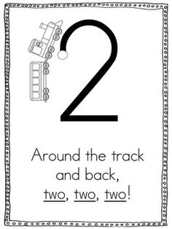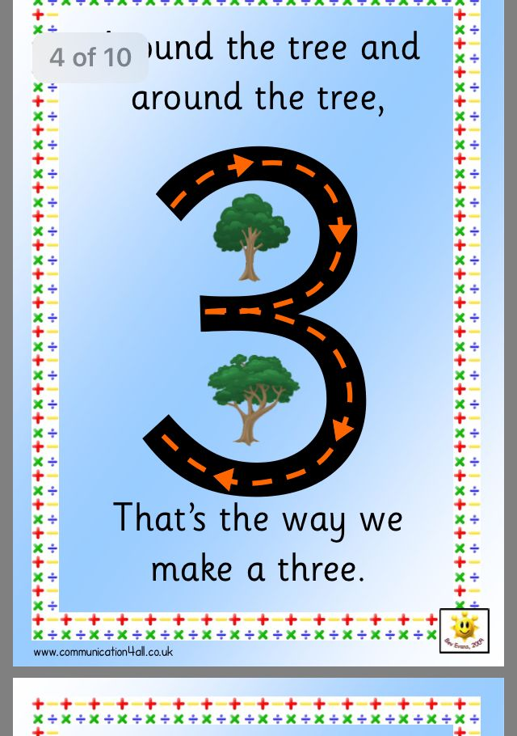

* **Number work:** Continue revision of number 4.

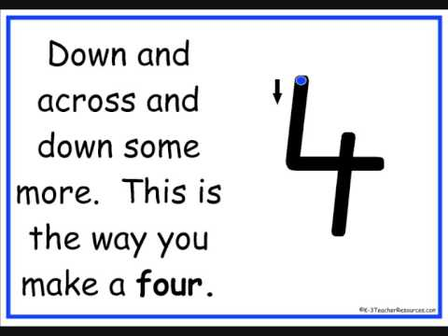

* Continue to practise writing the number four. Continue to make sets of four e.g. four teddies, four cars etc. Look for the number four on boxes/ labels in your home.
* Here are some more great videos about the number 4:

Sesame Street Number of the Day: <https://www.youtube.com/watch?v=_Aypxlfjv34>

Charlie and the Number 4: <https://www.youtube.com/watch?v=-XtSJIaKB5Q>

* **Capacity:**
* This week we are going to learn all about full and empty.
* Here are some good videos to explore the concept of full and empty:

[**https://www.youtube.com/watch?v=TJKwtpm6MaY**](https://www.youtube.com/watch?v=TJKwtpm6MaY)

[**https://www.youtube.com/watch?v=V7Ds6-rnvi0**](https://www.youtube.com/watch?v=V7Ds6-rnvi0)

* For this lesson you will need some cups, spoons, plastic containers and some water.
* Have a chat about all of the containers- which one do you think will hold the most water? Which one do you think will hold the least amount?
* Have a look at this cup- is it full or empty?
* How many cups of water will it take to fill this big plastic container?
* 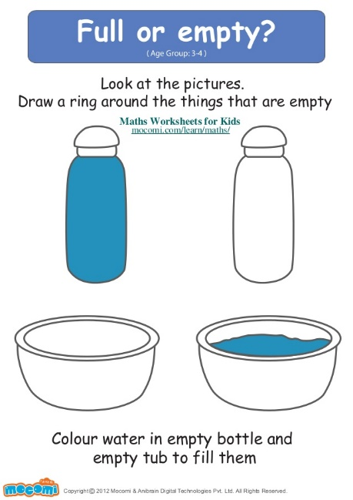

**Gaeilge**

* Look at programmes on TG4 and in particular, Cúla 4 online
* **BUA NA CAINTE**
* The Irish programme we use in school has become available online for home use.
* Go to [www.edco.ie/bua](http://www.edco.ie/bua)
* Select the PC folder for use on a laptop
* Choose Junior Infants and continue to Direct Download
* It may take a while to download and install
* Continue to revise Caitheamh Aimsire

**P.E:**

Here are some good dance videos for children. They are a great way of keeping active!

Just Dance Kids: I Like to Move It <https://www.youtube.com/watch?v=ziLHZeKbMUo>

Just Dance Kids: Pirates <https://www.youtube.com/watch?v=oe_HDfdmnaM>

Just Dance Kids: Gummy Bear https://www.youtube.com/watch?v=6Q7-tzCCh3w

Why not practice yoga – the boys and girls in junior infants love this! All you need is some space to lie down on the ground and maybe a nice rug.   
<https://www.youtube.com/user/CosmicKidsYoga>   
Pick a yoga lesson your child would like to complete. Some are as short as five minutes and some are longer.

**Art:**

Paper plate pizza: Children will need a paper plate, some coloured paper and red paint. Paint the middle part of the paper plate red (sauce). When dry, cut up some pieces of coloured paper for the toppings.

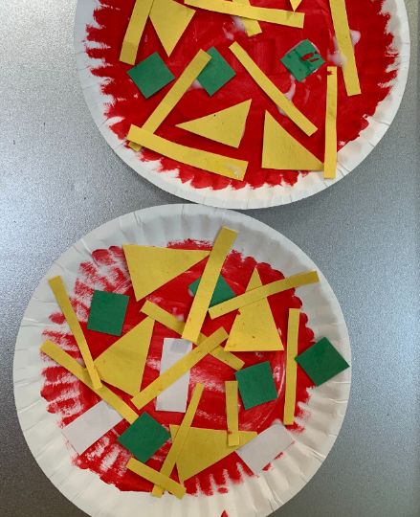

**Imaginative Play:**

* In February in Junior Infants we usually introduce Aistear. The theme for February is The Restaurant. Can you make a restaurant play area in your house using old boxes and toy food? Get into role as the chef/ waiter/ customer and have fun!

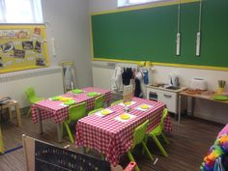

* Here is a little video all about the chef:

Let’s Play (The Chef): <https://www.youtube.com/watch?v=CcN-E1fkzik>

* Can you make some playdough food for your customers?

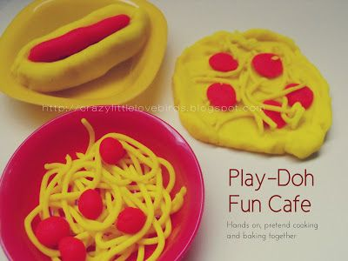

* Can you make a menu for your customers? What will you put on it? What will be the starter, main course or dessert?

