Welcome everyone to week 5 of our home learning!

8th – 12th February 2021

Dear parents and children,

We hope you and your families are still well and enjoying the slightly longer days now that we are in February. Thank you for all the work you are doing at home, we have really loved seeing all of the work that you’ve done. Our theme this week is Love/St. Valentine’s Day 💕 As we have mentioned before, please **do not feel under pressure** to complete every activity. The wellbeing of your child is more important now than ever before. Thank you to all those who collected the books in school, we will be posting up the pages to complete as we go along each week.

If you have any questions regarding SeeSaw or difficulty logging in please do not hesitate to email [kid@stphilipsjns.ie](mailto:kid@stphilipsjns.ie) and we will get back to you as soon as possible!

Take care and stay safe,

*Ms. Crimin, Mr. Conneely and Ms. O’Halloran*

**Phonics:**

**Sounds like Phonics Book**

**Revision of g:** pages 32, 33

**Revision of o:** 24, 25

* Our new sound this week is **‘f’.**

Say the sound ‘f’. Listen to the song from Jolly Phonics.

<https://www.youtube.com/watch?v=o2zRjc9h_ZY>

* Can you think of any words that start with ‘f’? Can you think of anything you could draw starting with ‘f’?
* Go on a letter hunt and see if you can find the letter ‘f’ in your books or on a label.
* Watch this video of Geraldine Giraffe learning the ‘f’ sound <https://www.youtube.com/watch?v=T0-KNJ0yXS8>
* Revision of sounds learned already: s, a, t, i, p, n, c, k, e, h, r, m, d, g, o, u and l.

Five minutes a day using your child’s sound book makes a big difference in helping the children to remember their sounds.

* Practise doing the actions for each sound and practise singing the songs.

<https://www.youtube.com/watch?v=_s-1sxzjPX8>

* Complete the online activities for ‘f’ on <https://slp.cjfallon.ie/>. Click on Book Ato find the letters.
* Game: I went to the shop and I bought… You and your child think of some ‘f words e.g fish, feet, fox, fork, feather, farm. First person says “I went to the shop and I bought Fish”. The second person says “I went to the shop and I bought fish and forks!” Each person adds a new item. Keep playing until someone forgets the list.
* Game: What sound is it Mr. Wolf?

Adult pretends to be Mr. Wolf and stands at a distance from the child. Child says ‘What sound is it Mr. Wolf?’ Mr. Wolf shows the child a sound e.g. a. The child thinks of as many words starting with that letter/ sound as they can e.g. apple, ambulance, ant. Child may hop forward for each word that they think of. Repeat then using another letter/ sound. When child reaches Mr. Wolf they win!

**Poetry:** Here are two short rhymes for Valentine’s Day. Which one is your favourite? Can you hear the words that rhyme?

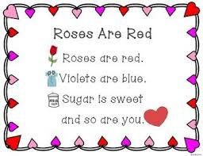

**I’m giving you a Valentine,**

**Don’t put it on a shelf.**

**It’s one that you can hold and love,**

**I’m giving you myself!**

We’d love to hear you saying the poem on Seesaw! Draw a picture to go with the poem. Who will be your Valentine?

**Story:**

* **Guess How Much I Love You** – <https://www.youtube.com/watch?v=zGuIUytF_6U>

Listen to the story. Did you like the story? What was your favourite part? How did the Nutbrown Hares show how much they loved each other? Can you draw a picture of the people that you love to the moon and back?

* **Groggle’s Monster Valentine –** [**https://www.youtube.com/watch?v=zfF4FP7UY_E**](https://www.youtube.com/watch?v=zfF4FP7UY_E)Who was Groggle making a Valentine for? What happened to the flowers he picked? Do you think Snarlina liked her card? Did you like Groggle’s rhymes?

**Handwriting:**

**Just write A1 Book**

**Complete the next 2 pages from where you stopped in school.**  
  
Revise practicing the letters below. These should be practised for a few minutes every day to develop child’s handwriting and pencil grip. Please encourage correct formation of letters.

* **Remember they ALL start with a ‘c’ shape**

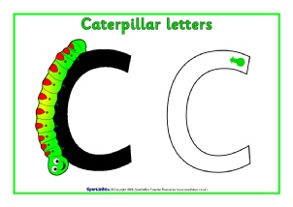 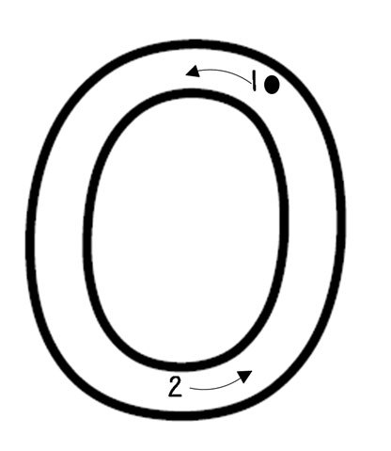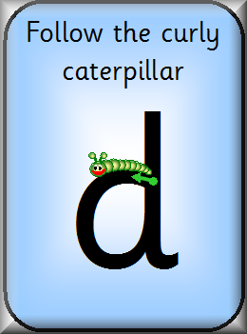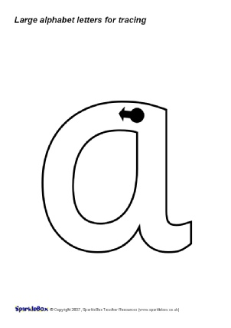

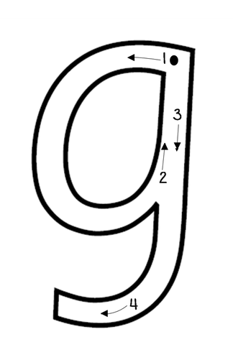

* Remember to sit up properly, have your other hand on the book/ paper and hold your pencil properly.

**Maths:**

**Planet Maths Big Book pages:**

**Revision:** pages 24, 25, 26, 27, 28

**Sets of 2**: pages 58, 59

**Capacity**: pages 90, 91

* **Days of the week:** It’s very important to check in with children every day and ask them what day of the week it is. What day is it today? What day was it yesterday? What day will it be tomorrow? What days are at the weekend?
* **Counting:**

Forwards 1-20 and starting on different numbers

Backwards from 5 down to 1, then 10 down to 1 when your child is ready

Saying the number ‘after’ e.g what comes after 3? What comes after 5? What comes after 2?

* **Grandma’s in the Kitchen:** Pick a number between 1 and 20 as your magic number and write it on a piece of paper. Child and adult then say the rhyme: *Grandma’s in the kitchen, doing a bit of knitting, how many stitches does she make?* Then child and adult count to and fro until they get to the magic number. E.g. child says 1, adult says 2, child says 3 etc. Person who says the magic number is the winner!
* **Teddy Bear Hide and Seek:** For this game you need a bowl/ box and up to 4 small toys/ teddies. Lay all 4 toys on the table. Child closes eyes and adult hides some of the toys under the box/ bowl. Child must guess how many toys are hiding. Take turns hiding the toys.
* **Fingers**: Can you show the numbers 1-10 using your fingers? I-5 first, then practice 6-10 when you are ready.
* **Numeral formation:**
* Continuous revision of numeral formation is important. Please practise writing the numerals 1- 4 at home.
* Go back and revise **number 2** in your **big maths book and small maths book.** It has a curved line and a straight line!

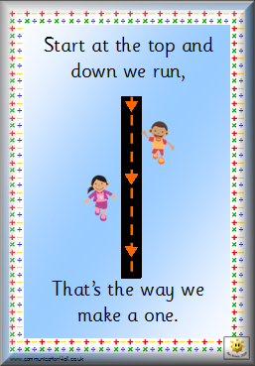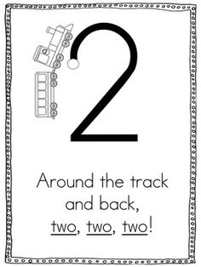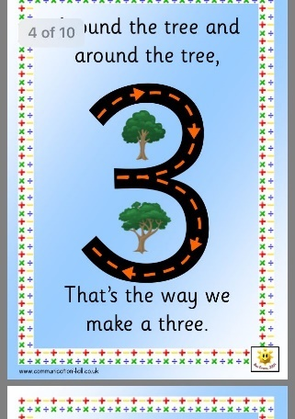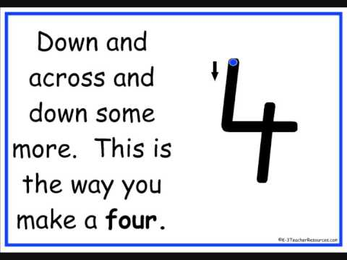

* **Capacity:**
* Keep experimenting with **full and empty,** and **more and less**
* Find three bowls in your kitchen that are different sizes, like in Goldilocks and the Three Bears. Use porridge to see which bowl can hold the most.

Which bowl is full? Which bowl is empty?

Which bowl has more? Which bowl has less?

* Complete pages 90 and 91 in your Planet Maths Book.
* **Biggest/Smallest**: Cut a variety of sizes as below. Order them in a line going from left to right, smallest to biggest. The stick them together with the biggest heart going on the bottom.



**Gaeilge**

* Look at programmes on TG4 and in particular, Cúla 4 online
* **BUA NA CAINTE**
* The Irish programme we use in school has become available online for home use.
* Go to [www.edco.ie/bua](http://www.edco.ie/bua)
* Select the PC folder for use on a laptop
* Choose Junior Infants and continue to Direct Download
* It may take a while to download and install

Look at lessons 1-4 on Éadaí.

**Music:** Some nice songs to sing along to and spread the love in your house!

* Join the Beat Bugs to learn All You Need is Love <https://www.youtube.com/watch?v=BcDRe7PzwAI>
* Five little hearts: <https://www.youtube.com/watch?v=n5noNWgcAAE>
* You’ve Got a Friend in Me: <https://www.youtube.com/watch?v=CNi02gxTI1M>

**P.E:**

* Here is a lovely Valentine’s special on cosmic kids yoga <https://www.youtube.com/watch?v=RSRKT5q7ZBQ>
* Some short and fun activities here for getting your heart pumping! <https://rtejr.rte.ie/10at10/>

**Art:**

Here are some nice ideas for St. Valentine’s Day art. If you don’t have red or pink paper, just colour some in with your crayons!

Maybe you could hang these Valentine friends in your window, so they can cheer up people who are walking past your house!

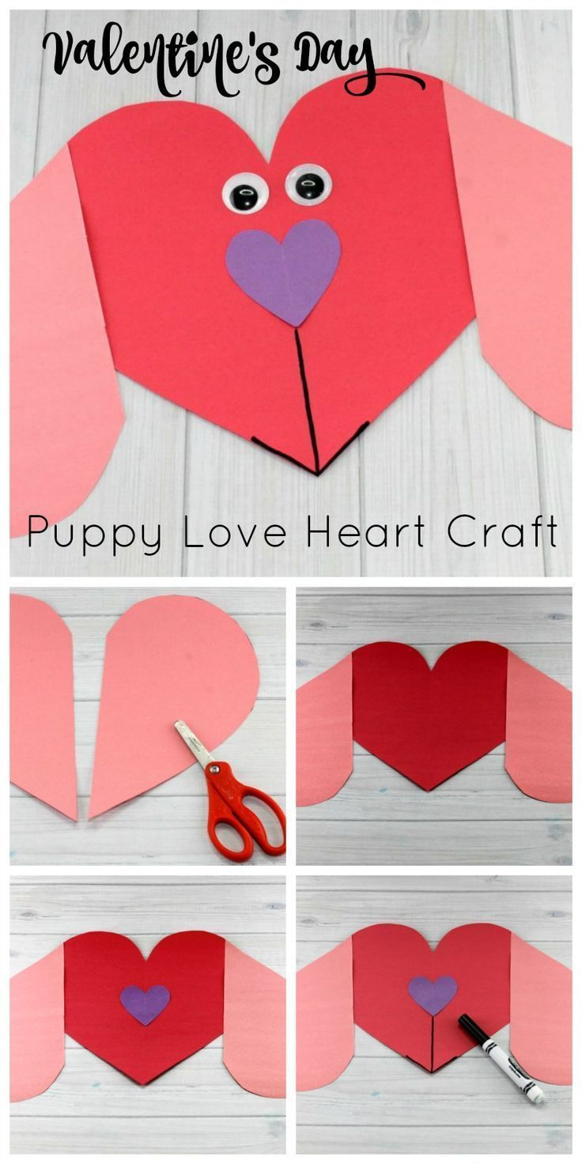  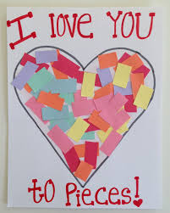

**Imaginative Play:**

* In February in Junior Infants we usually introduce Aistear. The theme for February is The Restaurant. Can you make a restaurant play area in your house using old boxes and toy food? Get into role as the chef/ waiter/ customer and have fun!

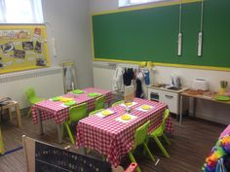

* Here is a little video all about the chef:

Let’s Play (The Chef): <https://www.youtube.com/watch?v=CcN-E1fkzik>

* Can you make some playdough food for your customers?

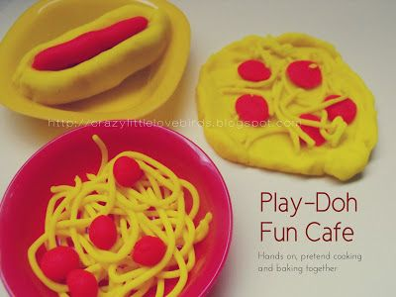

* Can you make a menu for your customers? What will you put on it? What will be the starter, main course or dessert?

