**15th – 17th February 2021**

Well done to everyone for completing SeeSaw activities, workbooks and these weekly plans. We understand that home-schooling is difficult and has many challenges so well done and thank you. This weeks plan is only for three days as we are on midterm break from Thursday.

As we said, please **do not feel under pressure** to complete every activity.

As mentioned, we love to see pictures/ videos of your children’s work- please post them to the SeeSaw app if you would like to share them with us. If you have any questions regarding SeeSaw or difficulty logging in please do not hesitate to email [kid@stphilipsjns.ie](mailto:kid@stphilipsjns.ie) and we will get back to you as soon as possible!

Take care and stay safe,

*Ms. Crimin, Mr. Conneely and Ms. O’Halloran*

**Phonics:**

* As this is only a **3 day week** we will not be moving onto a new sound. Please use these few days for revision and to revise all sounds learned since September.
* Please also be aware that we teach the letter sounds and not letter names as it can be a little overwhelming all at once.
* Revision of sounds learned already: **s, a, t, i, p, n, c, k, e, h, r, m, d, g, o, u, l and f**. Daily practice of these letters is really important as the children are missing out on the morning letter checks they would usually have with their teacher. Unfortunately, if the sounds aren’t practiced everyday your child will lose them.

Practise doing the actions for each sound and practise singing the songs.

<https://www.youtube.com/watch?v=_s-1sxzjPX8>

**Phonics games:**

* **Sound match:** write out all the sounds we have learned twice and turn them upside down and mixed up on the table. The child has to match the sound and make the sound when done. E.g. Flipping a ‘t’ and a ‘s’ is not a match but flipping two ‘a’ sounds would be a match.
* **Word scramble:** With the letters written out on pieces of paper/card ask the your child to use the letters to spell words out of the sounds learned. E.g. tap, hat, pin, dog, etc.
* **Word hop:** Write out sounds on large pieces of paper and put on the ground. Ask the child to ‘hop out’ a word. E.g. to hop out the word dog they have to hop on the page that says ‘d’ and then ‘o’ and finally ‘g’.
* **Sounds hunt:** Pick a sound and go on the hunt for words starting with that sound in our out of the house.
* **Splat:** Stick all the sounds on a wall and pick a sound to point to or tap with a fly swatter/spoon/etc. call out the sound and the two players have to find the sound the fastest.
* **Silly sounds:** Get the children to experiment with the sounds they know by making silly words out of the letters asking them to explain what their word means. E.g. Making up the word ‘hek’.
* **Sound flash:** Flash a sound to your child quickly and see can they make the sound.

**Poetry:**

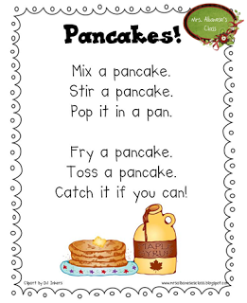

As it is pancake day on Tuesday we thought it might be fun for the children to learn a short poem about pancakes! We’d also love to see your pancakes! ☺

Can you draw a picture of your pancakes? What did you have on top of your pancakes? Whats your favourite toppings? [kids@stphilipsjns.ie](mailto:kids@stphilipsjns.ie)

**Story:**

* Listen to the story **Mr Wolfs Pancakes** <https://www.youtube.com/watch?v=CXQDiqHp-xM>   
  Why couldn’t Mr Wolf make pancakes? Who did he ask to help him read his shopping list? Who did he ask to help count his money? Who had the basket? Who did Mr Wolf ask to help make the pancakes? How did Mr Wolf feel when the pigs wouldn’t help him? How would you feel? Would you share your pancakes with your neighbours if they didn’t help you.
* Do you like Pancakes? Did you make any this week?
* Who were Mr Wolfs neighbours?

**Handwriting:**

* Keep practicing your writing boys and girls! Remember your pencil grip.

* Remember to sit up properly, have your other hand on the table and hold your pencil properly.
* Watch this video and practice the letters we’ve learned that are similar – c, a, o and g. Please do not do ‘d’ or ‘q’ as we have not learned them yet.   
   <https://www.youtube.com/watch?v=ZeOOB-GVOyI>

**Maths:**

* **What season is it? What are the signs of Spring? Can you find any signs of Spring?**
* **Revision - Counting:** Keep practising counting 1-10 and 1-20.
* Practice counting from a random number onwards, maybe start on the number 6, or 11.
* Can you say the number that comes next? This is a two-person game. One person says a number between 1-20 and the other person has to say what number comes next! E.g. what comes after 3? 5? 14? 17? Etc.
* Why don’t you dance while you count! Watch this video, count along with it and dance too! <https://www.youtube.com/watch?v=_MVzXKfr6e8>
* Play **Beat the Teacher (**Mum, Dad, Granny or your big sister or brother could be new teacher). Pick a target number e.g. 9. Starting on one, take turns saying a number each until you reach no.9. The person who says 9 is the winner!
* Fingers: Can you show the numbers 1-10 using your fingers? I-5 is easy, 6-10 can be a bit tricky but keep practising!
* Listen to this counting song;   
  [**https://www.youtube.com/watch?v=D0Ajq682yrA**](https://www.youtube.com/watch?v=D0Ajq682yrA)

**Other revision topics for these three days:**

* 2D shapes – circle, square, triangle, rectangle
* Days of the week
* Two and three colour patterns
* Sorting by size. E.g. all the big things together, small things together.
* Colour – Sorting objects by colour, revise colours.

**Gaeilge**

* Practice saying ‘hello’ in Irish and animals in Irish.
* Watch the video below and practice saying hello and your name in irish.
* <https://www.youtube.com/watch?v=LvBSZb6y5FA>
* Spelled phonetically:  
  deea guit – hello  
  iss misha John – My name is John   
  shin cot – That is a cat

Shin modra – That is a dog   
Shin ayn – That is a bird   
iss maw lum .. – I like…

**P.E:**

Why not practice yoga – the boys and girls in junior infants love this! All you need is some space to lie down on the ground and maybe a nice rug.

**Art:**

**Pancake art!** Please watch the following step by step video on how to draw funny pancakes! You can pause the video at any time. This is a step by step fun and child friendly video ☺   
<https://www.youtube.com/watch?v=nOsda7ca1WU&feature=emb_title>   
  
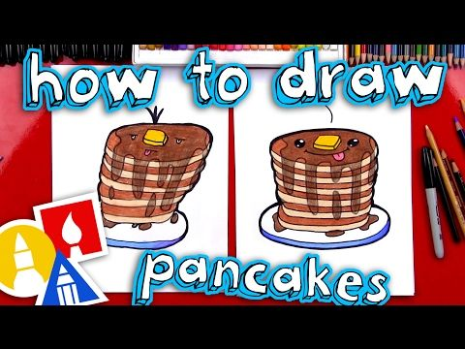

**Outdoor activies!**

Please enjoy the two days off for this midterm break and have a safe and enjoyable long weekend. You have been working hard! ☺