

Hi Everybody.
This is our work for week 8.
February 22nd – 26th
THEME:
Spring
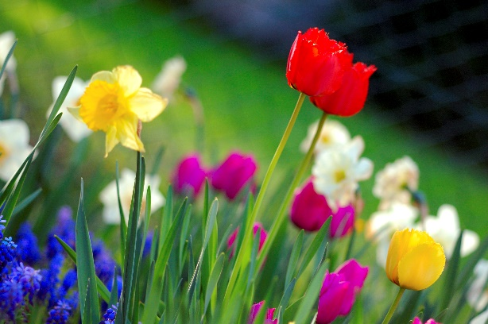

Remember to keep checking in on SeeSaw too.
There is plenty of work to keep everybody busy and learning. If you have any questions, please send them to your teacher on SeeSaw. You can send a video or a note. You can also send an email to kids@stphlipsjns.ie
Pop your teachers name on the subject bar and we will get your message.

English:

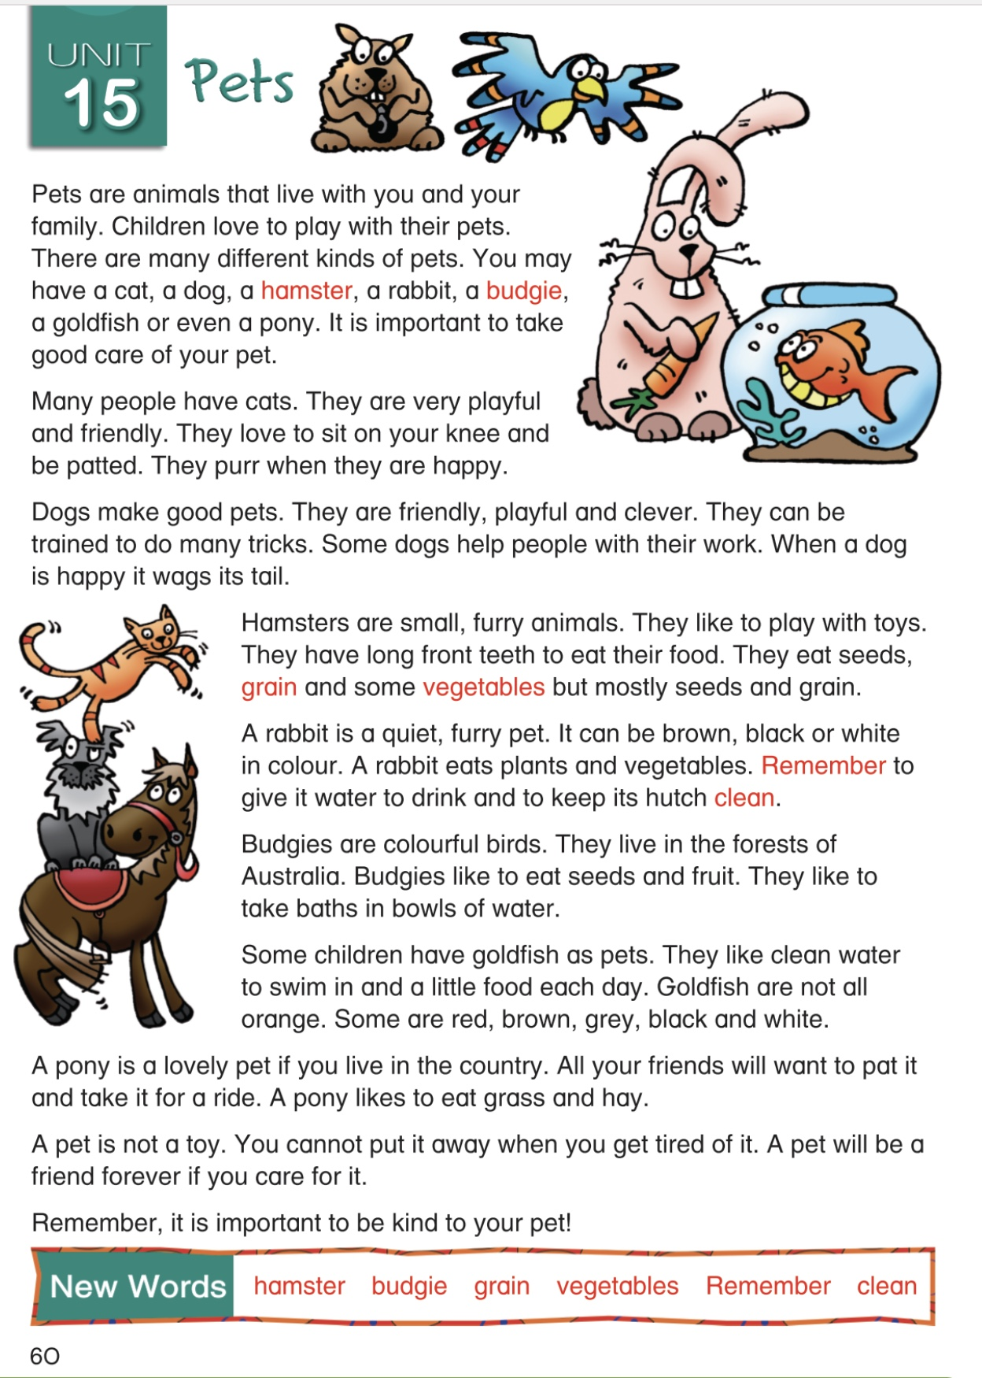
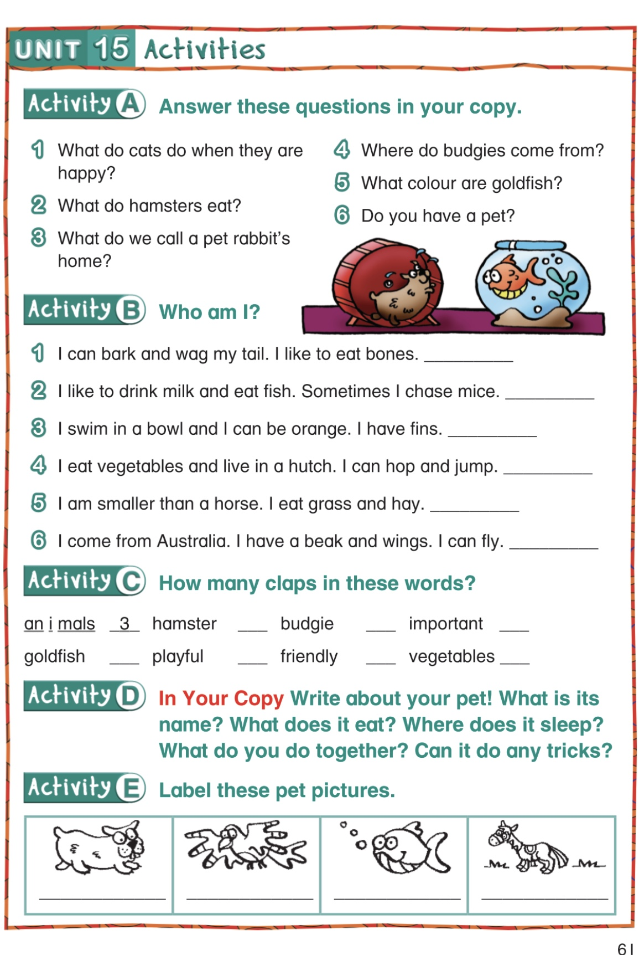

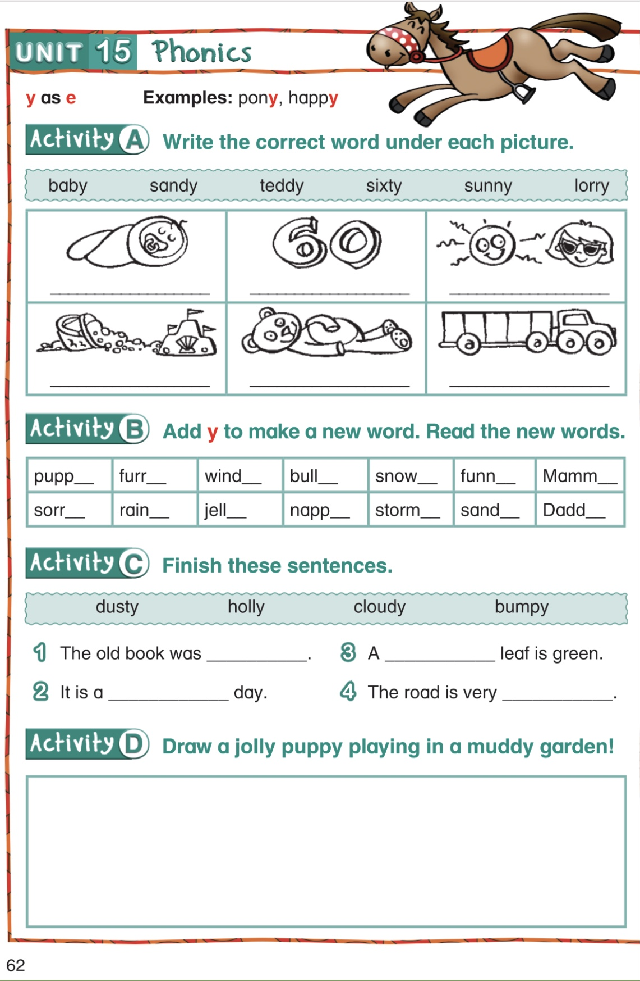
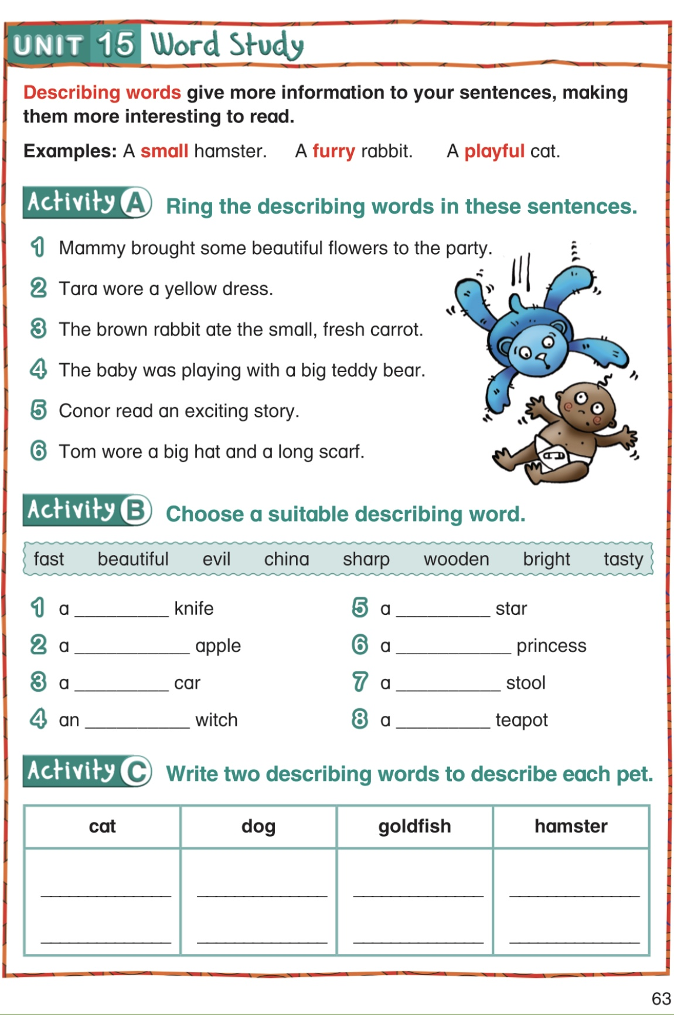

Maths:
Hundreds, Tens and Units
Here are some online games to help you with your place value
https://www.topmarks.co.uk/learning-to-count/place-value-basketball
https://ictgames.com/sharkNumbers/mobile/index.html

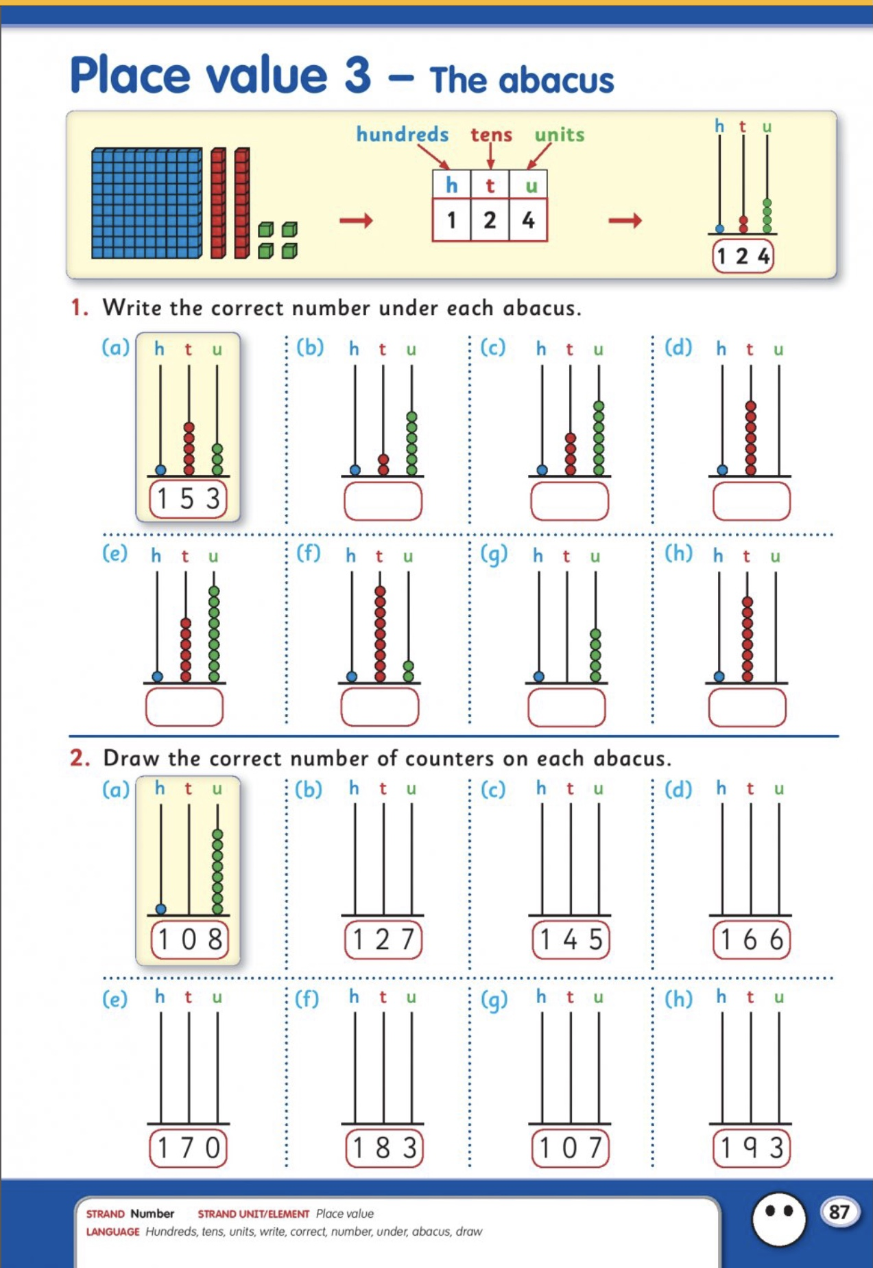

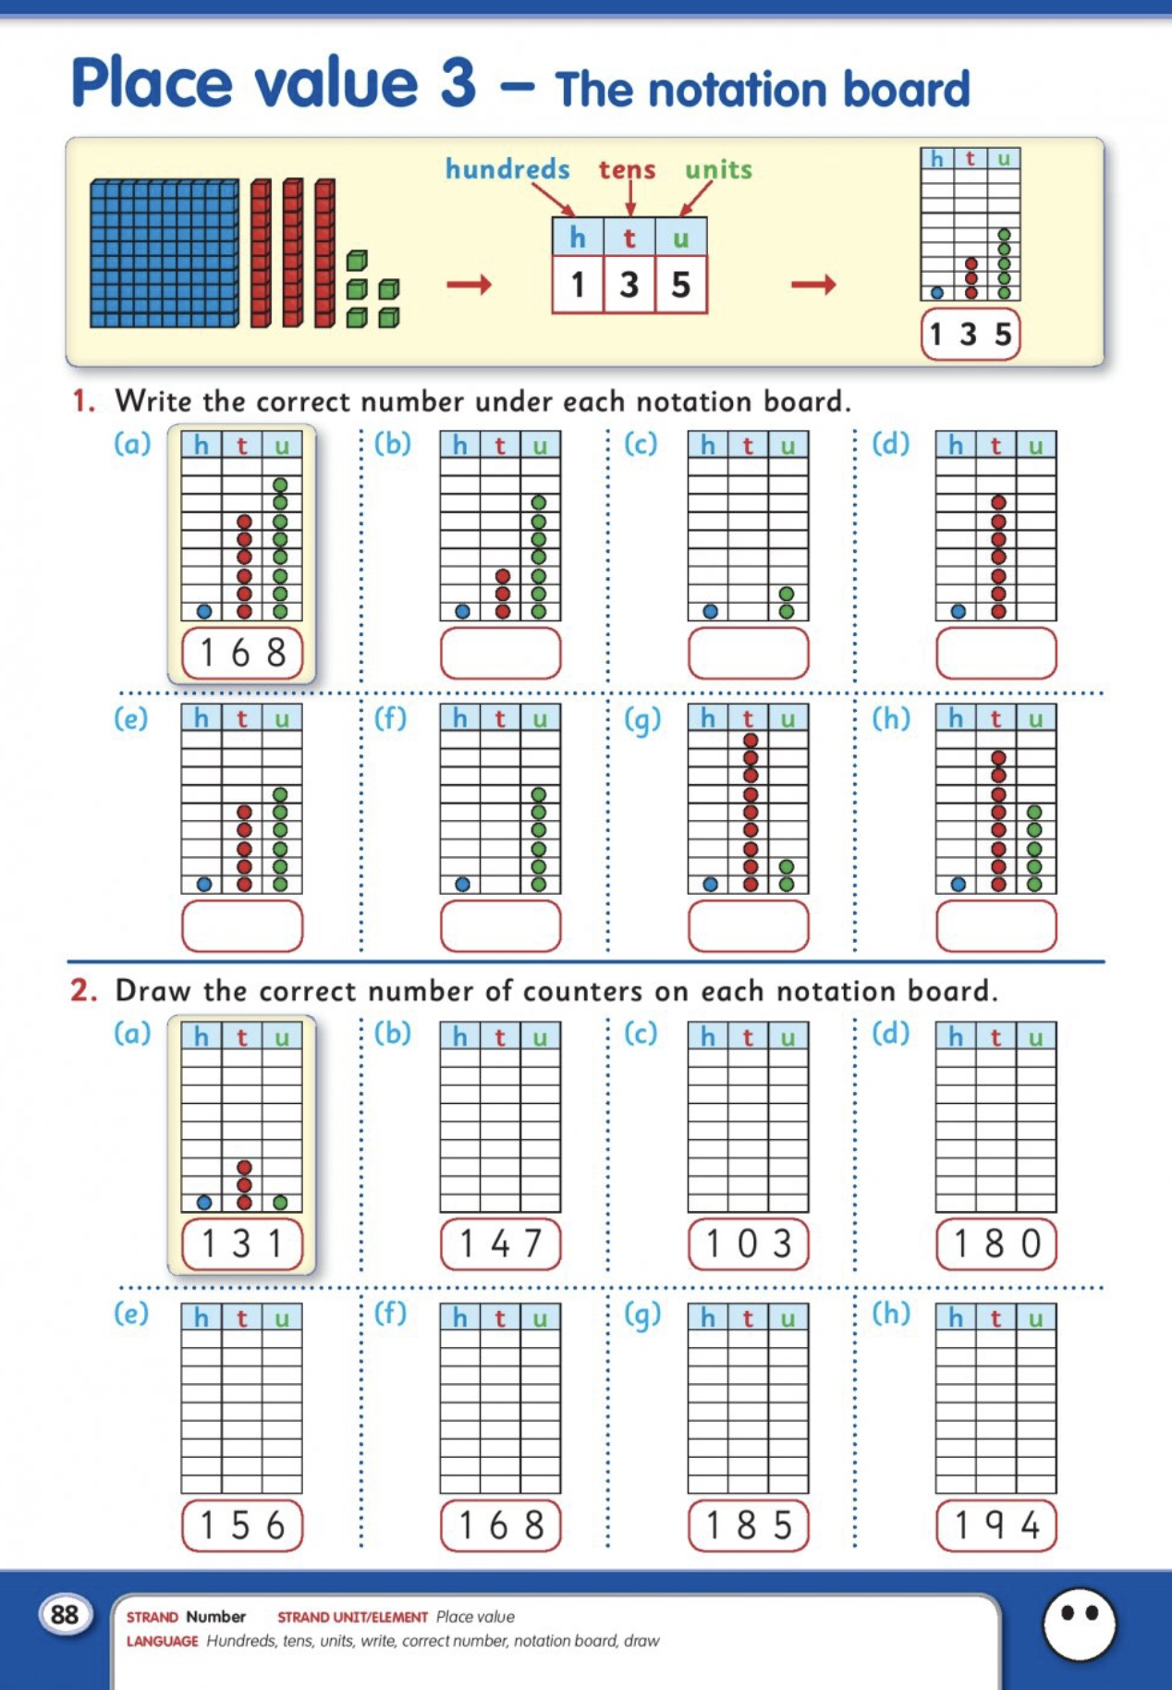

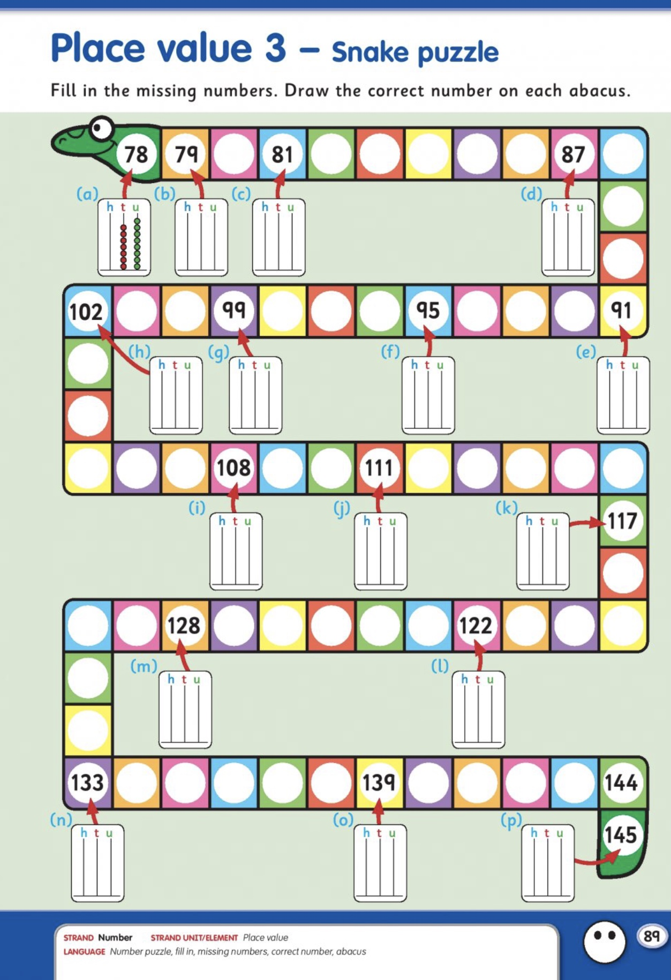

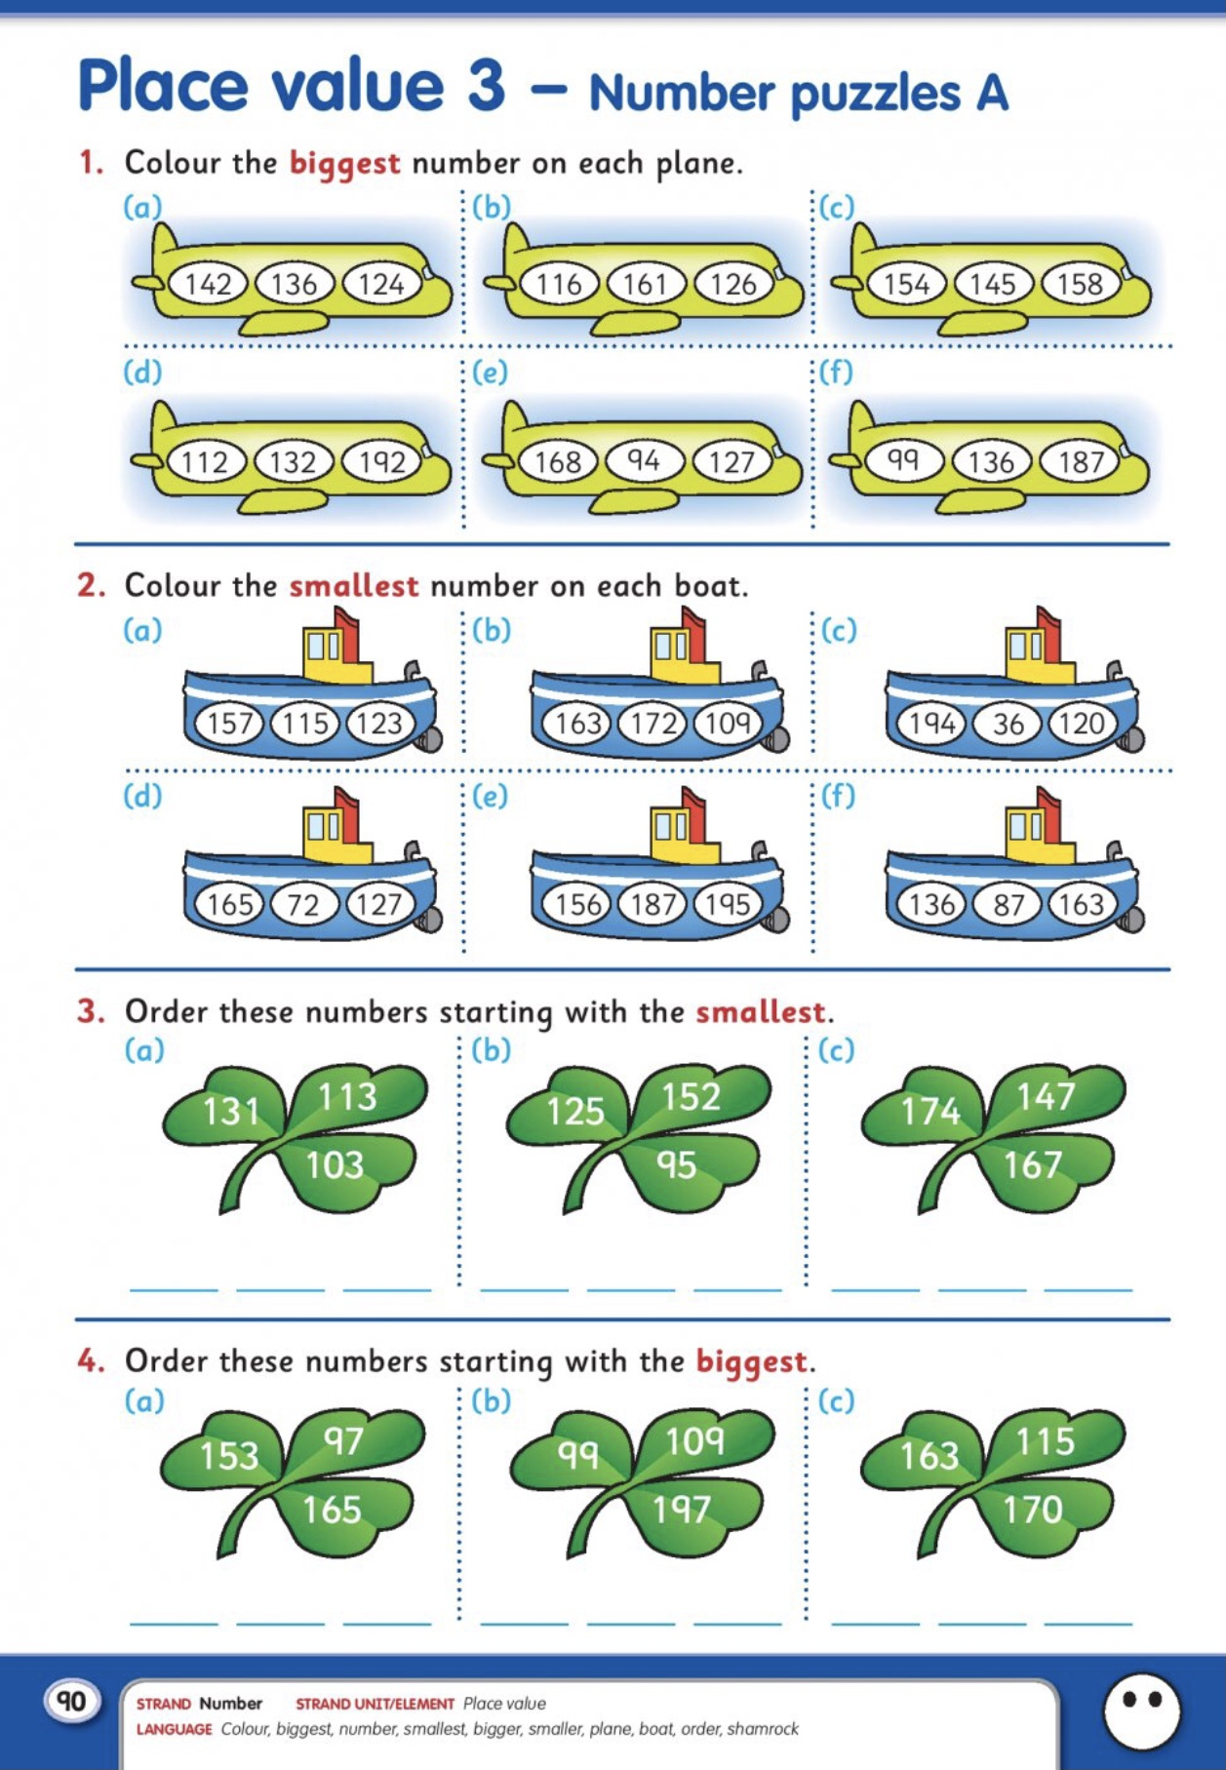

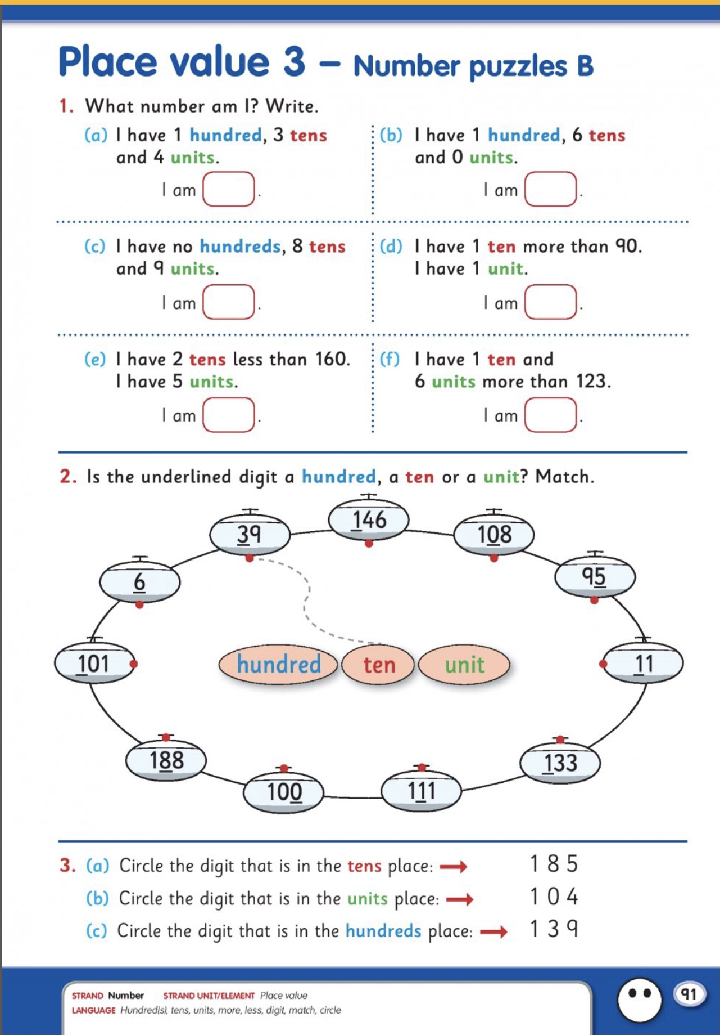

Gaeilge:
An Aimsir-An tEarrach

Na séasúir seasons
An tEarrach Spring
An Samhradh Summer
An Fómhar Autumn
An Geimhreadh Winter

Mionna na bliana Months of the Year
Eanáir January
Feabhra February
Márta March
Aibreán April
Bealtaine May
Meitheamh June
Iúil July
Lúnasa August
Méan Fómhair September
Deireadh Fómhair October
Mí na Samhna November
Mí na Nollaig December

https://downloads.edco.ie/bua/ to download the 2nd class programme tp PC at home
Username edcotrial Password edcotrial
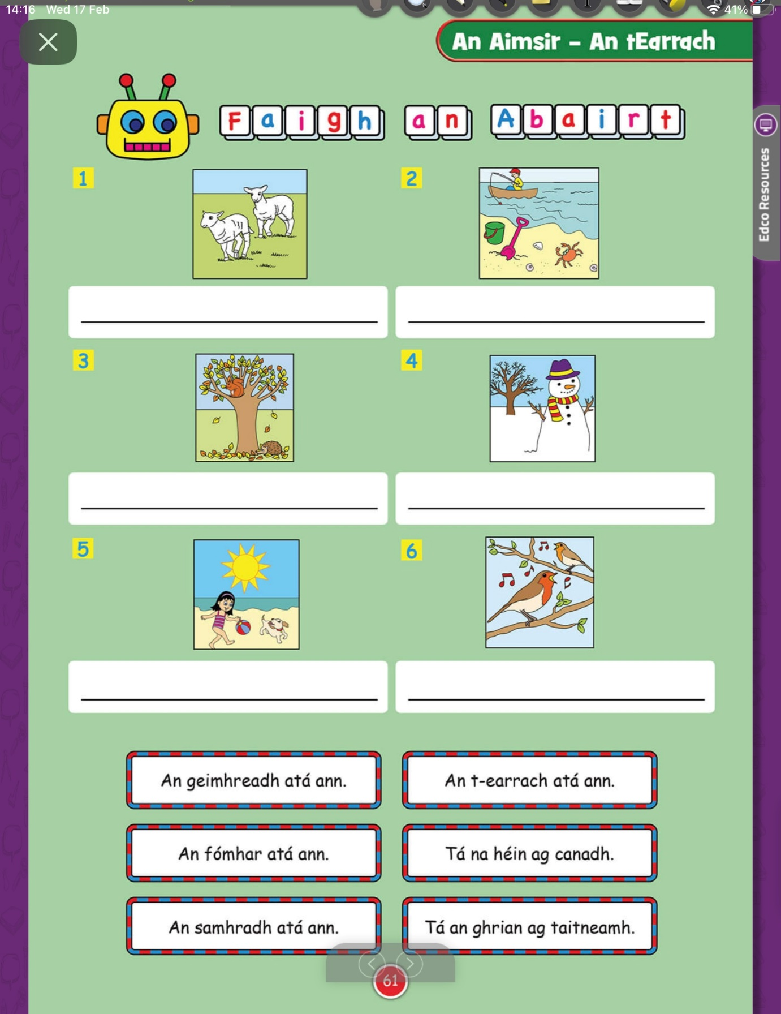
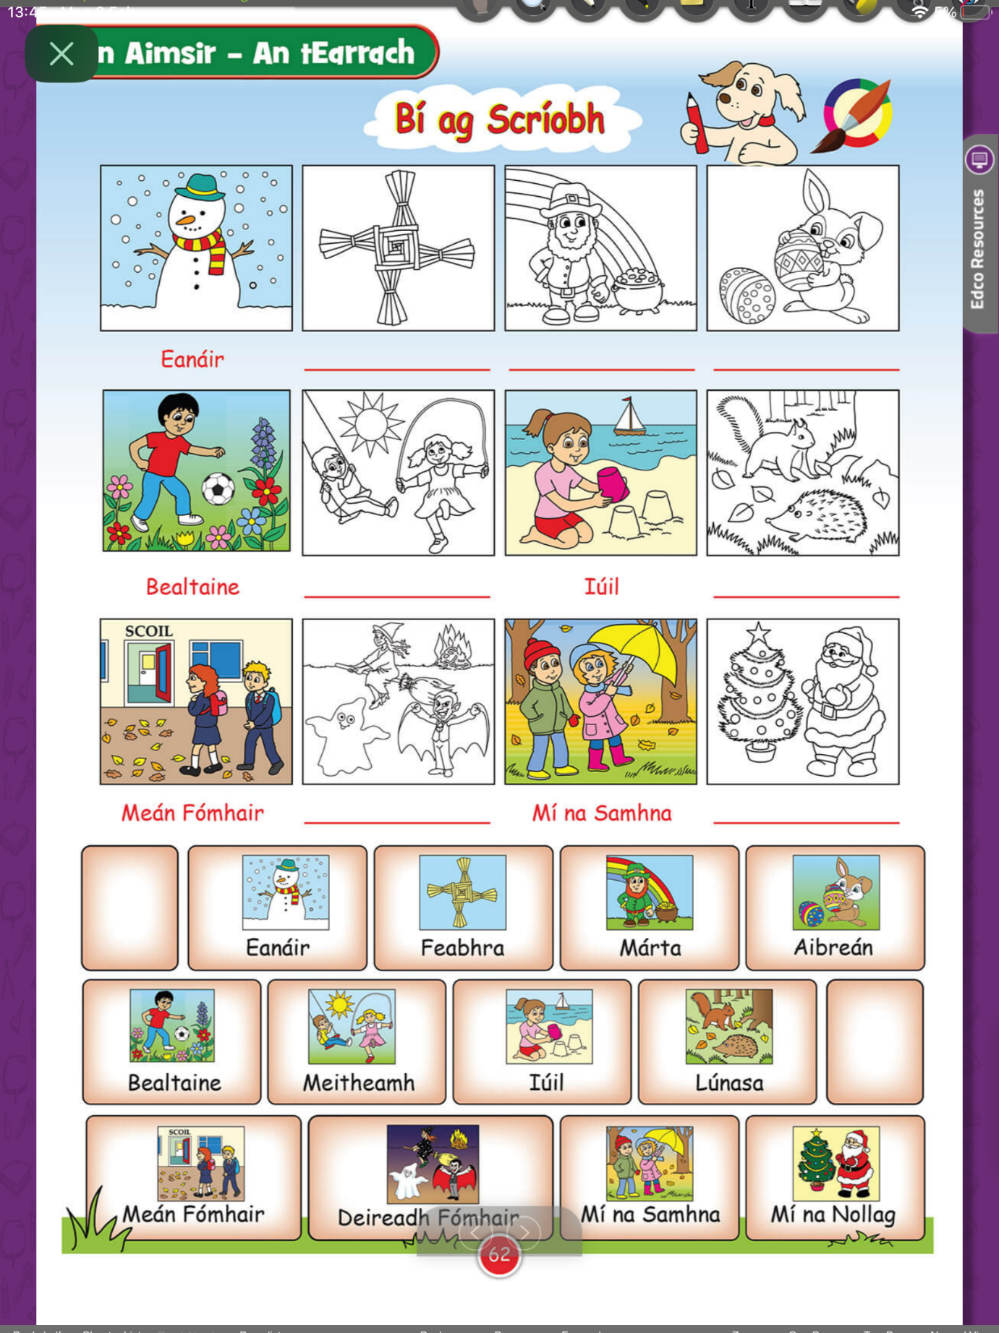

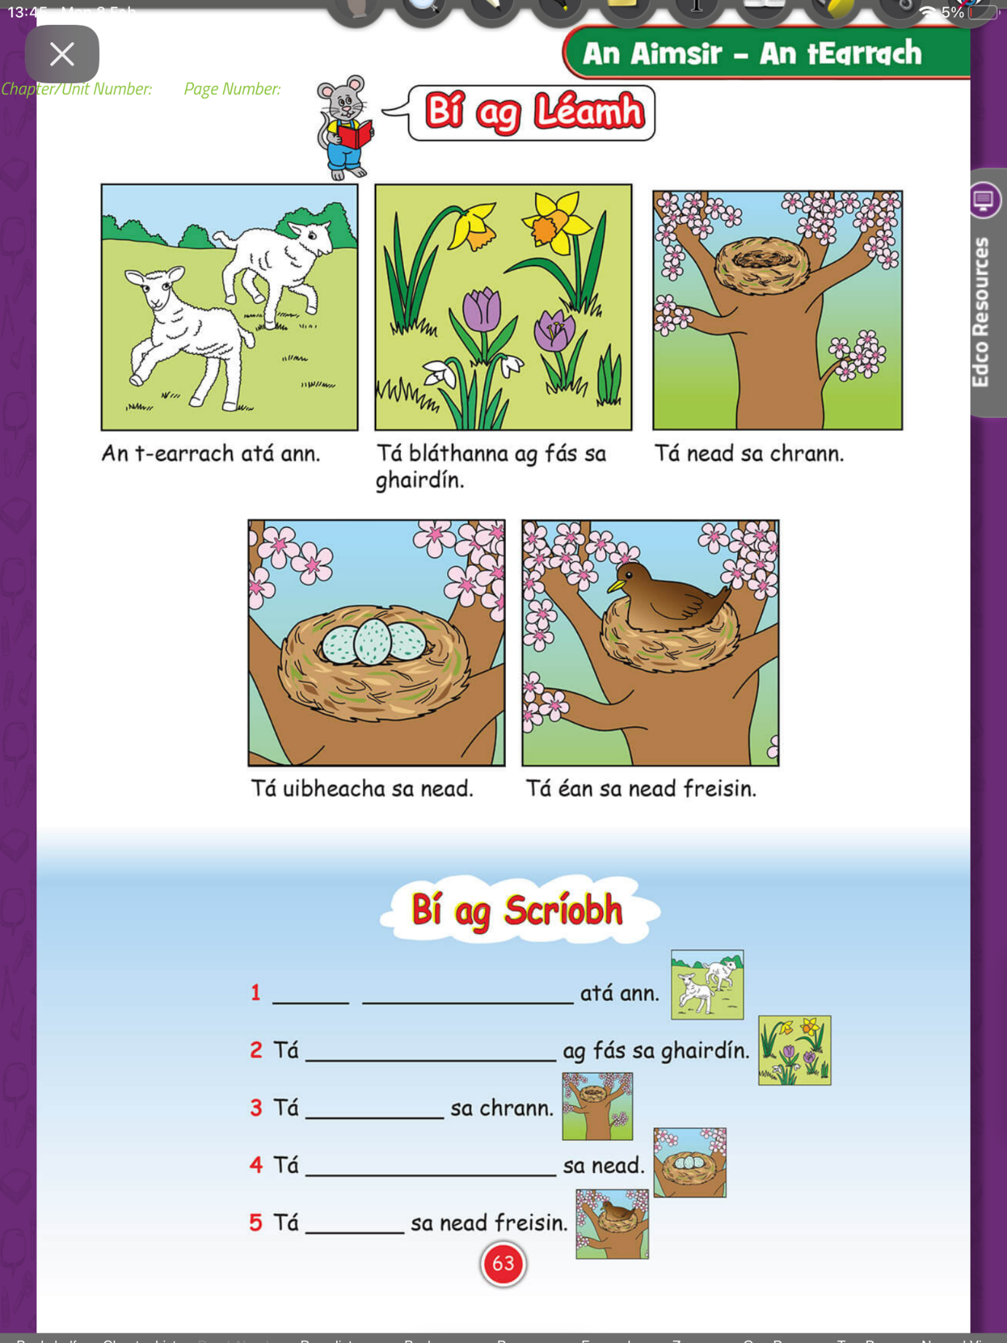
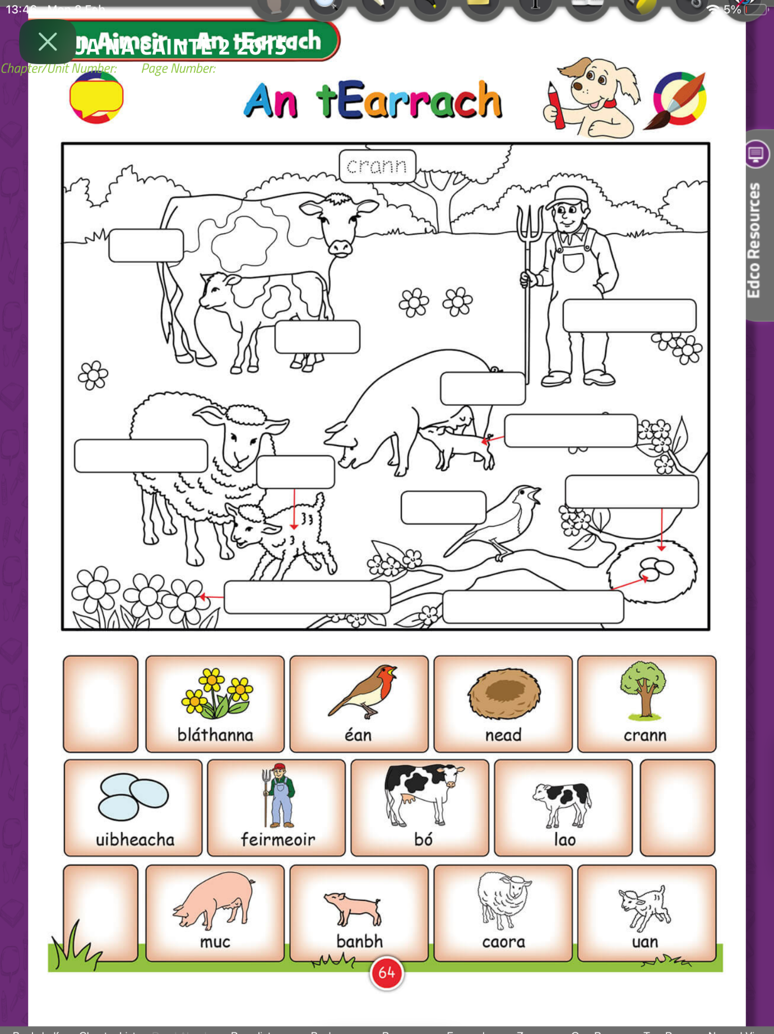

Spring
Read all about Spring
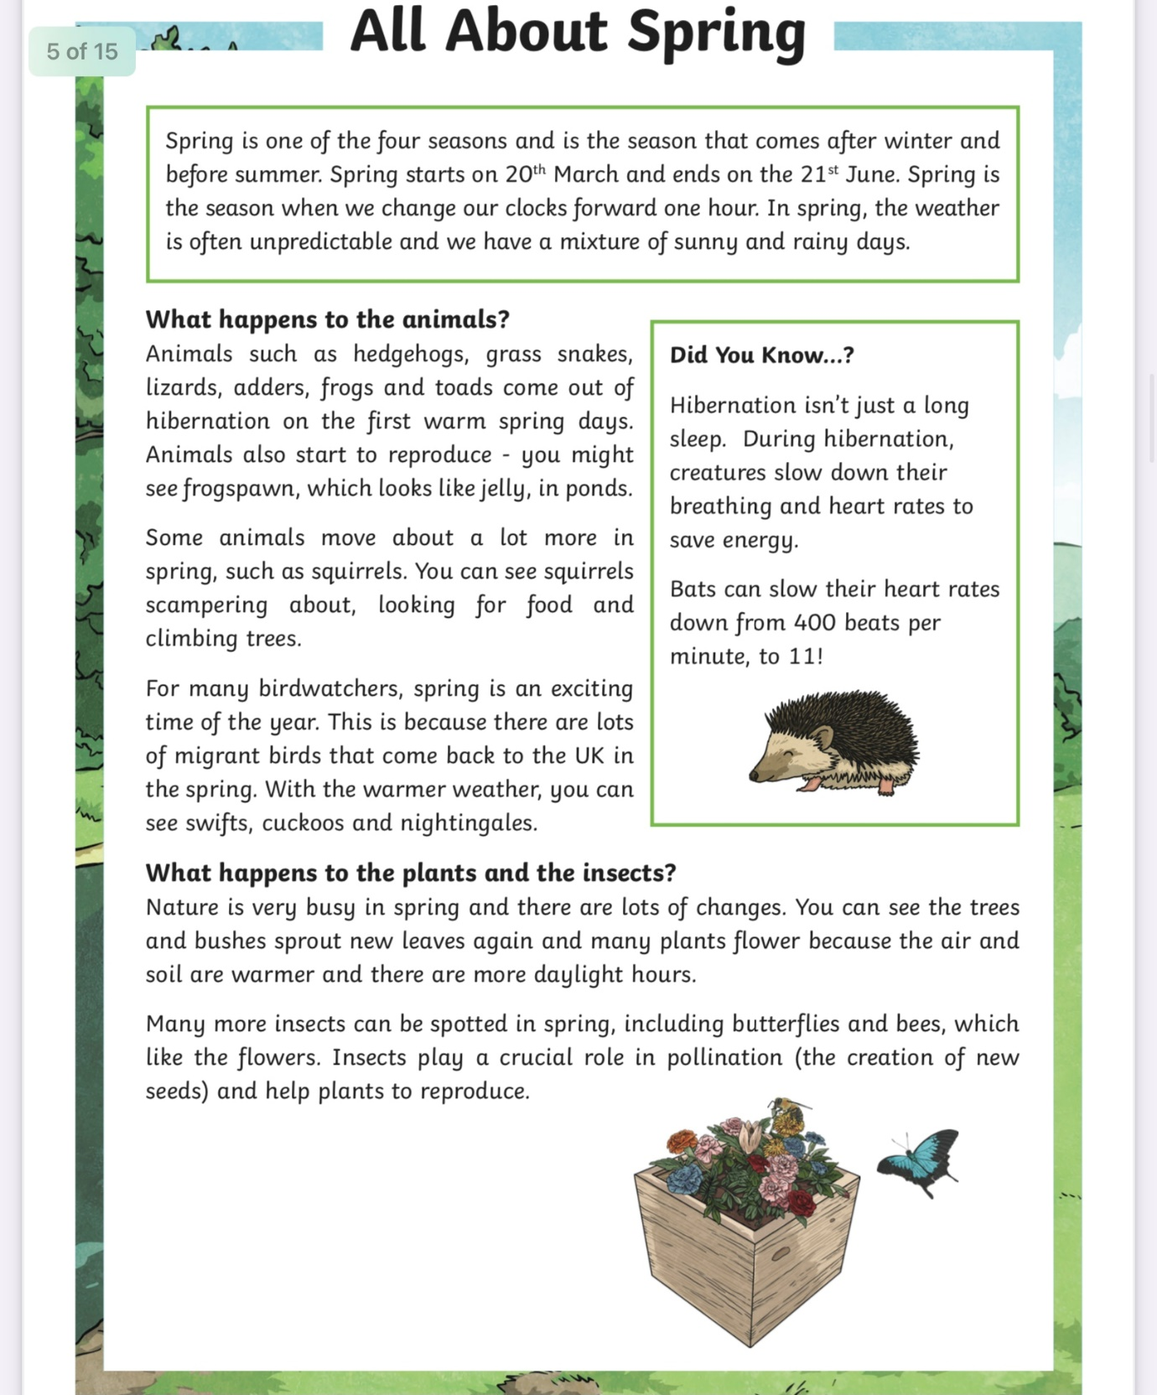

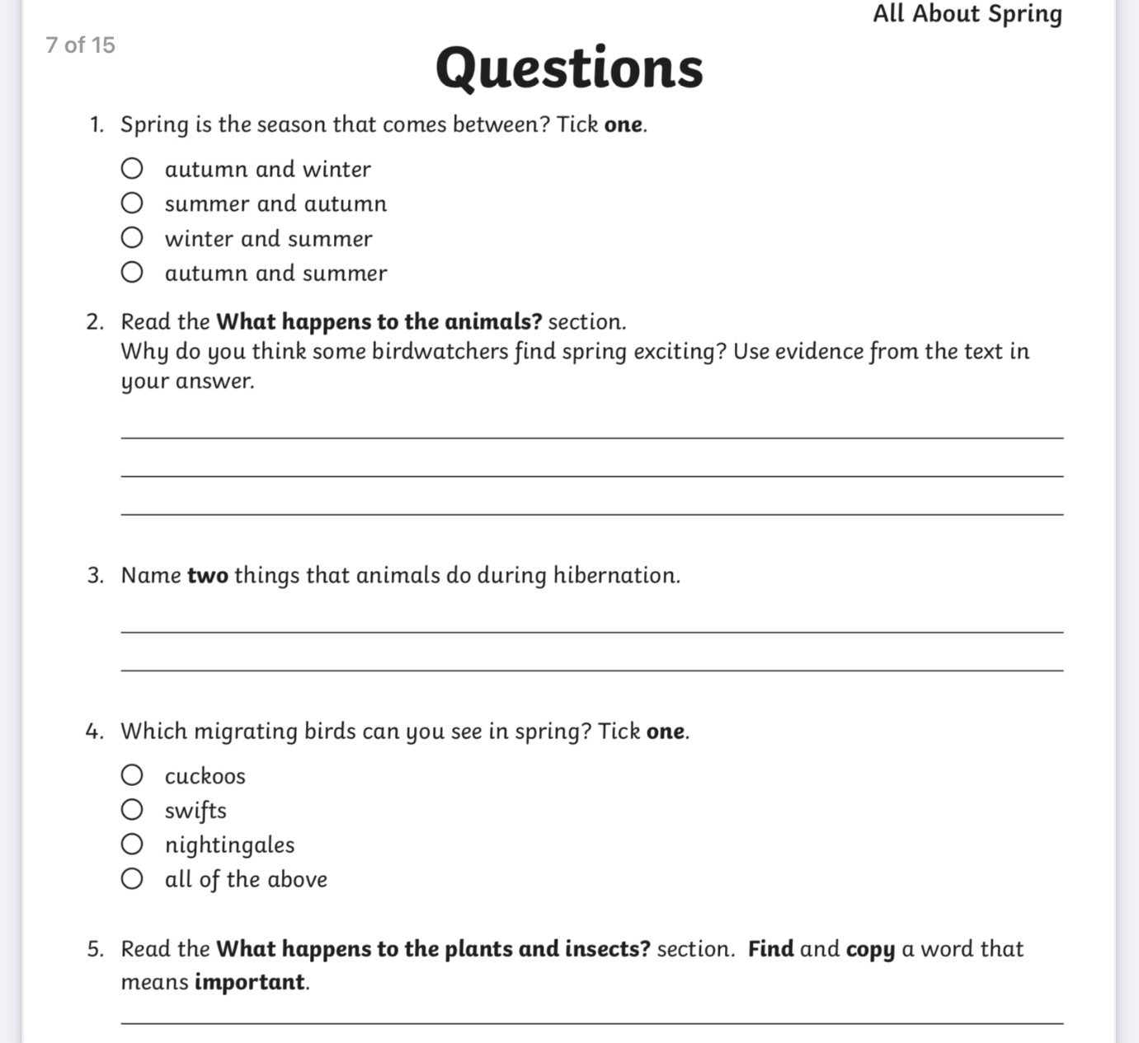

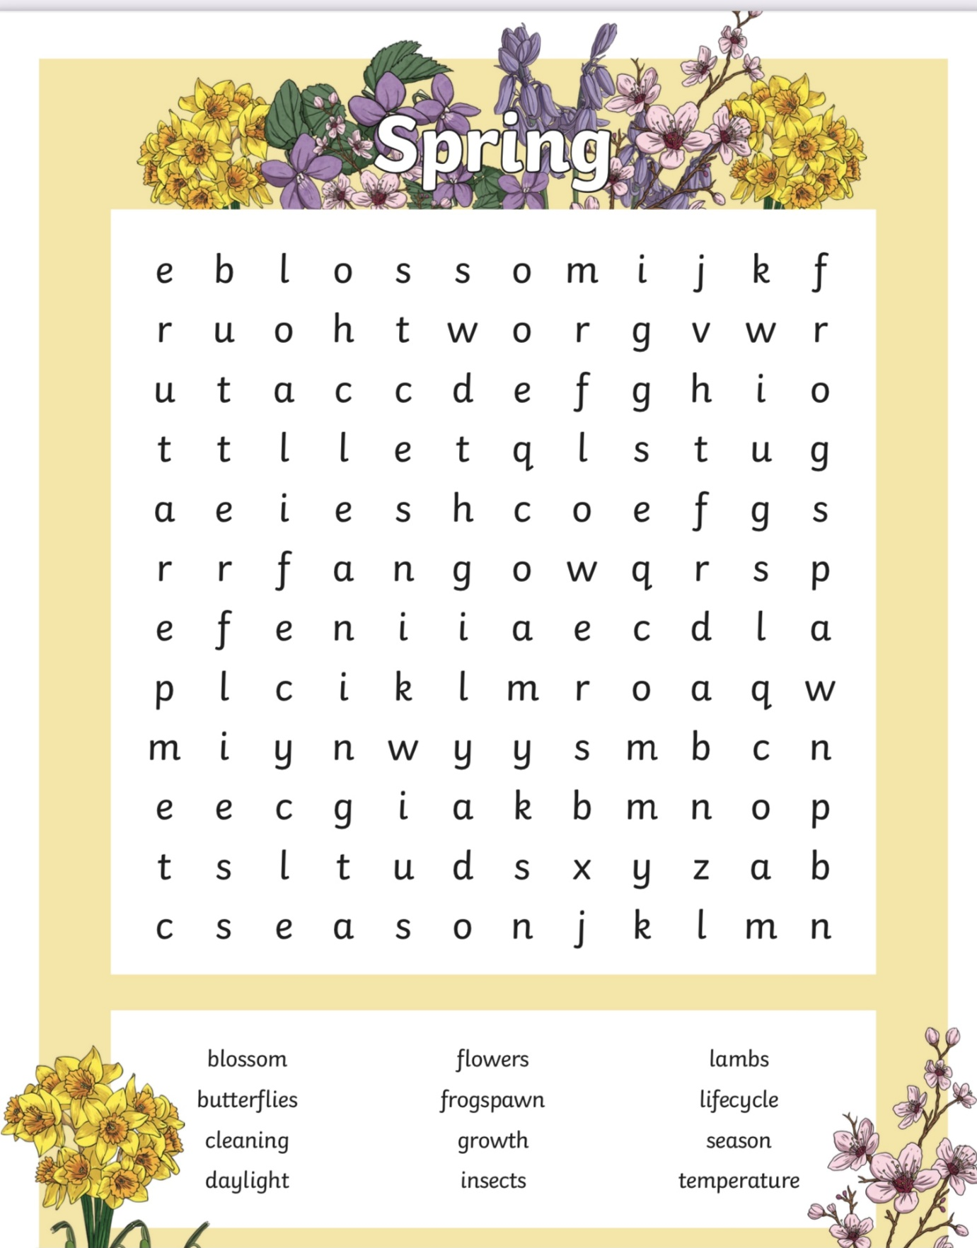

Look out for these things in Spring
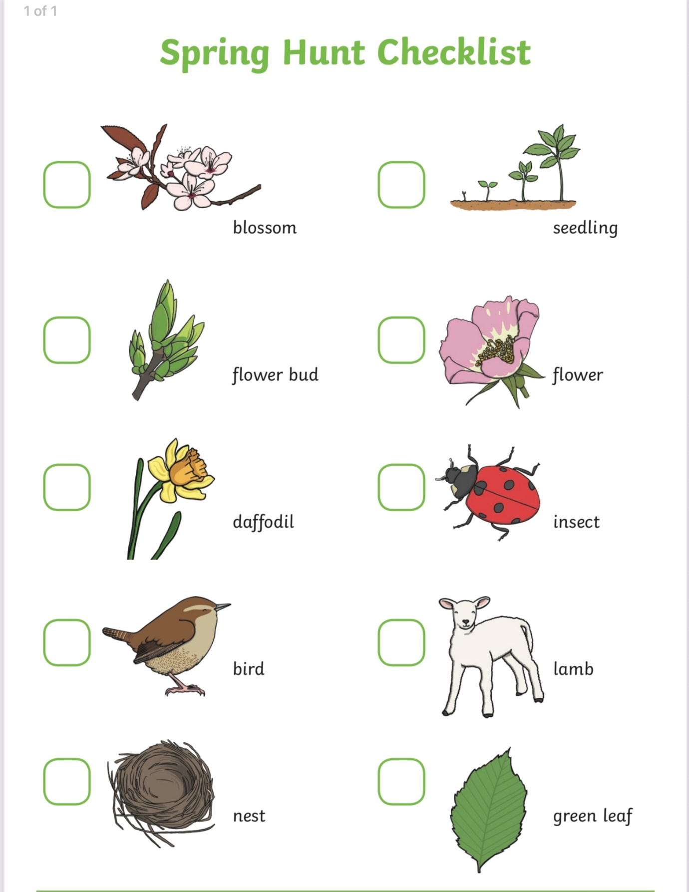

Music:
Listening and Responding
Listen to these 2 pieces of music
Spring by Vivaldi
https://www.youtube.com/watch?v=mFWQgxXM_b8
Dance of the Flowers by Tchaikovsky
https://www.youtube.com/watch?v=EF6nOpdl-k8
Answer the questions:
How did the music make you feel?
Was the music fast or slow?
Was the music loud or soft?
Which piece of music did you prefer?
Draw a picture to show what you heard when listening to the music

Art:
Spring Flowers
Can you name the Spring flowers?
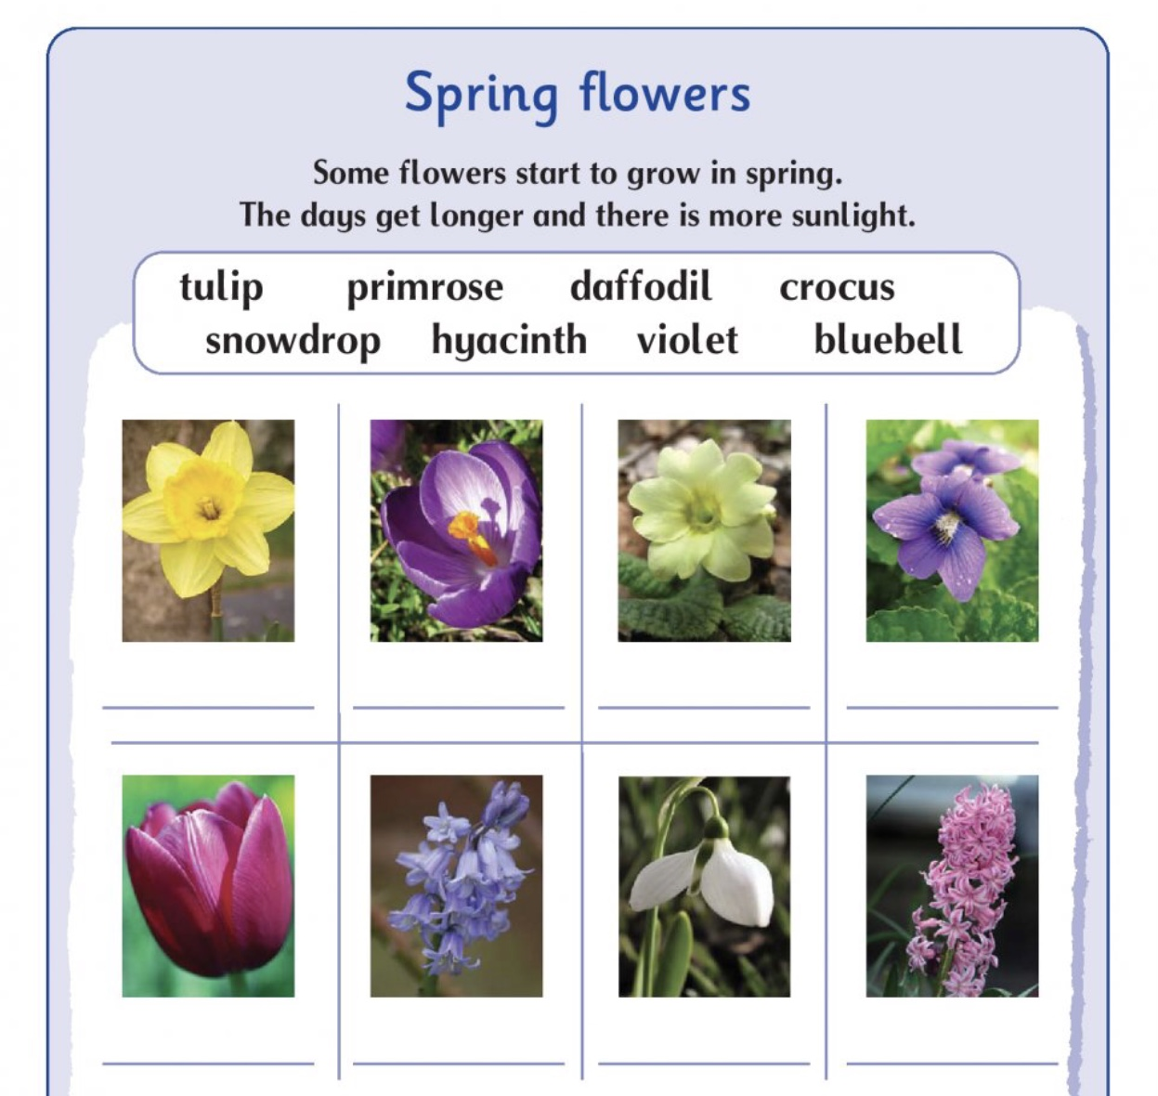

Try drawing a daffodil or a tulip
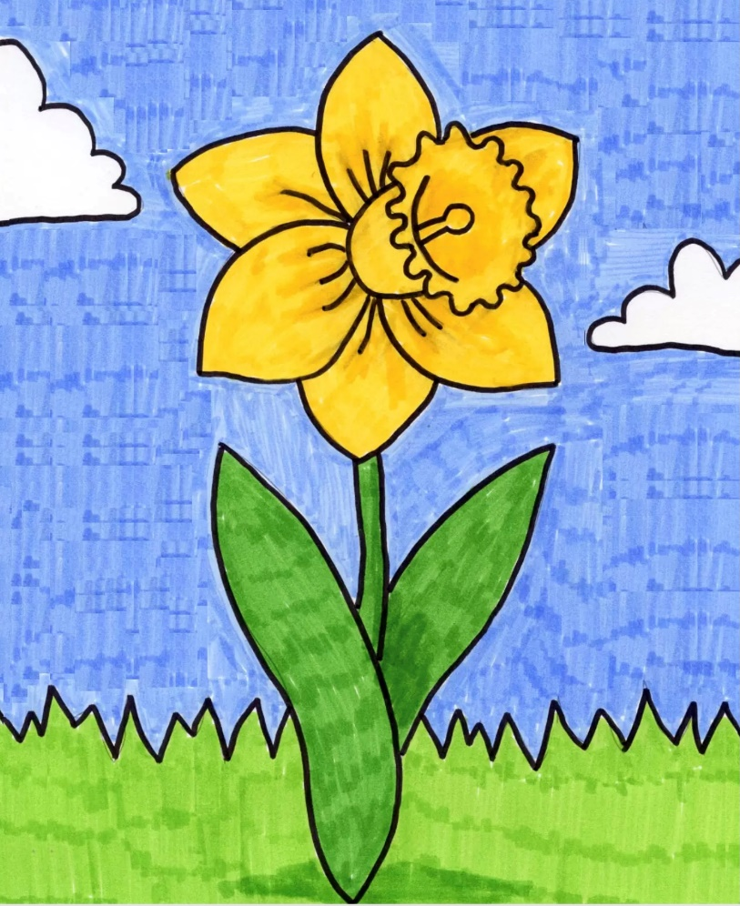
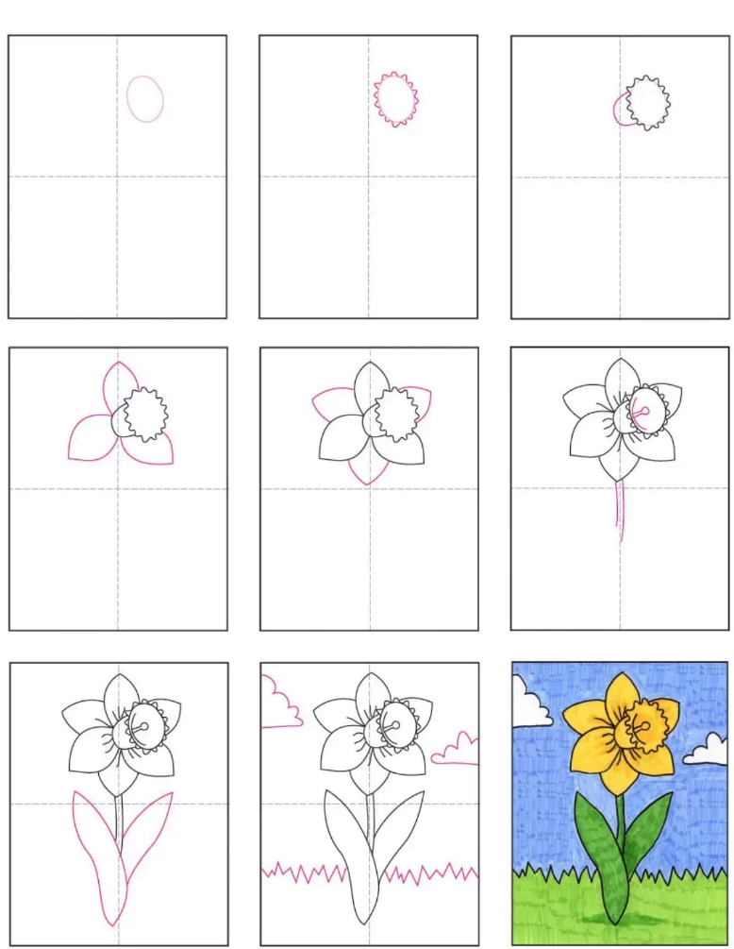

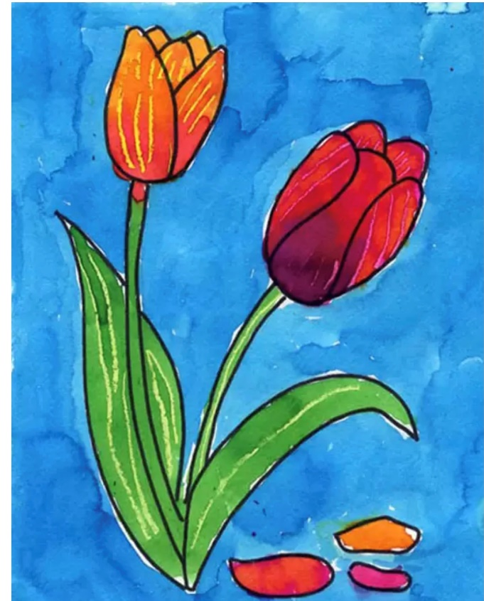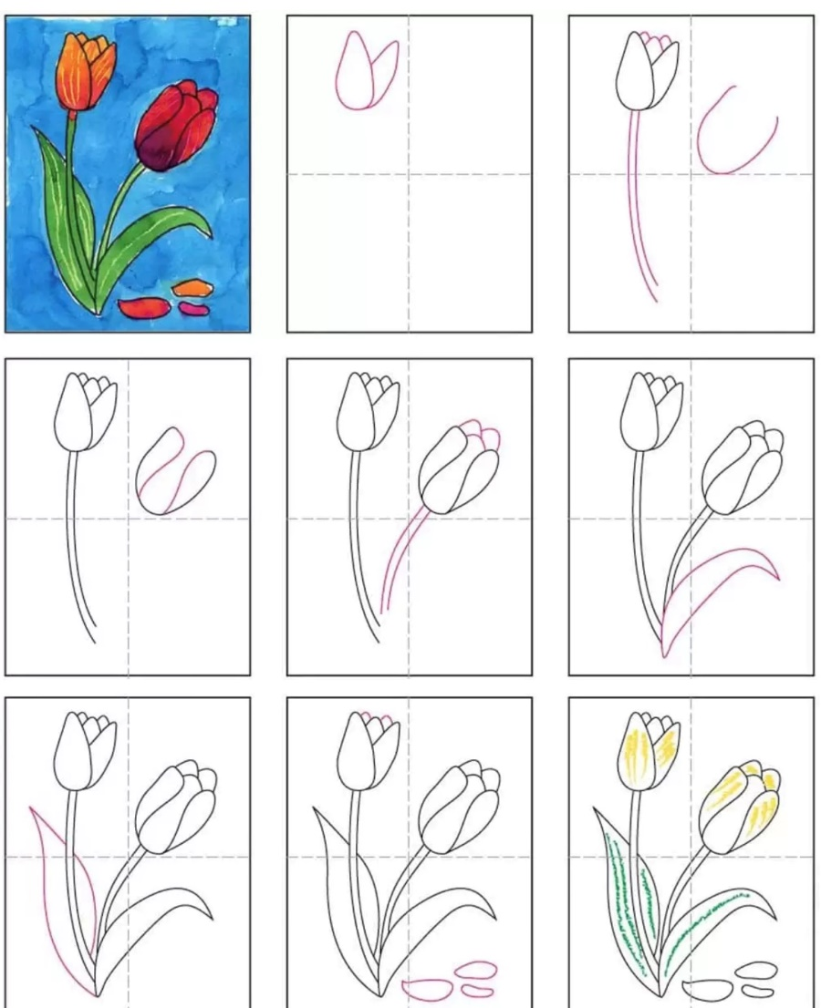

PE:


Please remember to exercise.
We love the following website in class.
https://rtejr.rte.ie/10at10/
There are loads of different episodes to choose from and all are only 10 minutes long. Keep exercising!!

