Dear Parents,
Please find attached the schedule for week 5. This is only a guide and all activities are optional.
GAA Learning
This is sure to be a hit with the majority of my class! Excellent learning and physical challenges for children to complete at home. https://learning.gaa.ie/primary-school
PATHSEdUK
Paths are releasing weekly lessons scheduled for every Tuesday. They can be followed on Facebook by parents. They also have suggestions for Brain breaks and every Thursday they will post new fun activities. Also included within their resources are SEL study guides for some popular books.
World Book Day
Free book activities to keep children busy, from craft ideas to free audiobooks. http://www.worldbookday.com
COOKING
Chef Theo Michael is hosting cookalongs for kids three times a week. ‘Kids Cook With Theo’ is streamed on Instagram and YouTube instagram.com/theocooks youtube.com/user/cookwiththeo
Primary 6 Transfer Group
Please follow the link that I placed on the website earlier this week in order to access free transfer papers. This would also be excellent revision for Primary 7.
Primary 7 Transition
Find a worksheet attached. It would be beneficial it someone could discuss the responses that the children place on their sheet. An older sibling/ cousin who have recently been through the transition process would be ideal.
Primary 7 End of Year
We are still no further forward as to where we expect to be, come the end of June. Please ensure that the children are very aware that myself and Miss McCauley have been making plans this week to give them a different type of a send of if we are unable to return to school.
Educational Television
BBC Bitesize daily television lessons found on BBC Red Button commence daily for KS2 at 9-40 a.m.– 10 a.m. The television schedule can be found on their website.
The online daily lessons for Primary 6 - all Literacy and Numeracy lessons are excellent revision this week apart from Wednesday’s Literacy lesson which is not relevant to your learning at this time. Primary 7 all Literacy and Numeracy lessons are extremely relevant. I will attach this on the website in the News Section.
Online Learning –Education City
I am constantly monitoring the use of Education City. Well done to Primary 7 pupils who are completing a lot of their activities. I have opted not to add any additional/change online activities this week to allow everyone to complete all activities. I am very aware it can be extremely challenging at home when we are sharing devices. If you are one of the pupils that have completed all your online education city tasks and accompanying worksheets please follow the Bitesize daily lessons for this week instead for the relevant days.
Please ensure children follow the online safety guidelines and exercise caution when using electronic devices. Don’t forget to download the DENI Safer Schools App to support you as you keep your children safer online.Download the App for free by searching for ‘Safer Schools’ in the Apple App Store or on Google play. (You can download it on more than one device!)
Religious Studies Programme
The Derry Diocesan Catechetical Centre have a beautiful resource online to help children know of the 50 days of Easter can be accessed along with other resources at www.catecheticalcentre.org
Grow in Love Programme. See details on the weekly schedule.
Login to Grow in Love – Religion Programme is: www.growinlove.ie
Email: trial@growinlove.ie
Password: growinlove
Pupil Wellbeing
- Relax Kids has produced a FREE MP3 ALBUM of mindful moments for children. www.relaxkids.com/calminthechaos
- A Covid -19 Time Capsule might be a nice idea to allow your child express how they are felling during this period of time https://s3.letsembark.ca/long-creations/2020-COVID-19-Time-Capsule-EN-US.pdf
- Coping Calendar is attached at the end of this schedule provided by Action for Happiness.
Club Challenges
Congratulations to all of you that are taking part in your club’s weekly challenges. I extend my best wishes to the boys and girls within my class that are taking part in the 24hour kick-a-thon on Saturday/Sunday. What a lovely thing you are doing to show support for all the parents within the class that work for the NHS and for the greater community.
Miss Devine and Miss McCauley.

Spelling Lists for Week 5
ture/sure
Year 6 Spelling List
Adventure
Culture
Pressure
Departure
Agriculture
Assure
Culture
Closure
Fracture
Displeasure
Furniture
Ensure
Gesture
Erasure
Venture
Exposure
Torture
insure
Year 7 Spelling List
Fracture
Displeasure
Erasure
Exposure
Composure
Enclosure
Acupuncture
Disclosure
Architecture
Caricature
Fissure
Temperature
Leisure
Miniature
Immature
Signature
Moisture
puncture

 | Monday | Tuesday | Wednesday | Thursday | Friday
9-15 -9-30 | Phonics  Worksheet/ Scaffold Text- see attached | Phonics  Use the dictionary to find the meanings to five of your spellings words | Phonics  Paper squares – one square per sound | Phonics  Create story using as many of the spelling words as possible | Phonics  Spelling Test
9-30-9-45 | Mental Maths  Complete Mental Arithmetic Book Section A/B or C or Mental Maths Daily test | Mental Maths  Mathsframe.co.uk | Mental Maths  Complete Mental Arithmetic Book Section A/B or C or Mental Maths Daily test | Mental Maths  Top Marks Daily 10  Select Level 5 P6  Level 6 P7 | Mental Maths  Complete Mental Arithmetic Book Section A/B or C or Mental Maths Daily test
9-45-10.30 | Religion – Weekly Activity  Grow in Love Details in above notes  P6 – Read pg64-65 Complete activity about occupations at top of page 65  P7 – Read page 78 and complete the activity | PATHS  Complete the weekly lesson – see Paths notes above. | STEM - Minecraft Education Lesson – Try the Lumen City Challenge to distinguish between renewable and non renewable energy. | PE – With supervision from parents try Annie Deery’s yoga class for kids. She can be found on Facebook – Annie Deery. | Music – try the Bitesize daily lesson on Rhythm and Percussion
Break
11.00 -11.45 | Literacy  Complete one of your comprehension activities found within your pack. | Literacy  Punctuation  Education City Online game+ accompanying worksheet  P6 – Let’s Eat Granny  P7 – Jungle Dash  If all completed fully follow Bitesize Daily lessons | Literacy  Discussion Texts  Research an issue that you have a strong opinion about. Do some research on it and complete the attached worksheet. | Literacy  Grammar  Education City Online game+ accompanying worksheet  P6 – Bad Hair Day  P7 – The Great Stensby  If all completed fully follow Bitesize Daily lessons | Literacy  Complete one of your cloze procedures found within your pack.
11.45-12.00 | Movement Break  PLEASE try GoNoddle this week, children will LOVE it.  https://family.gonoodle.com | Movement Break  PLEASE try GoNoddle this week, children will LOVE it.  https://family.gonoodle.com | Movement Break  PLEASE try GoNoddle this week, children will LOVE it.  https://family.gonoodle.com | Movement Break  PLEASE try GoNoddle this week, children will LOVE it.  https://family.gonoodle.com | Movement Break  PLEASE try GoNoddle this week, children will LOVE it.  https://family.gonoodle.com
12.00 – 12.45 | Numeracy  Number –  Education City  P6 – x6 Challenge +Worksheets and Multiplication Table  P7 – 8x Challenge +Worksheets and Multiplication Table  If all completed fully follow Bitesize Daily lessons | Numeracy  Data Handling  Education City  P6 – x6 Mean Beans +Worksheets  P7 - Worksheet Attached  If all completed fully follow Bitesize Daily lessons | Numeracy  Number – Education City  P6 – Ready Steady Bake – both activities  P6 – Water World Activities +Worksheets  If all completed fully follow Bitesize Daily lessons | Numeracy  No.  Negative Numbers worksheets attached | Numeracy  P6 – see attached  P7 - Time
Lunch
1.30-2.30 | WAU –  See Attached | Art  Attempt to recreate one of Van Gogh’s windmill painting | PE –PE with Joe Wicks – YouTube – try one of his classes | WAU – Log onto Newsdesk – Puzzles and Games – Climate Change Word Search and Jigsaw. | Golden Time  Try out some of the Lego/ Stem challenges attached
2.30 – 3.00 | Accelerated Reading | Accelerated Reading | Accelerated Reading | Accelerated Reading | Accelerated Reading

Monday- Phonics Primary 6

Complete the sentences with ture and sure words:
1. A time that has not happened yet: _____________________
2. To find the size or quantity of something: ______________
3. Uncertain: ____________________
4. Permanently fixed piece of household equipment; sports match: __
5. Animal, person or other being: _____________
6. An exciting journey into the unknown: _______________
7. Interesting or important part of something: _____________
8. To take prisoner: _____________
9. Ideas, customs and art of a society: _______________
10. A feeling of happiness: ________________

Anagrams:
11. truena ____________
12. stareeru ___________
13. russreep ___________
14. turardeep __________

Monday Phonics
Primary 7 ScaffoldText
The ‘ture’ and ‘sure’ Word Endings
Read the text. Can you find any ‘ture’ or ‘sure’ words?
Highlight or underline the ‘ture’ words in one colour and the ‘sure’ words in another.
Sam was starting a new business venture after the closure of his last. It had been torture to watch the business fail. Now, he was setting up a furniture removal company. He had made sure that he was well insured, as he didn’t want to risk exposure to a customer’s displeasure. It was a culture of lawsuits and legal action these days after all. Sam planned to tell his customers that he would do his very best to ensure the furniture was not damaged in transit. If, for any reason, the client was unhappy, Sam would take 5% off the bill as a goodwill gesture. His business would depend on word of mouth and he didn’t want to fracture the relationship with a customer. He wanted them to be happy and recommend him to others. Now, Sam was looking forward to the future.

Wednesday – Literacy P6 and P7

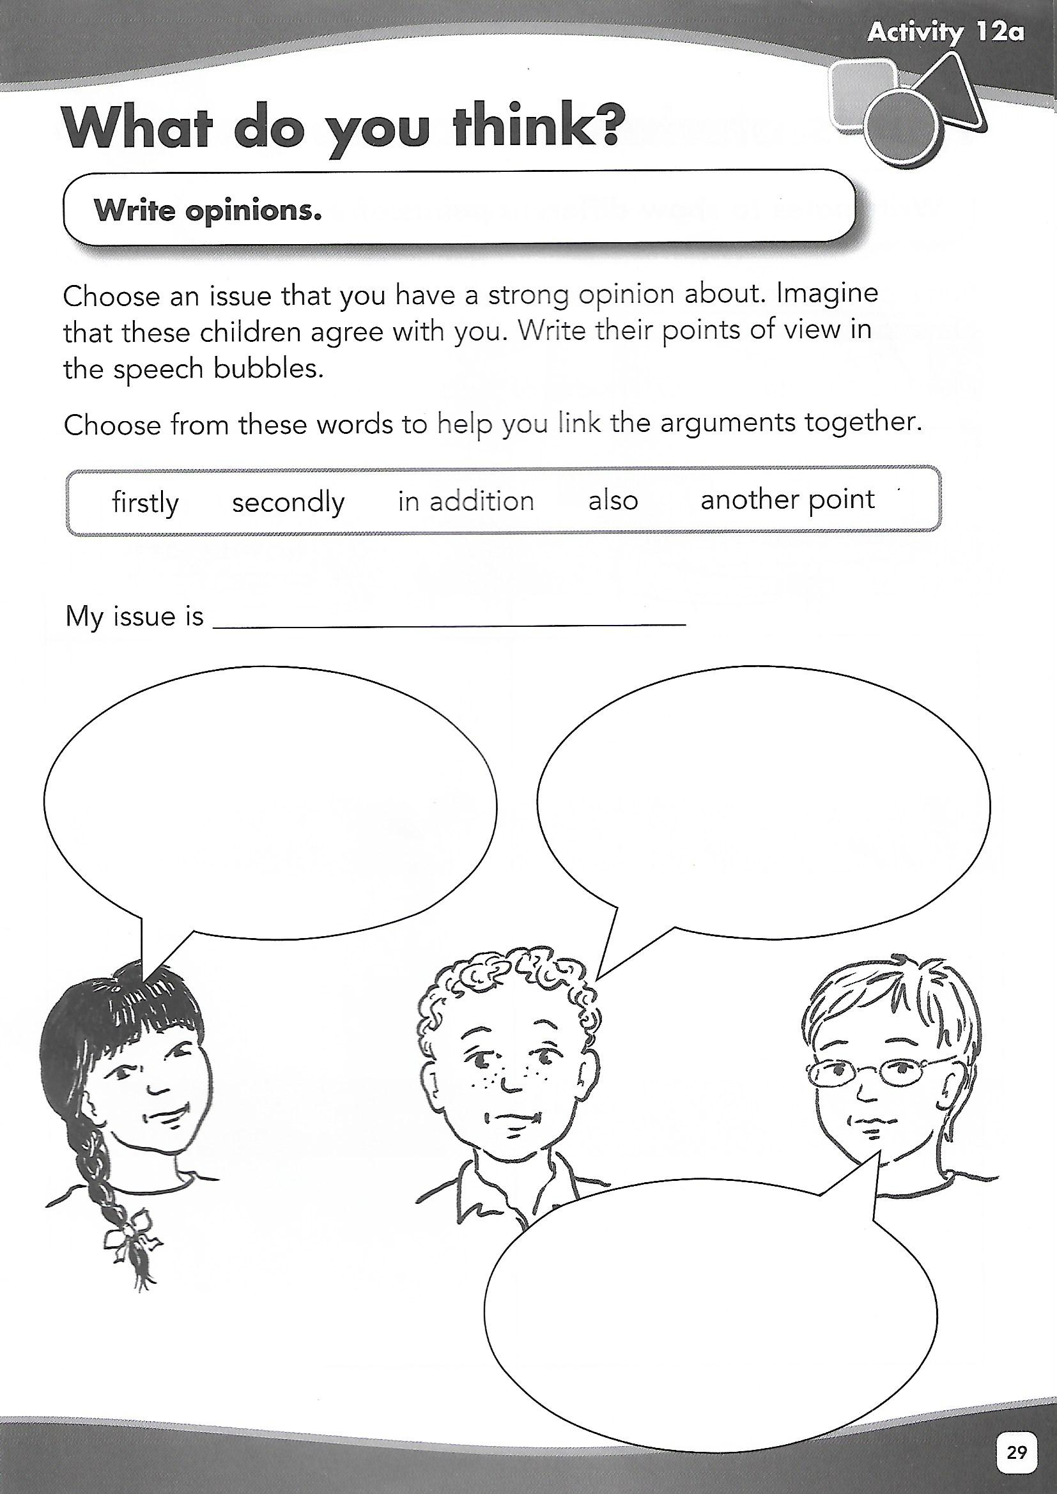
Numeracy – Thursday P6

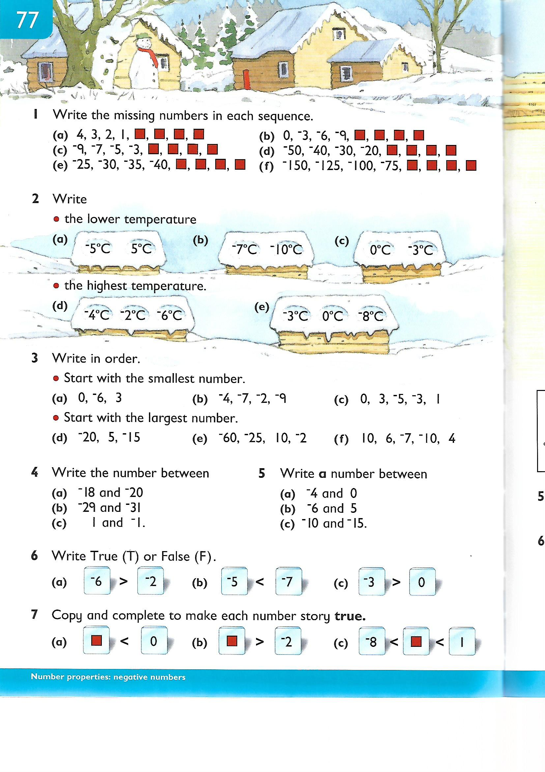
Numeracy – Thursday P7

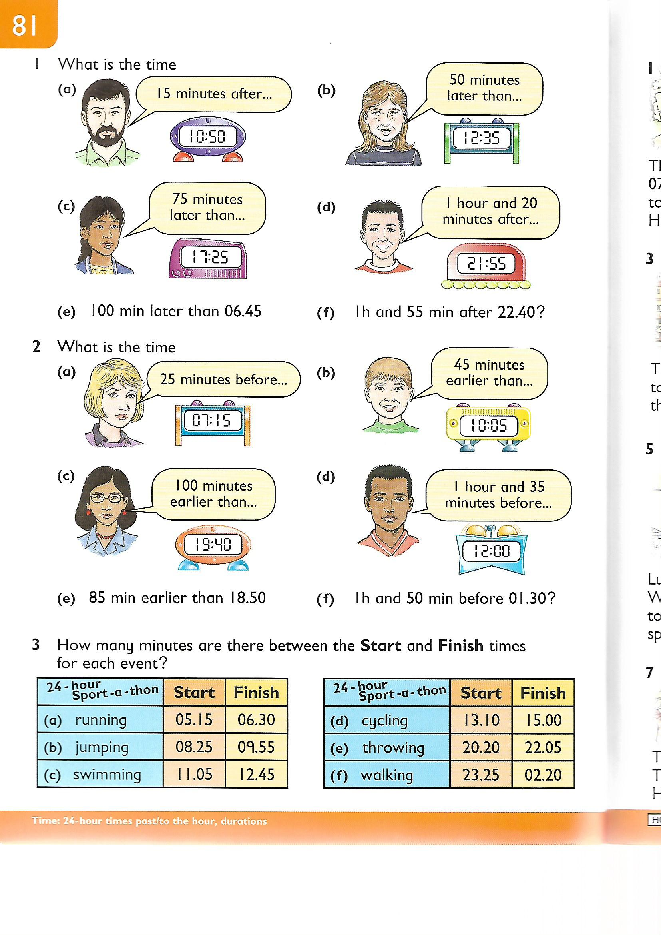
Numeracy – Friday P6

Go onto YouTube and search for Stuart Montgomery. I asked him to create a tutorial based on pie charts to help support this element of your learning. This will appear within the transfer exam.
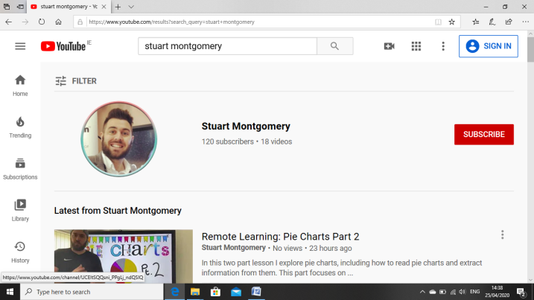

He has two tutorials based on Pie Charts, click on Pie Charts Part 1
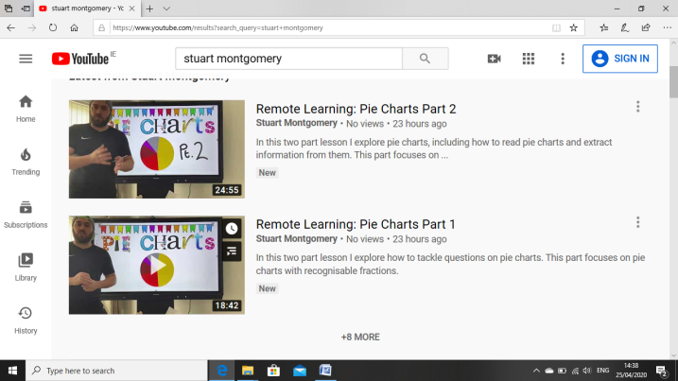

Click on the video and click on see more and you will notice a link for an attached worksheet. Watch the tutorial and complete the worksheet. Go back over the tutorial and this will support you with self assessment.
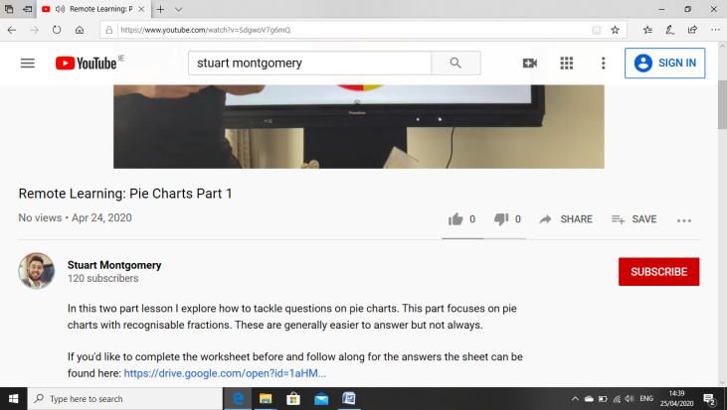

Numeracy – Friday P7

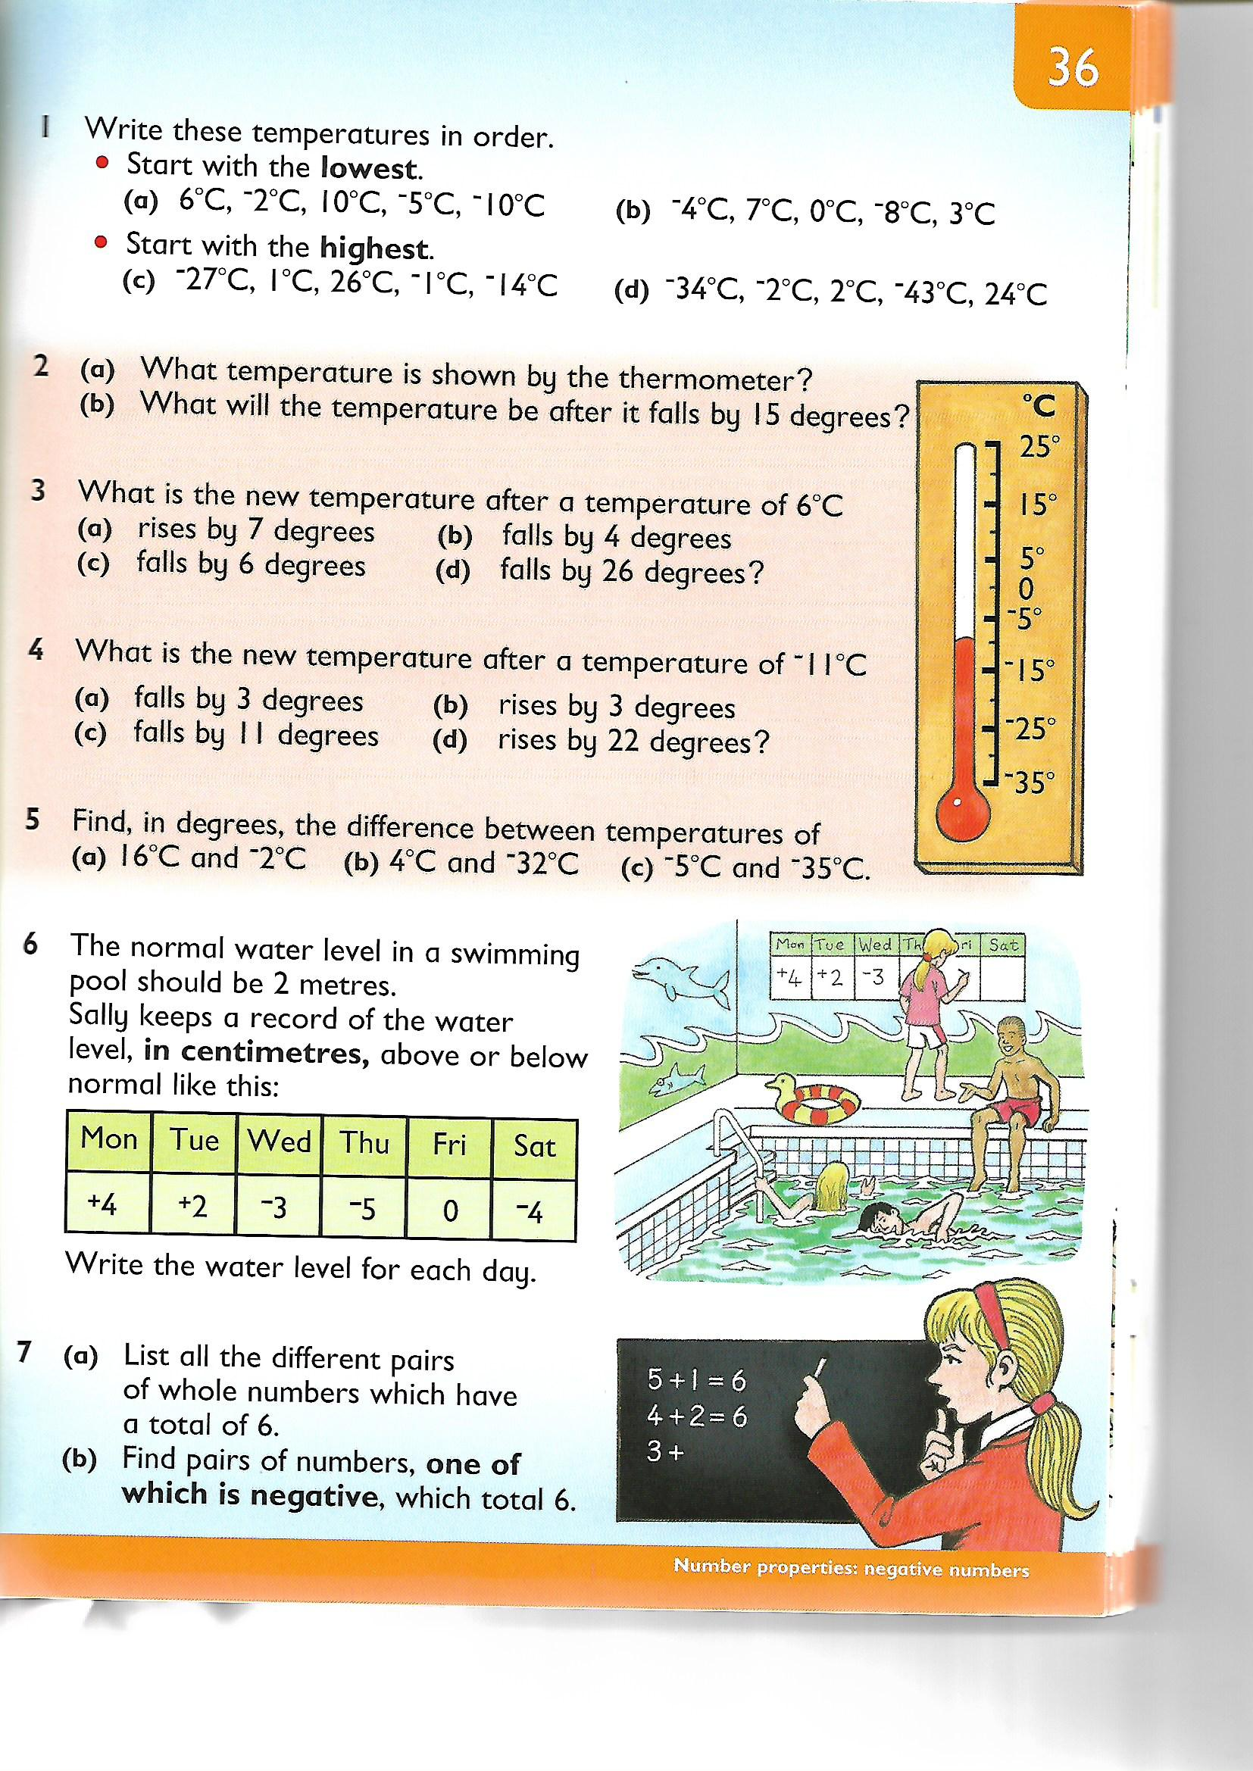

Stem Lesson – Tuesday

Minecraft
Minecraft have FREE digital lessons for the children to enjoy at home until 30th June these can be found in Minecraft Marketplace: Minecraft.net – www.minecraft.net/en-us/marketplace/education
Try the Lumen City Challenge to distinguish between renewable and non renewable energy.

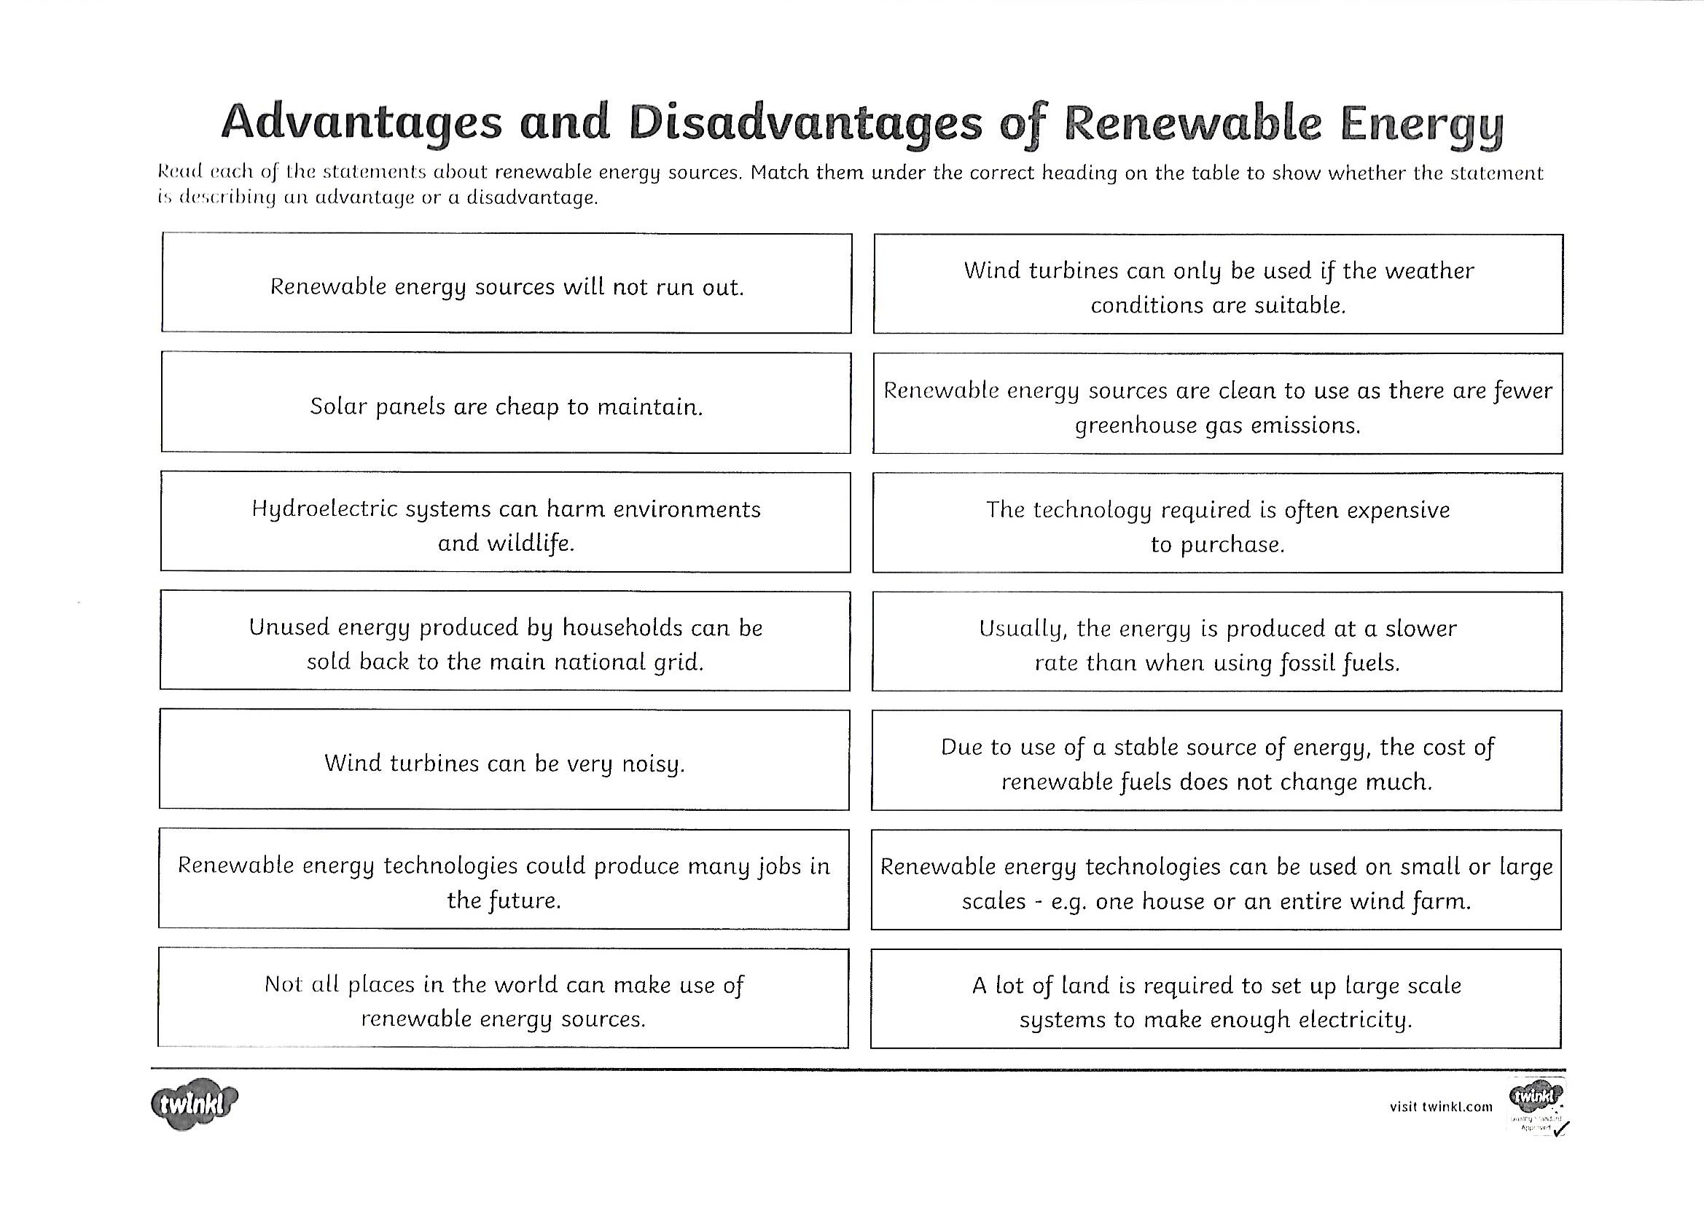
WAU Lesson Monday

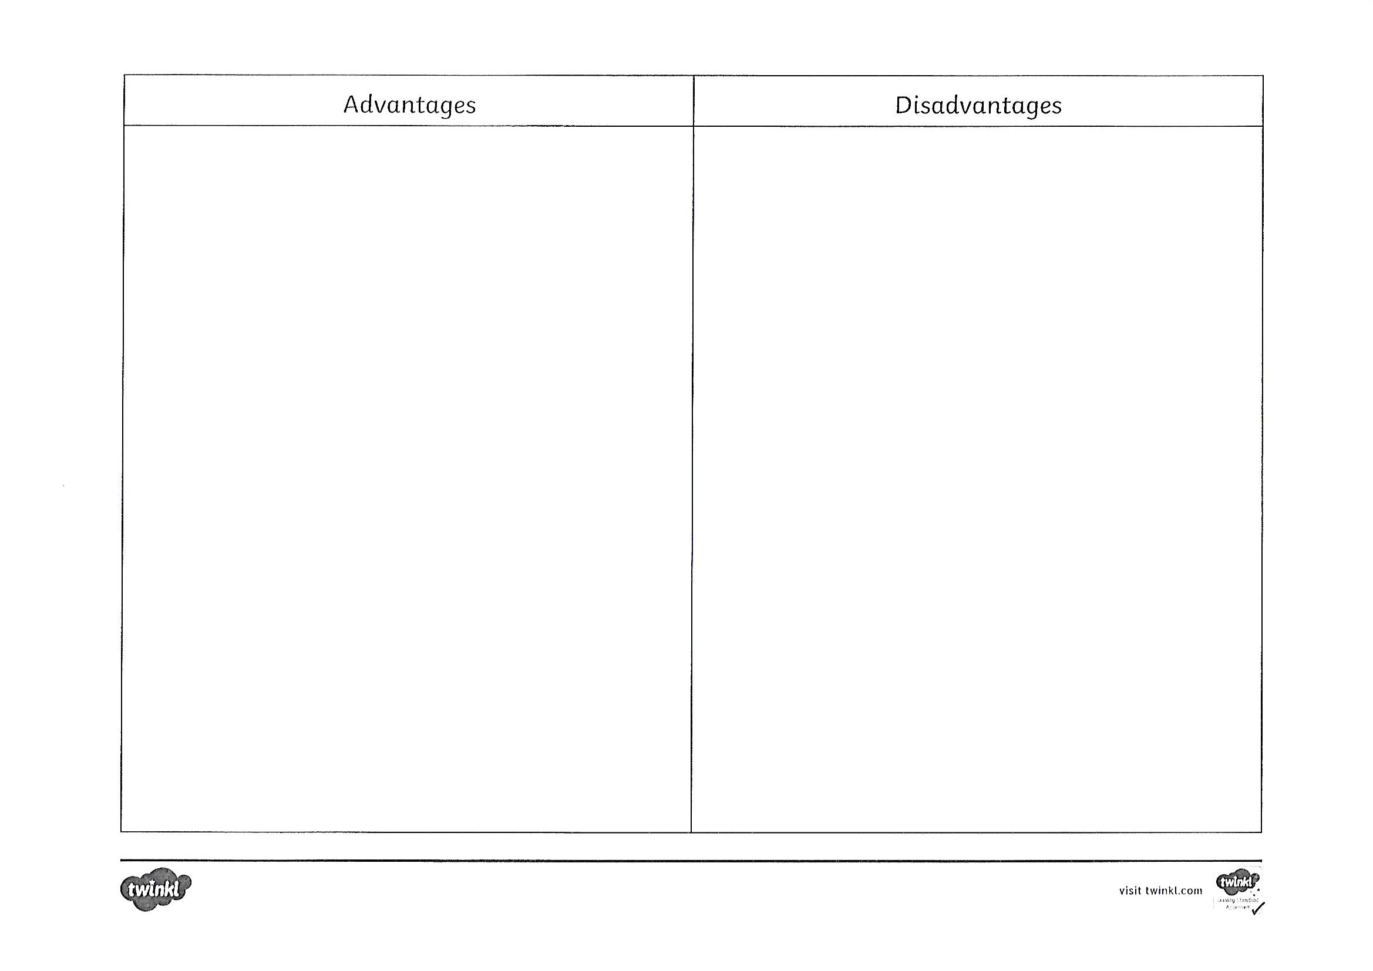
Wellbeing – Coping Calendar

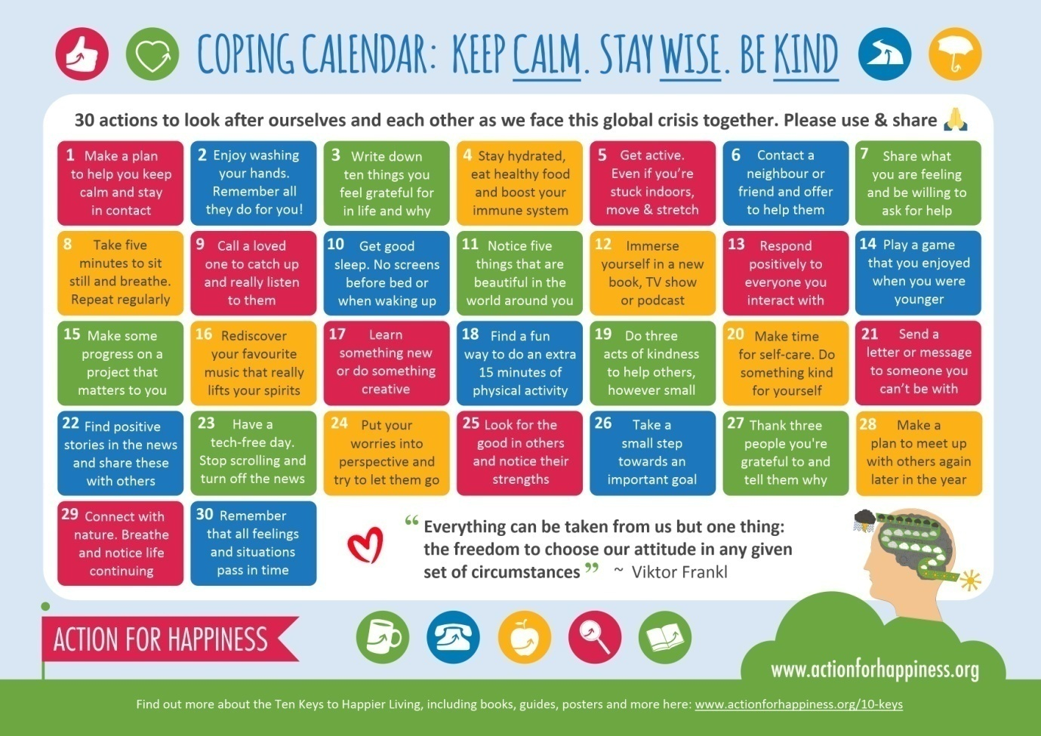

Golden Time Ideas
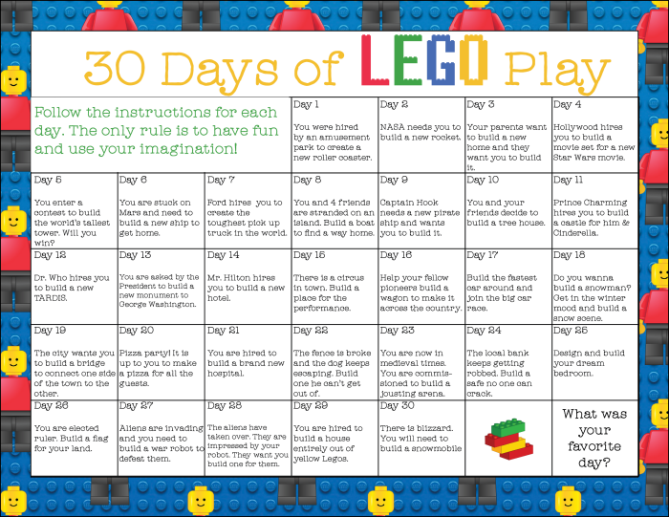

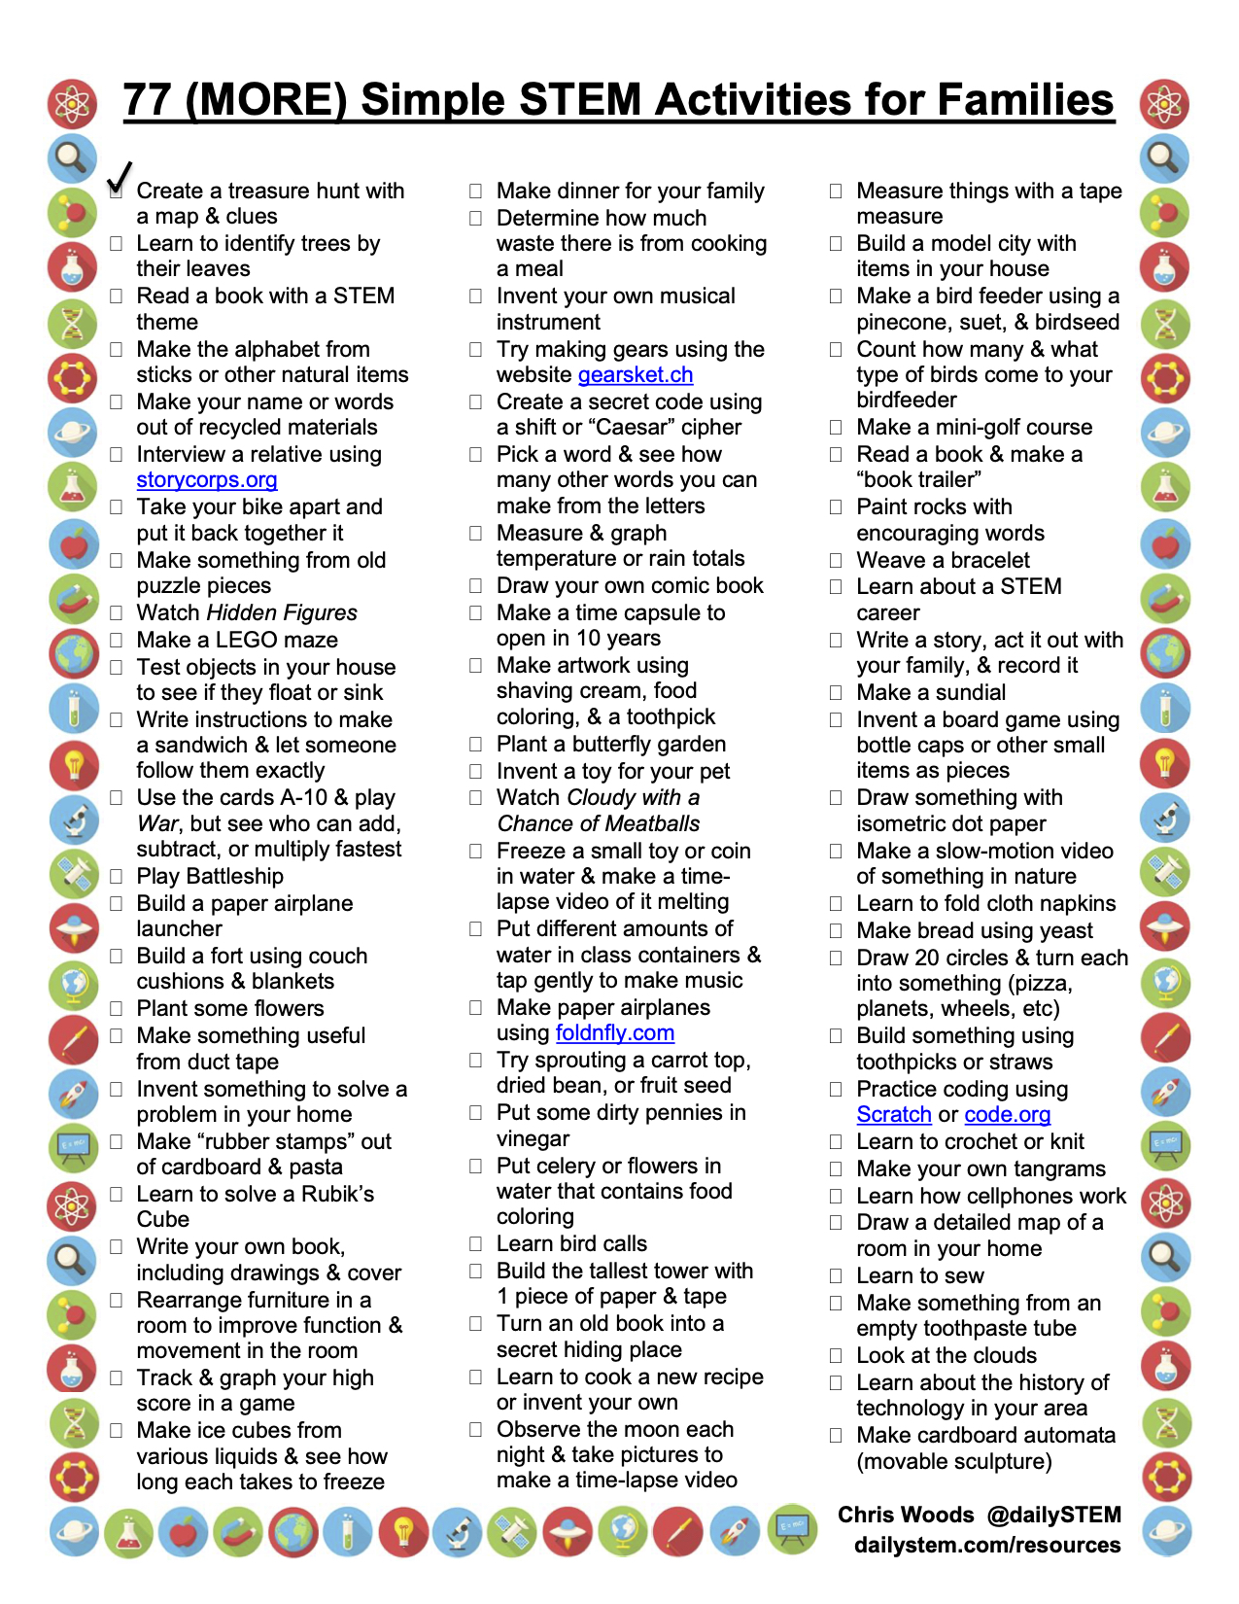

Transition Worksheet - GETTING READY FOR SECONDARY SCHOOL

- You will be thinking about your new school
- You may be worried – This is a natural feeling
- Please answer the questions by circling the number that best shows how you feel.
- 1 means you are not worried at all. 4 means you are very, very worried
Getting lost 1 2 3 4
Making Friends 1 2 3 4
Getting detentions or consequences 1 2 3 4
Having lots of different teachers 1 2 3 4
Finding class work too difficult 1 2 3 4
Homework 1 2 3 4
Doing PE 1 2 3 4
Changing and showering 1 2 3 4
Being late for school 1 2 3 4
Being late for lessons 1 2 3 4
Having your money stolen 1 2 3 4
Having other property stolen 1 2 3 4
Break time / Lunchtime 1 2 3 4
Doing tests and exams 1 2 3 4
Forgetting books or equipment 1 2 3 4
Getting ill 1 2 3 4

