Boys and Girls,
Here are some activities that you might enjoy.
Garage Band
News desk features digital music lessons using Garageband every Monday. Log onto Newsdesk and go to News Bank, the story is listed as ‘Musical Monday: Garageband.’ You are able to access all past lessons on this page. You will really enjoy this, I am!
The Poetry Games Competition
Log onto Newsdesk and go to News Bank, the competition is listed as The Poetry Games. Have a go and submit an entry!
Two Minute Tales Competition
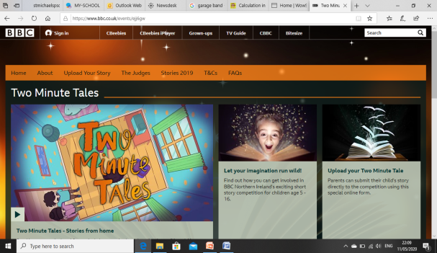
A creative writing competition open for children aged between 5-16 with the chance to have your short story brought to life on BBC Radio Ulster or even made into your very own animation. The theme is ‘Home’ and the story can be no more than 300 words. For more information log onto
https://www.bbc.co.uk/events/ejj6gw

Oxford Owls
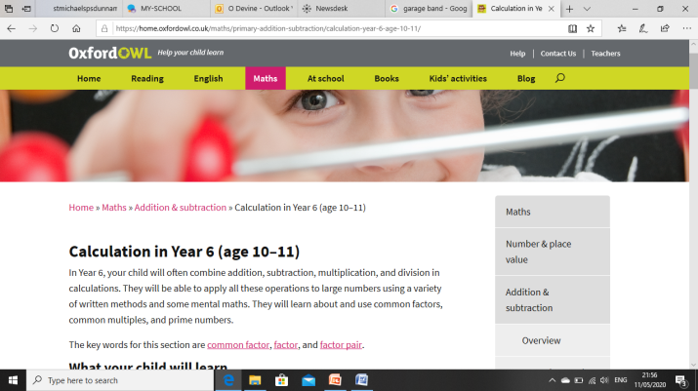
Not only do they have a wonderful array of guided reading books they now also feature a Numeracy section with answers included.

Young Enterprise
Young Enterprise has updated their FREE online resources with exciting ideas including challenges and competitions. Log onto https://yeni.co.uk/ and go to the Online Learning section for different challenges. There is an exciting competition within the News section called ‘Moy Park Challenge 2020’.
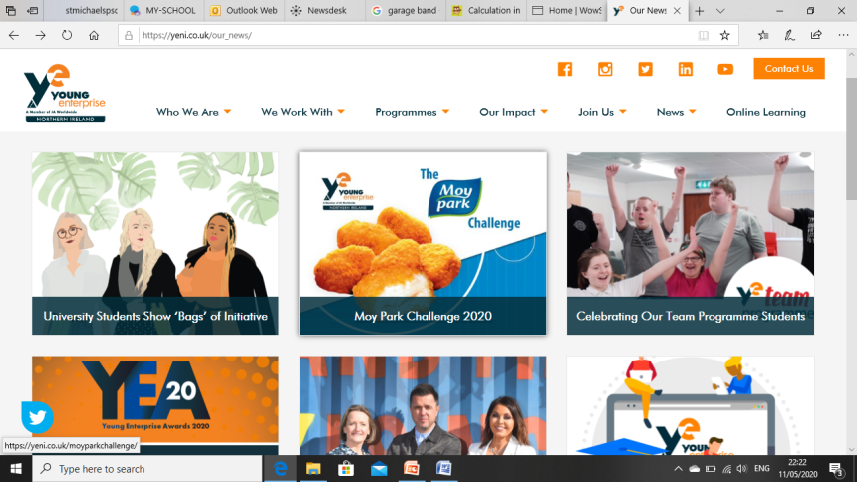

Take Care
Miss Devine

