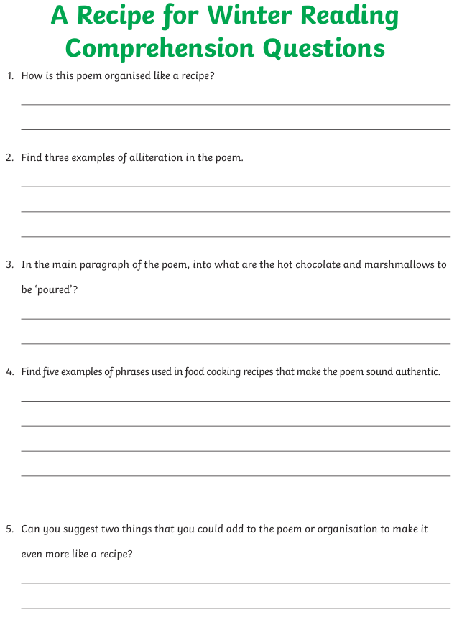
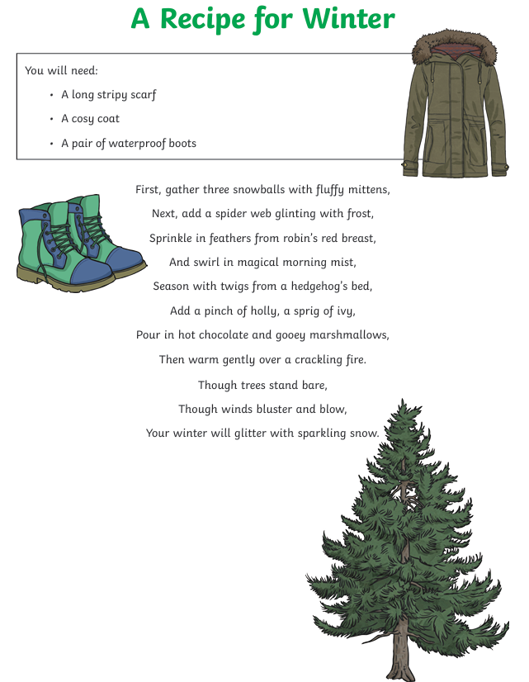

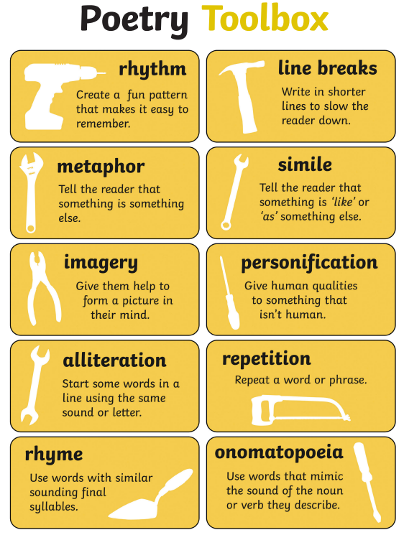
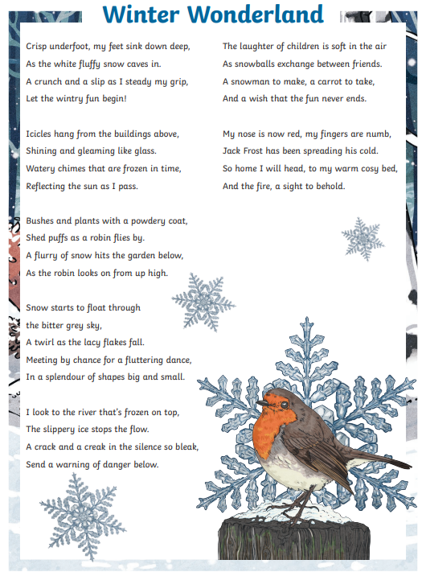
Read the poem Winter Wonderland. Can you write your own poem about the Winter Wonderland around your house this week. Please try and use 2 or 3 poetry terms from the Poetry Toolbox and complete your poem in your homework book or on a page.

