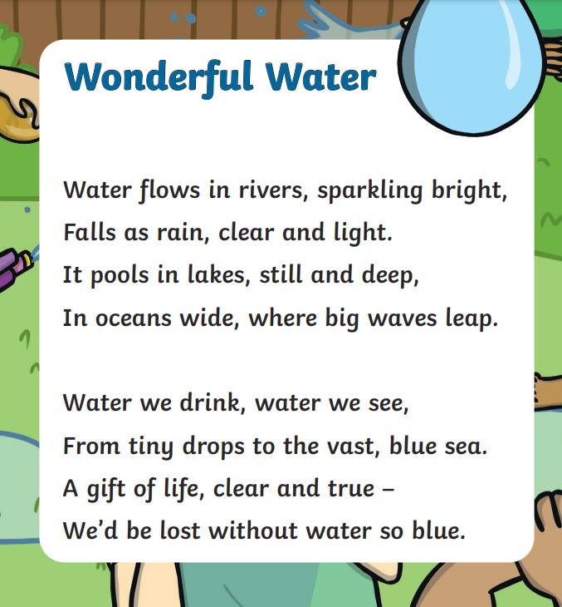

Read the poem above, recognise the rhyming words and structure of the poem. Now, create your own 2 verse poem on ‘Wonderful Water.’

