Dear Parents,
I hope you all have had a lovely Easter. Find attached your child’s schedule for Week 4. I can’t stress enough that this is only a guide. Some parents prefer a more structured timetable for their children so please take from this what is manageable for your family. I understand completely how challenging it is working from home, while home schooling children.
Our new topic on ‘Renewable Energy’ is starting on Monday 20th April and there will be activities set connected to this theme.
Primary 7 Transition to Post Primary
After Easter I have always focused on a transition programme for Primary 7 to help support and prepare them post primary. It is quite challenging to be able to do this remotely as it normally involves a lot of PDMU work and is mainly discussion/ practical based. However BBC Bitesize has developed a set of lovely videos to support children.
Go to Bitesize Home – Select Primary – Select Northern Ireland KS2 – Select PDMU – Topics Transition https://www.bbc.co.uk/bitesize/subjects/zksyb82

Educational Television
BBC Bitesize are launching daily lessons starting Monday at 9.00 am for all ages. They will also have a new dedicated TV channel full of learning content, podcasts on BBC Sounds and educational videos on iPlayer. Find attached the link to the weekly schedule https://bam.files.bbci.co.uk/bam/live/content/zjh72sg/pdf I want to draw particular attention to the Primary 6 English lessons on Monday and Tuesday and the Maths on Wednesday and Thursday. The elements which are covered on these particular days are extremely popular in the transfer papers.
I still can’t recommend RTE School Hub enough. On RTE 2 11 a.m. – 12 p.m. Monday to Friday.

Prim – Ed Publishing
This reputable firm that many schools use have produced downloadable home learning packs for parents for free once you register. I have reviewed them and they are excellent, they contain mainly daily literacy and numeracy 10 minute tasks.
https://www.prim-ed.co.uk/blog/post/parent-information-centre/

Online Learning – Newsdesk and Education City
I do try to give a balance of online learning and pencil paper exercise as I am aware how difficult it can be sharing electronic devices at home. This week I have set new tasks within Education City under the Homework section and I have scheduled them into the timetable, all online activities should be supported afterwards with the accompanying worksheet. If you don’t have a printer, don’t worry, read the question from the screen and note the answer down on a page. Well done to those children who completed the online Newsdesk activity set.
Please ensure children follow the online safety guidelines and exercise caution when using electronic devices. Don’t forget to download the DENI Safer Schools App to support you as you keep your children safer online. Download the App for free by searching for ‘Safer Schools’ in the Apple App Store or on Google play. (You can download it on more than one device!)
Numeracy Support
- If you are having difficulty explaining any mathematical concepts to your children this week Carol Vorderman is doing online maths tutorials www.themathsfactor.com
Libraries NI
https://www.librariesni.org.uk/Children/Pages/default.aspx Libraries Northern Ireland are setting weekly activities.
Religious Studies Programme
The Derry Diocesan Catechetical Centre have a beautiful resource online to help children know of the 50 days of Easter can be accessed along with other resources at www.catecheticalcentre.org
We have been granted free access for all our parents on a temporary basis to our Grow in Love Programme. See details on the weekly schedule.
Login to Grow in Love – Religion Programme is: www.growinlove.ie
Email: trial@growinlove.ie
Password: growinlove
Select Primary 6 for Year 6 and access the ebook on the right hand side of the screen, similarly do the same for Year7.
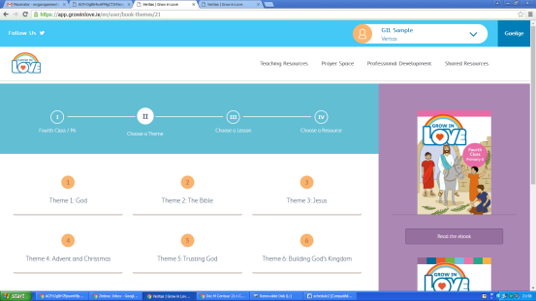
Pupil Wellbeing
- Relax Kids has produced a FREE MP3 ALBUM of mindful moments for children. www.relaxkids.com/calminthechaos
- Healthy Kidz Global Challenge – free access to mini workouts, games, beat the coach challenges and mindfulness tips.
- Don’t forget Autism NI have also created a fantastic ‘Anxiety Resource Pack,’ which can be downloaded from www.autismni.org/anxiety-resource-pack.html
- A list of free Apps that parents can download for their children to manage their self-care and emotional well-being : www.autismni.org/free-apps-for-children---self-care-and-emotional-well-being.html
Coping Calendar is attached at the end of this schedule provided by Action for Happiness.
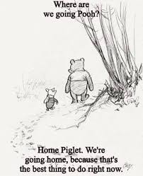
Please let the children know how much we are missing them right now and can’t wait until we are reunited to hear all their stories! There are a few Winnie the Pooh fans in the classroom and I hope regardless of how bored they may think they are, they will appreciate this image.

Take Care,
Miss Devine and Miss McCauley

Spelling Lists for Week 4
ible/able
Year 6 Spelling List
Admirable
Edible
Adorable
Incredible
Reliable
Forgettable
Arguable
Divisible
Flexible
Removable
Avoidable
Invincible
Irritable
Unmistakable
Believable
Considerable
Credible
payable

Year 7 Spelling List
Fashionable
Reasonable
Audible
Impossible
invincible
valuable
reversible
indestructible
permissible
understandable
accessible
susceptible
illegible
inflammable
legible
knowledgeable
changeable
available

 | Monday | Tuesday | Wednesday | Thursday | Friday
9-15 -9-30 | Phonics  Scaffold Text- see attached | Phonics  Word sort into the different variations | Phonics  Paper squares – one square per sound | Phonics  Create story using as many of the spelling words as possible | Phonics  Spelling Test
9-30-9-45 | Mental Maths  Complete Mental Arithmetic Book Section A/B or C or Mental Maths Daily test | Mental Maths  Mathsframe.co.uk | Mental Maths  Complete Mental Arithmetic Book Section A/B or C or Mental Maths Daily test | Mental Maths  Top Marks Daily 10  Select Level 5 P6  Level 6 P7 | Mental Maths  Complete Mental Arithmetic Book Section A/B or C or Mental Maths Daily test
9-45-10.30 | Religion – Weekly Activity  Grow in Love Details in above notes  P6 – Read pg61-63 Complete activities listed  P7 – Read pgs74-77 complete activities listed | STEM - Minecraft Lesson – Renewable Energy – see details below on how to access. | Religion – Weekly Activity  Grow in Love Details in above notes  P6 – Read pg61-63 Complete activities listed  P7 – Read pgs74-77 complete activities listed | PATHS  Do one thing from the 30 Days of SEL Poster – see attached. | PE – With supervision from parents try Annie Deery’s yoga class for kids. She can be found on facebook – Annie Deery.
Break
11.00 -11.45 | Literacy  Complete one of your comprehension activities found within your pack. | Literacy  Punctuation  Education City Online game+ accompanyingworksheet  P6 – Let’s Eat Granny  P7 – Jungle Dash | Literacy  Discussion Texts  See notes attached | Literacy  Grammar  Education City Online game+ accompanyingworksheet  P6 – Bad Hair Day  P7 – The Great Stensby | Literacy  Complete one of your cloze procedures found within your pack.
11.45-12.00 | Movement Break  PLEASE try GoNoddle this week, children will LOVE it.  https://family.gonoodle.com | Movement Break  PLEASE try GoNoddle this week, children will LOVE it.  https://family.gonoodle.com | Movement Break  PLEASE try GoNoddle this week, children will LOVE it.  https://family.gonoodle.com | Movement Break  PLEASE try GoNoddle this week, children will LOVE it.  https://family.gonoodle.com | Movement Break  PLEASE try GoNoddle this week, children will LOVE it.  https://family.gonoodle.com
12.00 – 12.45 | Numeracy  Number –  Education City  P6 – x6 Challenge +Worksheets and Multiplcation Table  P7 – 8x Challenge +Worksheets and Multiplcation Table | Numeracy  Measures – Time  Corbett Maths Primary See Attached Notes | Numeracy  Number – Education City  P6 – Ready Steady Bake – both activities  P6 – Water World Activities +Worksheets | Numeracy  Data Handling  Education City  P6 – x6 Mean Beans +Worksheets  P7 - Worksheet Attached | Numeracy  Problem Solving  Corbett Maths Primary- see attached Notes
Lunch
1.30-2.30 | WAU – KS2 Bitesize – What is Renewable and Non renewable Energy | Art  Complete Research on Van Gogh paying particular attention to his windmill paintings | PE –PE with Joe Wicks – Youtube – try one of his classes | WAU – Make a poster – see attached notes | Golden Time  Try out some of the Lego/ Stem challenges attached
2.30 – 3.00 | Accelerated Reading | Accelerated Reading | Accelerated Reading | Accelerated Reading | Accelerated Reading

Monday- Phonics
Primary 6 Scaffold Text

The ‘ible’ and ‘able’ Word Endings
Read the text. Can you find any ‘ible’ or ‘able’ words?
Remember to read the word to check it has the right sound before you highlight it.
In our house, I am responsible for any new technology; I am the only one capable of installing new products. I usually find it enjoyable to set up gadgets. However, I was having a terrible time trying to install the new television. I had connected all the flexible cables correctly and still the picture was fuzzy and the reception unreliable. An error message kept appearing that said, ‘It is advisable to check all possible connections if picture quality is not acceptable.’ I was really not in an agreeable mood and it didn’t help when everyone kept suggesting that the only sensible thing to do was turn the T.V. off and then back on again! I was very uncomfortable in my current position behind the television and I had a horrible headache.

Monday Phonics
Primary 7 Scaffold Text
The ‘ible’ and ‘able’ Word Endings.
Read the text. Can you find any ‘ible’ or ‘able’ words?
Remember to read the word to check it has the right sound before you highlight it.
Ali looked at the adorable car seat with the removable zebra-print cover in the shop. It was arguable that the considerable cost of the seat was because of the reliable reputation its makers had. Ali found the lure of the cute cover irresistible and she bought the seat. The shopkeeper said that she could make flexible payments to cover the cost. Later that evening, Greg’s irritable mood was unmistakable. When she spoke to him about it, he said he found it incredible and unbelievable that she would spend so much money without telling him and run up debts that were avoidable. He reminded her that they already had a perfectly good car seat. Ali tried to explain that the other one was just navy and forgettable but that this one had a zebra-print cover. Suddenly, she heard herself and realised that it would not be a workable option to keep spending their budget the way she had been. Soon, their money would have to be divisible between three people. She told Greg she would be more sensible in future.

Wednesday – Literacy P6
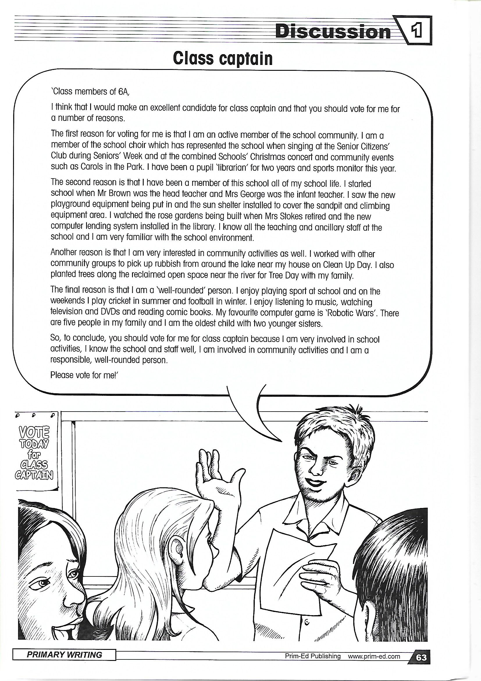

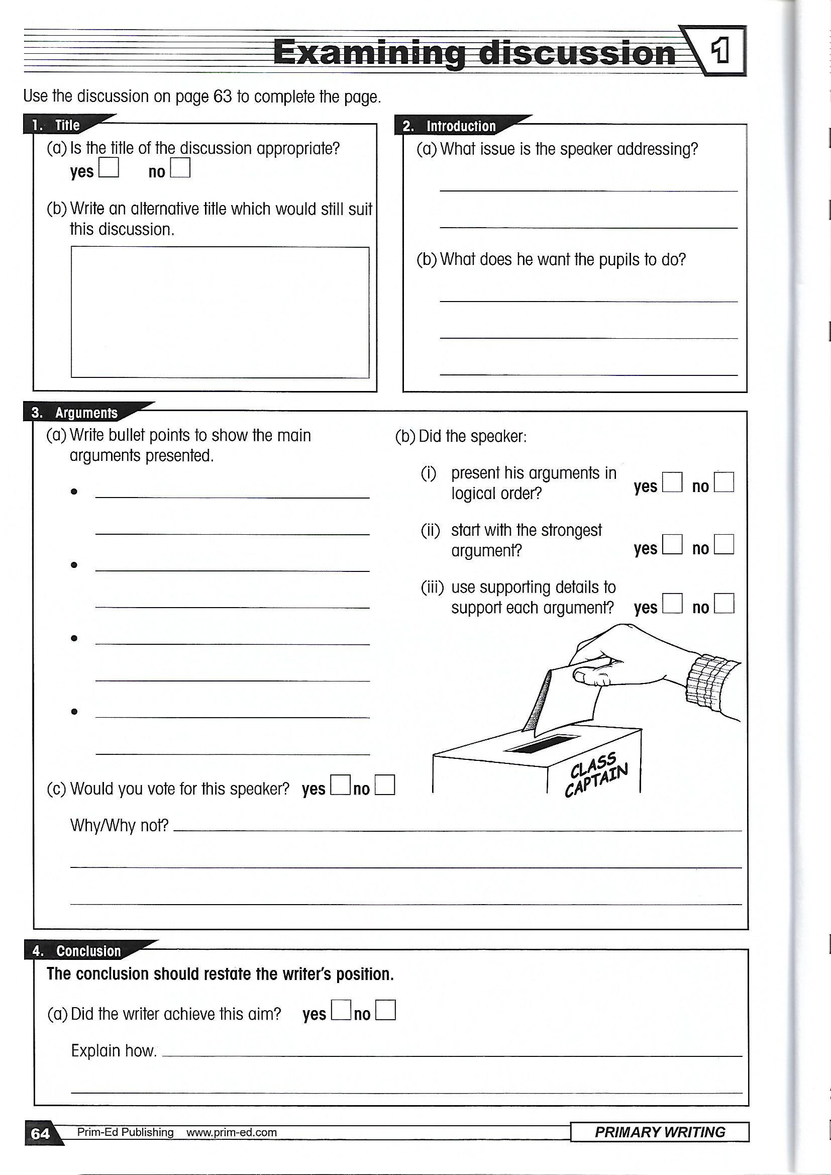

Wednesday – Literacy P7
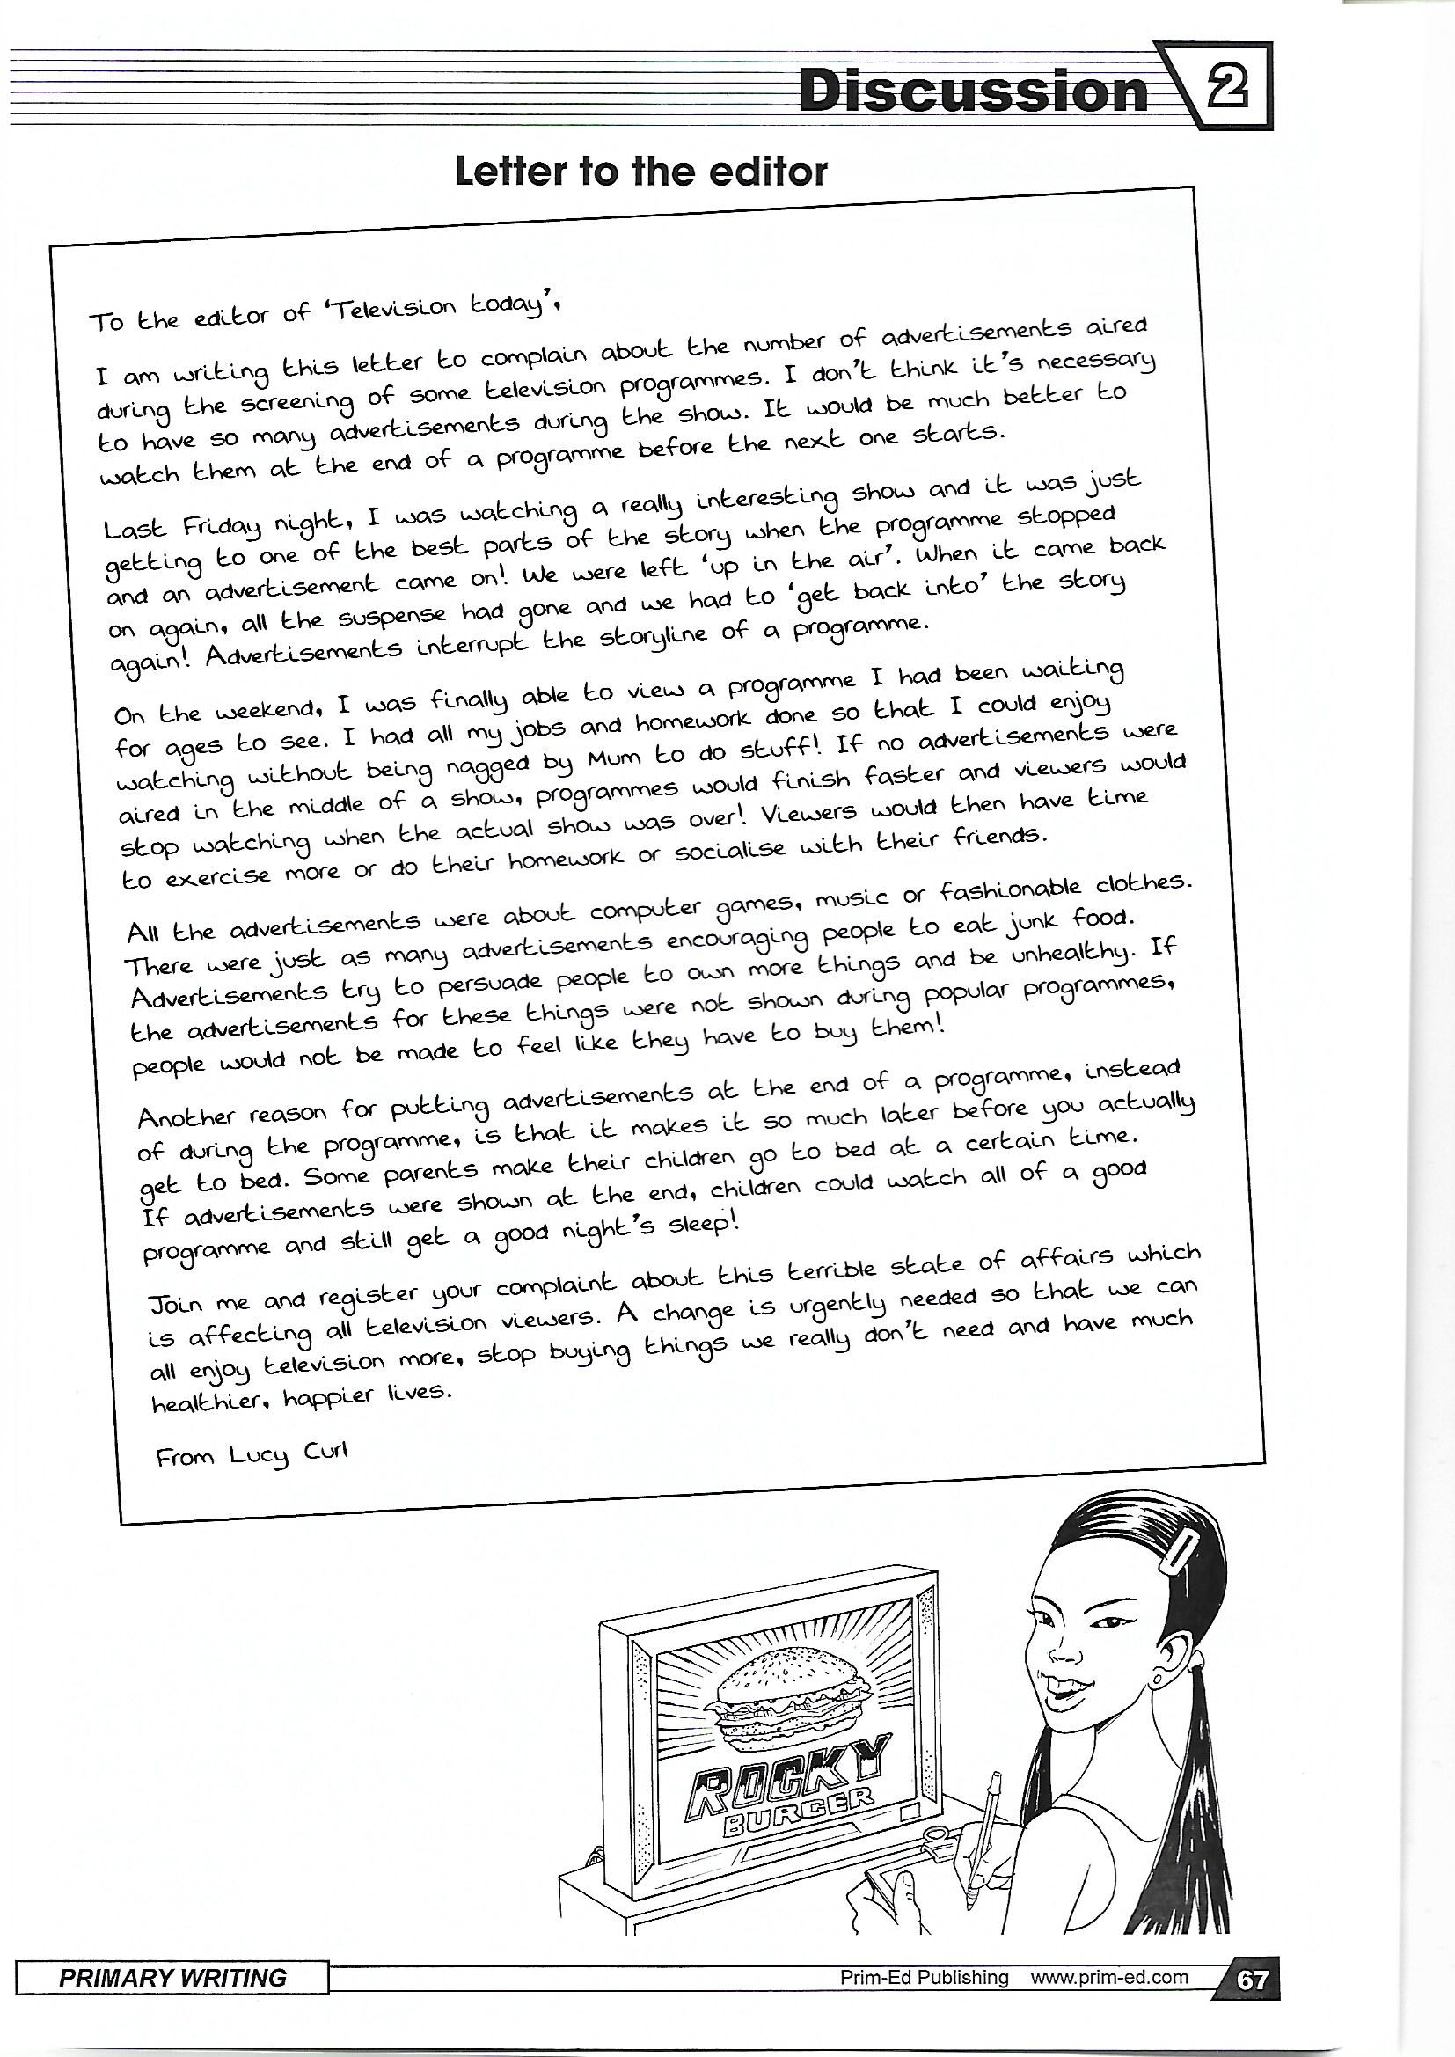

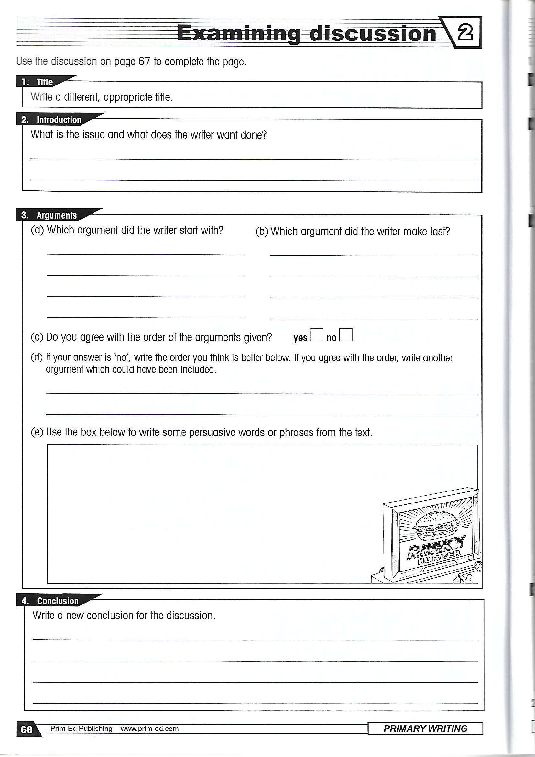

Numeracy - Tuesday
Maths activities will be taken from Corbett Maths Primary for Primary 6 and 7(it’s free with no registration required)

Primary 6
Log into https://corbettmathsprimary.com/ scroll down to videos (2nd Option) – scroll down to Time, select questions and click on the orange ‘Click here for Questions’ and complete the practise paper.
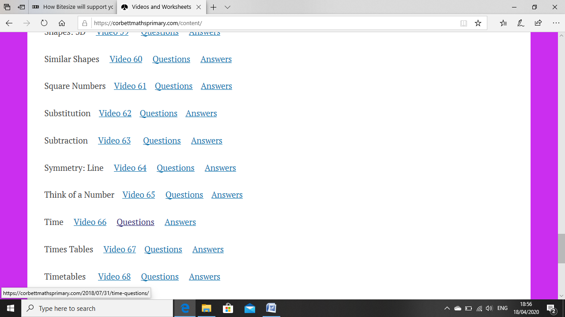
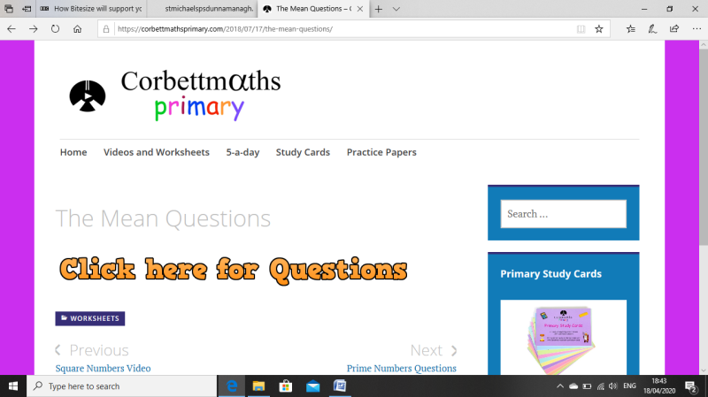

Primary 7
Log into https://corbettmathsprimary.com/ scroll down to videos (2nd Option) – scroll down to Timetables that has video 68 connected to it, select questions and click on the orange ‘Click here for Questions’ and complete the practise paper.
Numeracy Thursday Primary 7 – Data Handling

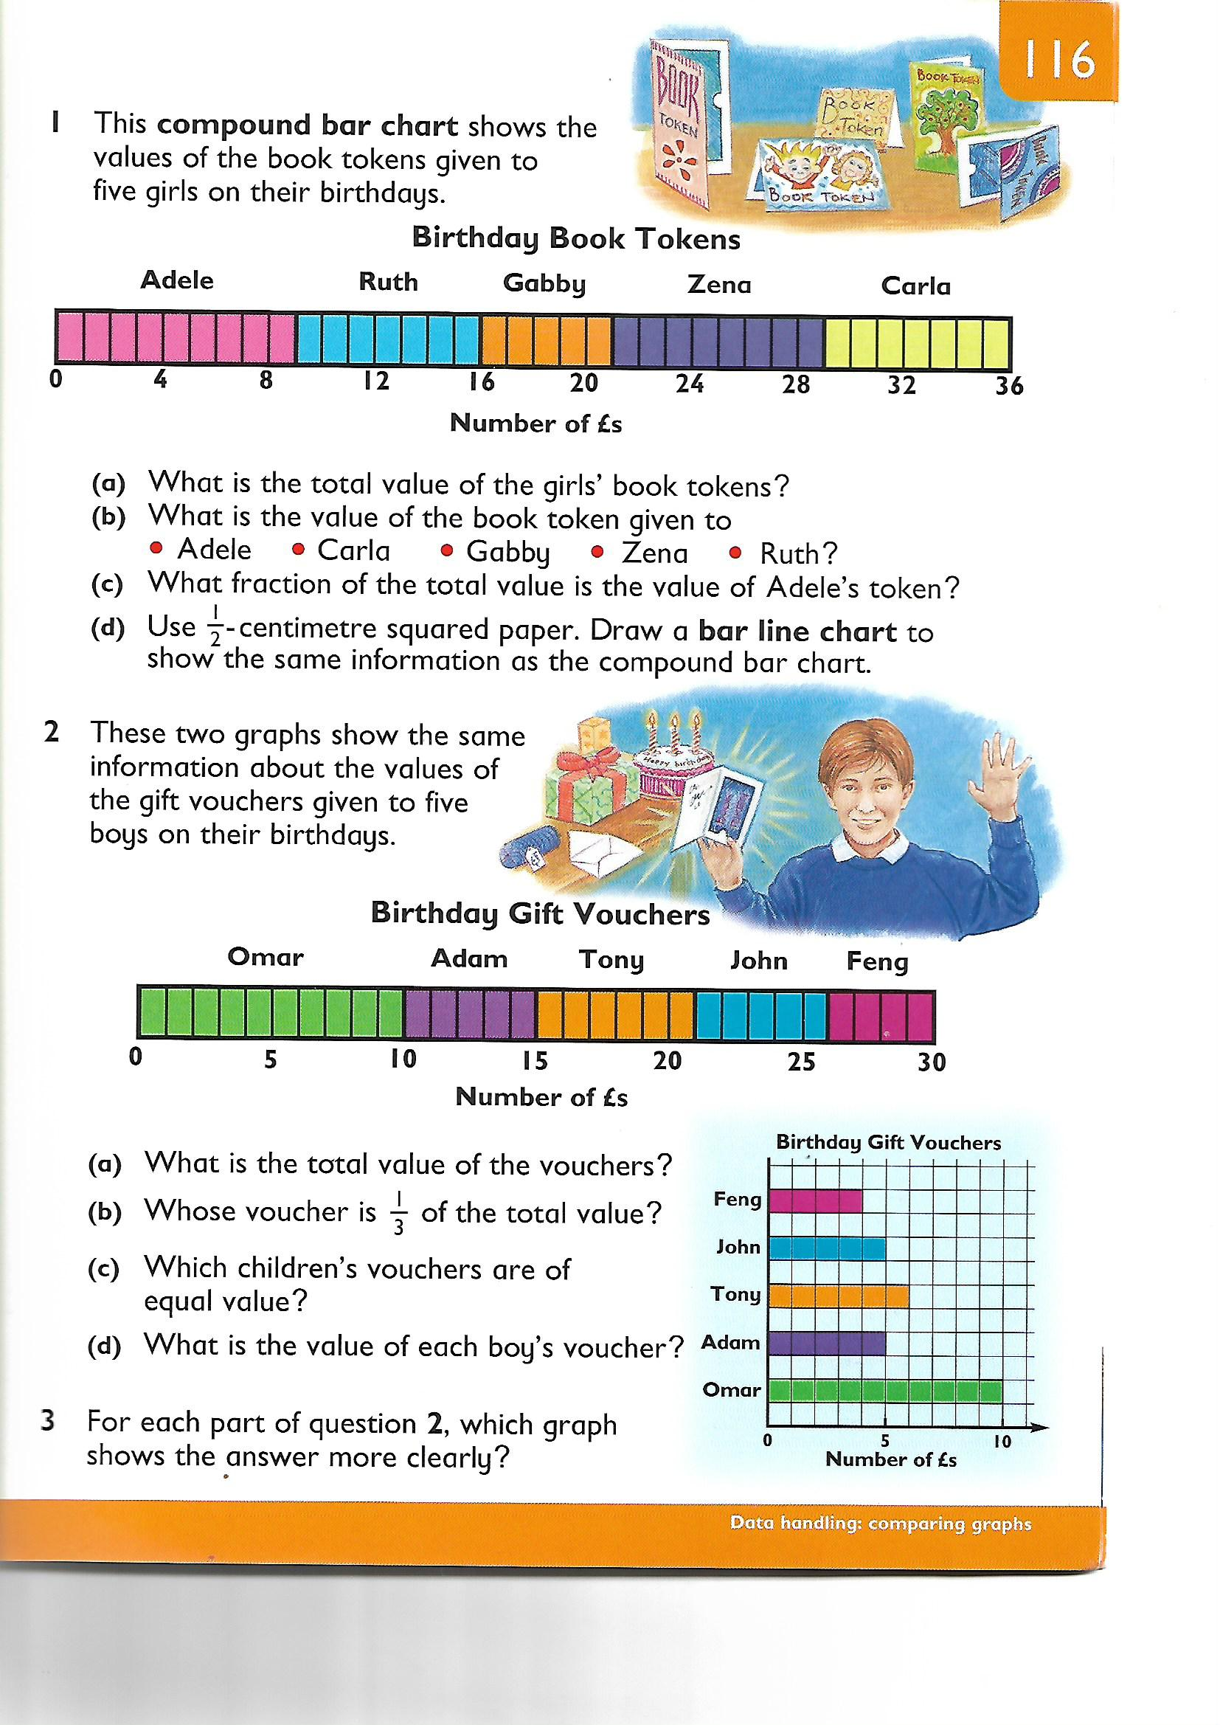

Numeracy Friday
Maths activities will be taken from Corbett Maths Primary for Primary 6 and 7(it’s free with no registration required)

Primary 6
Log into https://corbettmathsprimary.com/ scroll down to videos (2nd Option) – scroll down to The Mean, select questions and click on the orange ‘Click here for Questions’ and complete the practise paper.
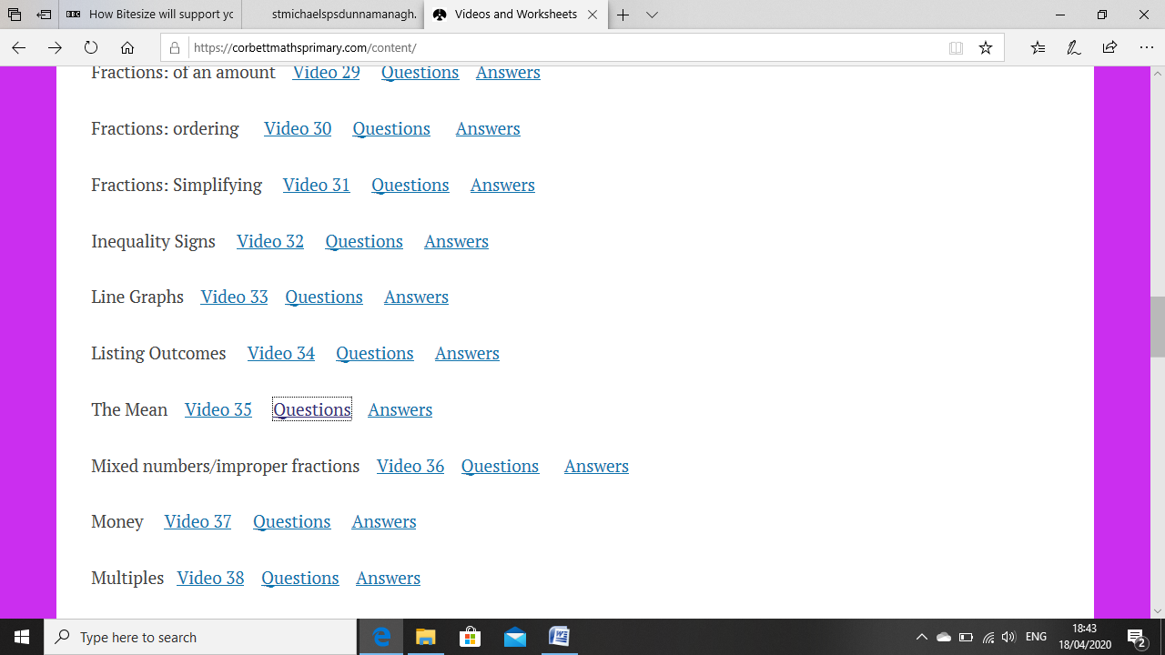

Primary 7
Log into https://corbettmathsprimary.com/ scroll down to videos (2nd Option) – scroll down to Equations, select questions and click on the orange ‘Click here for Questions’ and complete the practise paper.

Stem Lesson – Tuesday

Minecraft
Minecraft have FREE digital lessons for the children to enjoy at home until 30th June these can be found in Minecraft Marketplace: Minecraft.net – www.minecraft.net/en-us/marketplace/education
Try the Renewable Energy Lesson

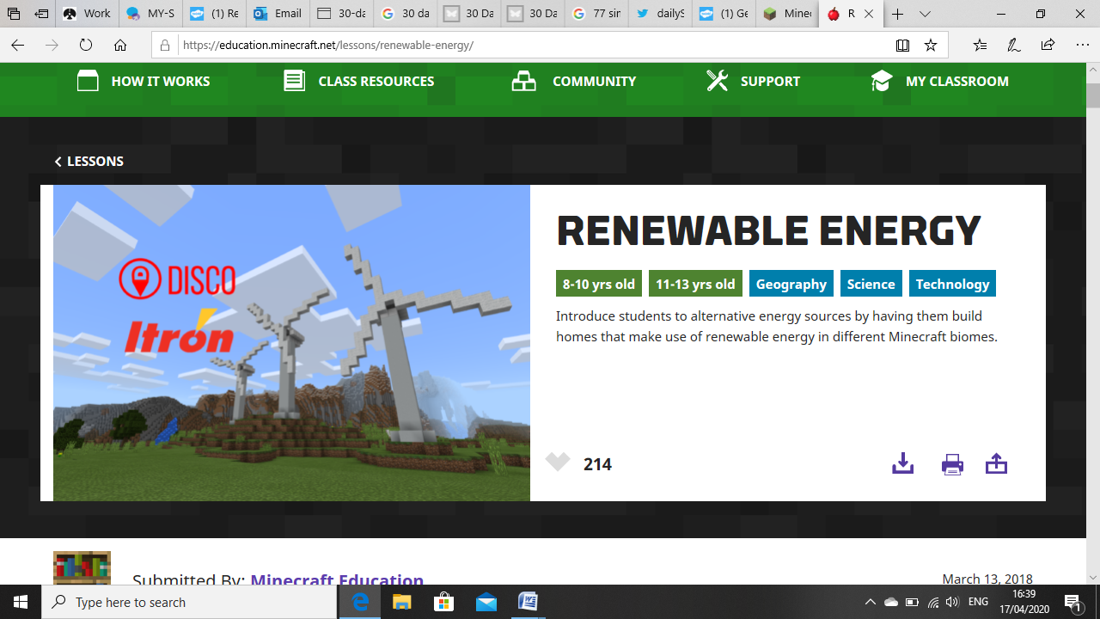

Paths Lesson - Thursday
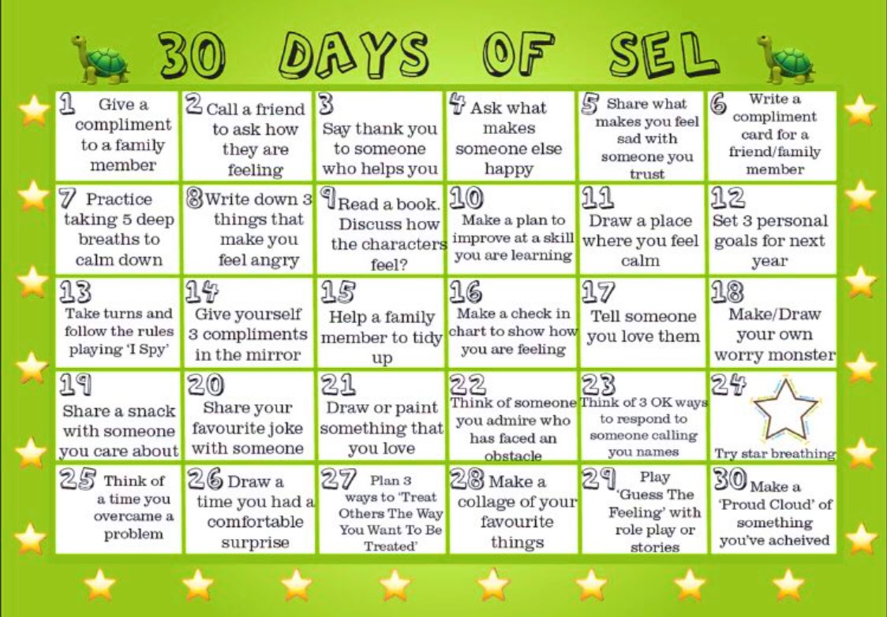

WAU Lesson Thursday
Make a poster / powerpoint about renewable and non renewable energy.
- Make a statement about what renewable energy is.
- Make a statement about what non renewable energy is.
- On your poster list three things we use energy for.
- Draw 2 sources of renewable energy and write a statement beside each one.
- Draw 2 sources of non renewable energy and write a statement beside each one.

Wellbeing – Coping Calendar

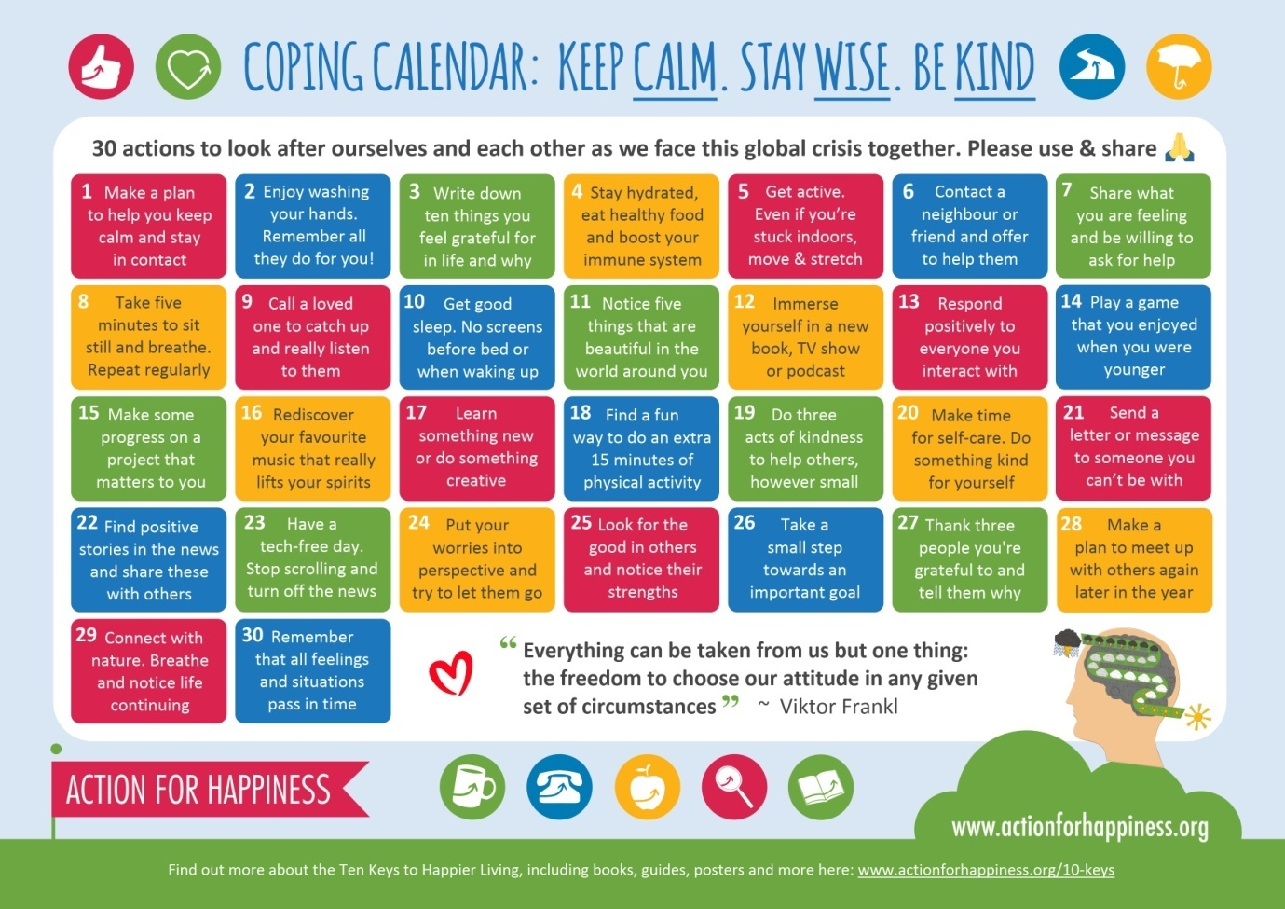

Golden Time Ideas
