Monday 22nd February
English:
Reading
Combined skills and reader (3A)
P22
1st Class “Minibeasts” Paragraph 1,2
2nd Class “France” Landmarks paragraph
Please read and understand all focus words at the bottom of the page.

Writing
News Copy- Write 5-10 sentences of own news over the last week. Any general news, things you got up to.

Spellings
Unit 10
Words 1-3
- Method
- Sentence
- Look, Say, Picture, Cover, Write, Check
Activity 1

Maths:
Master Your Maths Week 21, Monday

Tables: -4 Complete in Maths copy (see previous pages of Maths copy)
4-4=0
5-4=1
6-4=2
7-4=3

Topic: Place Value/Number

1st Class:
Busy at Maths P88 introduces the children to place value to 49. The pictorial representations on this page are of everyday items from the children’s environment. The children will need to be able to count in tens 10,20,30,40... They are required to count the objects in the diagrams in tens and units and then record the numbers in expanded form.
2nd Class:
Busy at Maths P99 requires the children simply to match the number/numeral to its correct number name.

Gaeilge: Éadaí
1st Bua na Cainte Ceacht 5 (50 Bí ag scríobh) Look at the story on Seesaw
2nd Bua na Cainte Ceacht 5 (P69 Bí ag léamh/ Bí ag scríobh)- Look at video on Seesaw

2nd Litriú
mé (me)
tú (you)
sé (he)
sí (she)

SESE: Going for a Spring Walk/ What changes in Spring?
The material will be uploaded on Seesaw Monday morning.
- Please read the different parts on “Weather, Plants and Trees, People, Farming, Animals”.
- In your SESE copy, write down the sentences which tell us about Spring.
- Look at the picture and write 3 sentences about signs of spring that you see.

Tuesday 23rd February
English:
Reading
P22 combined skills and reader

1st Class “Minibeasts” Paragraph 3&4
2nd Class “France” (Read about Food)
Please read and understand all focus words at the bottom of the page.
Writing
Skills book P24 (Grammar)
1st | 2nd
Do we use “is” or “are” in the sentence? | Adjectives
“has” vs “have” | Write the opposite to each adjective

Spellings
Unit 10- Words 4-6
- Method
- Sentence
- Look, Say, Picture, Cover, Write, Check
Activity 2

Oral Language
I will put up a Poster on Seesaw. Before you listen to the description of the poster, look at it, make your own predictions and judgements about what it will entail. There will be questions about the poster too so make sure you look and listen. I don’t need answers written down for this.

Maths:
Master Your Maths Week 21, Tuesday

Tables: Complete in Maths copy (see previous pages)
8-4=4
9-4=5
10-4=6
11-4=7
Topic: Place Value/Number
1st Class
Busy at Maths P89 involves the children further exploring place value to 49 by counting cubes and lollipop sticks arranged in tens and units matching these to the correct number/numeral.
2nd Class:
Busy at Maths P100 is a fun puzzle page.

Gaeilge:Éadaí
1st Bua na Cainte: (Ceacht 6) Look at the story on Seesaw
2nd Bua na Cainte: (Ceacht 6 P70 Bí ag léamh agus ag scríobh) Look at video on Seesaw

2nd Litriú-
ag rith (running)
ag léim (jumping)
ag ól (drinking)
ag siúl (walking)

SESE: Ants Unlocking SESE P121 DO THIS IN YOUR COPY NOT THE BOOK!
Ask the children what they know about Ants. Where do you find ants/minibeasts?
Fun fact: Ants can lift approximately 20 times their ow weight; Ants don’t have ears; The queen ant has wings; Queen ants have millions of babies.

https://www.youtube.com/watch?v=9SPixBok5ls&ab_channel=NationalGeographicKids
https://www.pestworldforkids.org/pest-guide/ants/
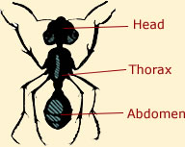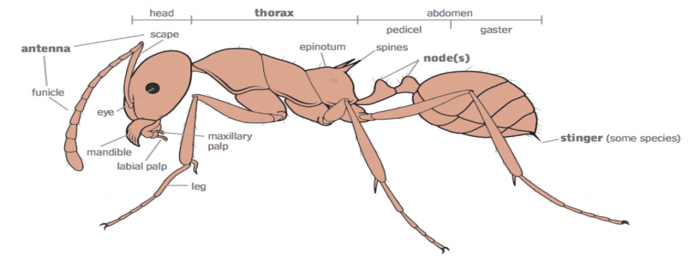
Complete P121 in SESE copy. Draw the ant and label. Research 5 facts about ants. Look at the 2nd link above. Extra information in the YouTube video (25 mins long)

Wednesday 24th February
Reading
P22 combined skills and reader

1st Class “Minibeasts”
2nd Class “France”
Please read and understand all focus words at the bottom of the page.
Writing
Starlight Combined skills and reader P25 Writing

Spellings
Unit 10- Words 7-9
- Method
- Sentence
- Look, Say, Picture, Cover, Write, Check
Activity 3

Maths:
Master Your Maths Week 21, Wednesday

Tables: Complete in Maths copy (see previous pages)
12-4=8
13-4=9
14-4=10
15-4=11
16-4=12

Topic: Place Value/Number
1st Class
Busy at Maths P90+91 requires the children to use the abacus and notation board to further explore place value to 49. P91 in a puzzle where the children are required to fill in missing numbers. At different points, the children are asked to represent numbers pictorially on notation boards.
2nd Class:
Busy at Maths P101 is an assessment page where the children must complete the place value grid. The grid presents the children with a number, a notation board representation, the expanded form of the number and the number words.

Gaeilge: Éadaí
1st Bua na Cainte: Ceacht 7 P51 (Bí ag scríobh) Look at the story on Seesaw
2nd Bua na Cainte: Ceacht7 P71 (Faigh an Abairt) Look at video on Seesaw

2nd Litriú
Tá mé ag rith (I am running)
Tá tú ag léim ( You are jumping)
Tá sé ag siúl (He is walking)
Tá sí ag ól (She is drinking)

PE:
PE with Joe. Available from 9am.

Please look at seesaw to see the challenges provided by Longford GAA.

Thursday 25th February Zoom call @1pm
Reading
Starlight Combined skills and reader P22
Read the rest of the story and please go through the Focus words again.

Writing
Combined skills and reader P23 (comprehension and vocabulary). 2nd class please complete part A in your English copy please.

Spellings
Unit 10- Words 10-12
- Method
- Sentence
- Look, Say, Picture, Cover, Write, Check
Activity 4

Maths:
Master Your Maths Week 21, Thursday

Tables revision: Complete in Maths copy (see previous pages)

Topic: Place Value/ Number
Busy at Maths
1st Class P92+93 invites children to fill in 3 items on a grid where various numbers are represented in number form, pictorial form using cubes, in expanded form and in word form. P93 displays various numbers on an abacus. The children are required to write the number in expanded, symbolic form as well as illustrating the number by colouring in the appropriate number of cubes.
2nd Class:
Busy at Maths P102 is an enjoyable place value crossword.

Gaeilge: Éadaí
1st Bua na Cainte; Ceacht 8 Listen to the story on seesaw
2nd Bua na Cainte: Ceacht 8 Listen to the story on seesaw

2nd Litriú- mé, tú, sé, sí
Revision P129 Complete page

Friday 26th February Virtual PE 10:30am
Reading:
Revise over story

PE: Longford GAA virtual PE session on Microsoft Teams. Begins at 10:30-10:50am please join at 10:25.

Writing:
4 Sentences- There are 6 words in yellow boxes (1st Part B)/ (2nd Part B) of Comprehension and vocabulary (P23). Write 4 sentences including a word in each sentence.
1st: backbone; slime; insect; odd; interesting; skeleton (Write in news copy)
2nd: Europe; euro; currency; population; crepes (Write in English copy)

Maths:
Master Your Maths Test 21 P86. Please complete this on your own.

Tables:
See Seesaw Friday for test in Test copy

Topic: Place Value
Busy at Maths:
1st Class P94 is a fun puzzle requiring children to closely examine three items at a time, two of which are equal while the third is the odd-one-out. They must colour the odd-one-out. The second part requires the children to look closely at various numbers in terms of tens and units and circle the part of the number that is the same as the written word.
2nd Class P103 revision

Gaeilge:

2nd Litriú- mé, tú, sé, sí
See Seesaw for spelling test (Litriú Gaeilge). To be done in Test copy.

