Monday 8th February
English:
Reading
Combined skills and reader (2B)
P18
1st Class “Worst Day EVER at school!” Paragraph 1,2,3 (as far as yard)
2nd Class “Historical Diary” (as far as and started to read…”
Please read and understand all focus words at the bottom of the page.

Writing
News Copy- Write 5-10 sentences of own news over the last week. Any general news, things you got up to. What game you might like to play on zoom this week.

Spellings
Now that you’ve all locked out of Spellings for me, you will start Unit 9. I’m sorry to add work. When you’ve been locked out, please click “Print Learning Words”. 8 grids will appear with 12 words per grid. Grid 1 will be unit 9. Please write the words into the box on top of Unit 9.
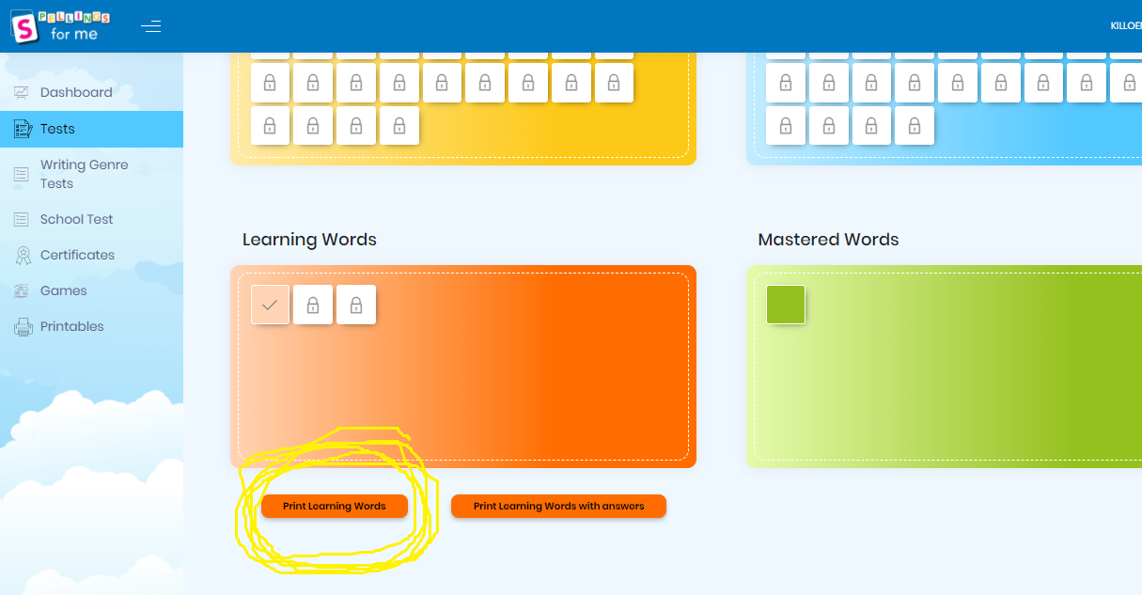
Words 1-3
- Method
- Sentence
- Look, Say, Picture, Cover, Write, Check
Activity 1

Maths:
Master Your Maths Week 20, Monday

Tables: -3 Complete in Maths copy (see previous pages of Maths copy)
3-3=0
4-3=1
5-3=2
6-3=3

Topic: Fractions

1st Class: ½ (Halves)
Busy at Maths P96 deal with establishing whether a series of shapes/objects have been divided into two equal pieces or not. The children must divide a number of pictures and shapes into two equal parts (halves)
2nd Class:
Busy at Maths P79/80 ½ and ¼ (halves and quarters)
P79 looks at whether a number of shapes/objects have been divided into two equal parts or not. The children must divide a number of pictures and shapes in half. P80 the children must use their knowledge of doubles to find half of the numbers/sets of objects.

Gaeilge: An Aimsir
1st Bua na Cainte Ceacht 1 (P37/38) Look at the story on Seesaw
2nd Bua na Cainte Ceacht 1 (P61 Faigh an abairt)- Look at video on Seesaw

2nd Litriú- Éadaí agus Dathanna (Colours) revision
Tá léine air
Tá bróga air
Tá stocaí air
Tá cóta gorm air

SPHE: Safer Internet Day
This is an area that has become very topical in schools in the last number of years. It is so important that we educate the children on the potential risks and threats in a digital environment. Over the course of the week I will ask you to do a few activities related around Safety Internet Day over the course of the week. I will email you with all the activities.

I am asking the children to take part in a Poster competition on: “Internet Safety”.

SESE: What is the weather like this week?
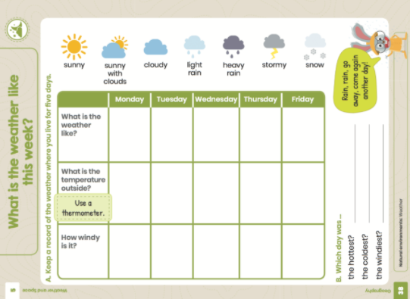
Keep a record of the weather for the next five days. Please make the chart in your SESE copy. The children have the option to draw pictures/symbols of weather or write or both.
-Take time to look at the links below.
- Look at weather in different parts.
- Show the children symbols used to describe weather.


https://www.met.ie/
https://www.rte.ie/weather/35523-longford/
https://www.timeanddate.com/weather/

https://www.youtube.com/watch?v=zUNEFefftt8&ab_channel=NationalGeographic (Thunderstorms) Plenty of cool videos on National Geographic + National Geographic Kids on YouTube

PE: For the week!!
Go onto YouTube and type in “PE with Joe”
https://www.youtube.com/user/thebodycoach1 Is a link to his home page. PE every Monday, Wednesday and Friday available from 9am.

Be watching out for videos on Seesaw. I will be posting a few challenges created by Longford GAA for you to give a try.

Tuesday 9th February
English:
Reading
P18 combined skills and reader

1st Class “Worst Day EVER at school!” Paragraph 4&5 (as far as break time)
2nd Class “Historical Diary” (Page 1 of Diary)
Please read and understand all focus words at the bottom of the page.
Writing
Skills book P20 (Grammar)
1st | 2nd
Joining words “and” | Making words ending in y plural*
Joining word “but” or “or” | Write the plural of each word
Write an ending or each sentence | Making words ending in f or fe plural**
*To make words ending in y plural.
- If letter before y is a vowel (a,e,i,o,u) add an s E.g Toy=toys
- If letter before y is a consonant, change the y to ies. Baby= babies

** To make words ending in f plural.
- Change the f to v and add es. E.g Wolf=wolves
- Change the fe to v and add es. E.g. knife= Knives

Spellings
Unit 9- Words 4-6
- Method
- Sentence
- Look, Say, Picture, Cover, Write, Check
Activity 2

Oral Language
I will put up a Poster on Seesaw. Before you listen to the description of the poster, look at it, make your own predictions and judgements about what it will entail. There will be questions about the poster too so make sure you look and listen. I don’t need answers written down for this.

Maths:
Master Your Maths Week 20, Tuesday

Tables: Complete in Maths copy (see previous pages)
7-3=4
8-3=5
9-3=6
10-3=7

Topic: Fractions
1st Class
Busy at Maths P97 deal with establishing whether a series of shapes/objects have been divided into two equal pieces or not. The children must divide a number of pictures and shapes into two equal parts (halves)
2nd Class:
Busy at Maths P81/82 ½ and ¼ (halves and quarters)
They look at whether a number of shapes/objects have been divided into quarters or not.

Gaeilge:An Aimsir
1st Bua na Cainte: (Ceacht 2 and 3 P39/40) Look at the story on Seesaw
2nd Bua na Cainte: (Ceacht 2 P62 Bí ag léamh agus ag scríobh) Look at video on Seesaw

2nd Litriú- Dathanna agus Éadaí dul siar revision
Tá bríste dubh air (He has black trousers)
Tá cóta uirthi (She has a coat)
Tá bróga uirthi (She has shoes

SESE: Record what the weather is like today on chart in SESE copy.

SPHE: Safer Internet Day
Read Buddy the Dog’s story. Discuss the importance of being safe on the internet throughout with your child.
Don’t forget to complete the poster and send it on.

PE:
I will send 2 or 3 challenges on Seesaw.

Wednesday 10th February
Reading
P18 combined skills and reader

1st Class “Worst Day EVER at school!”
2nd Class “Historical Diary” (Part 2 of Diary)
Please read and understand all focus words at the bottom of the page.
Writing
Starlight Combined skills and reader P20 Writing

Spellings
Unit 9- Words 7-9
- Method
- Sentence
- Look, Say, Picture, Cover, Write, Check
Activity 3

Maths:
Master Your Maths Week 20, Wednesday

Tables: Complete in Maths copy (see previous pages)
11-3=8
12-3=9
13-3=10
14-3=11
15-3=12

Topic: Fractions
1st Class
Busy at Maths P98 deal with the relationship between doubles and halves of sets to 20.
2nd Class:
Busy at Maths P83 deals with establishing quarters of sets within 20.

Gaeilge: An Aimsir
1st Bua na Cainte: Ceacht 5 P41 (Leigh an scéal) Look at the story on Seesaw
2nd Bua na Cainte: Ceacht3 P63 (Bí ag léamh/Bí ag scríobh) Look at video on Seesaw

2nd Litriú- Dathanna agus Éadaí
Tá stocaí uirthi (She has socks/she is wearing socks)
Tá hata glas uirthi (She has/wearing a green hat)
Tá gúna dearg uirthi (She has a red dress)

SESE: Complete weather chart in SESE copy

Geography: What’s the weather like in Ireland?
Discuss different counties the children have visited and the weather they experienced. Compare it to weather we get in Longford. Discuss the weather in labelled counties.
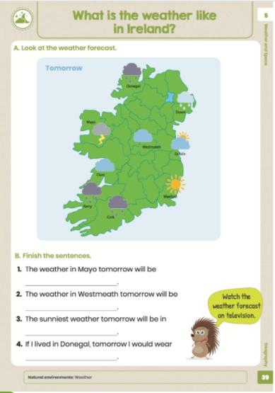

PE:
PE with Joe. Available from 9am.

Please look at seesaw to see the challenges provided by Longford GAA.

Thursday 11th February Zoom call @1pm
Reading
Starlight Combined skills and reader P18
Read the rest of the story and please go through the Focus words again.

Writing
Combined skills and reader P19 (comprehension and vocabulary). 2nd class please complete part A and D in your English copy please.

Spellings
Unit 9- Words 10-12
- Method
- Sentence
- Look, Say, Picture, Cover, Write, Check
Activity 4

Maths:
Master Your Maths Week 20, Thursday

Tables revision: Complete in Maths copy (see previous pages)

Topic: Fractions
Busy at Maths P99+100 require the children to solve a range of problems involving halves.
2nd Class:
Busy at Maths P84+85 deals with a series of problems involving halves and quarters of shapes, objects and sets within 20.

Gaeilge: An Aimsir
1st Bua na Cainte; Ceacht 6 (P42 An Nuacht) Listen to the story on seesaw
2nd Bua na Cainte: Ceacht 4 (P68) Listen to the story on seesaw

2nd Litriú- Dathanna
Revision P128 Complete page

SESE: Complete weekly weather chart

Religion:
1st Class- Reconciliation- “We celebrate God’s forgiveness in the Sacrament of Reconciliation” P32/33 (If you have the book)
2nd Class – Reconciliation- “We can be forgiven” P32/33

Please see Seesaw videos and pages associated with Grow in Love topic.

Friday 12th February
Reading:
Revise over story

PE: Longford GAA virtual PE session on Microsoft Teams. Begins at 10:30-10:50am please join at 10:25.

Writing:
3 Sentences- There are 3 words in (1st Part B)/ (2nd Part C words in box) of Comprehension and vocabulary (P19). Write a sentence for each word.
1st: accidentally; embarrassment; gear (Write in news copy)
2nd: blot; attic; dusty; turf (Write in English copy)

Maths:
Master Your Maths Test 20 P85. Please complete this on your own.

Tables:
See Seesaw Friday for test in Test copy

Topic: Place Value
Busy at Maths:
1st Class:P100 Revision
2nd Class P86 revision

SESE: Complete weekly weather chart

Gaeilge:

2nd Litriú- Dathanna
See Seesaw for spelling test (Litriú Gaeilge). To be done in Test copy.

