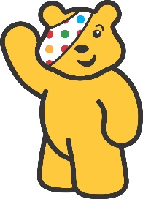7

Week Beginning:

13th November 2023

The Arts

*Children love finger painting. Using some paint your child could create some spotty dots like the spots on Pudsey’s Bandana.

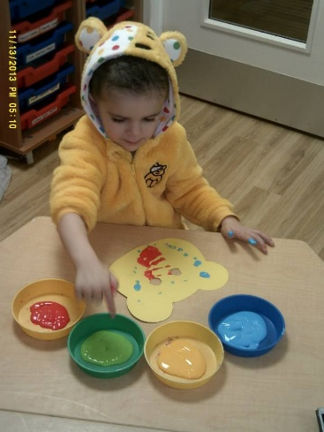

The World Around Us

* Using a plain bun, some icing and treats you could design a Pudsey Bear Bun together.

-See the Pudsey Bear Cupcake Recipe if you would like to bake your own.

Language Development

*Visit the website [www.bbc.co.uk/cbeebies](http://www.bbc.co.uk/cbeebies) and search *Pudsey* to listen to some stories and play some Pudsey Games.

Mathematical Experiences

*The children are recognising and copying simple patterns in Nursery.

*You could create a simple model or pattern with Lego, Duplo or blocks and ask your child to copy it.

Physical Development

*See the Pudsey Fine Motor Skills Activity sheet for some fun ideas to promote the development of Fine Motor Skills.

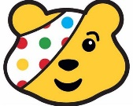

Personal, Social + Emotional

*This week is Anti-Bullying Week. We will be reading lots of stories about being a Kind Friend.

See the slides “All about Kindness” and discuss together.

Home Learning Ideas

