Week Beginning:

3rd June 2024

Home Learning Ideas

Personal, Social + Emotional

*We are learning all about Summer. Take a Summer walk, have a look at the Summer word Mat or work on some of the Summer activities shared on the Sunny Day Activity Sheet.

Physical Development

* We are getting ready for our Sports Day events. Why not use the cards at home and get some practice in before our events.

Language Development

* Practice letter formation by downloading this game.

[Online Letter Writing Game for Kids: Letter Tracing & Recognition Game for Children (calculators.org)](https://www.calculators.org/games/letter-writing/)

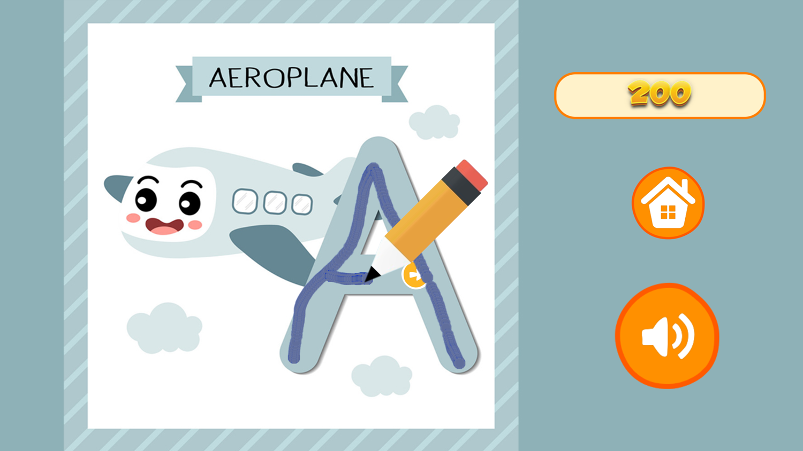

Mathematical Experiences

The children have all been very busy developing their pencil hold and fine motor skills. At home you could practice making marks maybe even trying to write your name! follow the instructions to practice the correct hold

The Arts

* In school we have loved drawing and painting with water outside. Why not take old paint brushes, toothbrushes or sponges and design your own creation. There is even some science involved in working out why is disappears when the sun comes out.

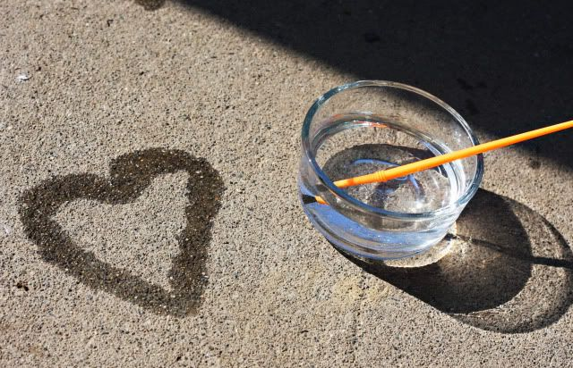

The World Around Us

*Our theme this month is Summer. Why not take a Summer walk in the park our around your street and see if you can find the items on our checklist.

.