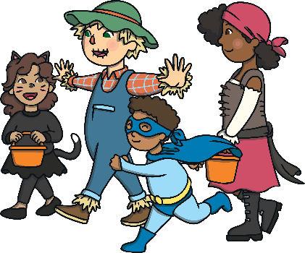
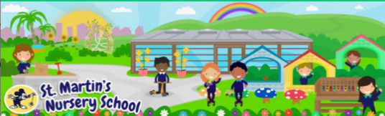
7
Week Beginning:
20th October 2025
The Arts
You could create some Halloween crafts or decorations for the house.
-See the Footprint Ghost Sheet for ideas

The World Around Us
You could go on a Spooky Scavenger Hunt with your child in your local park or Forest.
-See the Scavenger Hunt Sheet for ideas

Language Development
You could create a Halloween Themed Recipe together. This provides lots of opportunities for your child to listen to and follow instructions.
-See Halloween Monster Face Biscuits Recipe

Mathematical Experiences
Go for a walk and collect sticks together. Ask questions: Which is short/long? Which is thick/thin?
You could decorate one of the sticks and make a Magic Wand.

Physical Development
Fine Motor Fun-You could spray some shaving foam on the table/in a tray for your child to make marks in. You could add props such as spiders and make a Spooky Foam Web.

Personal, Social + Emotional
Halloween brings lots of excitement for children. Discuss with your child: Do you feel excited? Why? Are you looking forward to dressing up?
Discuss other emotions too (scared, worried) and explain how grown-ups are here to make you feel safe.

Home Learning Ideas

