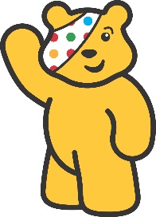
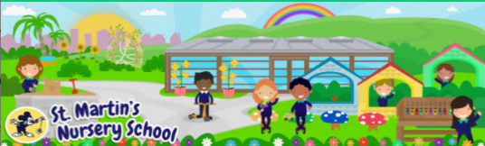
7
Week Beginning:
10th November 2025
The Arts
*Children love finger painting. Using some paint your child could create some spotty dots like the spots on Pudsey’s Bandana.
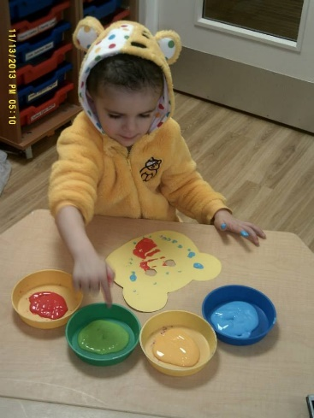

The World Around Us
* Using a plain bun, some icing and treats you could design a Pudsey Bear Bun together.

-See the Pudsey Bear Cupcake Recipe if you would like to bake your own.

Language Development
*Visit the website www.bbc.co.uk/cbeebies and search Pudsey to listen to some stories and play some Pudsey Games.
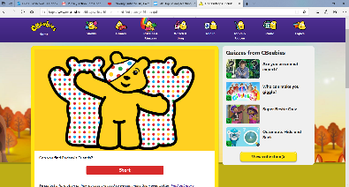

Mathematical Experiences
* The children are recognising and copying simple patterns in Nursery.
*You could create a simple model or pattern with Lego, Duplo or blocks and ask your child to copy it.

Physical Development
*See the Pudsey Fine Motor Skills Activity sheet for some fun ideas to promote the development of Fine Motor Skills.
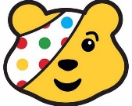
Personal, Social + Emotional
*This week is Anti-Bullying Week. We will be reading lots of stories about being a Kind Friend and talking about what bullying is.
See the slides “Power for Good” and “All about Kindness” and discuss together.

Home Learning Ideas

