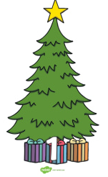
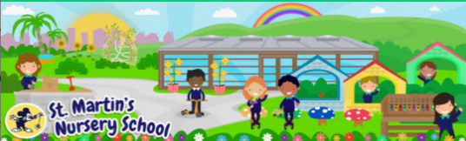
Week Beginning:
24th November 2025
Home Learning Ideas

Physical Development
* The children are developing their scissor skills in Nursery.
*You could give your child some different types of wrapping paper and ribbons alongside some scissors. They can practise their scissor skills as they are snipping and cutting the paper.

Personal, Social + Emotional
This week we are going to talk to the children about the excitement of the Birth of Jesus and read the Christmas Story.
-You could read the Nativity Story with your child or explore a version of the story on YouTube.




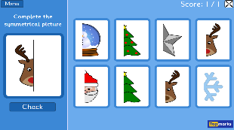

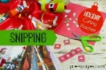
Mathematical Experiences
* Explore some festive interactive math games on www.topmarks.co.uk
Search: Christmas Games and Activities 3+ years/Early Years.

The World Around Us
* You could have a go at making some Christmas themed playdough together by adding different scents and essences.
*See the Christmas Playdough Recipe.

The Arts
* The children love exploring the Sensory Trays in Nursery. Sensory Trays encourage imaginative play, promote language skills as the children describe the different objects and promote fine motor skills (pouring, scooping etc)

*See the Christmas Sensory Bin Page for ideas on how you could create your own.

Language Development
* Have a look at the Story of the First Christmas that we shared and then using the Nativity Word Mat find the familiar characters from the story. Can your child recall the story in their own words?
