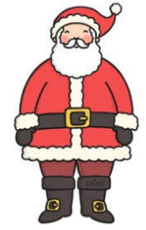
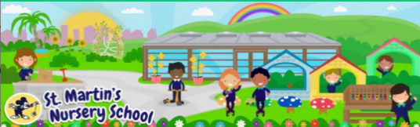
Week Beginning:
1st December 2025
The World Around Us
* You could have a go at making some festive snow dough together this week. All you need is baby oil and some corn flour. You could add glitter if you have some.
*See the Sparkly Snow Cloud Dough Recipe.

Language Development
* We play lots of games in Nursery which encourage Listening and Attention skills.
*See the Christmas I-Spy Activity page. Give your child clues. Can they find the picture you are talking about?
E.g. I see something that is red and white, and Santa wears it on his head…

Mathematical Experiences
* From reinforcing fine motor skills and encouraging imagination, to introducing maths and engineering the learning opportunities with Lego are endless. It is a favourite in Nursery.
*See the Christmas Bricks Challenge Cards.

Physical Development
* The children are developing their gluing skills in Nursery. Gluing activities promote fine motor development and hand-eye coordination skills.
*You could help your child to make and glue some decorations such as a festive paper chain.

Personal, Social + Emotional
* Talk about the Emotions of the Month:
“Surprised” and “Excited.”

* Talk about the countdown to Christmas. You could count down on a calendar until the Big Day. Talk about how we show excitement-big smiles, jumping up and down etc.

Home Learning Ideas


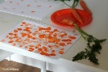


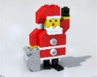

The Arts
*Reindeer Art Idea- You could help your child create a Christmas picture for the reindeers by printing with their favourite food, carrots!
Cut the carrots in a variety of ways, such as lengthways, in circular shapes or whole. Discuss with your child-What different patterns can you make?

