
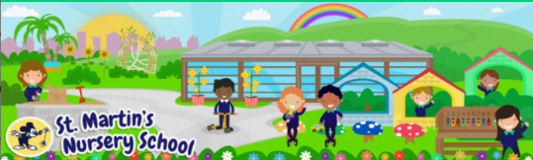
9
Week Beginning:
6th January 2025
The World Around Us
* We are learning about the signs of Winter in Nursery. You could look for signs in the garden or go on a Winter Walk with your child.
-See the Winter Word Mat and discuss the images with your child.

Language Development
* Explore some Winter themed stories on YouTube such as Guess How Much I Love you in Winter. Ask your child questions about the characters and events in the story/animations.

Mathematical Experiences
* In Nursery the children explore patterns and colours through a range of activities. An activity you could do with your child at home is getting them to help you match socks.
Ask questions- Are these socks the same? Why/ why not? Which socks are red, spotty, stripey? Etc

Physical Development
* To support the children with their mark making skills we use a range of resources to develop their interest and engagement. Using shaving foam (“winter snow”) on the table or on a tray is a fun way to encourage your child to draw and make marks.

Personal, Social + Emotional
* In Nursery we encourage the children to be independent. We have been focusing on putting on our own school coats for Outdoor Play.

-See the Dressing Hacks for Winter Clothes page for some useful tips.

Home Learning Ideas

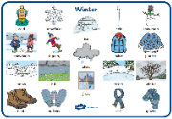
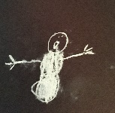

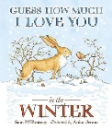
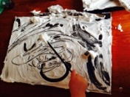
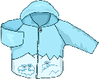
The Arts
* Create a snowman picture.
The children love to draw with chalk, and it is always a popular choice in Nursery. Give your child some ideas or draw together: Could you draw a frosty snowy picture? Could you draw a snowman?

