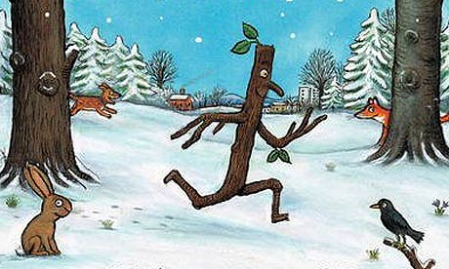
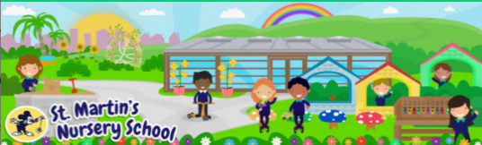
Week Beginning:
19th January 2026
The World Around Us
* In the story Stick Man floated in the water. You could gather a variety of materials for your child to explore in a basin or at the sink. Will the items float like Stick Man did?
-See the Float or Sink activity page

Language Development
* Click on the link below to listen to an animated film based on the book:
BBC iPlayer - Stick Man
Ask questions- Where does Stick Man live? How do you think Stick Man felt when he was lost? How did the Stick Family feel at the end of the story?

Mathematical Experiences
*Children love exploring natural resources and the opportunities are endless. You could gather up some natural items such as: twigs, leaves, pebbles, stones, and shells.
*E.g. You could ask your child to order the sticks by length or sort the leaves by colour.

-See the Winter Maths Challenge Cards

Physical Development
* Fine Motor Fun with Spaghetti
All you need to set up this activity is some dry spaghetti and a colander. Ask your child to post the spaghetti through the holes. This activity is great for developing fine motor, hand to eye coordination, and concentration skills.

Personal, Social + Emotional
*This week is Catholic Schools Week 2026.

-See activities shared throughout the week

Home Learning Ideas

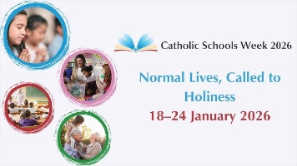
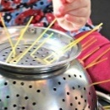
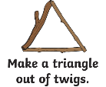
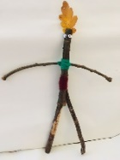
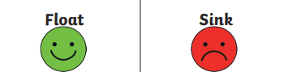
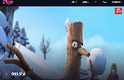
The Arts
* If you are out for a walk or in the garden you and your child could look for a stick to make a stick person. Or you could make your very own stick family!
-See the Stick People Instructions page

