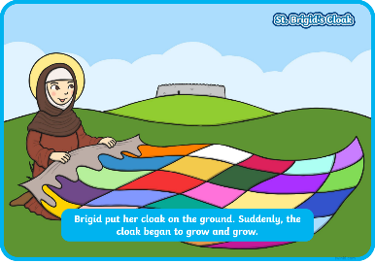
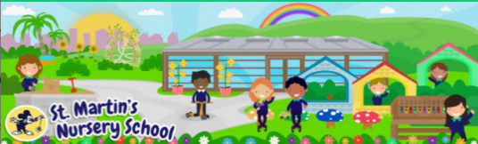
Week Beginning:
26th January 2026
The World Around Us
* In school we have been engaging in lots of Hot Chocolate themed activities. The children have also really enjoyed some delicious hot chocolate. Why not follow the recipe included and make some hot chocolate stirrers


Language Development
* Click on the link below to listen to an animated film based on the book:
BBC iPlayer - The Gruffalos Child
Ask questions- How do you think the Gruffalo’s Child feels? Have you ever felt frightened? Who helps you when you are feeling afraid?

Mathematical Experiences
*At our Maths table we have been matching, sorting and naming 2D shapes. This game from the Top Marks website is a game for learning shapes.
Shape Monsters - 2D Shapes Matching Game (topmarks.co.uk)
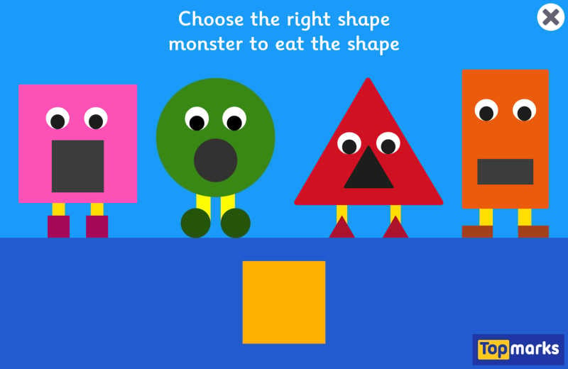

Physical Development
* We have been working on tracing our name in school. This activity helps develop promote our pencil hold as well as helping us recognise and become familiar with our names. Why not write your child’s name and get them to try and copy over the top of the letters

Personal, Social + Emotional
*This week is the start of the new month of February and we will be learning the story of St Bridget for her Feast Day 1st February. The Powerpoint included tells her story.
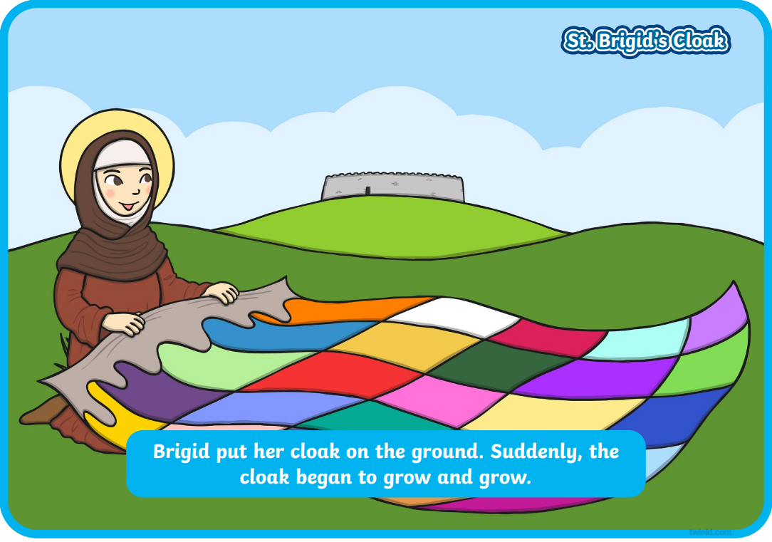

Home Learning Ideas

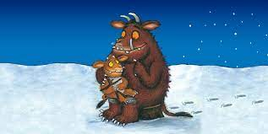
The Arts
* While the weather is still cold we are trying to help look after the animals by giving them some food. Why not follow these simple instructions and make a bird feeder for your house.
