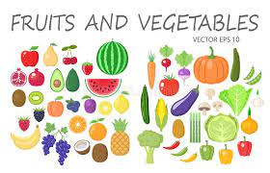
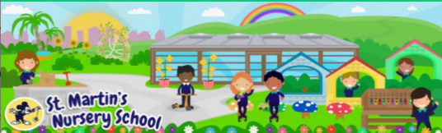
Week Beginning:
16th February 2026
The World Around Us
* Please find attached for some fruity themed recipes you could make with your child at home; why not try a delicious Banana Boat or a yummy Strawberry Smoothie
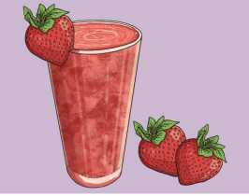

Language Development
* As our theme this week is all about Fruit and Vegetables we have been reading stories relating to this theme. One of our favourites is the story, ‘Handa’s Surprise’. Click on this link to listen to the story.
🌍🐆🐘 Kids Book Read Aloud HANDA'S SURPRISE I By Eileen Browne I StoryTime with Miss Randall - YouTube
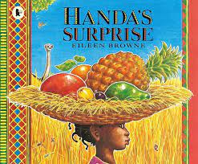

Mathematical Experiences
* We are sorting and matching fruiting as a math activity in school. Here is an activity on www.tinytap.com that your child could play.
Match It - Fruits and Vegetables Free Games online for kids in Nursery by Tiny Tap
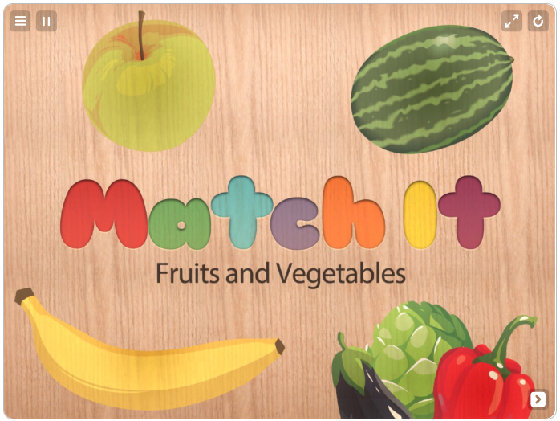

Physical Development
*A great way of promoting our fine motor skills and strength is chopping fruits or vegetables. Why not let you child chop up some vegetables for dinner or cut some fruit for a snack. This is such a fun activity that children just love but remember to use a safe and appropriate knife.
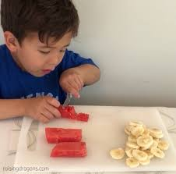

Personal, Social + Emotional
* We are going to be learning all about each other with our ‘All About Me’ boxes. Why not get your box ready to bring in to school filled with photos, a toy, a book, a special item from a day out or holiday or anything else that is special to your child.


Home Learning Ideas

The Arts
* FRUIT AND VEGETABLE PRINTING
With your child you could make some fruit and vegetable prints with paint from items you have at home. Talk about the shape, the colour, the size and the texture of the foods you are stamping with.
