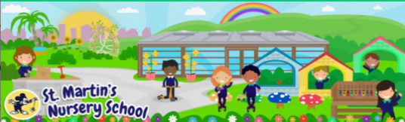
Week Beginning:
9th March 2026
The World Around Us
* Talk to your child about St. Patrick’s Day and why we celebrate it. Talk to your child about family traditions and how you like to mark this special day.
*See the word mat and discuss the pictures together.

Language Development
* Talk to your child about St Patrick.
Why was he so special? What colour do people wear to celebrate St Patrick’s Day? What is the name of the special leaf he used to teach people about God?
*See the St Patrick’s Day story slides and discuss with your child.

Mathematical Experiences
*You could draw and cut out 5 shamrocks for your child to decorate. Model touching each one as you count together.
*See the 5 Green Shamrocks rhyme. Read the rhyme and ask your child to “pick” a shamrock each time. How many are left? Count together. Practice counting backwards from 5-1.
Click Link: Five Little Shamrocks

Physical Development
* Fine Motor Rainbow Challenge

*Challenge your child to make a lucky St. Patrick’s Day Rainbow using the materials from around your house. They could build one with Lego, blocks or use markers/crayons to draw one.

Personal, Social + Emotional
*This week we are celebrating St Patrick’s Day. Talk about what a celebration is: a special day or event that we look forward to.
Discuss other celebrations with your child, such as Christmas, Easter, Birthdays etc. Discuss: How do you feel on this day? Can you show me a happy/excited face?

Home Learning Ideas


The Arts
*Listen to some Irish jigs and reels on YouTube. Watch this video of some Irish Dancers:
Irish Dancers - YouTube
Encourage your child to have a go at dancing to some Irish music at home!

