
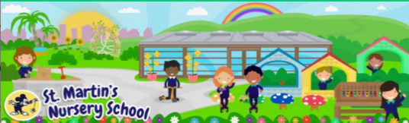
Week Beginning:
13th April 2026
Home Learning Ideas

Physical Development
* The weather during Spring is very changeable. We have included some activities that you could do outside with your child no matter the weather; a rainy day, a windy day and hopefully even a sunny day!


Personal, Social + Emotional
*Spring is a time for new life and to refresh. In school we will be tidying up our outdoor classroom and at home you could get your child to help with your ‘Spring Clean’ at home. Why not give them a job to tidy a specific area of your garden or clear out old toys from the toybox to donate to charity.


Mathematical Experiences
* We have been working on shapes and patterns at our Mathematical activities. There is a great game on TopMarks that helps children develop both concepts.
Shape Patterns (topmarks.co.uk)
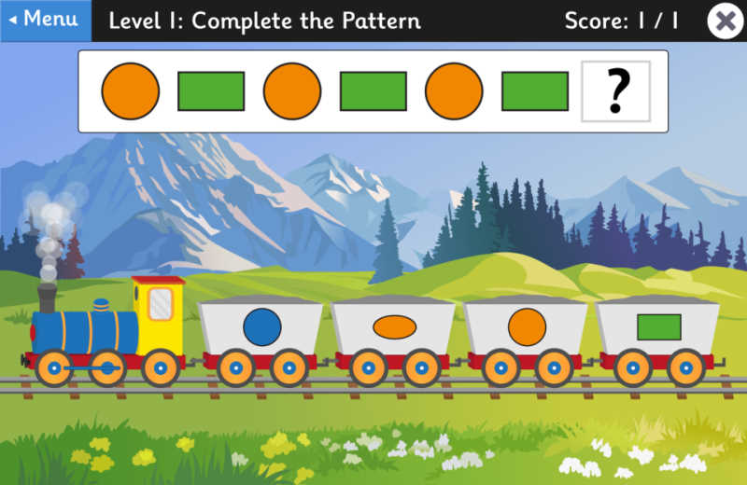

Language Development
* In school we are working on identifying our own name and some of us are even trying to write it too. Encourage your child at home to recognise their name, to trace the letters and if ready maybe even write it.



The World Around Us
- We are have been talking about the different types of Weather we are seeing in the Spring time. Talk with your child about different types of weather and maybe even keep a record of what the weather is each day.
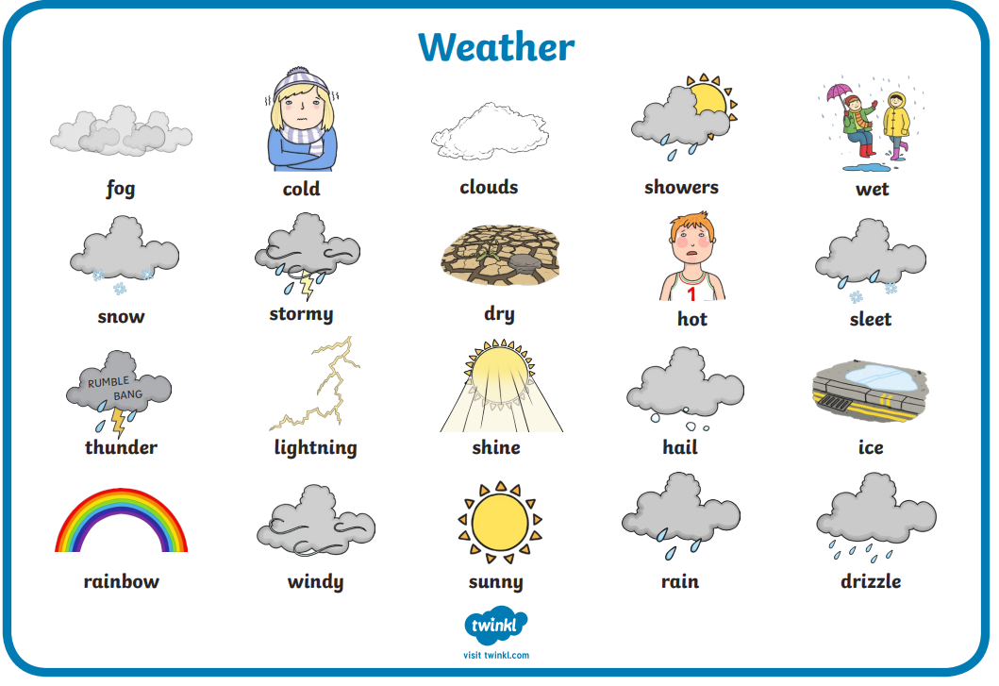

The Arts
- We are singing lots of Spring songs that also help us to count. Why not check out YouTube for songs such as 5 Little Ducks or 5 Little Speckled Frogs and encourage your child to sing along.
