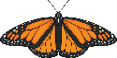
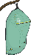
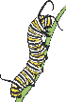
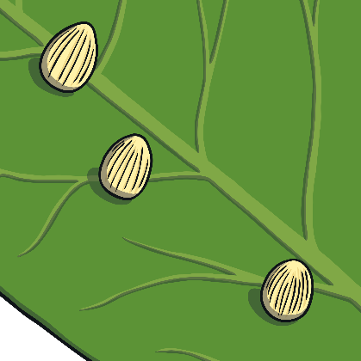
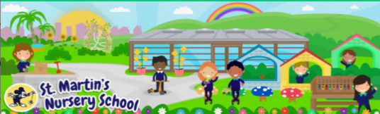
Week Beginning:
20th April 2026
The World Around Us
* We are learning all about the
Life Cycle of a Butterfly.
There are four main stages: egg, caterpillar, cocoon, and butterfly. Look at the Life Cycle Poster and discuss each stage with your child. Together you could draw a picture of each stage.

-See Butterfly Life Cycle

.

Language Development
* Explore the story of The Very Hungry Caterpillar together. Encourage your child to retell the story in their own words. Can they retell the main events? Ask questions: What happened at the start of the story? What foods did the caterpillar eat? Which is your favourite page in the book? Why?

Mathematical Experiences

*We are learning all about patterns. You could use paint to create some caterpillar finger painting patterns with your child. Talk about the colours.
E.g. Blue, red, blue, red…what comes next?

Physical Development
* Target your child’s gross motor skills by encouraging them to move their bodies like different minibeasts.
Can you wriggle like a caterpillar?
Can you flutter like a butterfly?

-See the Minibeast Action Cards
for more ideas

Personal, Social + Emotional
* You could go on a minibeast hunt together. Encourage your child to look after and care for minibeasts they find outside. Remind them to be quiet near the minibeasts and to be very gentle if they handle them. Also talk to your child about the importance of putting minibeasts back where they found them.

Home Learning Ideas






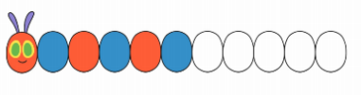
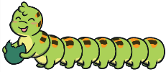
The Arts
* You could explore some songs about caterpillars and butterflies on YouTube.
-See the rhyme sheet for “There’s a Tiny Caterpillar on a Leaf.”
Sing the rhyme with your child and encourage them to add their own movements or actions for each part of the rhyme.
Click Link: The Tiny Caterpillar Song

