Introduction

All visitors to Mount Saint Catherine’s Primary School are warmly welcomed to our school community. We hope that the time you spend here will be useful and happy.

Contained in this booklet are items of information that should be useful to you as a visitor to the school; either as a substitute teacher, a student on work-experience or teaching practice or in any other capacity.

Please take time to read the booklet at the beginning of your visit and it should help make you feel more confident with our routines etc.
If anything is unclear or further information is required please do not hesitate to speak to the principal, Mr Gildea, myself, or any other member of staff, who will be happy to help you.

Yours truly,

Mrs Anne-Marie McLaughlin (vice-principal)

School Contact details:

Tel – 02837522241
School secretary – Mrs Jacqueline Trainor
Principal – Mr Peter Gildea
Vice – principal - Mrs AM Mc Laughlin (responsible for subs, students and trainees)
School Mobile (for contact outside school hours) - 07835152671

We are a school within the Network of Sacred Heart Schools with a proud and distinctive Catholic ethos and also a UNICEF Rights Respecting School. Please note Article 3 from the UN convention on the rights of the Child as it underpins all that our school is about:

Article 3
The best interests of the child must be a top priority in all things that affect children.

School Mission Statement
Teacher, parents and governors will work together to develop each child spiritually, morally, intellectually, socially, emotionally and physically within our Sacred Heart ethos so that by realising their potential, they can maximise it and have an appreciation of self-worth and self-learning.

“Welcome them with kindness and give them encouragement, so that their hearts will
Open out and you will be able to help them by advice to form their characters"

Saint Madeleine Sophie Barat (foundress of the Society of the Sacred Heart)

Absence:
In the event of being unable to come to school you are asked to contact us as soon as possible preferably on the numbers above. Home numbers if required:
Mr Gildea: Tel: 07989950366
Mrs AM McLaughlin: Tel 07835152671
If necessary please leave a message on the answer phone at school. When an absence is likely to extend beyond the first day please contact school before 3pm in case arrangements need to be made to cover your work.

Dress code:

All staff is asked to dress professionally and appropriately. We respectfully request that all clothing is modest. Denim jeans are generally not acceptable. For PE and other outdoor activities practical clothing such as trainers and a tracksuit is required.

SCHOOL ROUTINE

Key Stage One (Reception to Primary Four):

- 8.50a.m. - Pupils are supervised in the playgrounds by two members of staff.
- Pupils are not permitted in the school building unsupervised before 9.00a.m.
- 9.00am – Bell rings, pupils line up and are met in playground by teachers who escort them to classroom or assembly
- Whole School Assembly takes place on Friday morning for all classes.

In the event of inclement weather pupils go straight to the hall where all are supervised until 8.50 a.m. when they move to their classrooms escorted by their teachers or P.7 monitors.

Morning Break: 10.40 – 10.55
- The teacher on duty must open the main front doors promptly at 10.40 and be on duty for the other classes arriving.
- Teachers escort pupils to playground into the care of staff on duty.
- Pupils are allowed a “healthy snack”.
- Skipping with ropes is permitted if supervised.
- They can ask permission to go to the toilet from adults on duty.
- A Hall Pass will be given at the door.
- An injured or sick child must first see the adult supervising in the playground before going to the office where a member of staff will attend to them.
- Pupils line up when the bell is rung and are escorted to class by their teacher, helped by P.7 monitors, if required.

During wet playtimes the pupils remain in class where they are amused by two P.7 monitors and use their Rainy Day Boxes. The teacher on duty supervises the upstairs corridor. Classroom assistants will supervise in allocated rooms. For health and safety reasons pupils are not permitted to use scissors or the Internet during wet playtimes.

Lunchtime: 12.00 – 12.45

- P1 and P2 eat first at 12 noon. P3 and P4 play for 20 minutes n then eat at 12.20pm.Their teacher or Classroom assistant escorts pupils to the canteen in the playground.
- The supervisors serve pupils and assist lunch takers.
Classes line up in the playground at 12.45p.m and are met by their teacher

Key Stage Two (P.5 – P.7)

- 8.50a.m. - Pupils are supervised in the playgrounds by two members of staff.
- Pupils are not permitted in the school building unsupervised before 9.00a.m.
- 9.00am – Bell rings, pupils line up and are met in playground by teachers who escort them to classroom.
- Whole School Assembly takes place on Friday morning at 11.30am for all classes.

In the event of inclement weather pupils go straight to the hall where all are supervised until 8.50 a.m. when they move to their classrooms escorted by their teachers or P.7 monitors.

Morning Break Time: 10.40 – 10.55 Arrangements as for Key Stage One

Lunchtime : 12.45 – 1.30 Arrangements as for Key Stage One

If staff would like a school dinner please order it through the office in the morning before school starts. Staff are also free to use the Siena Restaurant in the campus of St. Catherine’s College.

Hometime: All pupils in P1, 2 and 3 are released to their family/carers at the classroom door.
All pupils in P4, 5, 6 and 7 are escorted to the gate on Windmill Hill by their teacher, where they are released to their family/carers.

Children who are not collected can remain at the school office reception while a phone call is made.

Registers
The register will arrive in the class before 9.00am in a blue folder.
Please complete the dinner and attendance registers and send them to the office as soon as possible before 9.30 am.
Class teachers are expected to complete the electronic SIMS register and update previously absent pupils if a reason has been obtained.

All monies collected from pupils must be counted and sent to the office in the zip folder, stating: class, amount and purpose of money, using the record sheet enclosed.

Directed Time:
Directed time is as follows:

Mon-Fri - 8.50 –9.00
Mon. & Tues: 3.00 – 3.45
Wednesday - 3.00-4.30
Thurs – 3.00 – 3.45
Friday – none (unless requested)
Students and substitute teachers are expected to use directed time to correct work, tidy work areas and ensure that all is left in order for the next day.
Class work – Planning and Marking etc.

- All classes should have a daily timetable displayed in the room. For long term substitutes planning sheets for each curriculum area are stored in the computer: Staff - Shared documents ► Public File ► Teachers ► File for Year Group

- The Key Stage Co-ordinator or your year group partner will help with
locating resources etc.

- The class teacher will have left a work schedule on the desk or in the planner in the event of a planned absence.

- Substitute teachers are expected to mark all work set on a daily basis, before leaving, at the end of the day.

Below are the most important points from the School Marking policy

- Staff are asked not to correct or comment on work with red pen – any other colour is acceptable.
- Teachers mark incorrect work with a DOT. Pupils know this means try again.
- Work should be dated and initialled whenever possible and good guidance given on how to improve.
- Staff use AfL (Assessment for Learning) marking, giving positive and useful feedback at all times. Errors should be explained discreetly to pupils.

Behaviour and Discipline

If there is any kind of serious or recurring problem with a pupil’s behaviour please let the class teacher or Key Stage Co-ordinator know as soon as possible. If you are a substitute teacher please leave a note for the teacher in the planner and inform the VP or principal on the day.
Pupils do not receive lines as a sanction – an extra piece of work is more acceptable.
There is the opportunity for unfinished work to be done during playtime in the “Homework Club”
They may only remain inside during a playtime if supervised by a member of staff. All teachers have a Behaviour book where incidents are recorded- should be in desk.
Our school has a Conflict Resolution Programme. Pupils are encouraged to solve disputes between themselves whenever possible. There are Class Peer Mediators who can help facilitate this when there has been no accommodation between the disputing parties.
For small misbehaviours in class we operate “Thinking Time” on a chair in a quiet place(a safe place of the teacher’s choosing) Length of Thinking Time corresponds with the age of the child (eg: 6 mins for a six year old) and a response should be sought from the pupil after the time has passed.
Please refer any serious matters to Key Stage Co-ordinators and the principal.

Break time / Staff room

Break time for classroom assistants is at 10.25 – 10.40
Break time for students on work-experience is at 11.00 – 11.15am, so that they are able to help supervise and also observe pupils during their playtime.

Students on Teaching Practice will not be timetabled to be on break duty but may want to offer to share duty with their class teacher. They may also be asked to supervise as the need arises. Break is 10-40 – 11.00am. for pupils and teaching staff.

All visitors and staff are welcome to use the tea and coffee making facilities in the staff room.

Teaching Practice Guidelines
- Students and class teachers need to organise a timetable together as soon as possible once practice has begun. A copy of these need to be given to Mrs AM McLaughlin and Mr Gildea.
- It is a good idea for the class teacher and student to arrange a weekly slot to discuss plans for the week.
- Please let your teacher and supervisor know as soon as you can about any visits from college tutors.
- Students on Teaching Practice will have a weekly evaluation/support meeting with their supervisor. Please have your file available for this meeting.
- Take your cue form the teaching staff in regard to relations with the pupils. Be careful not to become too familiar as this only makes maintaining discipline difficult later. All staff should be addressed by their title and surname ;Eg; Mr McVeigh.

Students on Work Placement/Work Experience
  - A timetable will be established before you begin placement.
  - Please ensure any attendance records are signed by your class teacher regularly during placement.
  - If you have any assignments please allow the class teacher time to view these with you.
  - Always remember that student observations must be anonymous in your recorded work.
  - Take your cue form the teaching staff in regard to relations with the pupils. Be careful not to become too familiar as this only makes maintaining discipline difficult later. All staff should be addressed by their title and surname ;Eg; Mr McVeigh.
  - Make sure that all events and observations made in school are confidential

Health and Safety

Mount St. Catherine’s is a non-smoking site and there are no designated smoking areas.

Please ensure the full supervision of pupils in all areas at all times.

Our code of conduct for travelling around the school is simple:
- We walk on the left in a single file
- We walk quietly
- We show good manners at all times.

In the event of a fire:
A continuous bell will sound, which the pupils will be familiar with:
At the classroom door are simple evacuation procedures.
Children rise and leave immediately in single file and quietly make their way to the playground by the railings on Windmill Hill
The register will be given to each teacher who will account for all pupils.

Use of Toilets:
Key Stage 2 pupils are expected to make use of the toilets at playtimes and are discouraged from going during lessons.

Child Protection
You are required to wear a visitor badge if you are visiting the school.
All teachers, students and volunteers working regularly with pupils are required to read the following documents before starting work/ placement :
- Staff Code of Conduct
- Child Protection Policy and Guidelines

The designated teacher for child Protection is Mrs McLaughlin, the deputy-designated teacher is Mrs McKenna. Please refer to these two staff members in event of a child protection issue or any concerns you may have.
The School governor who is in charge of child Protection is Sister Nora Smyth – you can contact her through the office.
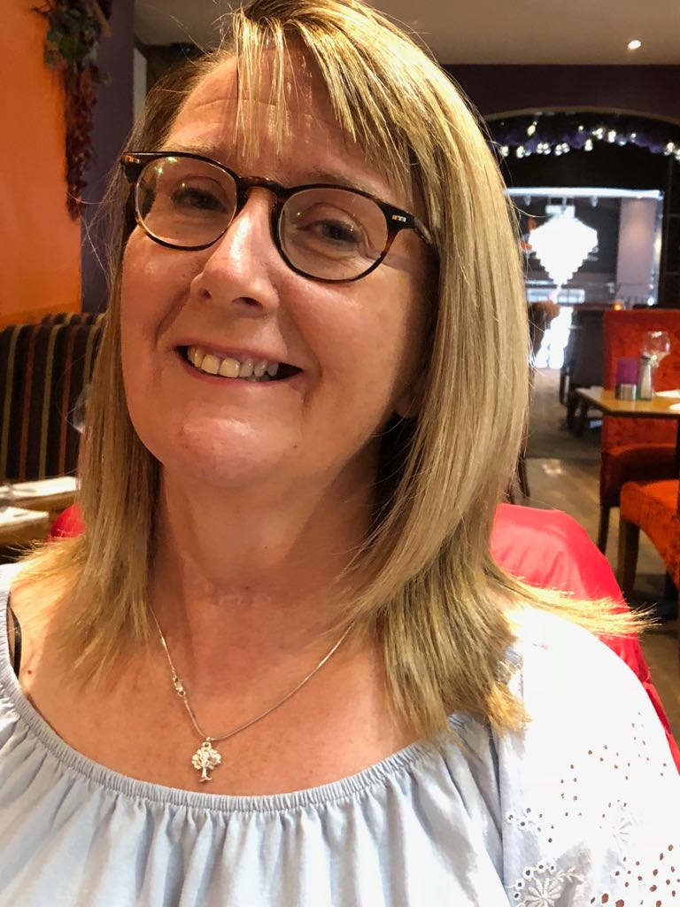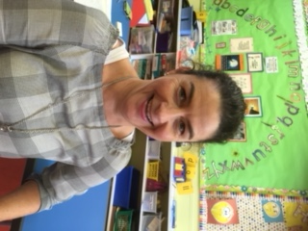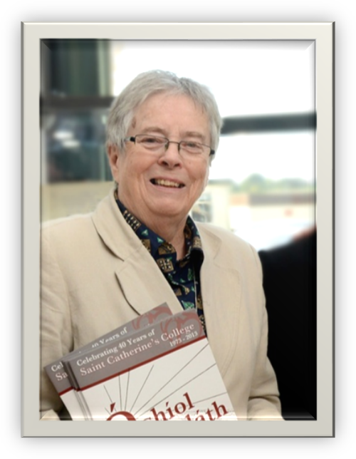
Mrs McLaughlin Mrs McKenna Sister Nora Smyth

The basic instructions below do NOT replace the need to read the full policy and guidelines:

- Never leave pupils unsupervised . Send a child if you need assistance.
- There is a RED Alert triangle by the door for you to send with a child to a nearby room if you have an emergency.
- There is a phone in most rooms. The office number is 201.
- Only make physical contact with a child for safety reasons.
- Speak to the DT or DDT asap if you concerned about a child.

- Never be alone with a child. Never use your phone during class and never show images to a child
- Only school cameras and devices to be used for recording pupils.
- Images are not to leave the premises.
- Never communicate with a pupil using social media.

Staffing Details

Principal: Mr Peter Gildea
Vice-Principal: Mrs Anne-Marie Mc Laughlin
Senior Leadership Team: Mr Gildea, Mrs McLaughlin, Mrs McKenna,
Mr Hughes and Mrs Jordan
Secretary: Mrs Jacqueline Trainor
Caretaker: Mrs Kim O’Hara
Teaching staff:

Class | Teacher/responsibilties | Room
P.1 | Mrs Roisin Brogan  Sacred Heart Network , Extended Schools. Health & Safety | 2
P.2 | Mrs Monica Jordan  Music , Foundation Stage co-ordinator, SLT.  Mrs Mary Coleman  WAU co-ordinator and School fundraising and charity projects. | 3
P3 | Mrs AnneMarie McLaughlin  RE, KS1 co-ordinator, Assessment and Monitoring, Pastoral Care, Student Tutor, DT for Child Protection  Mrs Betty Mc Nicholl:  Healthy Schools and Welcoming Schools. Cycling Proficiency. | 4  24
P.4 | Ms Claire McElhone  Maths , Anti-Bullying Week. | 22
P5 | Mrs Jolene McCaul  Rights Respecting Schools, Intercultural Education co-ordinator | 11
P.6 | Ms Nichola Rafferty  PE and Shared Education, Gifted and Talented Programme | 12
P7 | Mr Eoin McGuigan  Using ICT, Public Relations, School Website, | 14
P7 | Mr Sean Hughes  Literacy co-ordinator,KS2 co-ordinator  ECO School leader  Maths Team Member | 10
SENCO | Mrs Cathy McKenna  Special needs admin and support, Deputy Designated Teacher for child Protection. School Council. SLT  Professional Learning co-ordinator | 5

