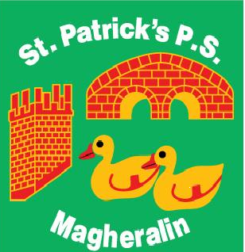
ST. PATRICK’S PRIMARY SCHOOL
12, Ballymacbredan Rd., Magheralin, Craigavon, BT67 OQU
Tel no – 028 3834 1400 Fax no - 028 3834 7376
Email: info@stpatricks.magheralin.ni.sch.uk
Web: http://stpatricksmagheralin.co.uk
Principal: Mrs M. McGrath BA(QTS), PQHSH, DipPD.

19th November 2018

Dear Parents

I write to invite you to our school open afternoon on, Sunday 2nd December from 12:00-1:30pm. This afternoon is for those parents wishing to enrol their child into Primary One or Reception in September 2019.

On this afternoon you may bring your child with you to see the educational opportunities within this school and meet the staff. The Principal will give a short address at 12:30pm.

You will receive guidance on the Admissions Criteria, the application process and our School Prospectus.

Please do not hesitate to contact the school if you require any further information.

We all look forward to meeting you and your child.

Yours sincerely

Mrs M. McGrath
Principal

