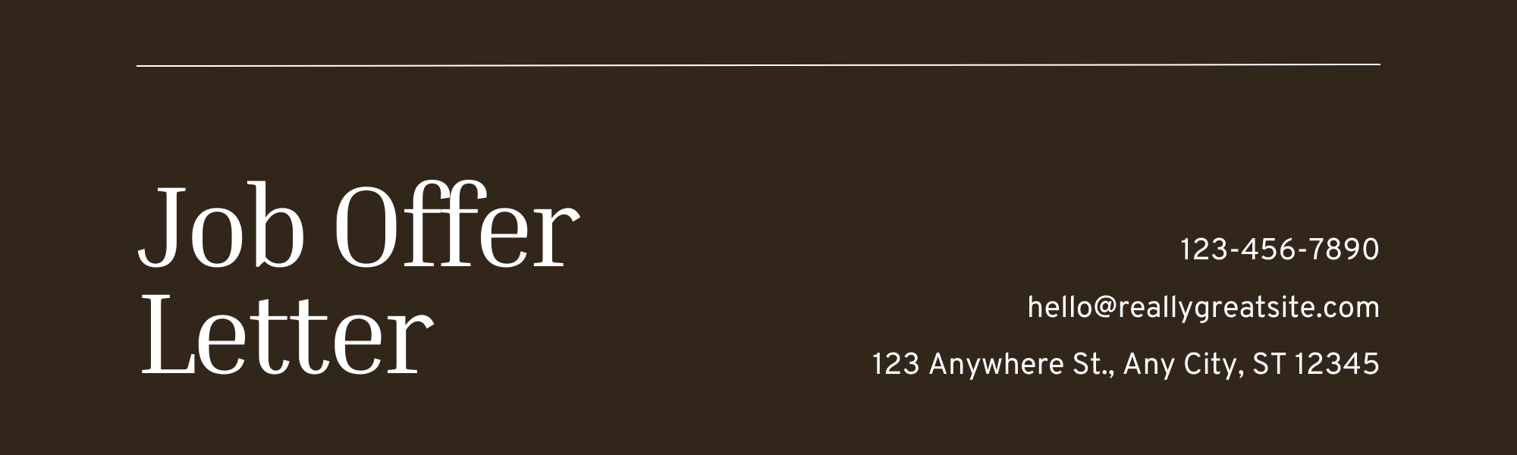

Sep 1, 2030

Dear [Candidate Name],

We’re thrilled to offer you the role of [Job Title] at [Company Name]. Your skills and experience are a great fit for our team, and we can’t wait to see the impact you’ll make.

This is a [type of employment, e.g., full-time, part-time, contract] position, with your start date planned for [start date]. As part of your role, you’ll enjoy a competitive salary and benefits package, including:

* **Salary:** [Amount]
* **Allowances:** [List applicable allowances]
* **Paid time off:** [Number of days/hours]
* **Health insurance:** [Coverage details]
* **Additional perks:** [E.g., stock options, performance bonuses]
* **Work schedule:** [Shift details, if applicable]

Your employment is contingent on the successful completion of background checks, document verification, and our onboarding requirements.

To accept this offer, please sign and return the enclosed copy by [deadline date]. If you have any questions or need clarification, feel free to reach out anytime at [phone number] or [email address].

We can’t wait for you to join us and accomplish great things together!

Best regards,

[Your Name]   
[Your Position]

|  |  |  |
| --- | --- | --- |
| **Credits**  This template is free for everyone to use, thanks to the following: | d8d31f07-92e3-40a8-8dff-4a7bc42f6632.png  For the template | Pexels, Pixabay  for the photos |