American University of Sharjah (AUS) GHG Study Data Sheet
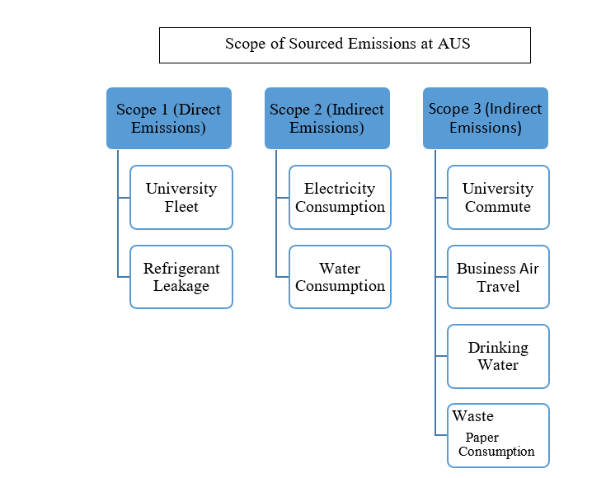
[Grab your reader’s attention with a great quote from the document or use this space to emphasize a key point. To place this text box anywhere on the page, just drag it.]

Scope 1: Direct Emissions
University Fleet: Refers to the university-based vehicles utilized in commuting either inside or outside the vicinity of the university.

Scope 2: Indirect Emissions
Electricity Consumption: The total quantity of the electricity consumed within the premise of the university.
Water Consumption: The total quantity of the water consumed within the premise of the university, which just covers the indoor water usage

Scope 3: Indirect Emissions
University Commute: AUS conducts an annual sustainability survey with a subsection on commute. The calculations are based on the type vehicle, fuel type, and distance traveled
Business Air Travel: Air travel was calculated in collaboration with the university travel agency in charge of the employees’ university funded travel. The calculation was done by entering the origin and destination points as well as class of travel into ICAO Carbon Emissions Calculator.
Drinking Water: The quantity of the drinking water consumed in the university is segregated into two sections. Firstly, the amount of single-use water bottles consumed through the outlets, as well as the vending machines provided in the university. Secondly, the water consumed through 5-gallon water coolers. This later point is extremely important as the tap water in Sharjah is potable by WHO water quality standards, but is not culturally accepted as potable.
Waste – Paper Consumption: The quantity of the waste disposed would be categorized into two sections. Firstly, the amount of paper consumed, would be quantified by obtaining the total amount of paper irrespective of the size and calculating the emission factors. Secondly, the waste sent to the landfill by the University will be quantified, through conducting regular waste audits conducted as part of the Sustainable Campus Initiative.
Total Carbon Footprint of the American University of Sharjah for the academic year 2018-2019
Sources of Emissions | CO2 Tons per Equivalence | % Contributions of Total Emissions
University Fleet | 352.2 | 0.37
Total Emissions of Scope 1 (tCO2e) | 352.2 | 0.37
Electricity Consumption | 57,596.3 | 60.85
Water Consumption | 195.8 | 0.21
Total Emissions of Scope 2 (tCO2e) | 57,792.1 | 61.05
Sum of Emissions from Scope 1 & 2 (tCO2e) | 58,094.18 | 61.42
Total Emissions of Scope 3 (tCO2e) | 36,514.5 | 38.57
Sum of Emissions from Scope 1 & 2 (tCO2e) | 94,608.7 | 100

