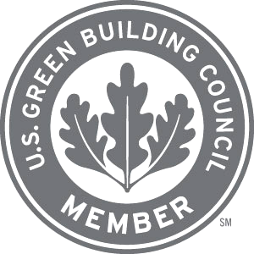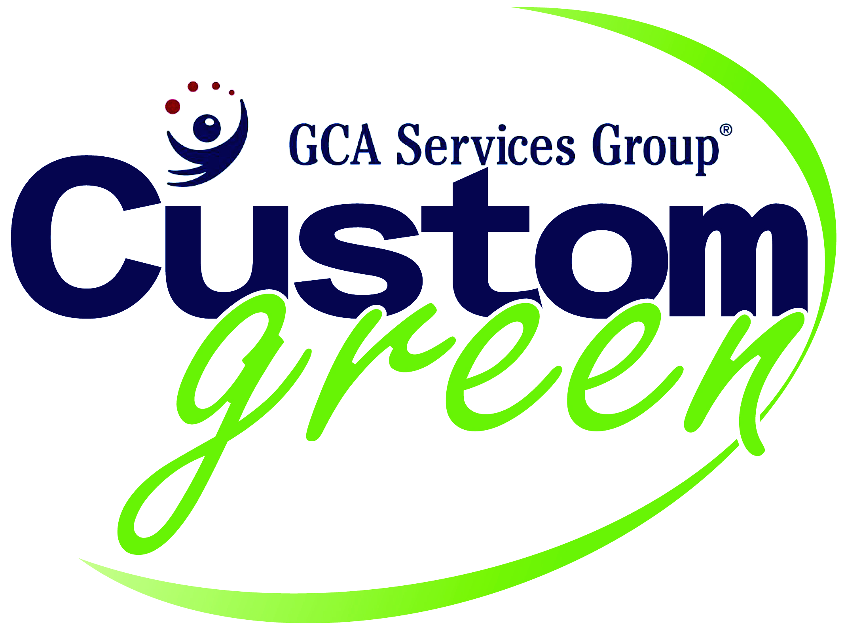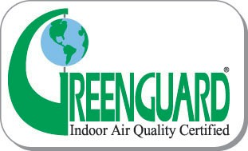
Custom Green R
Cleaning Program Policy

The GCA CUSTOM GREEN program offers a holistic approach to develop the most effective cleaning methods that protect human health and safety while reducing harmful impacts on the environment.

GCA Custom Green Cleaning Policy

- GCA Custom Green Cleaning Program to include corporate Standardized Operating Procedures:
  - Cleaning procedures
  - Chemical handling
  - Tracking requirements
  - Equipment maintenance
  - Operations procedures
  - Communication protocols and requirements
  - Training and inspection programs
  - Record keeping and reporting procedures
  - Must be reviewed on an annual basis for possible revisions

- GCA Site Specific Custom Green Cleaning Program includes:
  - Comprehensive communications plan (as established with the client) along with periodic effectiveness audit to protect human health and the environment.
  - Procedures for cleaning personnel to communicate with building management and occupants
  - Provide a system for feedback from building management and occupants
  - Floor maintenance plan to extend the life of flooring
  - Schedules of routine cleaning operations, periodical cleaning, equipment maintenance and operation, cleaning inspections, and accident preparedness plans (reviewed bi-annually)
  - Detailed description of how Custom Green cleaning procedures address high traffic and food preparation areas
  - Storage and chemical use, security of chemicals, and proper management of storage area
  - Proper ventilation concerning chemicals and recharging equipment
  - Address vulnerable populations (children, asthmatics, etc)
  - Address any sources of indoor contamination and pollutants
  - Special requirements of potentially hazardous materials including asbestos, and bloodborne pathogen standards
  - Cleaning of areas that have special concerns (inadequate ventilation, lighting, or restricted access)
  - Seasonal or periodic of increased or decreased use
  - Detailed description of the Integrated Pest Management program
  - Any cleaning procedure that may affect frequency of cleaning or negatively impact human health or the environment
  - Provide a detailed Bloodborne Pathogen Standard (OSHA Approved)
- All powered equipment (scrubbers, burnishers, extractors, power washers, etc) must maximize the effective reduction of building contaminants with minimal environmental impact
  - Vacuum cleaners meet Carpet and Rug Institute (CRI) Green Program requirements and operate at less than 70 dBA
  - Carpet extractors must meet minimum CRI Bronze Seal Award
  - Powered floor maintenance equipment must be equipped to collect and capture particulates while operating at a sound level of less than 70 dBA
  - Propane floor equipment must have low emission engines certified by the California Air Resources Board under SORE program and equipped with catalytic and exhaust systems; may only be used while building is unoccupied
  - Powered scrubbing machines must be able to dispense a variable rate of cleaning fluids to optimize the use of cleaning chemicals
  - Quarterly maintenance program that inspects and maintains the performance of all janitorial equipment documented on a maintenance log

- GCA Custom Green Cleaning Program to use only *environmentally preferable products (where applicable)
  - GS-37 = GP cleaners, floor, bathroom, glass, and carpet cleaners
  - GS-40 = Floor finishes and floor strippers
  - GS 41 = Liquid hand soap
  - GS 1 = Toilet and facial tissue
  - GS 9 = Paper towels and napkins
  - Plastic trash liners may contain a minimum of 10% post-consumer recycled content
* A disinfectant is currently not eligible for Green Seal approval

- GCA Custom Green Cleaning Program will reduce chemical waste resulting in more efficient use of chemicals
  - Provide written directions for cleaning staff in appropriate written or graphic languages for dilution of chemical cleaning products
  - Track quantities of chemical use on at least a quarterly basis
  - Use a chemical measuring and dilution control system
  - Train all workers on effective use of cleaning chemical products
  - Use appropriate technology for applying chemical product that does not waste nor result in overuse
  - Provide directions for proper rinsing and disposal of used or empty chemical solutions
  - Prevent other building areas from being adversely affected
  - Reduce, minimize, or eliminate the need for using cleaning chemicals when possible

- GCA Custom Green Cleaning Program will help reduce solid waste
  - Purchase products and supplies in quantities to minimize the amount of packaging and container waste generated
  - When possible, use reusable or microfiber technology in lieu of paper products (must only be used for two consecutive hours)
  - Reusable or microfiber materials must be placed in a sealable container and washed prior to reuse
  - Segregate & recycle all waste items (equipment) from cleaning operations

- Proper use and periodic maintenance of vacuums
  - All vacuums must have filter or bag and changed or cleaned during manufacturers recommendations
  - Vacuums bags must be inspected at least every two hours and changed or replaced when half-full
  - Precautions taken to limit worker exposure to dust and particulate matter when cleaning and/or replacing bags and filters

- GCA Custom Green Cleaning Program will keep all entryways free of debris and matting systems properly maintained
  - Walk-off matting both inside and outside building entryways are 10-20 feet in length (6-10 feet of scraper/wiper matting and 6-10 feet of wiper matting) emergency exits excluded
  - Matting is in accordance with appropriate daily maintenance schedule

- Hard Surface Floor Care
  - Vacuum to remove and contain particulate matter from floor surface or use mops equipped with reusable or cleanable collection heads
  - Heavy traffic areas (entrances, corridors, break areas, or primary work spaces) must be performed daily
  - Provide reasonable notice to building management prior to performing any non-routine floor cleaning operations
  - Apply restoration chemicals with mop or auto scrubber (NO SPRAY)
  - Burnishers and buffers must have particulate collection or capture devices
  - Restoration may only be performed on a “as needed” basis (no predetermined schedule)
  - Ensure proper ventilation during scrubbing and recoating operations
  - Minimum occupancy during floor stripping and refinishing

- Carpet Maintenance shall be vacuumed on a predetermined schedule to help extend the life span of soft surfaces
  - Heavy traffic areas may be vacuumed daily
  - Light traffic areas may be vacuumed periodically
  - Provide reasonable notice to building management prior to periodic light carpet cleaning and restorative cleaning
  - Carpet extraction on a as-needed basis (not on a regular schedule)
  - Carpets must dry in less than 12 hours after cleaning or extraction
  - Extraction must be scheduled during minimum building occupancy
  - Recommended to provide a interim maintenance (encapsulation) carpet cleaning program in lieu of carpet extraction

- May use disinfectants in areas or surfaces where pathogens can collect and breed
  - Disinfectants and devices must be EPA registered
  - Dilution rate and dwell time according to product labels must be followed

- All restroom care must be cleaned from high to low, toward the doorway with dry cleaning tasks performed prior to wet cleaning operations
  - Surfaces touched by hands must be cleaned and disinfected DAILY
  - Standing water or moisture on floor must be controlled and removed in a timely manner
  - Restroom cleaning equipment may only be used specifically for restrooms
  - Trash receptacles must be disinfected and liners pulled daily
  - Fill all drain traps on a regular basis

- Break Rooms & Dining Areas
  - All food preparation and consumption areas may be cleaned daily to protect human health
  - All surfaces that are touched by hands must be cleaned and sanitized DAILY
  - Waste containers likely to collect food waste must be covered, emptied when full, and cleaned/sanitized daily

- Trash Collection and Recycling
  - Remove general (office) trash and replace liners only when soiled from wet trash or prior to weekends or holidays
  - Dispose of trash in external, covered containers away from the immediate exterior of the building
  - Must mark recycling stations clearly and be accessible to building occupants
  - Food related recyclables must be collected and removed from the building prior to weekends and holidays
  - Must inspect and clean recycling areas and containers daily
  - Procedures for rinsing, separation, and locations of recyclable content must be communicated through building management
  - It is highly recommended to eliminate the use of trash liners if/where deemed appropriate

- Collect and dispose of all indoor plant debris such as fallen leaves and flower petals
(plants may not touch the carpet and may not be near HVAC vents)

- Schedule cleaning activities to avoid exposure to vulnerable populations
  - Adopt alternative cleaning practices that minimize chemical use
  - Chemicals must be used in well ventilated areas (blowers may be used to increase the rate of chemical dissipation
  - Prevent the transfer of impacts from cleaning to other areas of building

- Communications must be in conjunction with building owners, facility managers, and building occupants
  - Provide a system for employees to provide comments and suggestions about workplace issues or improvements of the service
  - Provide communication of pest or maintenance issues within facility
  - Provide building occupants feedback to reduce the need of more intensive cleaning processes (reduce clutter or reporting of spills)
  - Provide a product list and contact person for facility (MSDS)

- Proper care and maintenance of microfiber products
  - Microfiber may only be used for up to two hours of use prior to mandatory laundering
  - Microfiber must be laundered after two hours of use or when soiled
  - It is recommended to launder microfiber with warm to cool water temperatures, no bleach, and dry at a low setting (or air dry).

- Must provide initial, on-site or site specific and annual in-service training to employees
  - New hires must receive 12 hours of initial training followed by 24 hours of in-service training on an annual basis.
  - All cleaning personnel must be properly trained in handling of chemicals, P.P.E., equipment, and cleaning procedures prior to beginning independent work.
  - Safety training must be provided initially to all personnel to reduce and prevent ergonomic injuries and exposure to hazardous materials.
  - Site specific training must also be documented and retained at the facility for all current employees and one year for former employees.

*** GCA Services Group may conduct corporate on-site effectiveness audits and periodic monitoring to verify compliance

