|  |
| --- |
| College of Lake County |
| Landscape Management Plan – DRAFT |
|  |

|  |
| --- |
| 4-27-2017 |

**Contents**

**Landscape Management Plan Overview** 3

**Landscape Maintenance Zones** 4

**Grounds Management Staffing** 7

**Inventory and Management of Natural Areas:** 8

**Tree Survey and Management Plan** 14

**Arboretum** 15

**Sustainable Farm** 17

**Donation of Trees and Shrubs** 18

**Integrated Pest Management Plan** 19

**Sustainability Trail** 20

**Appendix A: Groundcover and Land Use Table (2014)** 22

**Appendix B: Palette of Preferred Native and Sustainable Forbs and Grasses** 23

**Appendix C: Palette of Recommended Trees and Shrubs** 24

**Appendix D: College of Lake County – Tree Donation Form** 27

**Appendix E: Bee Campus USA** 28

**Appendix F: Tree Campus USA and Arboretum Accreditation Criteria** 29

**Appendix G: Bioswale Operations and Management** 32

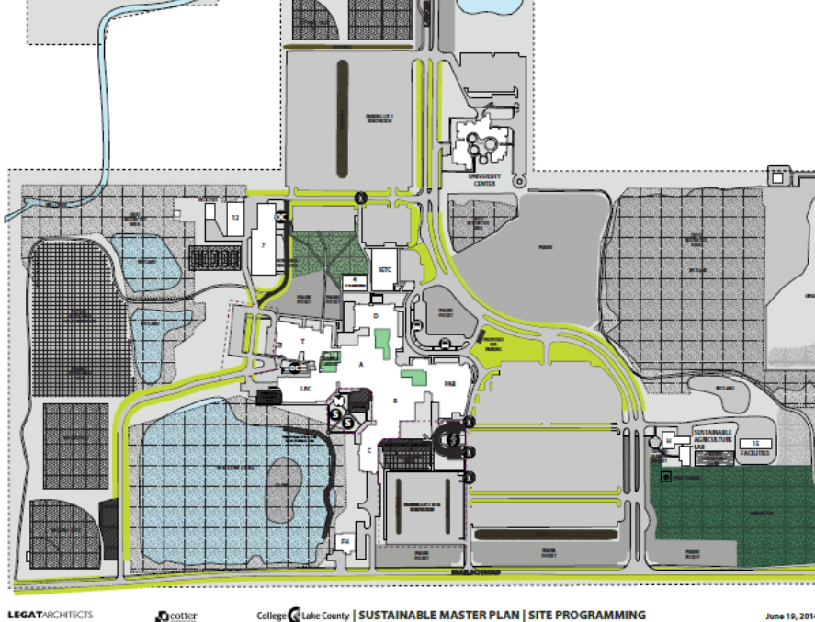 34

# **Landscape Management Plan Overview**

The College of Lake County comprises a total of 250 acres of land located on the Grayslake, Southlake and Lakeshore campuses. CLC’s campuses provide a variety of landscapes, ranging from manicured lawns and gardens, to prairie, wetland, and pond habitat restoration areas, to the campus arboretum and learning farm. Campus grounds serve as a valuable resource for our learning community. Students benefit by visiting the lake, prairie, wetlands and landscaped areas with instructors as their living laboratory.

The College of Lake County (CLC) is promoting sustainable landscape practices in a way that meet the aesthetic needs and the environmental and budgetary concerns of the college in a meaningful way. Sustainable landscape practices reduce the negative impacts of landscaping maintenance on human health and the surrounding environment by minimizing unnecessary mowing and trimming and by limiting the use of fertilizers, herbicides, and irrigation. Sustainable landscapes also promote the use of native landscaping, which regenerates ecosystems and improves stormwater management. Priority 3 of CLC’s Sustainability Plan recommends developing sustainable landscape practices in “a site management and training plan, establishing high, medium, and low maintenance zones in landscaped areas, including: turf, natural areas, prairie garden pods, stormwater best management practices, lake/pond shoreline buffers, green roofs, bike paths, butterfly garden, arboretum, and the farm.”

Landscaping is an important visual component of the branding of the college. Using the palette of native perennial flowers and grasses provided in Appendix B will convey to visitors that CLC is a place that values sustainability. Native flowers, grasses, trees, and shrubs also provide valuable habitat for beneficial wildlife including birds and butterflies. Integrated pest management is a sustainable approach to landscape management that will help the college to reduce its dependence on irrigation, fertilizers, and pesticides, while also improving air and water quality. As the word “native” implies, these plants demonstrate that the college appreciates its own natural heritage by provided a sense of place.

The Grayslake Campus is located in the Mill Creek Watershed. CLC participated with the Lake County Stormwater Management Commission in the development of the Mill Creek Watershed Plan in 2014. CLC was able to apply for and to receive grant monies to install bioswales in four of its parking lots. As a condition of the grant, CLC has developed the Operation and Management Plan for the Bioswales, which is included in this overall Landscape Management Plan.

# **Landscape Maintenance Zones**

This Landscape Management Plan establishes the high, medium, and low zones, outlining the types of landscaping and corresponding maintenance needs of each zone. By assigning different maintenance levels, the college is able to prioritize and reduce its maintenance load.

Tree and shrub care is often seen as less of a priority in landscapes. However, the 2015 tree survey calculates the cumulative value of our existing trees at $2,393,535 on the Grayslake Campus. Proper pruning, mulching, and other tasks are essential in maintaining these resources and ensuring that they thrive.

Use of native plant materials and integrated pest management are sustainable elements of landscape maintenance that are consistent across all three landscape zones. Native plants require dedicated maintenance in first 2-3 years to make sure that they thrive. Once they get established, these garden beds will require less maintenance as they will shade out competing weeds and will require little-to-no irrigation.

**High Maintenance Zones**

High Maintenance Zones are located in areas of high visibility and high intensities of use, including entry points to each of the three campuses and also the athletic fields.

It is important that CLC maintain a formal appearance for visitors entering the campuses, thus requiring the highest levels of maintenance. Just as they would in most any garden, native flowers and grasses may be selected for their appropriateness of the location. Many of the flowers and grasses identified in Appendix B Plant Palette would be appropriate in high maintenance zones, given their limited height and less aggressive nature. While annual flowers are discouraged, they may be especially helpful in adding color to planters near entrances for the entire growing season.

High level maintenance may require regular mowing, trimming, irrigation, and occasional fertilization/herbicide application. Mowing heights are lower than in other zones. The tolerance for weeds in the turf grass is also lower than elsewhere. Athletic fields have unique maintenance requirements with regard for the safety of athletes practicing and competing on them. They require regular mowing and seasonal fertilizer application, and proper grading and drainage to keep them functional.

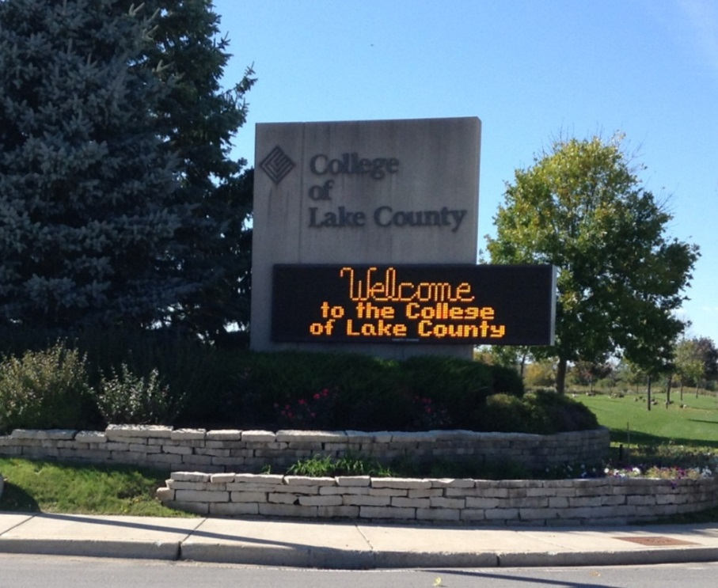

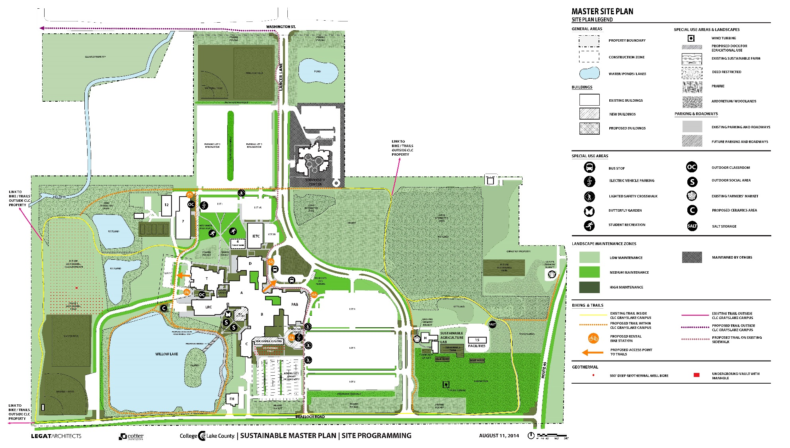

**Medium Maintenance Zones**

Most of the landscaping across all three campuses will tend to be Medium Maintenance, including the largest areas of turf grass. These turf areas are set back away from main walkways and road entrances. Medium Maintenance areas may be mowed at higher levels, require less trimming and irrigation, and reduce fertilizer and herbicide application, if any at all.

**Low Maintenance Zones**

Low Maintenance Zones include the natural areas of restored prairie, wetlands, ponds, and woodlands. These areas require less frequent maintenance on a short term basis, but suffer when left untended for years. Restored natural areas are vulnerable to incursions of invasive species. Invasive species are typically but not always non-native in origin. It generally takes a couple of years for native plants to thrive and be able to outcompete invasive species. The soils supporting these restoration efforts have been farmed for many years and then compacted with trucks re-grading the terrain to make way for development. See the Inventory and Management of Natural Areas below for more information about CLC’s prairie, wetlands, ponds, and woodlands.

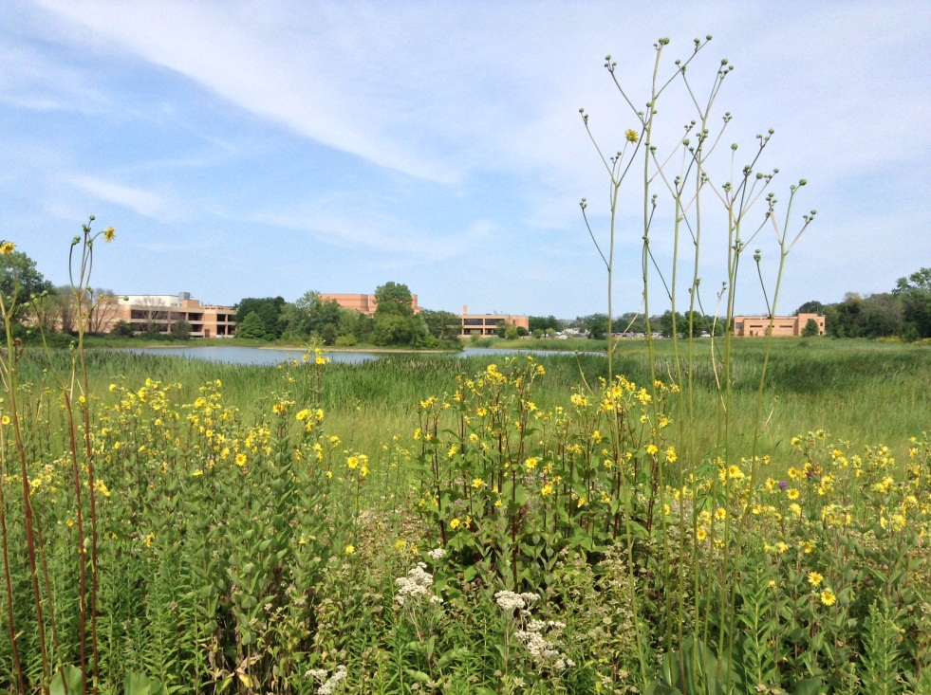

# **Grounds Management Staffing**

Grounds Crew

Mowing, snow removal, trash collection

Supervising Engineer

Natural Areas Coordinator

Maintenance of prairie, wetland, woodland, and pond buffers

Horticultural Coordinator

Maintenance of ornamental plantings, pruning and care of trees and shrubs

# **Inventory and Management of Natural Areas:**

**Prairie:**

The College of Lake County has roughly 9 acres of restored prairie on its Grayslake Campus located east of Lancer Lane, between the University Center and the Horticulture Building. The prairie restoration began in the 1980s as a living laboratory for environmental biology classes and resource on the CLC Fitness Trail. There are an additional 12 acres of what could be described as scrub grassland on the Glunz and Gwaltney properties, which were acquired in 2013 and 2014, and to the by the geothermal wells on west side of the campus.

Prairies are ecosystems considered part of the temperate grasslands, savannas, and shrublands biome by ecologists, based on similar temperate climates, moderate rainfall, and a composition of grasses, herbs, and shrubs, rather than trees, as the dominant vegetation type. While prairies are a predominantly indigenous ecosystem to Lake County, they are threatened by invasive plant species. Prairies must be maintained in a way that helps to simulate pre-settlement conditions. The Lake County Forest Preserve District provides [recommendations](http://www.lcfpd.org/conservation/natural-resource-management/) for management of natural areas, including [controlled burns](http://www.lcfpd.org/conservation/controlled-burns/) that stimulate native prairie plant growth and discourage many invasives.

CLC’s Horticulture Department developed a list of priority prairie management items:

* Remove of old sediment fencing and steel posts
* Develop a controlled burn schedule for a five year cycle, randomize block zones with random fall-spring burns
* Purchase burn equipment in order to conduct burns without having to borrow
* Seeding – area of sewer disturbance area needs seeding with basic prairie matrix mix
* Overseeding – mix of more diversified forbs (15-20 species) to enrich grass matrix
* Woody plant management – Target willows (*Salix*) and dogwoods (*Cornus*) for cutting and herbicide
* Herbaceous weed management – Target common reed (*Phragmites*) and purple loosestrife (*Lythrum)* for cutting and herbicide

*Aerial Photo of Grayslake Campus Prairie*

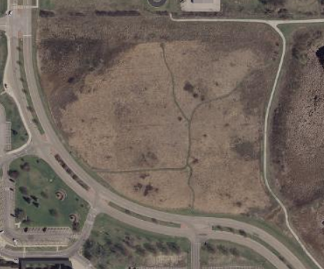

**Wetland:**

A wetland is a land area that is saturated with water, either permanently or seasonally, with its own distinct ecosystem, with characteristic vegetation, adapted to moist to wet conditions with hydric soils. Wetlands play a number of roles in the environment, principally water purification, flood control, carbon sink and shoreline stability. See Shoreline Buffer section below for information about the original Army Corps of Engineers deed restriction which later included the wetlands east of the prairie and south of Willow Lake.

Wetlands have been present on the Grayslake Campus since pre-settlement times. From the late 1800s to early 1900s several areas of historic wetlands were drained for farming, however with limited success. With the building out of the campus from the 1970s to 2000, wetland areas were recreated to manage stormwater flow better and to reintroduce habitat for plants and animals. Wetlands are found on the Southlake Campus, to the west of the parking lot, around the detention pond, and on the southwest corner of the parcel south of Port Clinton Road.

There are two major zones of wetland to manage on the Grayslake Campus. Zone 1 includes the wetland areas east of the walking path from the main prairie, which should be managed with the prairie in terms of burning, seeding and weed control. Zone 2 within the Willow Lake buffer between the south shore and the walking path that borders Brae Loch Road, which should be managed as part of the overall lake buffer. CLC’s Horticulture Department developed a list of priority wetland management items:

Zone 1

* Removal of old sediment fencing
* Burn schedule for 5 years as noted above in coordination with prairie area
* Overseeding – mix of more diversified forbs (12-15 species) to enrich prairie cordgrass (*Spartina*) and cattails (*Typha)* matrix
* Woody plant management – several zones of willows (*Salix)* and dogwoods (*Cornus)* should be cut and herbicided
* Weed management – Common reed (*Phragmites)* (several zones of concern) and purple loosestrife (*Lythrum)* targeted with herbicide treatment

*Zone 1 Wetlands*

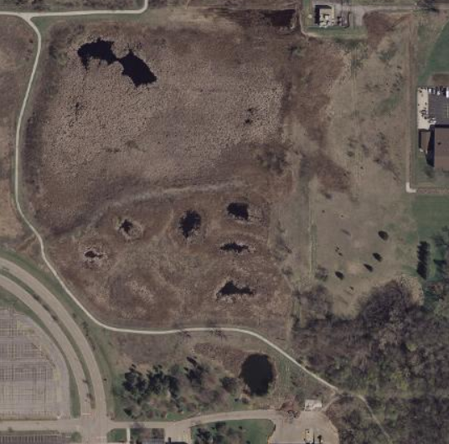

Zone 2

* Burn schedule for 5 years as noted above in coordination with buffer area
* Overseeding – mix of more diversified forbs (12-15 species) to enrich prairie cordgrass (*Spartina)* and cattails (*Typha)* matrix
* Woody plant management – several zones of willows (*Salix)* and dogwoods (*Cornus)* should be cut and herbicided
* Weed management – Common reed (*Phragmites)* (several zones of concern) and purple loosestrife (*Lythrum)* targeted with herbicide treatment

*Zone 2 Wetlands, around Willow Lake and Ponds*

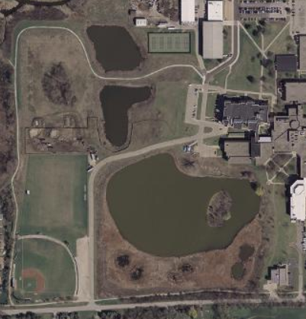

**Shoreline Buffer:**

Willow Lake was created in the early 1970s with the development of the original A and B building wings. The Fremont Avon Ditch (aka Mill Creek) widened to serve as a detention pond for the High School Technology Campus built in the late 1970s. The two detention ponds, between Willow Lake and the Avon Fremont Drainage Ditch, were constructed around 2001 before the addition of the Technology Building. The detention pond north of the University Center of Lake County was excavated in 2004, with the construction of the University Center. The detention pond at the Southlake Campus began as an excavated wetland with two separate ponds in the late 1970s, which were joined and enlarged with the construction of the V Building in 2005.

Each of the ponds, including Willow Lake, have been created for stormwater detention purposes, as they help manage stormwater runoff from the buildings and parking lots, by reducing flow and the impurities from entering into the Fremont Avon Ditch and Third Lake. Willow Lake, the two adjacent detention ponds, and the surrounding wetlands are protected by deed restrictions set forth in the 2000 Army Corps of Engineers Permit.

CLC’s Horticulture Department developed a list of priority lake and shoreline management items:

* Maintain and enhance native plantings in shoreline buffer areas, see wetland management recommendations
* Conduct full water quality assessment to ascertain if chemical reason behind lack of aquatic vegetation
* Re-engineer and repair of weir structure to allow water control (requiring review from the Army Corps of Engineers)
* Control Canada geese (e.g. coyote decoy, dog contract, grape flavoring spray)
* Repair and restoration of erosion blowouts adjacent to drainage outfall pipes
* Consider coir-fiber logs (biologs) to address bank under cutting
* Plant newly protected zones with appropriate wetland species tolerate of variable water levels
* Install geo-grid along service road access (north shore of lake, south of library wing) to provide more stable vehicle access and extend buffer plantings closer to building
* Install interpretive signage to explain shoreline area to students and visitors
* Install trail pathway and consider a boardwalk on a small stretch of shoreline to increase access to shoreline in selected areas, to encourage exploration of shoreline habitat and to deter trampling and compaction from visitors

**Woodlands:**

CLC’s woodland area to the south east of the Grayslake Campus and on the south parcel at the Southlake Campus have historically served as homestead locations. Mature trees are visible in historic aerial photos dating back to 1939. While the area was likely to have been clear cut in the 1800s, this area contains some of the oldest trees in the area, including several oaks and a large larch. Unfortunately, with lack of forestry care, they have become overun with invasive species including European buckthorn, honeysuckle, and garlic mustard. The woodland area on the southeast side of the Grayslake Campus has also suffered from an incursion of ash trees and the infestation of the emerald ash borer. Many of these dead trees remain in the woodland. Limited funding makes it difficult to maintain these valuable habitat resources.

*Aerial Photo of Woodlands*

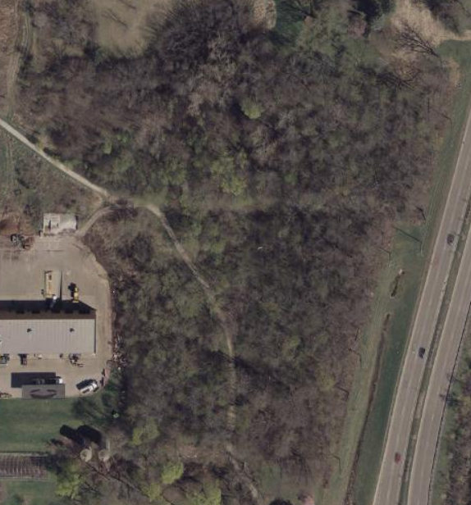

**Southlake Campus:**

CLC’s Southlake Campus in Vernon Hills has several areas that fit within the category of natural areas. The detention pond to the west of the parking lot was dug out of an existing wetland in the 1990s and expanded with the construction of the V Building in 2005. The wooded parcel south of Port Clinton Road is a lesser utilized part of Southlake Campus. This parcel contains many mature trees that were once part of a farmstead. Western parts of this parcel are considered to be wetlands. The eastern parts of the parcel are landscaped. There are mature trees in this area that are in need of maintenance.

*Aerial Photo of Southlake Campus*

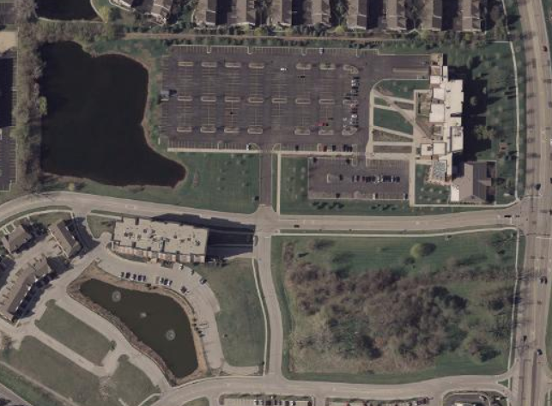

# **Tree Survey and Management Plan**

In February, 2016, the College of Lake County in Grayslake, IL retained Bartlett Tree Experts to perform an inventory of trees in the landscaped areas of the Grayslake campus and to develop a management plan. The Tree Survey and Management Plan are available in the Facilities Office and results of the tree survey are available online with the ArborScope™ web-based management system. The survey identified 1,008 trees, including 139 species. The attributes that we collected include tree latitude and longitude, size, age and condition class, and a visual assessment of tree structure, health, and vigor.

The inventory included:

* identifying trees and attaching to each tree a tag with assigned tag number (Tags 1-900);
* identifying the trees’ condition, health, and vigor;
* recommending risk evaluations and removals of appropriate trees;
* recommending tree care, soil care and fertilization, structural support, and pest management treatments to promote tree safety, health, appearance, and longevity; and
* mapping the trees using GPSr hardware and Geographic Information System (GIS) software, and Bartlett Tree Experts’ ArborScope™ web-based management system

Tree Inspection Methodology

In conducting the inventory, specialized equipment and software were used following specific procedures to determine tree characteristics, risk evaluations, and recommendations. The Inventory Team used Trimble® Geo GPSr hardware units, TerraSync™ and GPS Pathfinder® Office GIS software, and Bartlett Tree Experts' ArborScope™ web-based management system to inventory the trees. The attribute data we collected on site are listed below.

* botanical name and regional common name according to local ISA Chapter Tree Species List
* tree location based on GPS coordinate system
* tag number
* diameter at breast height (DBH)
* canopy radius
* age class
* height class
* condition class
* root zone infringement, based on dripline and estimated grayscape(e.g.,sidewalks) impact on root zone
* infrastructure interaction (between trees and grayscape) that may cause an undesirable condition
* priority of tree and shrub work (based on 3-year management plan)
* pruning
* need for and inspection of existing structural support systems
* need for and inspection of existing lightning protection systems
* need for advanced tree risk assessments (Level 3)
* tree removals
* soil care and fertilization recommendations
* plant health care recommendations
* noted defects/observations
* observed pests/diseases

# **Arboretum**

**College of Lake County Arboretum**

The CLC arboretum was developed by past Horticulture Department faculty and staff to serve the purpose of teaching woody plant identification for various horticulture classes. Dr. Mark Zampardo, faculty and department chair until 2008, and Barry Wilson, staff horticulturist until 2008, planted an extensive collection of approximately 300+ species and varieties of trees and shrubs, but no formal map or list of these plants was available, nor were the plants placed in any specific design approach. Many were not labeled in any manner, and in recent years, many of the labels that were present have been lost. Over the period of 2008-2016, many of the ash trees present were impacted by Emerald Ash Borer (EAB), and other trees were damaged in storms, particularly severe wind storms during July, 2011. Still other trees have become structurally unsound due to their age, as a number of the more mature trees date back to when the property was a farmstead pre-CLC. A “restoration and renewal” plan for the arboretum was needed.

In December, 2015, Rory Klick, current horticulture faculty and department chair, proposed including an arboretum renewal plan as part of her sabbatical work for the 2016-2017 academic year. This project would utilize the larger campus tree survey and inventory conducted by Bartlett in 2016, and work to incorporate permaculture and sustainability standards per the new sustainable agriculture academic track started in 2012.

The goals for the arboretum renewal plan are as follows:

1. Develop an overall plan for the arboretum plantings that reflects an aesthetically pleasing layout of trees, shrubs, perennials, groundcovers, vines and landscape features so as to provide an appealing outdoor destination on the Grayslake campus for all CLC students and staff
2. Incorporate built landscape features such as benches, tables and outdoor classroom space to make the arboretum more usable for classes; include an area that is ADA compliant to allow universal access, and also demonstrate permeable paving options
3. Work with college staff to include trail points for interpretation as part of the larger campus sustainability trail
4. Remove diseased, dead, dying or structurally damaged trees and any invasive species
5. Plant the ~40 missing species of trees and shrubs that are part of the horticulture curriculum but not present in the collection
6. Develop a list and placement for additional edible tree and shrub crops (hazelnuts, raspberries, pecans, walnuts, etc.) and fruit trees (apples, pears, plums, etc.) which would support the agriculture courses and expand the campus farm food production
7. Curate the collection so that it is labeled and the information is available to the public
8. Work with college facilities staff to include arboretum issues into the overall landscape/tree management plan of the college; this would include but is not limited to proper mulched tree rings, watering during drought periods, monitoring for pest/disease issues, and structural pruning as needed
9. Apply for designation as a “level I arboretum” per guidelines through the association of arboreta (see details in appendix #)
10. Work with college facilities staff to apply for designation as a Tree Campus USA (requirements in appendix #)

The most significant challenge to achieving these goals is the lack of staffing to maintain the arboretum. In 2014, the full-time staff horticulturist position that was part of the academic horticulture department was cut, as was the half-time horticultural assistant position. These two positions (60-hours/week) were replaced by one 25-hour/week part-time horticultural assistant. While the Grounds Department of the college assists by mowing the turf within the arboretum and periodically helping with emergency tree removal, but the Grounds staff is insufficient to support proper maintenance of the arboretum as a resource. The Grounds staffing is insufficient to keep up with the overall acreage of the campuses they maintain at a most basic level per professional grounds maintenance, with only 5 full-time staff overseeing 226 acres. Optimum staffing based on APPA (The Association of Higher Education Facilities Officers), standard is 12 acres per Groundsworker, therefore our number of Grounds staff should be at least 18.8 for the Grayslake campus, and slightly higher given duties on the Vernon Hills and Waukegan campuses. In short, CLC is so significantly understaffed with regard to grounds care, that renovation of the arboretum may simply not be a worthwhile investment until further staffing is resolved.

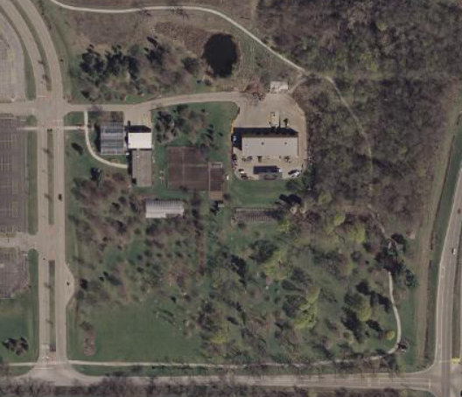

# **Sustainable Farm**

*To be developed with assistance of Rory Klick and the Horticulture Department.

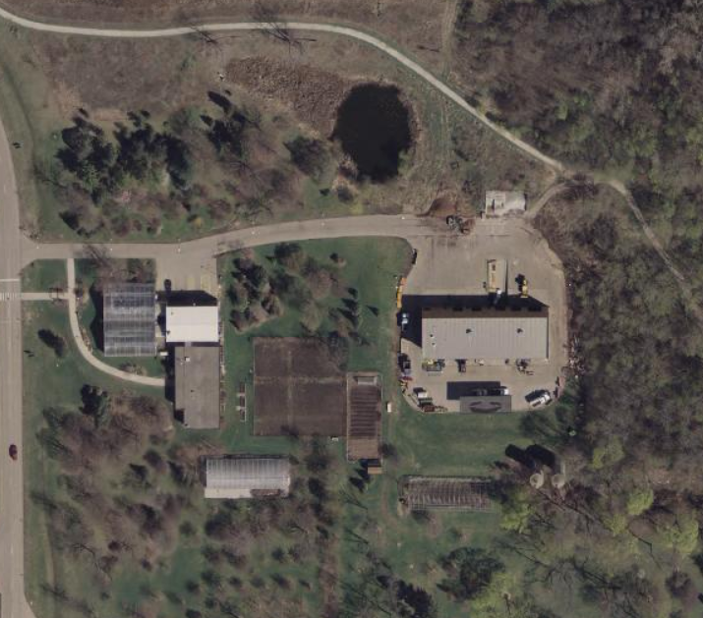

Apiary

Sustainable Farm and Horticulture Buildings

# **Donation of Trees and Shrubs**

Tree and shrub donations are welcome at the College of Lake County. Such landscaping helps to beautify the campus and promote sustainability by promoting clean air and water. Over the years, the College of Lake County has received requests for tree donations. These donations are typically intended to memorialize someone with a special connection to the college.

This section of the Landscape Maintenance Plan provides specifications and procedures and must be consistent with the College of Lake County Gift Acceptance Policy and Procedures. This policy may be adapted to apply to the donation of shrubs or gardens, however changes to the specifications below may require approval from the Campus Environment and Operations Commission or other entities.

Specifications:

* Any tree donation is subject to approval by the Department of Horticulture and the Facilities Department.
* Donated trees are to be planted within the Grayslake Campus Arboretum.
* Species of trees proposed for donation should be consistent with the list of Recommended Trees, identified in Appendix C of the Landscape Maintenance Plan, that are hardy to our climate, appropriate to the proposed location, and contribute to the biodiversity of the campus.
* Planting should take place during the spring or fall, as determined by the college.
* The fee of $200, payable to the College of Lake County Foundation, is tax deductible.
* The fee pays for a 1.5-2” caliper tree (or equivalent) and supports the costs of purchasing, planting, and maintaining the tree. The fee also includes a metal tag with identifying information, if desired.
* Exceptions to any of these specifications will require additional review and approval.
* While the college does everything that it can to protect its trees, the permanence of any donated trees cannot be guaranteed beyond one year.

Procedure:

* + Individuals or groups wishing to donate a tree should first contact the College of Lake County Facilities Department at 847/543-2080.
  + The donor should complete the form found in Appendix D. to proceed with the tree donation.
  + The donation must meet the specifications identified above.

# **Integrated Pest Management Plan**

Whereas traditional pest control involves the routine application of pesticides, Integrated Pest Management (IPM) focuses on pest prevention and only uses pesticides as needed. Pesticide use is based on the management of rather than the eradication of pests. This provides a more effective, environmentally sensitive approach.

IPM programs take advantage of all appropriate pest management strategies, including the judicious use of pesticides. Preventive pesticide application is limited because the risk of pesticide exposure may outweigh the benefits of control, especially when non-chemical methods provide the same results.

IPM is not a single pest control method but rather involves integrating multiple control methods based on site information obtained through inspection, monitoring, and reports. Consequently, every IPM program is designed based on the pest prevention goals and eradication needs of the situation.

Correct pest identification is required to determine the best preventive measures and reduce the unnecessary use of pesticides. Additionally, correct identification will prevent the elimination of beneficial organisms. When monitoring for pests, maintain records for each building detailing: monitoring techniques, location, and inspection schedule.

The EPA recommends that schools use IPM - a Smart, Sensible and Sustainable approach to pest control:

* Smart because IPM creates a safer and healthier learning environment by managing pests and reducing children’s exposure to pests and pesticides.
* Sensible since practical strategies are used to reduce sources of food, water and shelter for pests in school buildings and grounds.
* Sustainable because the emphasis is on prevention, which makes it an economically advantageous approach.

IPM is an effective and environmentally-sensitive approach that offers a wide variety of tools to reduce contact with pests and exposure to pesticides. The website focuses on providing vital information in the school setting to parents, school administrators, staff and pest management professionals. Knowledgeable, proactive stakeholders can enable a community to prevent or significantly reduce pollution from unnecessary pesticide use. ([US EPA](https://www.epa.gov/managing-pests-schools/introduction-integrated-pest-management#Principles))

Elimination of pesticides that contain neonicotinoids is an example of an IPM strategy to avoid non-target species such as honey bees. CLC works to reduce and eliminate where possible pesticides, focusing rather on prevention of disease and treating the cause with cultural, manual, biological methods of control.

# **Sustainability Trail**

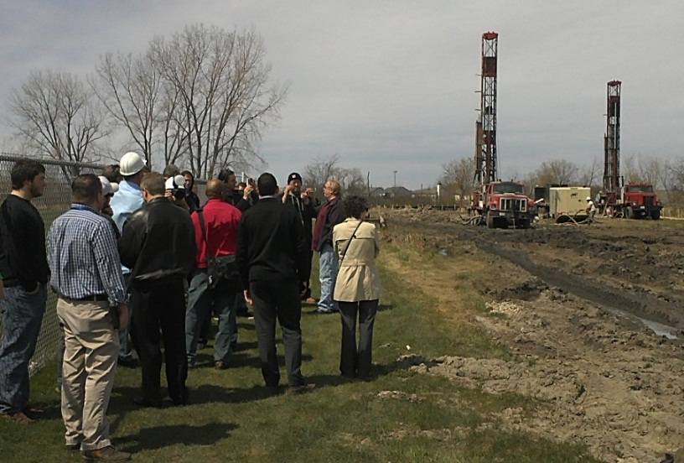

*CLC HVAC students meeting with geothermal well drill team*

With the building out its Sustainable Master Plan, the College of Lake County boasts its new and renovated buildings designed to USGBC LEED Gold and Platinum standards, new geothermal well fields, and sustainable landscapes and restored natural areas. These new sustainable features provide excellent educational opportunities for CLC students and community members. By connecting these elements along a Sustainability Trail, students, faculty, staff, and other visitors will be able to learn about how they benefit the environment, financial resources, and our diverse populations.

The Sustainability Trail will highlight the college sustainable landscape management practices across the campus grounds, eventually on all three campuses. Trail signage will identify prairie and wetland restoration areas, bioswales on parking lots to manage stormwater runoff, benefits of native plants and associated fauna, and the college apiary, sustainable farm, and arboretum. The trail may also identify the college’s integrated pest management strategies.

With a $10,000 Green Genome award from the AACC SEED Center in 2016, CLC is developing interpretive signage to help in identifying the trail routes and sustainable features across campus. Signage will educate visitors about features such as the geothermal, solar photovoltaic, and solar thermal renewable energy systems and also the restored prairie and wetlands, the sustainable farm, apiary, and campus arboretum. CLC will seek involvement from students to develop language and aspects of design for the signage. CLC will evaluate the possibility of hiring a design firm to develop a comprehensive scheme with images to complement the narrative information. Once designed, the signs will need to be printed, mounted, and installed along the trail. CLC will evaluate developing on-line applications, trail guide pamphlets and/or phone apps to enhance the impact of the trail, both on and off-campus.

Lake County is developing its regional bicycle and walking trail system, integrating resources from its forest preserves, state parks, park districts, schools, and public rights of way countywide. The Grayslake Campus is located in the center of the county and is participating in this connection. In 2013, CLC worked with the Village of Grayslake to connect a neighborhood to its northeast with its trails and a pre-existing connection to the rest of the village’s trail system. In 2015, the Lake County Division of Transportation worked with CLC to construct a multi-use trail connecting the campus to the nearby [Lake County Forest Preserve Trails](http://www.lcfpd.org/maps/) at Rollins Savanna and the countywide Millennium Trail.

The Sustainability Trail will play a significant role in highlighting features across the campus and grounds, educating students and visitors about the benefits of sustainability and green job opportunities, connect our Living Laboratory with the rest of the county.

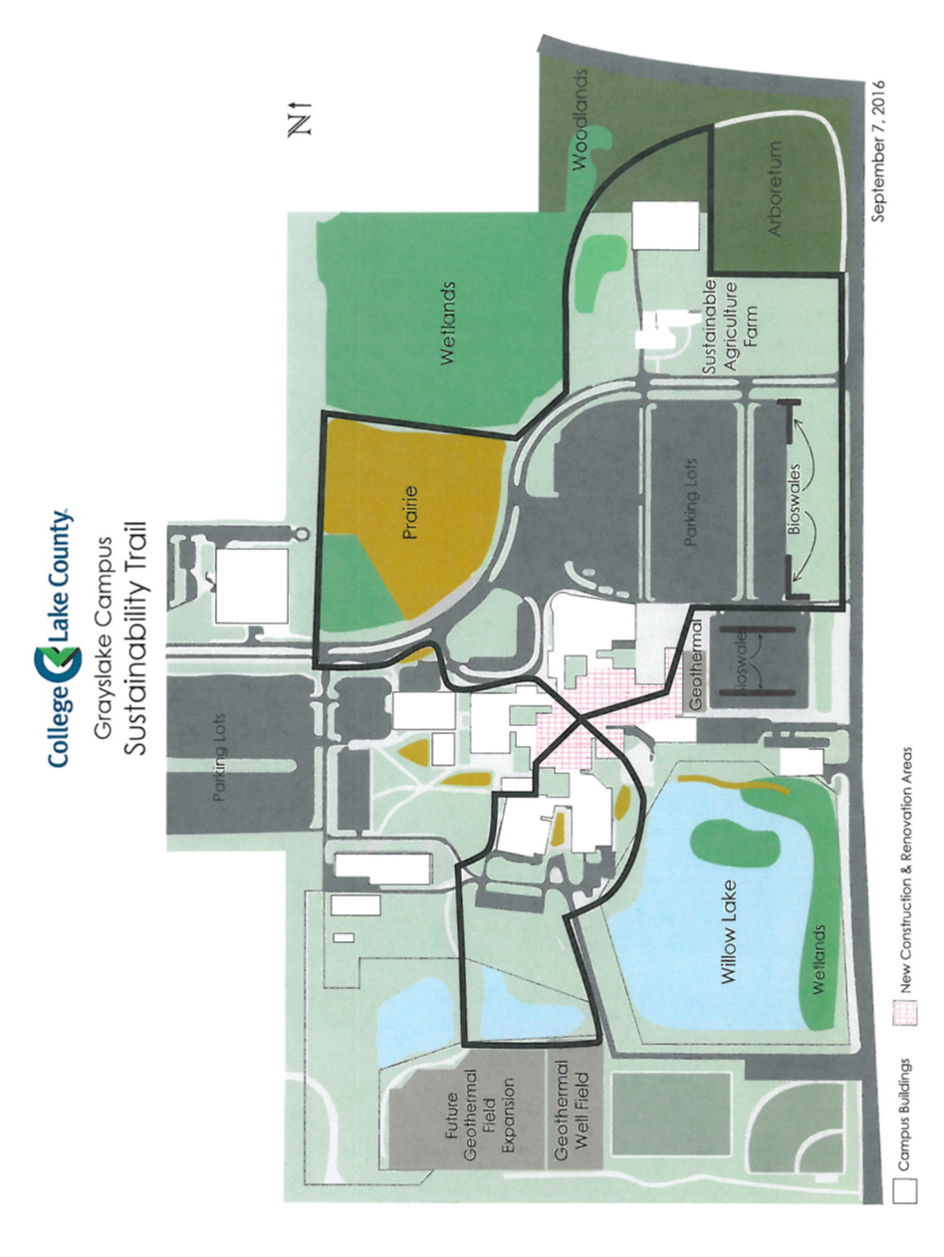

# **Appendix A: Groundcover and Land Use Table (2014)**

|  |  |  |  |
| --- | --- | --- | --- |
| **Ground Cover/Land Use** | **Acres of Land for Each Campus** | | |
| **Grayslake** | **Southlake** | **Lakeshore** |
| Buildings | 11.3 | 1.0 | 1.0 |
| Parking Lots | 31.7 | 4.4 | 1.0 |
| Roads | 18.5 |  |  |
| Turf Grass and Garden | 88.7 | 4.7 | 0.8 |
| Sport Fields | 16.4 |  |  |
| Arboretum | 6.9 |  |  |
| Wetlands | 32.7 | 1.9 |  |
| Woodland | 5.8 | 4.9 |  |
| Willow Lake and Ponds | 13.7 | 1.9 |  |
| Gages Lake | 16.6 |  |  |
| Prairie | 8.6 |  |  |
| Grassland | 12.1 |  |  |
| Farm | 1.5 |  |  |
| **SUM** | **229.1** | **18.9** | **1.8** |

# **Appendix B: Palette of Preferred Native and Sustainable Forbs and Grasses**

Plant species installed on the College of Lake County campuses should include perennials that are indigenous to Lake County and to the northeastern Illinois region. Exceptions can be made to this list, especially in potted planters, which may include annuals for full summer color. Many native and sustainable species can be adaptable to formal plantings, while others would be best be used in natural settings. See also Appendix G-1 for a list of plants to be used in the bioswales. Native and sustainable plants are identified below by their preferred habitat conditions, in terms of amount of sun and soil moisture.

**Flowers and Grasses - Sunny and Dry to Medium Soils:**

|  |  |
| --- | --- |
| * *Allium cernuum* – Nodding Wild Onion | * *Eryngium yuccifolium* – Rattlesnake Master |
| * *Asclepias tuberosa* – Butterflyweed | * *Geum triflorum* – Prairie Smoke |
| * *Aster laevis* – Smooth Blue Aster | * *Liatris aspera* – Rough Blazing Star |
| * *Baptisia australis* – Blue Wild Indigo | * *Penstemon digitalis* – Foxglove Beardtongue |
| * *Chasmanthium latifolium* – Northern Sea Oats | * *Rudbeckia subtomentosa* – Sweet Black-Eyed Susan |
| * *Dalea purpurea* – Purple Prairie Clover | * *Schizachrium scoparium* – Little Bluestem |
| * *Desmodium illinoense* – Illinois Tick Trefoil | * *Solidago rigida* – Stiff Goldenrod |
| * *Echinacea purpurea* – Purple Coneflower | * *Sporobolus heterolepis* – Prairie Dropseed |

**Flowers and Grasses – Full to Part Sun, Moist to Wet Soils:**

|  |  |
| --- | --- |
| * *Acorus calamus* – Sweet Flag | * *Helenium autumnale* – Sneezeweed |
| * *Asclepias incarnata* – Marsh Milkweed | * *Iris virginica* – Blue Flag Iris |
| * *Carex comosa* – Bristly Sedge | * *Liatris pycnostachya* – Prairie Blazing Star |
| * *Carex stricta* – Common Tussock Sedge | * *Physostegia virginiana* – Obedient Plant |
| * *Chelone glabra* – Turtlehead | * *Solidago ohiensis* – Ohio Goldenrod |
| * *Eleocharis palustris* – Great Spike Rush | * *Symphyotrichum* (formerly *Aster*) *novae-angliae* – New England Aster |
| * *Eupatorium perfoliatum* – Common Boneset | * *Tradescantia ohiensis* – Ohio Spiderwort |

**Flowers and Grasses – Part Sun to Shade, Medium to Moist Soils**

|  |  |
| --- | --- |
| * *Anemone canadensis* – Canada Anemone | * *Elymus hystrix* – Bottlebrush Grass |
| * *Asarum canadense* – Wild Ginger | * *Eupatoreum purpurea* – Joe Pye Weed |
| * *Carex grayii* – Gray’s Sedge | * *Geranium maculatum* – Wild Geranium |
| * *Carex pennsylvatica* – Penn Sedge | * *Phlox divericata* – Woodland Phlox |
| * *Carex rosea* – Curly-Styled Wood Sedge | * *Solidago flexicaulis* – Zig Zag Goldenrod |

# **Appendix C: Palette of Recommended Trees and Shrubs**

**Canopy Trees:**

|  |  |  |  |
| --- | --- | --- | --- |
| **Native** | **Street** | **Botanic – Common Name** | **Habitat** |
| Illinois | Yes | *Acer nigrum* – Black Maple | (Full to Part Sun/Medium Moisture) |
| Lake |  | *Acer saccharum* – Sugar Maple | (Full to Part Sun/Medium Moisture) |
| Lake | Yes | *Aescalus glabra* – Ohio Buckeye | (Full Sun to Part Shade/Medium Moisture) |
| Illinois |  | *Betula nigra* – River Birch | (Full Sun to Part Shade/Medium to Wet) |
| Lake |  | *Carpinus caroliniana* – American Hornbeam | (Full to Part Shade/Medium Moisture) |
| Lake | Yes | *Carya cordiformis* – Bitternut Hickory | (Full Sun to Part Shade/Medium to Wet) |
| Illinois |  | *Carya illinoinensis* – Pecan | (Full Sun to Part Shade/Medium Moisture) |
| Lake | Yes | *Carya glabra* – Pignut Hickory |  |
| Lake |  | *Catalpa speciosa* – Northern Catalpa | (Full Sun to Part Shade/Medium to Wet) |
| Lake | Yes | *Celtis occidentalis* – Hackberry | (Full Sun to Part Shade/Medium to Wet) |
| Lake |  | *Crataegus coccinea* – Scarlet Hawthorn |  |
| Lake | Yes | *Crataegus crus-galli* – Cockspur Hawthorn |  |
| Lake |  | *Crataegus mollis* – Downy Hawthorn |  |
| Illinois | Yes | *Gymnocladus dioica* – Kentucky Coffeetree | (Full Sun/Medium Moisture) |
| Lake |  | *Juglans cinerea* – Butternut |  |
| Lake | Yes | *Juglans nigra* – Black Walnut |  |
| Illinois |  | *Larix laricina* – Tamarack | (Full Sun/Medium to Wet) |
| Illinois |  | *Liquidambar styraciflua* – Sweet Gum | (Full Sun/Medium Moisture) |
| Illinois | Yes | *Nyssa sylvatica* – Tupelo/Sour Gum | (Full Sun/Medium Moisture) |
| Lake | Yes | *Ostrya virginiana* – Ironwood | (Full to Part Sun/Medium Moisture) |
| Lake |  | *Pinus banksiana* – Jack Pine |  |
| Lake |  | *Pinus strobus* – Eastern White Pine | (Full to Part Sun/Medium Moisture) |
| Lake | Yes | *Platanus occidentalis* – Sycamore | (Full to Part Sun/Medium to Wet) |
| Lake |  | *Prunus serotina* – Black Cherry | (Full Sun/Dry to Medium) |
| Lake | Yes | *Quercus alba* – White Oak | (Full Sun/Medium Moisture) |
| Lake | Yes | *Quercus bicolor* – Swamp White Oak | (Full Sun/Medium to Wet) |
| Lake | Yes | *Quercus macrocarpa* – Burr Oak | (Full Sun/Medium Moisture) |
| Lake |  | *Quercus muehlenbergii* – Chinquapin Oak | (Full to Part Sun/Medium Moisture) |
| Lake | Yes | *Quercus rubra* – Northern Red Oak | (Full to Part Sun/Medium Moisture) |
| Illinois |  | *Taxodium distichum* – Bald Cypress | (Full Sun/Wet) |
| Lake | Yes | *Tilia americana* - American Basswood/ Linden | (Full Sun to Part Shade/Medium Moisture) |

**Understory/Ornamental Trees:**

|  |  |  |  |
| --- | --- | --- | --- |
| Lake |  | *Amelanchier arborea* – Serviceberry | (Part Sun/Medium Moisture) |
| Lake |  | *Amelanchier laevis* – Allegheny Shadblow | (Part Sun/Medium Moisture) |
| Illinois |  | *Cercis canadensis* – Red Bud |  |
| Lake |  | *Cornus alternifolia* – Pagoda Dogwood | (Full Sun to Part Shade/Medium Moisture) |
| Lake |  | *Hamamelis virginiana* – Witch Hazel | (Full Sun to Part Shade/Medium Moisture) |
| Lake |  | *Prunus americana* – American Plum | (Full Sun/Dry to Medium) |
| Lake |  | *Prunus pumila* – Sand Cherry |  |
| Lake |  | *Prunus virginiana* – Chokecherry | (Full Sun to Part Shade/Medium Moisture) |

**Shrubs:**

* *Aronia arbutifolia* - Red Chokeberry (Full Sun to Part Shade/Medium to Wet)
* *Aronia melanocarpa* – Black Chokeberry (Full Sun to Part Shade/Medium to Wet)
* *Ceanothus americanus* – New Jersey Tea (Full Sun to Part Shade/Medium Moisture)
* *Cephalanthus occidentalis* – Buttonbush (Full Sun to Part Shade/Medium to Wet)
* *Cornus sericea* – Red Osier Dogwood (Full Sun to Part Shade/Medium to Wet)
* *Corylus americana* – Hazelnut (Full Sun to Part Shade/Medium Moisture)
* *Diervilla lonicera* – Bush Honeysuckle (Full Sun to Part Shade/Medium Moisture)
* *Hydrangea arborescens* – Smooth Hydrangea (Full Sun to Part Shade/Medium Moisture)
* *Ilex verticillata* – Winterberry (Full Sun to Part Shade/Medium to Wet)

**Shrubs (continued):**

* *Juniperis horizontalis* – Trailing Juniper (Full Sun to Part Sun/Dry, Well Drained)
* *Lindera benzoin* – Spicebush (Full Sun to Part Shade/Medium to Wet)
* *Potentilla fruticosa* – Shrubby Cinquefoil (Full Sun to Part Sun/Dry to Medium)
* *Rhus aromatica* – Fragrant Sumac (Full Sun to Part Shade/Medium Moisture)
* *Rhus copallina* – Shining Sumac (Full Sun /Dry, Well Drained)
* *Rhus glabra* – Smooth Sumac (Full Sun/Dry, Well Drained)
* *Symphoricarpos alba* – Snowberry (Full Sun to Part Shade/Medium Moisture)
* *Symphoricarpos orbiculatus* – Coralberry (Full Sun to Part Shade/Medium Moisture)
* *Viburnum dentatum* – Arrowwood (Full Sun to Part Shade/Medium Moisture)
* *Viburnum lentago* – Nannyberry (Full Sun to Part Shade/Medium Moisture)

**Common Invasive Landscaping Species to Avoid:**

* *Acer platanoides* – Norway Maple
* *Euonymus alatus* – Burning Bush
* *Lonicera spp.* – Non-native Honeysuckle species
* *Pyrus calleryana* – Callery Pear

# **Appendix D: College of Lake County – Tree Donation Form**

Tree donations are welcome at the College of Lake County. Trees help beautify the campus and promote sustainability, by helping to clean the air and water. This form identifies donation specifications and procedures, consistent with the College of Lake County Gift Acceptance Policy and Procedures and the Landscape Maintenance Plan.

Specifications:

* Any tree donation is subject to approval by the Department of Horticulture and the Facilities Department.
* Donated trees are to be planted within the Grayslake Campus Arboretum.
* Species of trees proposed for donation should be consistent with the Palette of Recommended Trees and Shrubs, identified in Appendix C of the Landscape Maintenance Plan, or otherwise recommended by the Horticulture Department, that are hardy to our climate, appropriate to the proposed location, and contribute to the biodiversity of the campus.
* Planting should take place during the spring or fall, as determined by the College.
* The fee of $200, payable to the College of Lake County Foundation, is tax deductible.
* The fee pays for a 1.5-2” caliper tree (or equivalent) and supports the costs of purchasing, planting, and maintaining the tree. The fee also includes a metal tag with identifying information, if desired.
* Exceptions to any of these specifications will require additional review and approval.
* While the College does everything that it can to protect its trees, the permanence of any donated trees cannot be guaranteed beyond one year.

Procedure:

* + Individuals or groups wishing to donate a tree should first contact the College of Lake County Facilities Department at 847/543-2080 and then the Horticulture Department at 847/543-2320.
  + The donor(s) should complete this form to proceed with the tree donation.

I/We _____________________________________________________________________________________

would like to purchase a tree for donation to the College of Lake County and agree to the specifications identified above.

I/We wish to include a memorial metal sign/tag to acknowledge that this tree is being planted in commemoration of ___________________________________________________________________________________________

___________________________________________________________________________________________

I/We can be reached by phone at _____________________ or by email ________________________________

Signed:

_____________________________________________

_____________________________________________

Date: _____________________________________________

# **Appendix E: Bee Campus USA**

The College of Lake County (CLC) is committed to doing its part to support and protect pollinators, both native bees and European honey bees. This appendix, with the seven points outlined below, demonstrate CLC’s completion of the requirements for its application to BEE CAMPUS USA program.

1. The College of Lake County (CLC) maintains a Landscapes Subcommittee of the Environmental Action Committee, charged with reviewing the BEE CAMPUS USA commitments. This subcommittee is comprised of the Sustainability Manager, grounds department staff, Facilities Director, Horticulture Department Chair, Biology Department (and other) faculty, and students. This subcommittee is charged with developing and maintaining this Landscape Management Plan, which includes Appendix A: Preferred Native and Sustainable Plant and Appendix B: Preferred Native Trees and Shrubs. Appendices A and B contain lists of locally native, pollinator-friendly plants that will help the college to meet its goal to develop and preserve pollinator habitats across its three campuses. Included in this Landscape Management Plan is CLC’s integrated pest management (IPM) plan which outlines CLC’s commitment to minimize use of herbicide and fertilizer use wherever possible. The preferred plant lists and IPM plan are publicized with this report, which is made available on the [Greening our Campus webpage](http://www.clcillinois.edu/aboutclc/who-we-are/green-initiatives/greening-our-campus).
2. CLC hosts events throughout the year to raise awareness of the importance of pollinators, planting pollinator-friendly gardens and natural areas, and reducing herbicide application throughout the year.  Regular annual events include Climate Week, the One Earth Film Festival, and Earth Week. Each of these events will present visitors with opportunities to learn about pollinators and CLC as a partner with BEE CAMPUS USA.
3. CLC sponsors and tracks student service-learning projects to enhance pollinator habitats on-and off-campus each year. Events are sponsored through the Horticulture Department and the Horticulture Club.
4. CLC provides workshops on pollinator ecology and integrates integrated pest management and landscaping for pollinators into several of its horticulture courses, including HRT 150 Landscape Maintenance and HRT 285 Sustainable Landscapes.
5. CLC is developing its Sustainability Trail to educate the campus and broader community about the sustainable practices on campus. See the description of the program identified in this Landscape Management Plan. Signage on CLC’s Sustainability Trail will highlight CLC’s apiary, native landscaping, and sustainable practices that benefit pollinators.
6. CLC shares educational and community service activities on its [Greening our Community webpage](http://www.clcillinois.edu/aboutclc/who-we-are/green-initiatives/greening-our-community) with its sustainability community calendar.
7. CLC agrees to apply for renewal of its designation as part of BEE CAMPUS USA and will submit a brief report of the previous year’s BEE CAMPUS USA activities in the appropriate format.

# **Appendix F: Tree Campus USA and Arboretum Accreditation Criteria**

**Standard 1 - Campus Tree Advisory Committee:**  A Campus Tree Advisory Committee comprised of members representing the diverse audience of those with a stake in campus trees is established and meets regularly.

This committee must include a representative from each of the following audience:

* Student (undergraduate or graduate)
* Faculty
* Facility Management
* Community - for example - city forester, municipal arborist, community tree board member

Each individual campus may also have other interested student organizations, alumni, faculty, or staff that could be represented such as administration, sustainability coordinator, professor emeritus, etc.

While responsibility of the campus trees often ultimately lies with the campus forester, arborist, landscape architect, or designated facilities department, the Campus Tree Advisory Committee can assist in providing guidance for future planning, approval of a comprehensive campus tree plan, education of the campus population as to the benefits of the campus trees, and development of connectivity to the community.

**Standard 2 - Campus Tree Care Plan:** A Campus Tree Care Plan should be flexible enough to fit the needs and circumstances of the particular campus. The Tree Care Plan should be goal oriented and provide the opportunity to set good policy and clear guidance for planting, maintaining, and removing trees. It also provides education to the campus community, citizens, contractors, and consultants about the importance of the campus forest and the protection and maintenance of trees as part of the growth and land development process.

A Campus Tree Care Plan must include:

1. Clearly stated purpose.
2. Responsible authority/department - who enforces the Campus Tree Care Plan.
3. Establishment of a Campus Tree Advisory Committee, terms of the representatives, and role committee plays.
4. Campus tree care policies for planting, landscaping, maintenance and removal including establishing and updating a list of recommended and prohibited species; managing for catastrophic events.
5. Protection and Preservation policies and procedures - include process for implementing tree protection plan including step-by-step process that every project must follow including construction and trenching.
6. Goals and Targets - develop at least one goal and target for your Campus Tree Plan. These could include (but are not limited to) tree canopy target, development of a link between the Campus Tree Plan and other green initiatives on campus or in the community; completion of a campus-wide tree inventory, etc. Include how the goal will be measured.
7. Tree damage assessment - enforcement, penalties, and appeals.
8. Prohibited practices.
9. Definitions of terminology related to campus trees.
10. Communication strategy - how the campus tree care plan will be communicated to the college community and contractors to heighten awareness about policies and procedures as well as the goals of the institution.

**Standard 3 – Campus Tree Program with Dedicated Annual Expenditures:**  A college campus, to be designated a Tree Campus USA, must allocate finances for its annual campus tree program. Evidence should be shown that an annual work plan has been established and expenditures dedicated towards that work plan. It is suggested, but not mandatory, that campuses work towards an annual expenditure of $3 per full-time enrolled student.

Expenditures could include, but are not limited to:

* Cost of trees purchased
* Labor, equipment and supplies for tree planting, maintenance (pruning, watering, fertilization, mulching, competition control, etc.) and removal, if needed
* Value of volunteer labor and other contributions from student or civic organizations
* Staff time dedicated to campus forest planning, tree care contractors
* All associated costs of the campus tree management including:
  + public education related to the campus forest;
  + professional training;
  + related association memberships (International Society of Arboriculture and local chapter, Society of Municipal Arborists, state urban forest council, etc.);
  + campus tree inventory

**Standard 4 – Arbor Day Observance**: An Arbor Day observance provides a golden opportunity to educate the campus community on the benefits of the trees on their campus property and in the community. The Arbor Day observance can be on the campus or held in conjunction with the community where the campus is located. Your observance may be held at an appropriate time for your campus as long as it is related to trees in some way.

Evidence—recording of the date the observance was held with attachment that includes program of activities, news coverage, and/or pictures—will be required when submitting your application.

**Standard 5 – Service Learning Project:** The Service Learning Project should be an outreach of the spirit of the Tree Campus USA initiative. This project should provide an opportunity to engage the student population with projects related to trees and can be part of a campus or community initiative. The project must be done within the course of the year application is submitted.

Project ideas include, but are not limited to:

* Volunteer tree plantings or tree maintenance
* Tree inventory (campus or community)
* Establish a Nature Explore Classroom for young children at an early childhood development center on your campus or in your community.
* Establishment of campus arboreta
* Student-led effort to have community designated a Tree City USA
* Coordinate internships with the urban forestry or parks department in your community
* Assist Project Learning Tree or other programs centered around trees in training teachers at schools near your campus or organize training for your school’s College of Education
* Other tree-related service learning or educational programs for students
* Partnership with state forestry departments on regional projects

<https://www.arborday.org/programs/treecampususa/standards.cfm>

**Arboretum LEVEL I CRITERIA**

The most basic level of accreditation requires achievement of the following standards:

* An arboretum plan: documentation of some sort, such as an organizational plan, strategic plan, master plan, or other, that defines the purpose of the arboretum, its audience(s), the types of plants that are to be grown to achieve that purpose and serve those audiences, provisions for the maintenance and care of the plants, and provisions for the continuing operation of the organization through time with a clear succession plan.
* An arboretum organizational group of people or governing board or authority that is dedicated to the arboretum plan and its continuation beyond the efforts of a single individual. Such an organizational group can affirm fulfillment of standards and authorize participation as an accredited arboretum.
* An arboretum collection with a minimum number of 25 kinds (species or varieties) of trees or woody plants that have been planted and are growing in accordance with the arboretum plan. Plants in the arboretum collection must be labeled in some way as to identify them taxonomically, including scientific name and cultivar if applicable, and documented in some way so that information on their acquisition (source or origin, date of acquisition, etc.) is available for access.
* Arboretum staff or volunteers who ensure fulfillment of the arboretum plan and provide for the basic needs of the arboretum collection and functions of the arboretum.
* An arboretum public dimension that includes some level of public access, and at least one public event or educational program each year focused on trees or arboretum purposes (for example, an Arbor Day observance).

<http://arbnet.org/accreditation/levels-accreditation/level-i-criteria>

# **Appendix G: Bioswale Operations and Management**

**COLLEGE OF LAKE COUNTY (CLC)**

**PARKING LOT BIOSWALES**

**FAA#3191506**

OPERATIONS & MAINTENANCE PLAN

FOR CLC PARKING LOTS 2, 3, 6, & 7 BIOSWALES

|  |  |
| --- | --- |
| **CONTENTS** | |
| MAINTENANCE PLAN NARRATIVE | Page 1 |
| SHORT TERM MAINTENANCE PROGRAM | Page 5 |
| LONG TERM MAINTENANCE PROGRAM | Page 6 |
| ON-GOING OPERATIONS & MAINTENANCE ACTIVITIES | Page 7 |
| APPENDIX G-1: BIOSWALE PLANT LIST | Page 8 |

MEAI Project No. 02-15-14-018

Date: 6/28/16

**MAINTENANCE PLAN NARRATIVE**

The College of Lake County (CLC) installed parking lot bioswales as Best Management Practices (BMPs) to reduce nonpoint source pollution in Willow Lake, which feeds into Third Lake before reaching Mill Creek. Willow Lake is located on the College of Lake County Grayslake Campus between Willow Way and Brae Loch Road, Grayslake, Illinois. The Illinois Environmental Protection Agency (Illinois EPA) provided grant funds through the Clean Water Act Section 319 Nonpoint Source Pollution Reduction Program for installation of the bioswales and requires a minimum 10-year obligation to maintain the project area in accordance with an approved Operations & Maintenance (O&M) Plan, which in this case is designed to cover the time frame from 2017-2027.

The project included the installation of 2,150 linear feet of parking lot bioswales in four existing parking lots (2, 3, 6, & 7) on the College of Lake County campus in Grayslake, Illinois. Parking lots 7 and 7A were reconstructed (2016) into one newly configured parking lot 7, with the adjacent construction of the new science building.

**BIOSWALES:**

Bioswales are long, narrow depressions or channels designed with absorbent soils and planted with deep-rooted vegetation. They provide a way to filter, retain, and route excess stormwater away from where it is not wanted (United States Environmental Protection Agency, 2015). Parking lots are a significant source of nonpoint source pollution impacting waters downstream and are good locations for the installation of bioswales. See **Figure 1** for the Bioswale Cross Section. Bioswales with deeply rooted native plants improve water quality by reducing the stormwater flow velocity, increasing infiltration, and removing impurities from parking lot runoff.

**FIGURE 1: Bioswale Cross Section** (with optional underdrain pipe)

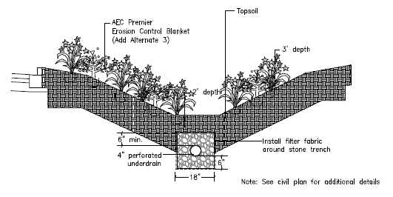

The exact locations of the bioswales for lots 2 and 3 are still being evaluated with the CLC grounds department, in order to respond to plans for renovation and to maximize efficiency. CLC will adhere to the agreed upon total linear feet for parking lot bioswales identified in the Section 319 grant agreement. See **Figure 2** for a map of the CLC Grayslake Campus Parking Lot Bioswales & Snow Stockpiling Map. An updated map of the locations of parking lots 2 & 3 bioswales will be added to the O&M Plan when finalized.

**FIGURE 2: CLC Grayslake Campus – Parking Lot Bioswale Locations & Snow Stockpiling Map**



7

6

2 3



Bioswales

Preferred Snow Stockpile Locations

**PURPOSE**:

The bioswales shall be designed to filter runoff so as to remove suspended sediment, heavy metals, oil and grease, nutrients, and other suspended and soluble nonpoint source pollutants, as well as reduce runoff volume and velocity while providing other beneficial hydrologic functions. The bioswales will be constructed and maintained in a way that collects and infiltrates the stormwater runoff from the parking areas, roadways and adjoining areas. As a center for sustainability learning in Lake County, College of Lake County’s (CLC) parking lot bioswales will provide a highly visible example of stormwater Best Management Practices (BMPs) for students and members of the community.

The short term maintenance program (years 1-2) and the long term maintenance program (years 2-10+) list the bioswales stormwater infrastructure elements, their inspection periods, and possible repair and maintenance activities to be performed. The long term maintenance plan includes items that could not be addressed adequately in the short term maintenance plan and consisting of more extensive maintenance and repair or replacement as required, depending on the wear and tear of the parking lot bioswales.

**PLANT MATERIAL:**

Plants installed in the bioswales include forbs, grasses, and sedges that are native to the region and that have been shown to be reasonably salt tolerant. Shrubs and trees were included in the parking lot bioswales landscaping. Bioswales for parking lots 6 and 7 were planted in the summer of 2016 and parking lots 2 and 3 were planted in spring of 2017.

CLC staff and consultants utilized plant material that can be found in the Practice Standards of the [Illinois Urban Manual](http://www.aiswcd.org/illinois-urban-manual/), [Table A](http://www.aiswcd.org/wp-content/uploads/2013/06/urbst880a1.pdf). Grass, forb, and sedge species selected for low maintenance areas utilized the [Illinois Native Plant Guide](http://www.nrcs.usda.gov/wps/portal/nrcs/detail/il/plantsanimals/?cid=nrcs141p2_030715#species) and other resources such as the [Lake County Forest Preserve District](http://www.lcfpd.org/lake-county-species/). The plant list for parking lots 6 and 7 bioswales are included in **Appendix A**. While plugs were planted in the bioswales, a seed list for over-seeding has been included by McClure Engineering.

CLC’s grounds maintenance staff of the facilities department will be responsible for maintaining the bioswales with technical training from CLC’s horticulture department faculty and Sustainability Manager. Maintenance will include the items included in the short-term and long-term maintenance program.

**RESPONSIBILITIES:**

CLC’s Sustainability Manager and the Grounds Supervisor of the Facilities Department are responsible for both short and long term overall maintenance of the parking lot bioswale BMPs. CLC may elect to contract with other firms/organizations to perform certain maintenance/monitoring services to ensure proper management of the bioswales. As with the CLC Grounds Department staff, any contracted landscaping company would receive training on proper monitoring and maintenance practices from CLC horticulture faculty and/or the Sustainability Manager.

**MAINTENANCE CONSIDERATIONS:**

The CLC Sustainability Manager will be working in conjunction with horticulture professors and educated students to perform in-class and hands-on trainings with the CLC grounds maintenance staff. All trainings and some of the initial maintenance activities will be overseen and supervised by the Sustainability Manager. The grounds staff is currently being trained on native plant maintenance in other areas of the CLC campus.

Cleaning and repairing bioswale outflow pipes, grates, outlet structures and manholes is particularly important. If these subsurface elements become clogged, then water may flood the pavement surface and may cause extensive erosion damage or water flow blockage. The bioswale, outflow pipes, grates and manhole cleaning will be a routine maintenance activity that is scheduled several times a year, and may also need to be carried out on an as needed basis. Experience will show the required cleaning frequencies for specific drainage structures.

**COST CONSIDERATIONS:**

Regular monitoring and maintenance and repair/replacement needs and costs will be part of CLC’s annual Facilities Department budget. Frequent maintenance program work execution will lead to less frequent and less costly long term maintenance and repair, possibly requiring replacement. The attached short term and long term maintenance provisions may need to be adjusted based on experience recorded over the initial period of occupancy.

**RECORD KEEPING:**

Separate and distinct records shall be maintained by the CLC Sustainability Manager to record the specific activities thereof for the short term and the long term maintenance plan implementation. The records shall include the dates of maintenance visits, specific work performed, and associated costs if repair or replacement is required.

**INTERPRETATION AS TO REQUIREMENTS UNDER THIS MAINTENANCE PLAN:**

The requirement for this maintenance plan is part of the Illinois EPA Section 319 grant for the 10 year O&M period. Therefore, the interpretation of the maintenance requirements set forth in this maintenance plan shall be interpreted on the basis of the intent and requirements of said grant requirement. Specific areas for concern are identified in the following sections of this maintenance plan.

**SHORT TERM MAINTENANCE PROGRAM**

**(Years 1-2)**

The prescribed periodic inspections for the short term maintenance program are to be supplemented by additional inspections and maintenance work on an as-need basis such as at times following periods of substantial rainfall or high winds.

|  |  |  |  |
| --- | --- | --- | --- |
| **Infrastructure Elements** | **Inspection Timing** | **Concerns to Address** | **Repair Work** |
| General – All Areas | March - November | Disturbed surface areas | Seed grass area, mulch protection |
| Manholes/Grates | March - November | Branches, leaf litter, trash | Collect and dispose |
| Monthly | Displaced covers/lids | Reset covers/lids |
| Curb Cuts | March - November | Branches, leaf litter, trash | Clear out and dispose |
| Disturbed surfaces | Provide erosion protection |
| Outlet Control | March - November | Branches, leaf litter, trash | Collect and dispose |
| Check for adequate flow |
| Bioswales | March - November | Vegetation | Control/remove invasive species |
| Replace native plants as needed |
| Monthly | Branches, leaf litter, trash | Clear and dispose |
| Pathways made thru vegetation | Add plants and signage, or consider stepping stone installation |
| Weekly (during first growing season) |  | Water as needed |
| Annually (before start of each growing season) |  | Remove dead plant material |

**LONG TERM MAINTENANCE PROGRAM**

**(Years 2-10+)**

Long range maintenance activities are necessary when a stormwater infrastructure element could not be addressed adequately in the short term maintenance plan work and/or normal wear and tear, or advertent or inadvertent acts, have adversely and substantially impacted the parking lot bioswales. The maintenance inspection periods for may need to be adjusted on an as-need basis.

|  |  |  |
| --- | --- | --- |
| **Stormwater Infrastructure Elements** | **Inspection Timing** | **Repair Work (as needed or as specified)** |
| General – All Areas | Bi-annually | Seed Grass Area, Mulch Protection |
| Tree Trimming | Annually | Trim/Prune |
| Sewer/Swale Outfalls | Annually | Remove Siltation, Re-seed |
| Flared End Sections | Annually | Repair/Restore/Replace |
| Bioswales | 3-5 Year Intervals | Re-plant Native Plants |
| Prescribed Burn (if possible) |
| Annually | Mowing – To remove dead vegetation at the beginning of the growing season |
| Remove Siltation, Herbicide Application by State-Licensed Applicator |
| Stone | Annually | Re-stabilize/Replace |
| Manholes | Annually | Repair/Replace |

**ON-GOING OPERATIONS & MAINTENANCE ACTIVITIES**

**VEGETATION:**

Prepare adequate seed bed with relatively smooth topsoil, free from stones, clods, sticks, and other debris.

Follow germination requirements and establishment practices according to each separate native plant species to be planted, whether by seed, or live planted, or by rootstock. Generally rootstock and live plants shall be planted between the date of the last frost and mid-June. Seeding can be performed in the spring between March 1and May, and after November 15 in the fall, for dormant seeding. Seeding in July and August requires adequate irrigation. If initial seeding is followed by a dry period, irrigation may be required until the plants are fully established, and can withstand a drought. Irrigate in a manner that does not erode the soil.

Most native species do not require any traditional fertilization to become established, and fertilization is discouraged, as it promotes the growth of undesirable weeds.

Any landscaping company contracted to maintain BMPs will have training in identifying native and invasive species and also training in this O&M plan, prior to commencing work. As with the CLC grounds department staff, any contracted landscaping company would receive training from CLC horticulture faculty and/or Sustainability Manager.

If any invasive species are found, they may be controlled with selective herbicide application, to prevent from overtaking the desired planted material, apply herbicide in accordance to BMP’s, consistent with the label indications, and in a manner which does not impact other nearby plants. A licensed applicator must be used for herbicide applications.

Prescribed burning over time will promote the desired native species and reduce many of the non-fire adaptive species. Prescribed burning requires an Open Burning Permit from the Illinois EPA as well as permission from the local fire department, and other contingencies.

Mowing may be used to control some invasive species, in order to reduce weed competition in the early stages. Native vegetation establishment areas should be mowed during March and/or August once or twice per year with a mower height of 6 inches to 12 inches.

**STORMWATER INFRASTRUCTURE ELEMENTS:**

Monitor and maintain a protective measure, such as a cell or compartment of plastic or nylon mesh, as a technique to prevent depredation of vegetation due to wildlife eating the plant material.

Consider cover crop (reduces invasive species during establishment), mulch, or an erosion blanket to hold and stabilize the soil, until the described permanent vegetation is established.

**WINTER MAINTENANCE:**

CLC ground department staff will avoid storing plowed snow in the swales whenever possible, rather, snow will be piled on the periphery of parking lots away from bioswales. See Figure 2 for location of preferred snow removal stockpile areas.

CLC grounds department staff apply salt as needed to melt ice and avoid safety hazards. A policy is being developed that will specify how salt will be applied to parking lots and sidewalks only as much as necessary, in order to avoid excessive application.

**DOCUMENTATION:**

Take representative photographs. Establish permanent photograph locations so photographs can be reviewed over time.

**APPENDIX G-1: BIOSWALE PLANT LIST**

|  |  |
| --- | --- |
| PLANTS: (Plugs/Containers) | COMMON NAME: |
| *Asclepias incarnata* | Red Milkweed |
| *Carex stipata* | Awl Fruited Sedge |
| *Elymus virginicus* | Virginia Wild Rye |
| *Heliopsis helianthoides* | Ox Eye Sunflower |
| *Iris versicolor* | Blue Flag Iris |
| *Liatris spicata* | Dense Blazing Star |
| *Monarda fistulosa* | Wild Bergamot |
| *Rudbeckia subtomentosa* | Sweet Black-Eyed Susan |
| *Schizachrium scoparium* | Little Bluestem |
| *Solidago ohioensis* | Ohio Goldenrod |
| *Spirea alba (shrub)* | Meadow Sweet |
| *Sporobolus heterolepis* | Prairie Dropseed |
| FORBS: (Seed) | COMMON NAME: |
| *Allium cernuum* | Nodding Wild Onion |
| *Asclepias incarnata* | Red Milkweed |
| *Cacalia atriplicifolia* | Pale Indian Plantain |
| *Echinacea purpurea* | Purple Coneflower |
| *Eupatorium maculatum* | Joe Pye Weed |
| *Eupatorium perfoliatum* | Boneset |
| *Helenium autumnale* | Dogtooth Daisy |
| *Heliopsis helianthoides* | Ox Eye Sunflower |
| *Iris versicolor* | Blue Flag Iris |
| *Liatris pycnostachya* | Prairie Blazing Star |
| *Liatris spicata* | Dense Blazing Star |
| *Monarda fistulosa* | Wild Bergamot |
| *Ratibida pinnata* | Yellow Coneflower |
| *Rudbeckia hirta* | Black-Eyed Susan |
| *Rudbeckia subtomentosa* | Sweet Black-Eyed Susan |
| *Solidago ohioensis* | Ohio Goldenrod |
| *Solidago rigida* | Stiff Goldenrod |
| *Symphyotrichum laeve* | Smooth Blue Aster |
| *Veberna hastata* | Blue Vervain |
| *Vernonia fasciculata* | Ironweed |
| *Zizia aurea* | Golden Alexander |
| LEGUMES: (Seed) | COMMON NAME: |
| *Cassia hebecarpa* | Wild Senna |
| *Desmodium canadense* | Canada Tick Trefoil |
| GRASSES, SEDGES, RUSHES: (Seed) | COMMON NAME: |
| Carex hystericina | Porcupine Sedge |
| Carex scoparia | Broom Sedge |
| Carex stipata | Awl Fruited Sedge |
| Carex vulpinoidea | Fox Sedge |
| Elymus virginicus | Virginia Wild Rye |
| Schizachrium scoparium | Little Bluestem |