SIMAP Greenhouse Gas Summary Report for 2017

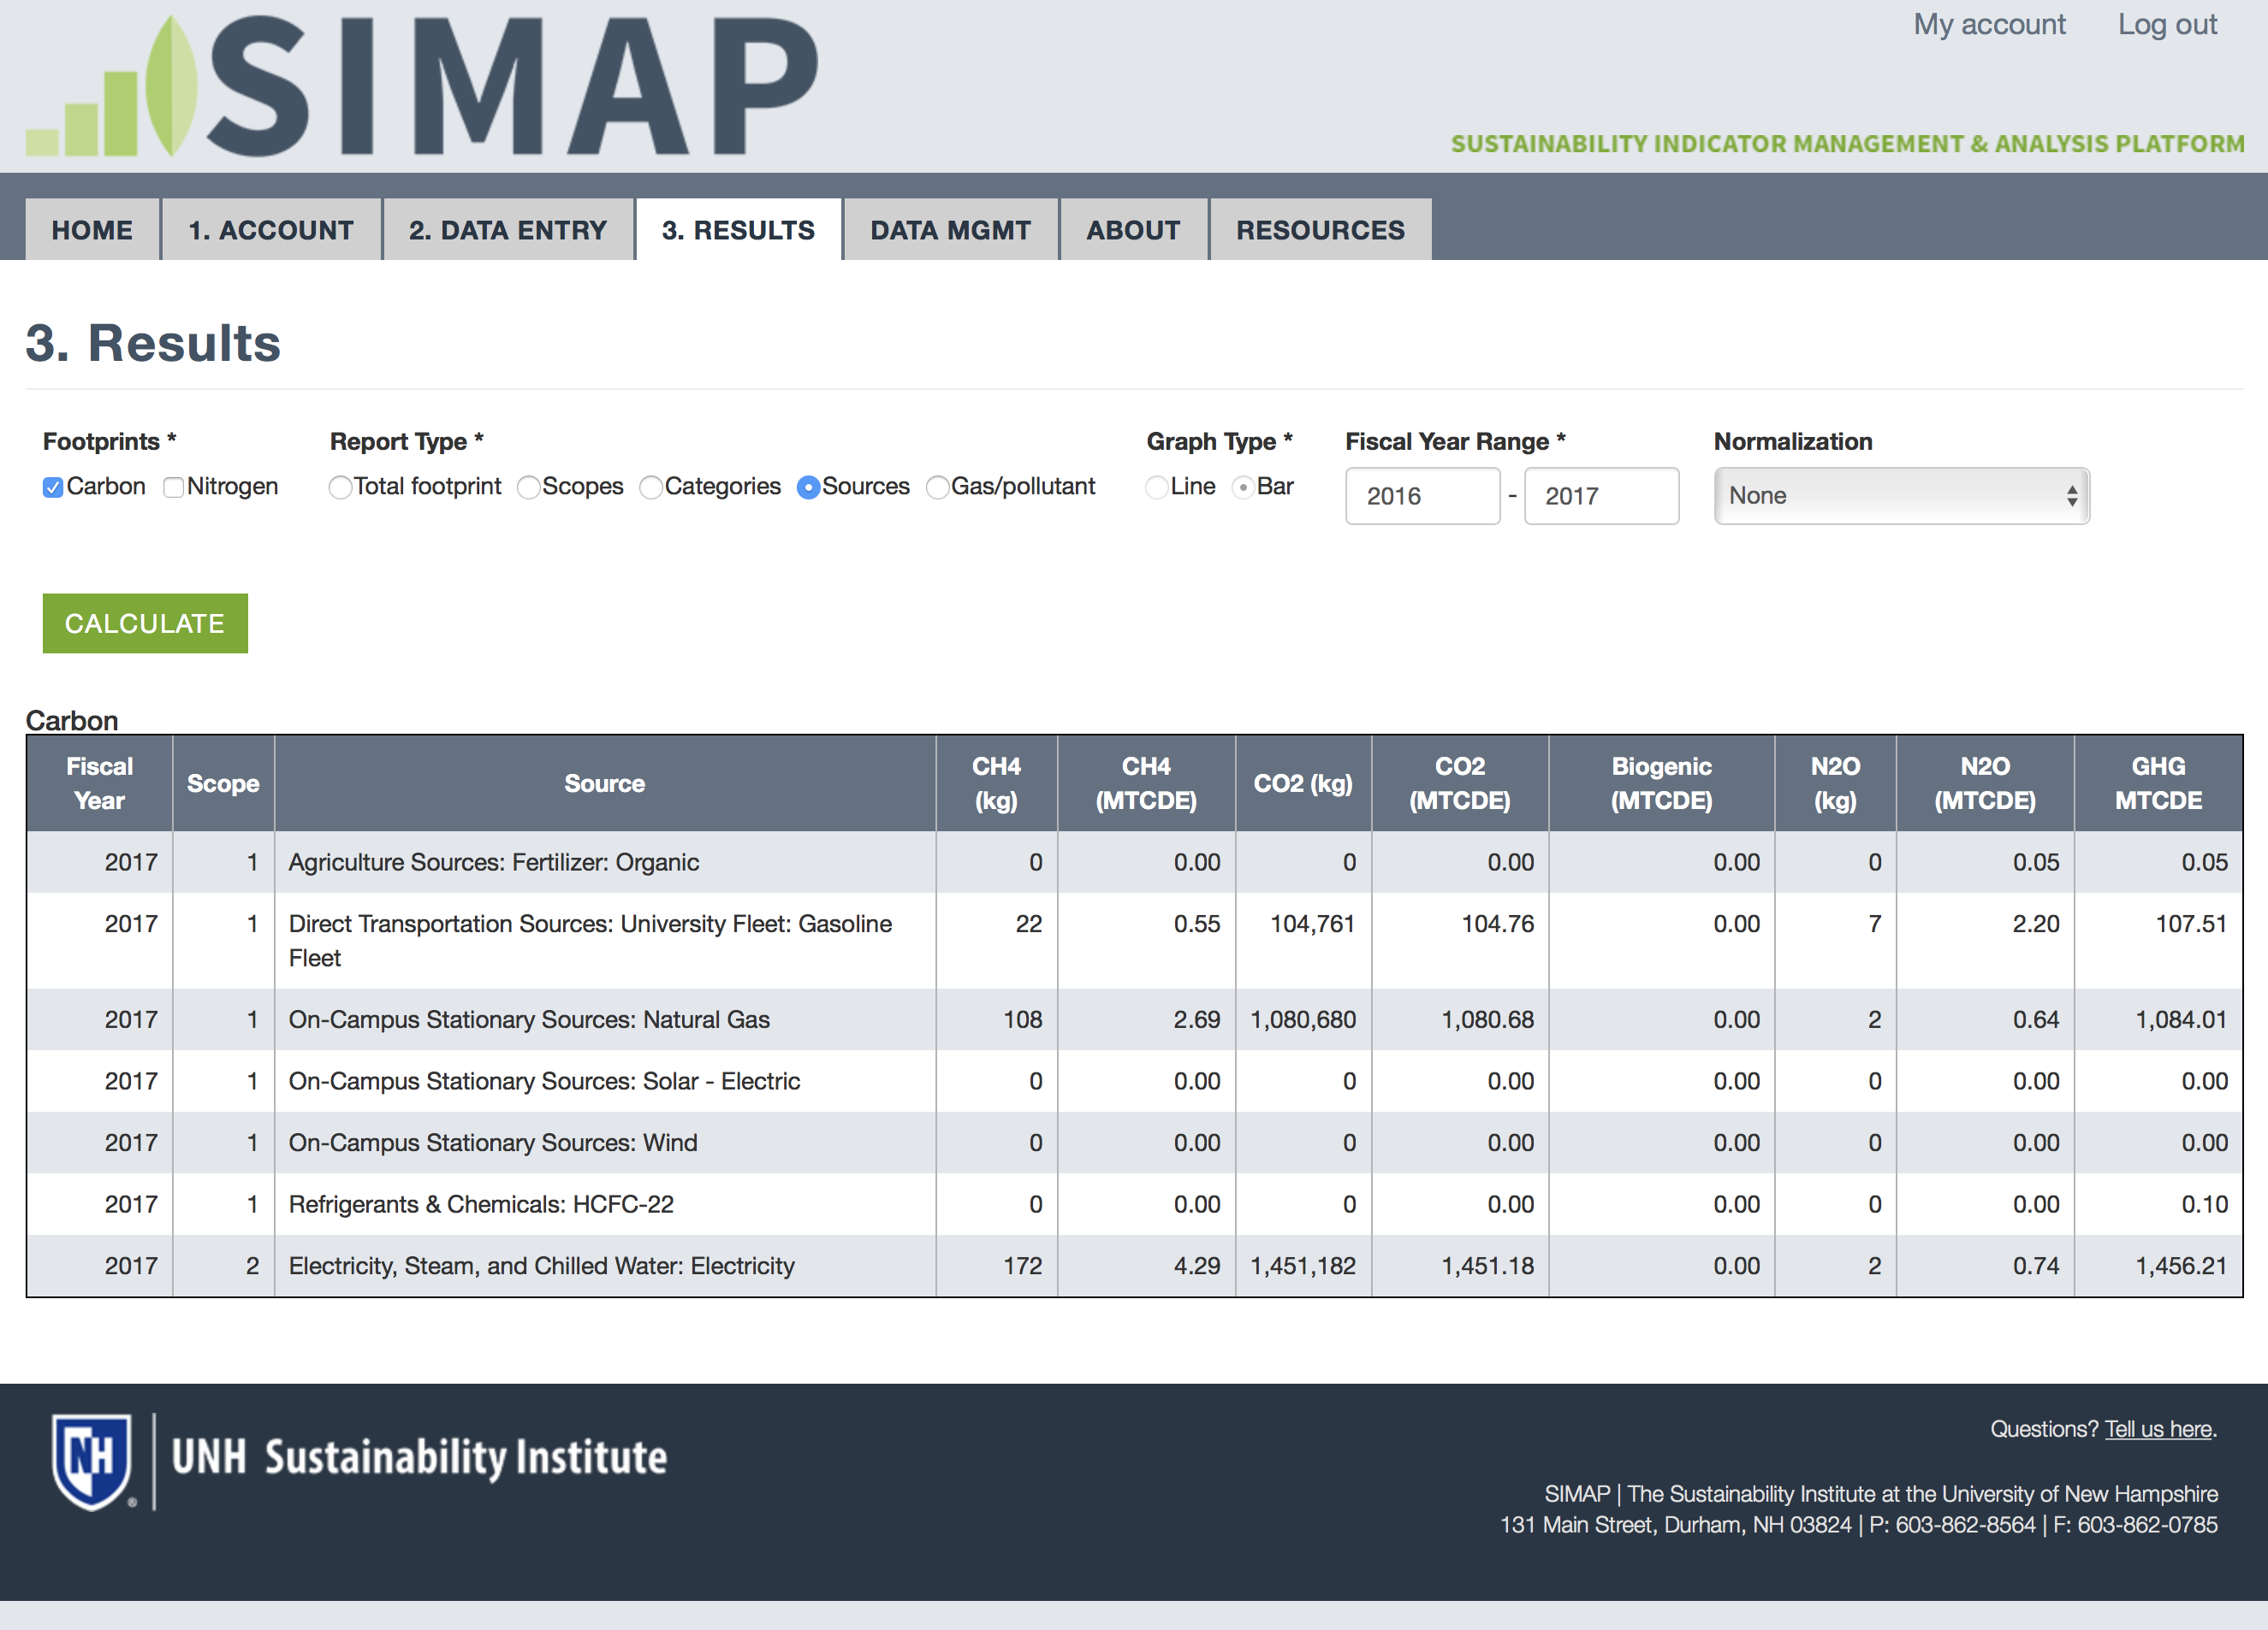

Stationary Fuels

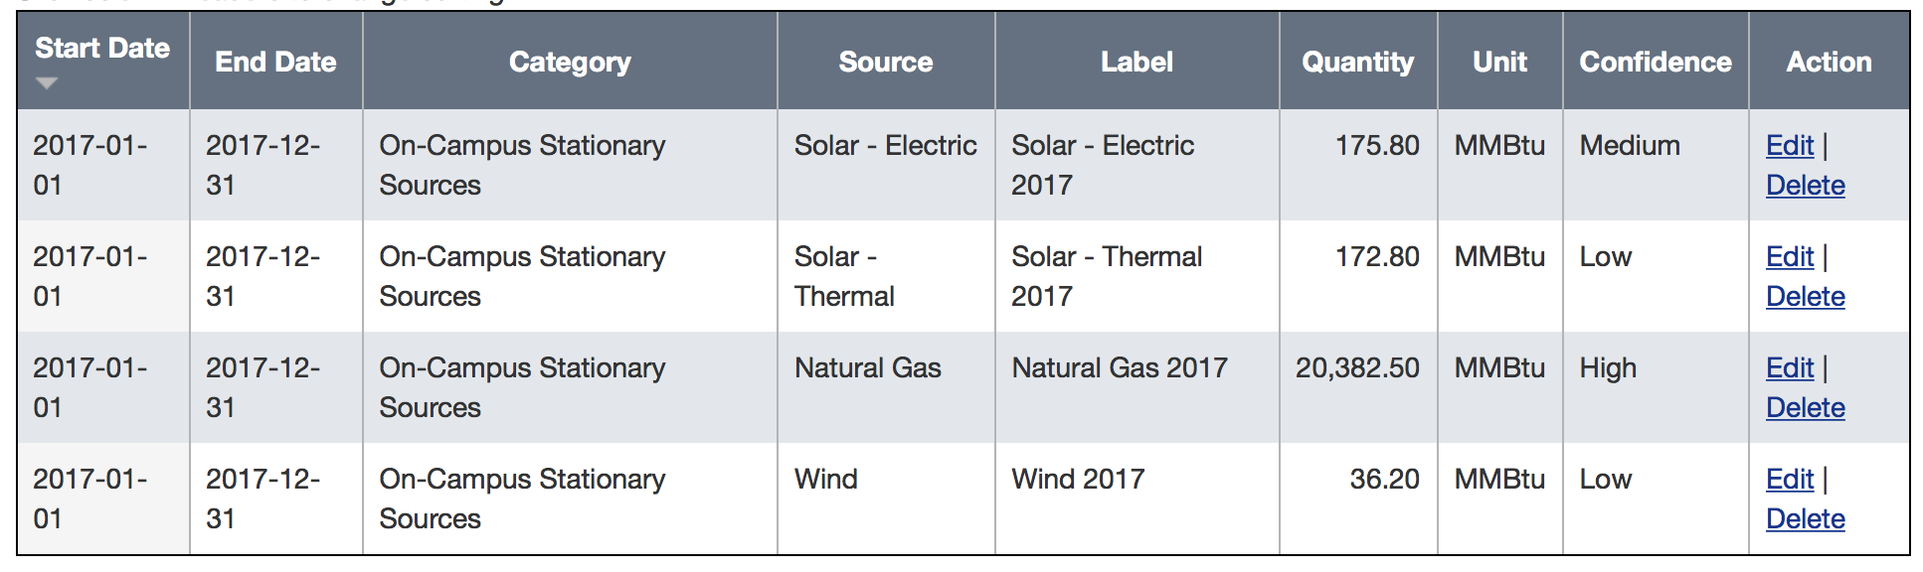

Campus Fleet

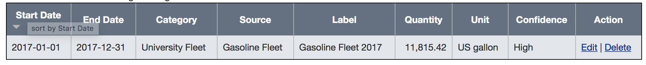

Fertilizer & Chemicals

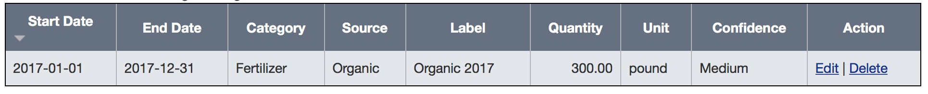

Refrigerants

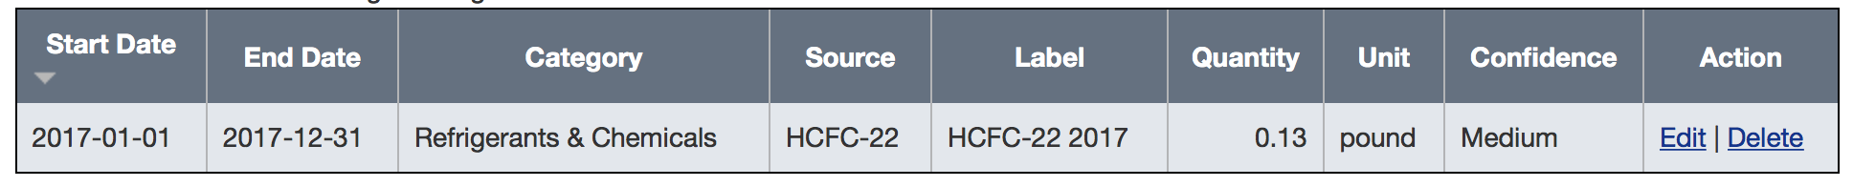

Utility Consumption (Electricity)

