Office of Sustainability
PO Box 4074
Flagstaff, AZ 86001
Nau.edu/sustain

Bryan McLaren
Sustainability Coordinator
Bryan.McLaren@nau.edu
928-523-0656

September 17, 2012

LETTER OF AFFIRMATION

To Whom It May Concern:

This Letter of Affirmation is to confirm the implementation of the Green Jobs for Jacks initiative. Northern Arizona University uses a centralized software database, which is accessible online, to promote job opportunities and volunteer opportunities to students at the University. The Jobs for Jacks program is a resource that is available for employers to promote positions for their company, and for students to search for employment opportunities. Recently, the Office of Sustainability has teamed up with the Jobs for Jacks team to create the Green Jobs for Jacks section. This is a specific section within the Jobs for Jacks program to advertise employment and volunteer opportunities specifically related to sustainability. Green Jobs for Jacks is a resource for the entire campus and community as a centralized location for sustainability related employment and volunteering.

Sincerely,

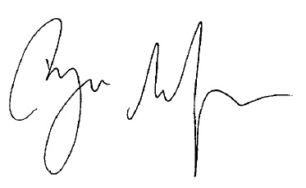

Bryan McLaren
Sustainability Coordinator for Northern Arizona University

