# Sustainability Cultural Assessment

1. How familiar are you with the following sustainability-related resources and programs on campus?

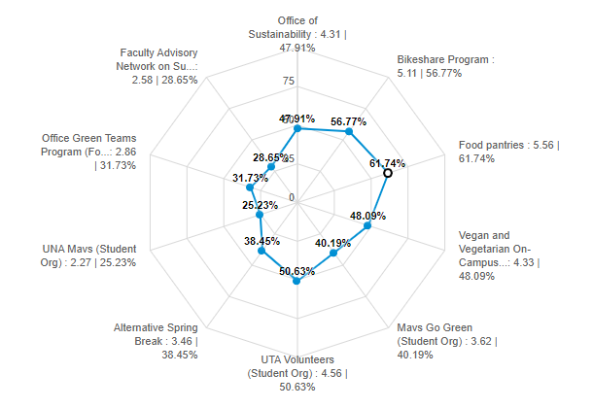

* 1. Respondents are most familiar with food pantries followed by Bikeshare program
  2. Least familiar with UNA Mavs followed by the Faculty Advisory Network
  3. The percentages of familiarity ranges from 25.23% and 61.74%

1. Have you ever volunteered or partaken in any service learning during your time at UTA?
   1. 34.67% of respondents have volunteered or partaken in service learning at UTA
   2. 45.92% of respondents that said no said that they plan to in the future.
2. How do you hear about sustainability opportunities on campus?

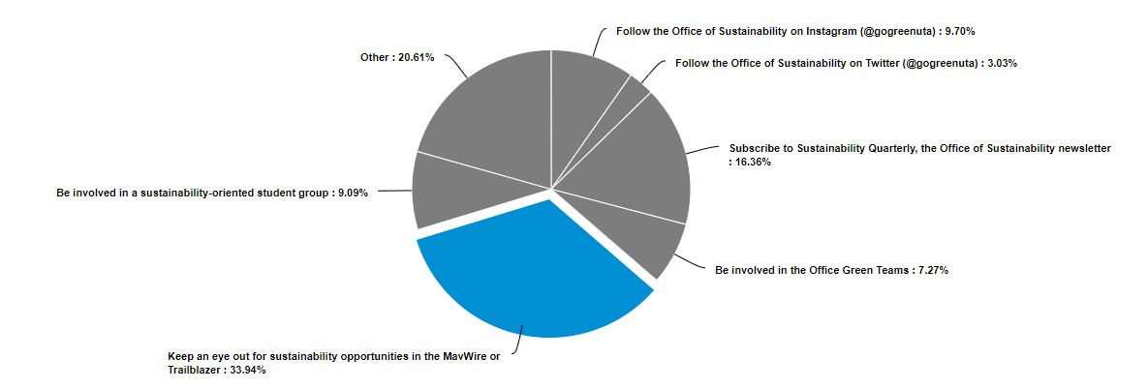

* 1. Most common method is through email newsletters
  2. Least common is through Twitter

1. Which of these items can be recycled on campus through general recycling bins on campus?

|  |  |  |  |  |
| --- | --- | --- | --- | --- |
| **Item** | **Correct** | **% Correct** | **Wrong** | **% Wrong** |
| *Envelopes* | 117 | 78% | 7 | 4.67% |
| *Styrofoam* | 75 | 50% | 27 | 18% |
| *Cardboard* | 137 | 91.33% | 5 | 3.33% |
| *Aluminum cans* | 132 | 89.19% | 4 | 2.7% |
| *Used napkins* | 97 | 65.1% | 22 | 14.77% |
| *Dead batteries* | 49 | 32.67% | 62 | 41.33% |
| *Metal cans* | 103 | 69.59% | 15 | 10.14% |
| *Used takeout boxes* | 90 | 60.81% | 30 | 20.27% |
| *Plastic grocery bags* | 58 | 38.67% | 63 | 42% |
| *Colored paper* | 96 | 64% | 20 | 13.33% |
| **Total** | **954** | **63.6%** | **255** | **17%** |

* 1. The average score on this recycling assessment is 63.6%

1. If you are a student, do you intend on incorporating sustainability into your life after graduation?
   1. 138 out of 158 students (87.34%) intend to incorporate sustainability into their lives after graduation either through their daily practices, their career, or through another means
   2. 11.39% of students said they are not sure and 1.27% said no.