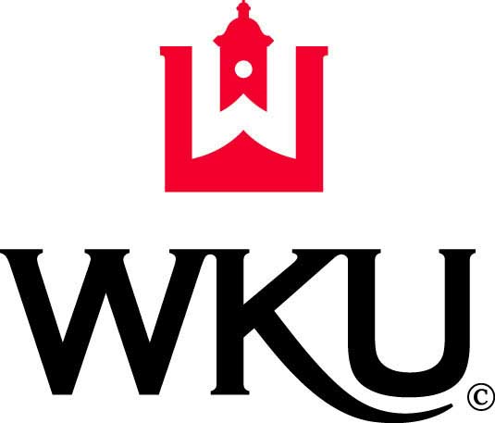

Western Kentucky University
Position Description

Title: Coordinator of Resource Conservation
Department of Facilities Management

Purpose of Position
Under the general supervision from the Manager of Campus Services, the Coordinator of Resource Conservation is responsible for operating and coordinating WKU’s solid waste and recycling program in addition to liquidating university assets through the WKU surplus department. This position will educate the campus community on awareness programs for recycling; waste reduction and surplus re-use initiatives. Responsibilities will also include supervising student workers, overseeing the waste and surplus property collection, collaboratively working on the logistics of campus recycling, public outreach and community events, and the campus reuse and/or liquidation of university surplus property.

Primary Duties and Responsibilities
The following duties are customary for this position, but are not to be construed as all-inclusive. Duties may be added, deleted and assigned based on management discretion and institutional needs.
- Develop recycling education and awareness programs and projects for the campus and community including field trips, outreach campaigns, and networking
- Coordinate large-scale auctions (silent and live) to liquidate hundreds of state-owned surplus items quickly, including, but not limited to, university vehicles and other large-scale asset tagged equipment
- Research other institutional waste management “best practices;” create, implement, maintain, promote, and track new programs and existing program results; assess programs for effectiveness; expand programs as needed
- Work with student crew to develop, promote, and implement project/program proposals for operations and promotional ideas
- Function as resources liaison to campus, community, dining, athletics and Housing related programs, operations and promotions, including: training, collection and consolidation
- Collect and maintain detailed recycling and solid waste weight data records and detailed transaction data for the sale of state assets
- Assign, direct, evaluate and review work of student crew including supervision of outreach projects that may gain them course credit
- Coordinate recycling for special events including, but not limited to, tailgate recycling and Housing/Resident life move-in and move-out, catered events, and special requests
- Ability to compose routine reports and correspondence including program goals & initiatives, updating managers, communicating with over three hundred DFM employees on three different shifts
- Coordinate university computer refurbishing, donation program and manage all e-scrap for university including correspondence with e-scrap company
- Maintain and develop content for the Recycling department website and maintain surplus materials website
- Work with WKU Purchasing department and inventory control to ensure assets are properly disposed of in accordance with federal and state laws
- Continuously seek and obtain new avenues to dispose of university surplus and recycling
- Operate University vehicle

Secondary Duties and Responsibilities
- Maintain excellent communication/customer service with both internal and external campus community as well as other DFM team members
- Communicate bi-laterally with other campus services staff, area teams, central trades groups, as well as other DFM team members to coordinate work activities between groups
- Perform related duties as assigned

Minimum Training and Experience Required
- Bachelor’s degree in logistics analysis, environmental studies or business
- Two years of related work experience required
- Must possess and maintain a valid Kentucky driver's license

Knowledge and Skills Essential for Success
- Ability to read, analyze and interpret general business manuals, professional journals, technical procedures and governmental regulations
- Ability to respond to common inquiries or complaints from customers, regulatory agencies or members of the business community
- Excellent communication and time management skills
- Ability to compose routine reports and correspondence
- Ability to apply concepts such as fractions, percentages, ratios and proportions to practical situations
- Ability to prioritize and analyze data and meet multiple deadlines
- Ability to conduct research, to analyze and interpret findings and to prepare clear and concise reports
- Ability to make financial decisions and work independently
- Advanced knowledge of recycling and source reduction practices, public relations, federal and state laws relating to recycling and solid waste management
- Possess advance computer skills in work processing, database, spreadsheets and presentation applications
- Ability to motivate, develop and direct people on the resource conservation environment campaign
- Website creation and management skills
- Knowledge or participation in student-run organizations
- Ability to build a constructive team spirit where team members are committed to the goals and objectives of the University
- Being reliable, responsible, dependable and able to fulfill obligations
- Strong attention to detail with the ability to work effectively in a service-oriented environment
- Adhere to all University policies and regulations

Physical Abilities Required
- Requires long hours outside year round
- Ability to sit for prolonged period of times
- Requires repetitive movement

Pay Grade: 107

