**Post-event Traffic Flow for Diddle Arena at WKU**

During large campus events, WKU runs an Emergency Operations Center to centrally coordinate operations between Parking & Transportation Services, WKU Police Department, Facilities Management, and Athletics. In addition, students from the campus Meteorology Department are present and are able to provide highly localized weather monitoring and forecasts, which has been very helpful during threats of severe weather. In addition to managing event parking, Parking & Transportation Services provides shuttle services for large events. In the EOC, we monitor traffic patterns with cameras. The camera views below show the exiting traffic flow from Parking Structure 1 (Figure 1) and Parking Structure 2 (Figure 2.)

Figure 1 illustrates event traffic leaving Parking Structure 1. During a weekend game, upwards of 400 vehicles will park there. At the start of traffic control, the Avenue of Champions exit (A) is closed inside the structure. This accomplishes two things: (1) restricts volume of traffic added to the Avenue and (2) reduces vehicular pedestrian conflicts at the exit. A high volume of pedestrians cross the Avenue of Champions exit as they return to their vehicles. While the Avenue of Champions exit is closed, all traffic inside the structure is directed to the College Heights Blvd exit (B). Police presence at this exit sends traffic right (C) or left depending on traffic flow. Traffic directed to the right are directed up College Heights Blvd at the next intersection (D). This again limits traffic volumes on the Avenue of Champions. Beyond camera view, there is an additional intersection on College Heights Blvd that acts as a three way stop. Parking & Transportation Services provides personnel to waive event traffic through the intersection.

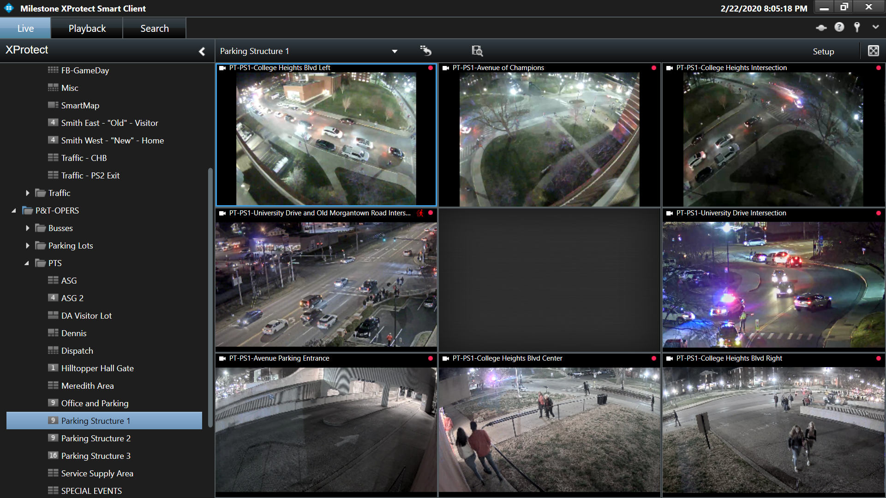

**CB**

**DB**

**A**

**BB**

Figure 1. Event traffic leaving Parking Structure 1.

Parking Structure 2 routinely holds 500 vehicles or more during large campus events. In normal operations, traffic enters and exits the structure from University Blvd, which is a four-lane highway. In the past, three police officers stationed in the highway controlled event traffic and alternated traffic flow between the highway and the parking structure. Historically, post-event traffic using this approach easily took close to an hour with vehicles idling the entire time.

With the new traffic flow, the entrance is closed during the “out”. The first floor traffic exits onto University Blvd with no assistance (A). Traffic leaving floors 2-5 use an alternate exit that is created by blocking off spaces on the first floor (B) to provide access to the adjacent sidewalk (C) towards Avenue of Champions. The Avenue is a two lane campus road and there are surface lots above this exit. We divert traffic into the left hand lane so that traffic exiting Parking Structure 2 can move freely onto the Avenue using the right hand lane (D). At the bottom of the hill on the edge of campus, there is a large intersection with Russellville Rd and University Blvd. The Kentucky Transportation Cabinet has given the WKU Police Department equipment which allows a police officer to manually control the timing of the traffic light (E). The officer is able to hold the green phase of the traffic light as needed to move event traffic off campus.

With this traffic plan, we have reduced the post-event traffic operations from an hour or more to approximately 30 minutes. This dramatically reduces the amount of idling time for exiting vehicles, which reduces energy consumption and carbon emissions. Our event shuttles benefit from the improved traffic control as well as they are able to move with traffic. We’ve also improved the safety of pedestrians and police officers and improved the service to the patrons parking in the structures.

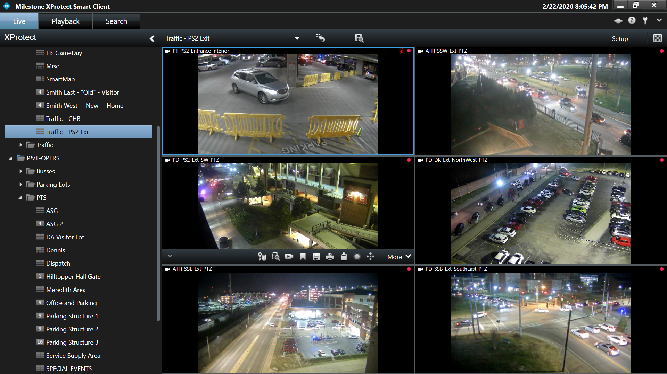

**E**

**D**

**C**

**B**

**A**

Figure 2. Parking Structure 2 post-event traffic flow.