**SURVEY ANALYSIS**

**Sustainability Cultural & Literacy Assessment 2022**

**“Introduction”**

This survey was conducted between September 21st and October 21st, 2022 using SurveyMonkey.

It was open to UFV students and employees and was shared through our social media, monthly newsletter, an email to all employees, and faculty willing to share with their courses.

The survey combined questions related to both sustainability literacy and culture.

The questions were separated over three main pages: The first page asked questions related to the participants’ awareness of and engagement with sustainability at UFV. The second page posed questions about the participants’ sustainability behaviours related to transportation, energy use, and waste management and reasons for their behaviours. The last page involved questions related to sustainability literacy and knowledge.

The questions were developed to help the Office of Sustainability better understand the current knowledge, engagement, and awareness levels of UFV members about sustainability and will be used to inform our programing and plans. We plan to conduct the survey annually.

**Responses Statistics**

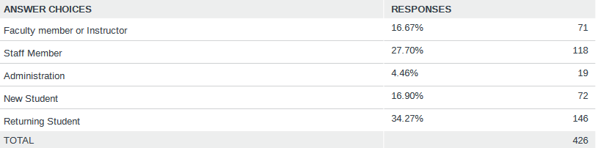

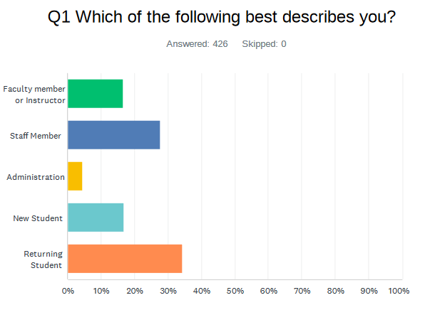

**Analysis:** Most of the respondents were students (51.17%) and the remaining were UFV employees (staff, faculty, and administrators) (48.83%). The responses totaled 426 which is a positive number showing that both students and faculty are interested in sustainability related issues at UFV with an almost equal participation rate of 50% each.

**Staff, Faculty, and Administrators:** 209

**Faculty member/ instructor:** 71

**Staff member:** 118

**Administration:** 20

**Students:** 218

**New Students**: 72

**Returning Students**: 146

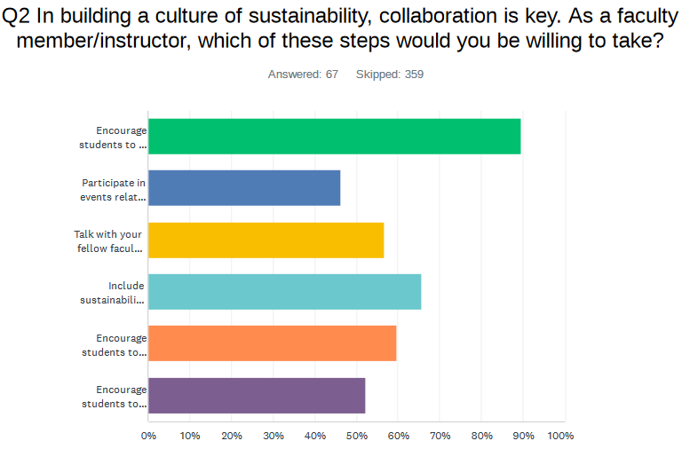

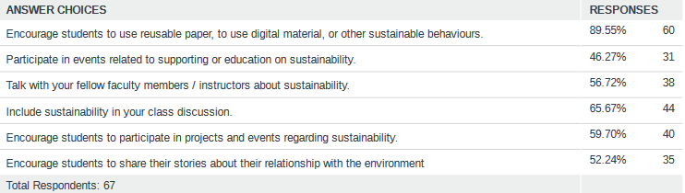

**Analysis:** Out of 67 Faculty members and instructors, almost 90% of them encourage students to use reusable paper and incorporate use of digital materials for learning course contents. Furthermore, almost 66% incorporate sustainability discussions in classroom topics increasing the student awareness of sustainability issues. However, the participation rate in sustainability related events is comparatively lower at 46.27%.

This questions was only asked to faculty.

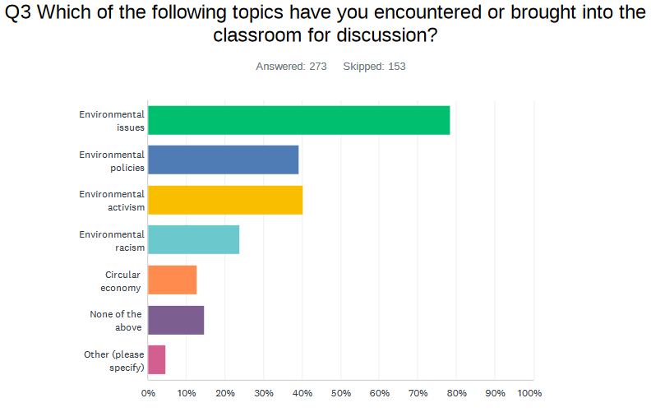

**Analysis:** Majorly, environmental issues (78.39%) stand as the most discussed topics in classroom followed by environmental activism and policies (39.74%). Circular economy and Environmental racism are the least discussed topics (18.32%). Other topics not listed discussed are sustainability practices for future, water conservation, land-based learning, ecosystem working and pollutants, environmental ethics, relationship with nature, etc.

**Staff members/ Faculty:** Same responses as in general.

**Students:** Same responses as in general.

This question was only asked to students (new and returning) and faculty.

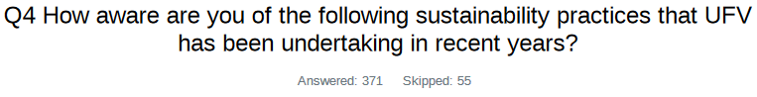

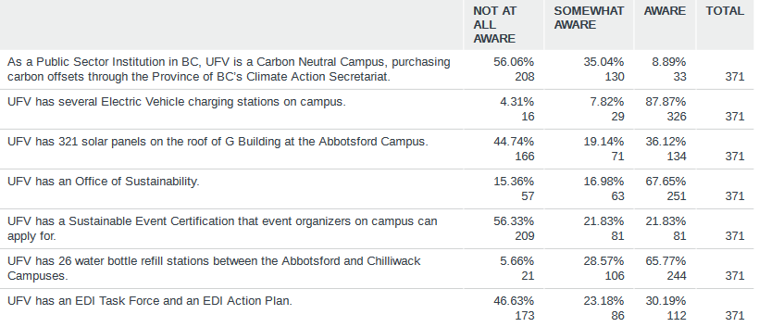

**Analysis:** Most of the UFV stakeholders/community are aware of the presence of Electric Vehicle charging stations, UFV’s Sustainability Office and water bottle refilling stations on campus. There is mixed awareness of solar panels on the roof of G building and presence of an EDI action plan. On the other hand, more awareness needs to be spread in the area of UFV’s efforts towards being a Carbon Neutral Campus and sustainable event certification application procedure so that event organizers know how to get one.

**Staff members/ Faculty:** Results are similar to the general with 92.55% aware of Electric Vehicle charging stations and 79.79% aware of UFV’s Sustainability Office. However, it is observed that 51.60% of faculty members are aware of the EDI Action Plan.

**Students:** Results are almost similar but less students are aware of UFV’s Office of Sustainability (55.43%) and 98 out of 184 are ‘not at all aware’ of sustainable event certification. From analysis of student’s knowledge about UFV’s EDI Action Plan, it is evident that most students (72.28%) are ‘not at all aware’ unlike faculty members.

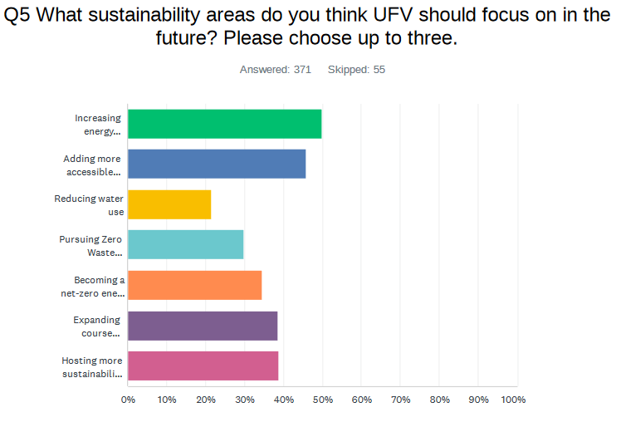

**Analysis:** Top 3 recommendations that UFV should be focusing on: -

1. Increasing energy efficiency and lowering GHG emissions associated with buildings and facilities
2. Adding more accessible urban farms/gardens
3. Hosting more sustainability-related events for students and/or staff

**Staff members/ Faculty:** Additional recommendations by faculty members: -

1. Reducing emissions of faculty particularly through unnecessary inter campus commuting (for meetings)
2. Get rid of noise-producing electric hand dryers in washrooms. I have to close my office door in CEP due to this noise especially at break time.
3. Better/clearer waste management - the comingled waste that gets sorted later does not make sense.

**Students:** Interesting recommendation by a student: -

*“More AFFORDABLE plant-based meal options on campus. For example, Chilliwack campus does not offer very many, if any plant-based meal options, and the only option for coffee is soy milk, which is a common allergen and comes at an increase in cost, which does not encourage people to make the more sustainable choice to avoid animal products. The Abbotsford campus Tim Hortons does not have almond or soy milk available to my knowledge despite that most other Tim's locations do. Also, encouraging public transit. Many of your students commute from Chilliwack, Mission, Langley, etc. but the shuttle service is largely insufficient. It is often full, does not run late/early enough for some classes, etc. It's also inconvenient for anyone who does not live near the pickup/drop-off points. Allowing the u-pass to include the FVX and increasing frequency & range of shuttle services would allow more students to take transit instead of drive to campus.”*

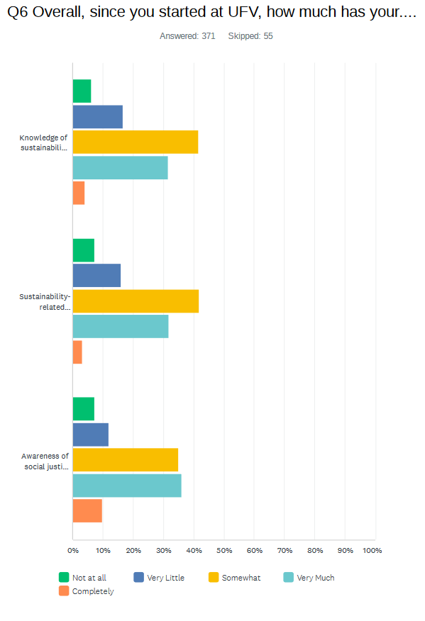

**Analysis:** Neutral results are obtained from this question: -

1. Knowledge of sustainability issues has grown ‘somewhat’
2. Sustainability related behavior has increased ‘somewhat’
3. Awareness of social justice issues has increased ‘very much’

From the above analysis, further events/ social media awareness is needed to spread knowledge about sustainability issues and suitable behavior to ensure sustainability.

**Staff members/ Faculty:** Same responses as in general.

**Students:** Same responses as in general.

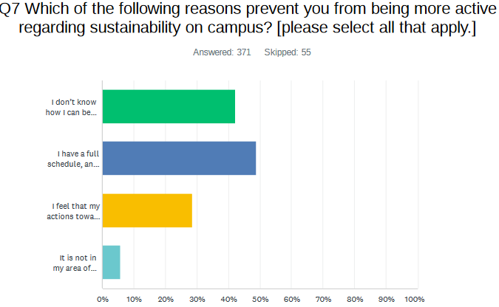

**Analysis:** The major factor that stops the respondents from participating is full-time course load which makes it difficult to take time out for sustainability.

**Staff members/ Faculty:** Same responses as in general.

**Students:** Same responses as in general.

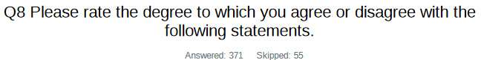

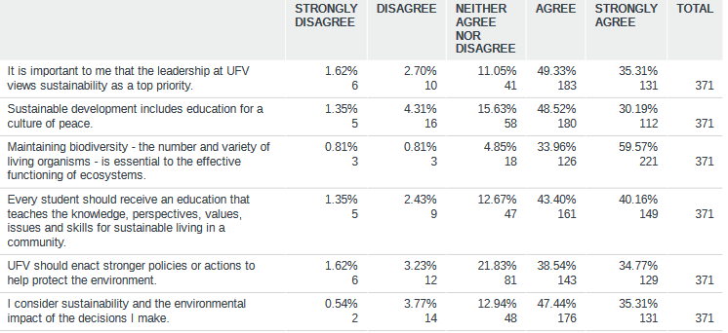

**Analysis:** Most of the respondents ‘agree’ with all the statements but almost 49.33% want that leadership at UFV should view sustainability as a top priority and sustainability development should include education for culture of peace. ‘Strongly agreed’ statement was maintaining biodiversity for effective functioning of ecosystems.

**Staff members/ Faculty:** Similar responses observed as were in general. An interesting observation is that hardly 10 (or less than) faculty members out of 188 disagree with the above statements.

**Students:** Similar responses observed as were in general. Again, the number of students that disagree was less than 5% (8 or less out of 184) among students also.

Agree & Strongly Agree

1. 84.64%

2. 78.71%

3. 93.53%

4. 83.56%

5. 73.42%

6. 82.75%

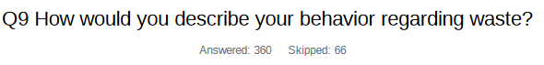

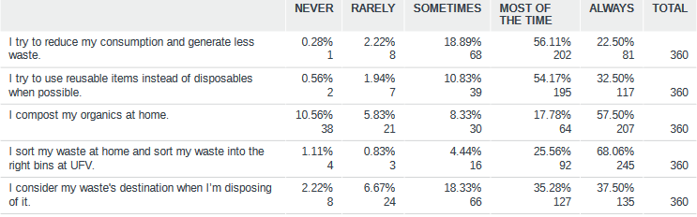

**Analysis:** As per respondents: -

* Most of the time, they try to reduce consumption, generate less waste and use reusable items.
* Always compost organics, sort waste to right bins and consider waste’s destination when disposing of it.

**Staff members/ Faculty:** Same responses as in general.

**Students:** Same responses as in general.

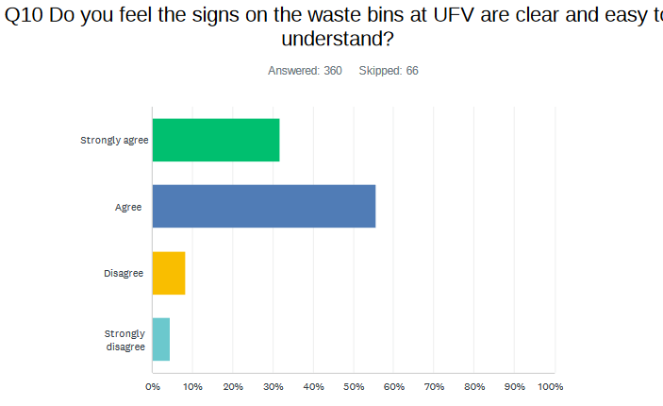

**Analysis:** Most of the respondents agree that they don’t have any difficulty in understanding the signs on the waste bins at UFV.

**Staff members/ Faculty:** Same responses as in general.

**Students:** Same responses as in general.

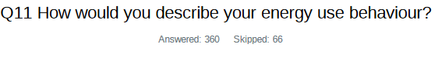

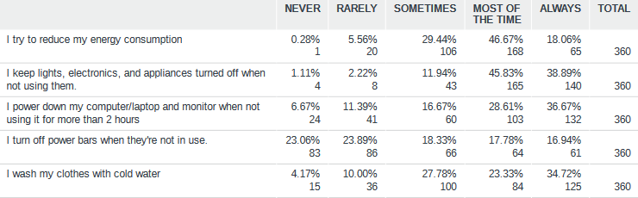

**Analysis:** Respondent’s statistics show that ‘most of the time’, they reduce their energy consumption and turn off appliances and electronics when not in use. However, there is a much variation in the responses when it comes to turning off power bars when not in use.

**Staff members/ Faculty:** 49 out of 183 (26.7%) faculty members ‘never’ turn off power bars when they’re not in use.

**Students:** From the survey results, it is evident that students are more focused on conserving energy as their rate of ‘never’ responses is very low (only 5%). In comparison to faculty, only 34 out of 178 (19.10%) students ‘never’ turn off power bars when they’re not in use.

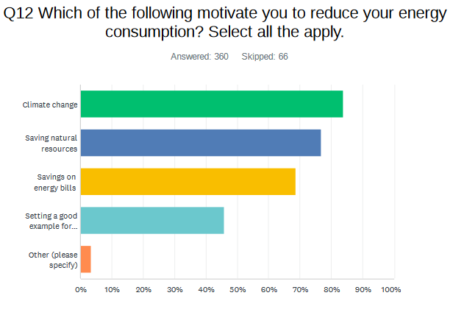

**Analysis:** 83.89% of the respondents are driven by climate change as a motivation to reduce their energy consumption. This shows that they are cautious about the adverse effects of climate change on the present and future generations and are taking the necessary steps on an individual level to prevent it.

**Staff members/ Faculty:** Motivation in order of preference: -

1. Climate change
2. Savings on energy bills
3. Saving natural resources
4. Other responses:
   1. It is my duty as a human living in this era
   2. For future generations
   3. It is a part of a healthy lifestyle

**Students:** Motivation in order of preference: -

1. Climate change
2. Savings natural resources
3. Saving on energy bills
4. Other responses:
   1. Full understanding of its consequences +
   2. future based mindset
   3. Altruis



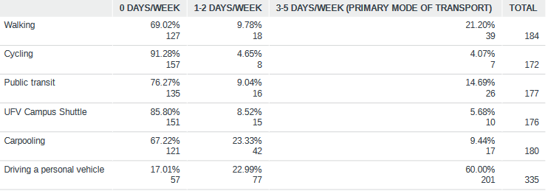

**Analysis:** Most of the respondents (60%) drive their personal vehicles to get to UFV which can be a concern for the climate. Very few uses eco-friendly methods like cycling and carpooling to get to UFV. Hence, as per the analysis, awareness in this field is necessary to educate people about the impact of their actions on the environment. It can only be noted that the existence of online courses has reduced the travel to UFV as both faculty and students prefer this medium which saves them travel to UFV.

**Staff members/ Faculty:** 133 out of 175 drive personal vehicles, and the rest 15.79% walk to UFV and only 10.53% use carpooling.

**Students:** UFV Campus Shuttle is the least used mode of transportation by students as only 9 out of 161 students use this mode. Primary mode of transportation is personal vehicle (42.24%) followed by walking (23.44%) and Public Transit (20%).

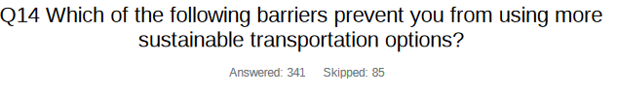

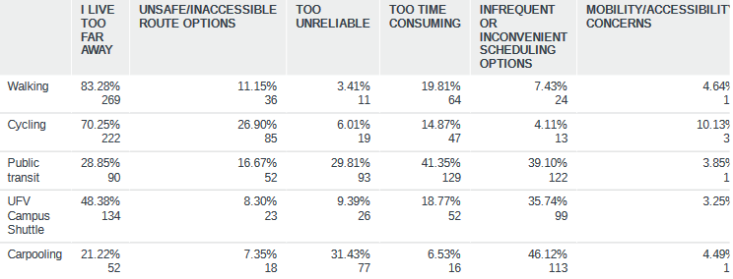**Analysis:** Public transit and UFV Campus Shuttle have been seen very inefficient and unreliable in terms of time and scheduling options which prevents the respondents from using it. Carpooling is not possible primarily due to variable schedules. This shows that significant improvement is needed in public transportation to encourage its usage. UFV might work on coordinating work schedules for colleagues to reduce variable schedules as much as possible.

**Staff members/ Faculty:** Same responses as in general.

**Students:** Same responses as in general. An additional concern expressed is the early cut-off time of UFV campus shuttle at 7:20p, and Route 66 Fraser Valley Express at 7:30pm. This discourages use of UFV Campus shuttle (which is the least preferred mode as found in Q13) because students generally have classes late in evening till 10pm.



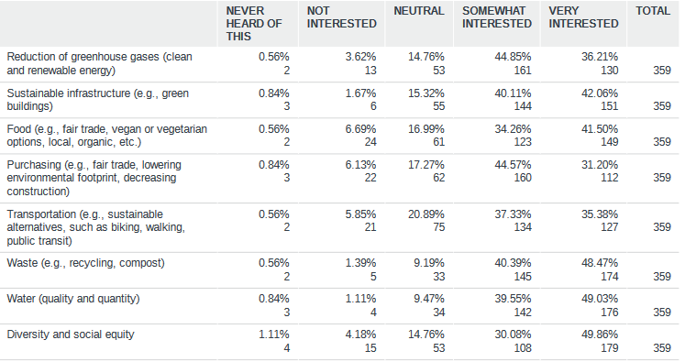

**Analysis:** Respondents are ‘very interested’ in the following issues: -

1. Sustainable infrastructure (e.g., green buildings)
2. Food (e.g., fair trade, vegan or vegetarian options, local, organic, etc.)
3. Waste (e.g., recycling, compost)
4. Water (quality and quantity)
5. Diversity and social equity

**Staff members/ Faculty:** Same responses as in general.

**Students:** Same responses as in general.

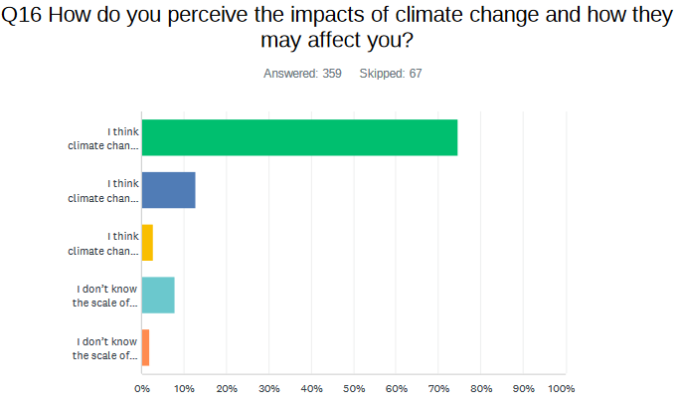**Analysis:** 74.65% respondents believe that climate change impacts are significant, and they are worried that they might affect their life. Just 12.81% are not worried that they might affect their life. This shows the overgrowing concern of respondents about climate change and the subsequent direct or indirect effects on their day-to-day lives.

**Staff members/ Faculty:** Same responses as in general.

**Students:** Same responses as in general.

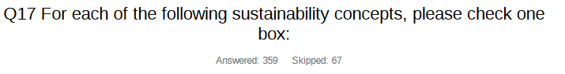

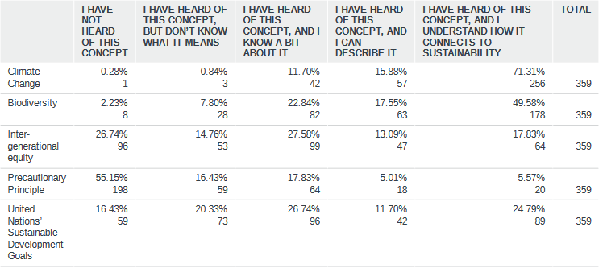

**Analysis:** As per respondents: -

* Climate change & Biodiversity: they are well-aware of the concept and understand its connection to sustainability.
* Inter-generational equity & United Nations SDGs: there is a varied response to these concepts, but there is a need to shed some light on these concepts to spread sustainability related literacy on this matter.
* Precautionary principle: As per response, 55.15% of the respondents haven’t even heard of this concept and therefore, this needs to be top-priority on the literacy list.

**Staff members/ Faculty:** It is observed that faculty members’ knowledge about inter-generational equity and UN Sustainable Development Goals is more than students as about 32% have heard of these concepts but their understanding is limited.

**Students:** It is observed that about half of students have not heard or if they have heard they don’t know about Inter-generational equity and Precautionary principle. UN Sustainable Development Goals is a more prominent concept among students.

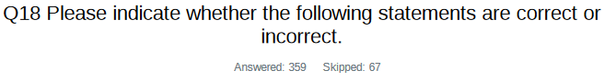

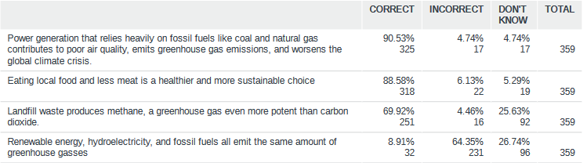

**Analysis:** Popular answers to the questions are as follows: -

* Power generation that relies heavily on fossil fuels like coal and natural gas contributes to poor air quality, emits greenhouse gas emissions, and worsens the global climate crisis – CORRECT
* Eating local food and less meat is a healthier and more sustainable choice- CORRECT
* Landfill waste produces methane, a greenhouse gas even more potent than carbon dioxide – CORRECT (1 out of 4 respondents don’t know)
* Renewable energy, hydroelectricity, and fossil fuels all emit the same amount of greenhouse gases – INCORRECT (1 out of 4 respondents don’t know)

**Staff members/ Faculty:** 48 and 56 out of 183 don’t know about question 3 and 4 respectively.

**Students:** 44 and 41 out of 177 don’t know about question 3 and 4 respectively.

**CONCLUSION & RECOMENDATIONS**

* **Summary of analysis: -**
  + **Positives: -**
    - Most of the respondents don’t have any difficulty in understanding the signs on the waste bins at UFV.
    - Most of the time, respondents try to reduce consumption, generate less waste and use reusable items. Always compost organics, sort waste to right bins and consider waste’s destination when disposing of it.
    - Most of the time, respondents reduce their energy consumption and turn off appliances and electronics when not in use
    - 74.65% respondents believe that climate change impacts are significant, and they are worried that they might affect their life
    - 83.89% of the respondents are driven by climate change as a motivation to reduce their energy consumption.
  + **Negatives: -**
    - There is a much variation in the responses when it comes to turning off power bars when not in use. A significant 23 % never, rarely and sometimes turn off power bars.
    - 60% drive their personal vehicles to get to UFV which can be a concern for the climate.
    - Very few uses eco-friendly methods like cycling and carpooling to get to UFV.
  + **Some suggestions: -**
    - Significant awareness of environmental impact when it comes to how people get to UFV is needed.
    - Public transit and UFV Campus Shuttle have been seen very inefficient and unreliable in terms of time and scheduling options which prevents the respondents from using it. Carpooling is not possible primarily due to variable schedules. This shows that significant improvement is needed in public transportation to encourage its usage. UFV might work on coordinating work schedules for colleagues to reduce variable schedules as much as possible.
* **Need for more sustainability events and incentives to increase the participation rate:** From Q2, it was concluded that the participation rate in sustainability events is least at UFV, and this was recommended further in Q5 where respondents felt the need for more of such events. With given statistics, it is recommended that such events should be incentivized to attract more people and thereby increase the sustainability engagement.
* **Promote classroom discussion:** Q3 responses showed that there is a need to promote more classroom discussions on topics like Environmental racism and Circular Economy.
* **Awareness about UFV’s efforts:** It was evident from Q4 that significant awareness about the undertaken efforts by UFV as a Carbon Neutral Campus needs to be spread. Also, 56.33% of the respondents are not even aware of the Sustainable Event Certification that event organizers can apply for.
* **Recommended/interested sustainability areas/issues to focus on:** 
  + Increasing energy efficiency and lowering GHG emissions associated with buildings and facilities
  + Adding more accessible urban farms/gardens
  + Hosting more sustainability-related events for students and/or staff
  + Sustainability at UFV to be top priority for the leadership team
  + Sustainability development to include education for a culture of peace
  + Maintaining biodiversity for effective functioning of ecosystems
  + Sustainable infrastructure (e.g., green buildings)
  + Food (e.g., fair trade, vegan or vegetarian options, local, organic, etc.)
  + Waste (e.g., recycling, compost)
  + Water (quality and quantity)
  + Diversity and social equity
  + Inter-generational equity & United Nations SDGs: there is a varied response to these concepts, but there is a need to shed some light on these concepts to spread sustainability related literacy on this matter.
  + Precautionary principle: As per responses, 55.15% of the respondents haven’t even heard of this concept and therefore, this needs to be top priority on the literacy list.