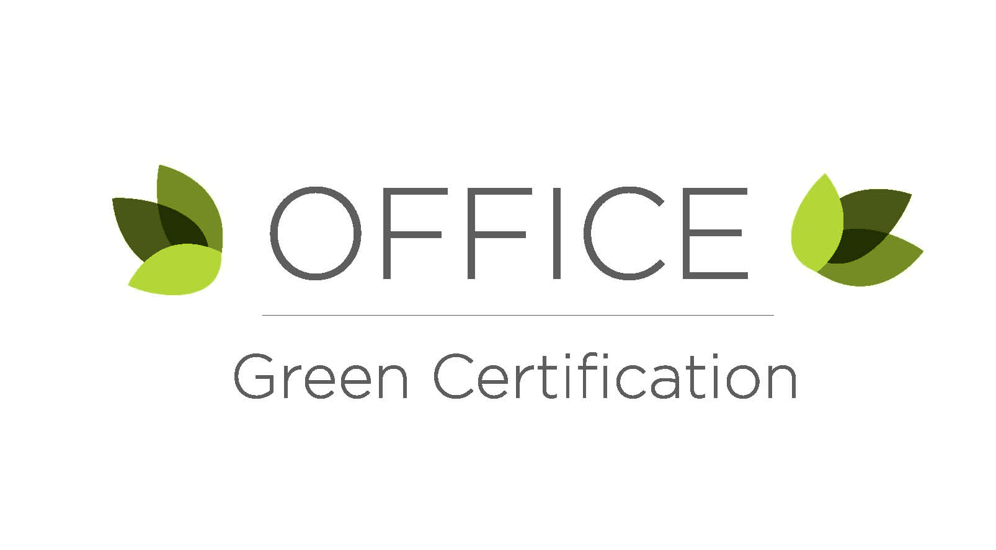

Departments and offices on campus represent a large portion of energy and material use, and production of waste on campus. Offices can also be great places for teamwork, participation, and innovation. The University of Utah has set a goal for carbon neutrality by 2050; if all offices make smarter choices, the University can achieve its goal and ensure its long-term viability.

There are three levels of certification: Bronze (70-79.9% of applicable points), Silver (80-99.9% of applicable points), and Gold (90-100% of applicable points). Each action item is worth 1 point (unless otherwise noted).

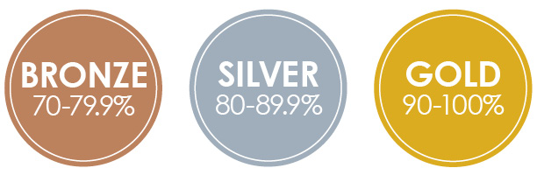

**How it Works**

1. Complete this certification form and email it to [karren.nichols@utah.edu](mailto:karren.nichols@utah.edu).
2. A green-office specialist from the Sustainability Office will schedule a visit with your office to review the form.
3. Receive a certificate to display on your wall as well as recognition on the Sustainability Office’s social media outlets.

**Contact Information**

|  |  |
| --- | --- |
| **Today’s Date:** |  |

|  |  |  |  |
| --- | --- | --- | --- |
| **Primary Contact:** |  | **Email:** |  |
| **Dept. or Office:** |  | **Phone:** |  |

**Green Office Responsibilities**

Identify a team member willing to take on the following responsibilities:

* Send out office announcements, including sustainability tips:
* Monitor the maintenance of your Green Office:
* Introduce new employees to Green Office program:

**Office Inventory**

* Number of people in the office:
* Number of office computers: *Desktops*       *Laptops*
* Number of personal printers:
* Number of multi-user (networked) printers:
* Number of personal heaters and fans:
* Number of lamps (do not include overhead lighting):
* Do you have a water cooler? Yes  No
* Do you have a kitchen or kitchenette? Yes  No 
  + If yes, which:  Kitchen  Kitchenette (small makeshift kitchen area)
* Which of the following appliances do you have in your office/office kitchen:

Industrial Coffee Maker  Countertop Coffee Maker

Single-Cup Coffee Maker  Microwave  Mini-fridge

Full-size refrigerator  Other:

**Action Items**

|  |  |  |  |
| --- | --- | --- | --- |
|  |  | For office use | |
| ***PURCHASING*** | Check if Yes | Point Applicable? | Point Confirmed |
| We use paper containing at least 30% recycled content |  |  |  |
| We only purchase ENERGY STAR or EPEAT-certified models for appliances and equipment |  |  |  |
| We provide office supplies made from recycled materials, such as pens, Post-It Notes, etc. |  |  |  |
| We return our printer’s ink cartridges to be recycled or refilled |  |  |  |
| We purchased furniture at the University of Utah Surplus & Salvage (bit.ly/uofusurplus) |  |  |  |
| We have a centralized location for shared office supplies |  |  |  |
|  |  |  |  |
|  |  |  |  |
| ***ENERGY*** |  |  |  |
| Computers and monitors are shut off when not in use and overnight |  |  |  |
| Sleep mode is enabled on all copiers and printers after 15 minutes (or less) of inactivity |  |  |  |
| All lights are turned off when not in use and overnight |  |  |  |
| We have signs posted to remind staff to switch off lights and electronics |  |  |  |
| Occupancy sensors turn off lights after 15 minutes (or less) of inactivity |  |  |  |
| There are no personal printers in our office |  |  |  |
| We use shared appliances, such as coffee makers or microwaves |  |  |  |
|  |  |  |  |
|  |  |  |  |
| ***TRANSPORTATION*** |  |  |  |
| We provide and display information about public transportation (Shuttles, UTA buses and TRAX, etc.) |  |  |  |
| We participate in the annual Clear the Air Challenge (cleartheairchallenge.org) |  |  |  |

|  |  |  |  |
| --- | --- | --- | --- |
|  |  | For office use | |
| ***KITCHEN/KITCHENETTE*** | Check if Yes | Point Applicable? | Point Confirmed |
| We purchase paper products (napkins, plates, etc.) that are at least 30% recycled content or compostable products |  |  |  |
| The kitchen is stocked with reusable silverware |  |  |  |
| The kitchen is stocked with reusable plateware |  |  |  |
| The kitchen is stocked with reusable mugs and cups |  |  |  |
| There are no disposable options in our kitchen |  |  |  |
| Dishwashing soap and other cleaning supplies are biodegradable and non-toxic (look for Green Seal products) |  |  |  |
| Office purchases coffee and tea that is organic and/or fair trade |  |  |  |
| The office collects pre-consumer food waste and volunteers take the materials home or to the Edible Campus Gardens for composting |  |  |  |
|  |  |  |  |
|  |  |  |  |
| ***OFFICE EVENTS*** |  |  |  |
| In the past year, our office certified at least one Green Event through the Sustainability Office |  |  |  |
| We hold paperless meetings by using PowerPoint presentations and projectors, and/or by sending agendas via email before the meeting |  |  |  |
|  |  |  |  |
|  |  |  |  |
| ***PARTICIPATION*** |  |  |  |
| We post green tips, sustainability events, etc. on social media or a office bulletin board |  |  |  |
| We send out electronic newsletters that include green tips, sustainability events, etc. |  |  |  |
| Our office/department follows the Sustainability Office on social media (Facebook, Twitter, Instagram, and Sustainable Utah blog) |  |  |  |
| We inspired another group to pursue the Green Office Certification |  |  |  |
| * If yes, which office or department: | | | |
| We include information about our office’s sustainable policies and goals in new hire packets |  |  |  |
|  |  | For office use | |
| ***RECYCLING & WASTE*** | Check if Yes | Point Applicable? | Point Confirmed |
| Paper recycling bins are in all common areas adjacent to waste bins |  |  |  |
| Recycling sings are clearly posted on and/or near recycling bins |  |  |  |
| We received the recycling pamphlet from Facilities Management via email |  |  |  |
| We keep a scrap paper pile near out printer and/or copy machine |  |  |  |
| Double-sided printing is set as a default on all office computers |  |  |  |
| We reduce page margins to decrease the number of pages in a document |  |  |  |
| There is at least one reusable bag in the kitchen or break room for staff to use in place of plastic bags |  |  |  |
| Each work station has a desk-side recycling bin for paper |  |  |  |
|  |  |  |  |
|  |  |  |  |
| ***BONUS POINTS*** |  |  |  |
| We use 100% recycled paper |  |  |  |
| Our office has hosted 3 or more certified Green Events in the past 12 months |  |  |  |
| 50% or more of our staff uses methods other than single-occupant vehicles to get to work on a regular basis (including walking, biking, public transportation, Zimride, etc.) |  |  |  |
|  |  |  |  |
|  |  |  |  |
| ***INNOVATION (2 points for your office’s great ideas!)*** |  |  |  |
|  |  |  |  |
|  |  |  |  |

***You’re finished! Now what?*   
Email your completed form to** [**karren.nichols@utah.edu**](mailto:karren.nichols@utah.edu) **with the subject line “Green Office Certification.” You will be contacted to schedule an appointment to review your organization’s submission.**